Lecture No.: 4
The Biomechanics of Human Skeletal Muscle
Introduction:
Muscle is the only tissue capable of actively developing tension. This characteristic enables skeletal, or striated, muscle to perform the important functions of maintaining upright body posture, moving the body limbs, and absorbing shock. Because muscle can only perform these functions when appropriately stimulated, the human nervous system and the muscular system are often referred to collectively as the neuromuscular system.
- BEHAVIORAL PROPERTIES OF THE MUSCULOTENDINOUS UNIT
The four behavioral properties of muscle tissue are extensibility, elasticity, irritability, and the ability to develop tension. These properties are common to all muscle, including the cardiac, smooth, and skeletal muscle of human beings, as well as the muscles of other mammals, reptiles, amphibians, birds, and insects.
Extensibility and Elasticity
The properties of extensibility and elasticity are common to many biological tissues. As shown in Figure 1, extensibility is the ability to be stretched or to increase in length, and elasticity is the ability to return to normal length after a stretch. Muscle’s elasticity returns it to normal resting length following a stretch and provides for the smooth transmission of tension from muscle to bone.

Figure 1: The characteristic properties of muscle tissue enable it to extend, recoil, and contract.

The elastic behavior of muscle has been described as consisting of two major components. The parallel elastic component (PEC) “passive elastic property of muscle derived from the muscle membranes”, provided by the muscle membranes, supplies resistance when a muscle is passively stretched. The series elastic component (SEC)” passive elastic property of muscle derived from the tendons”, residing in the tendons, acts as a spring to store elastic energy when a tensed muscle is stretched. These components of muscle elasticity are so named because the membranes and tendons are respectively parallel to and in series (or in line) with the muscle fibers, which provide the contractile component. The elasticity of human skeletal muscle is believed to be due primarily to the SEC. Modeling studies show that the height of a jump increases when a countermovement (knee flexion) immediately precedes it due to increased elasticity of the SEC in the lower-extremity muscles.
Other research supporting the increase in muscle force following stretch has shown that part of the force enhancement also comes from the PEC. Both the SEC and the PEC have a viscous property that enables muscle to stretch and recoil in a time-dependent fashion. When a static stretch of a muscle group such as the hamstrings is maintained over time, the muscle progressively lengthens, increasing joint range of motion. Likewise, after a muscle group has been stretched, it does not recoil to resting length immediately, but shortens gradually over time. This viscoelastic response is independent of gender.
Irritability and the Ability to Develop Tension
Another of muscle’s characteristic properties, irritability, is the ability to respond to a stimulus. Stimuli affecting muscles are either electrochemical, such as an action potential from the attaching nerve, or mechanical, such as an external blow to a portion of a muscle. When activated by a stimulus, muscle responds by developing tension.
The ability to develop tension is the one behavioral characteristic unique to muscle tissue. Historically, the development of tension by muscle has been referred to as contraction, or the contractile component of muscle function. Contractility is the ability to shorten in length. However, as discussed in a later section, tension in a muscle may not result in the muscle’s shortening.
- STRUCTURAL ORGANIZATION OF SKELETAL MUSCLE
There are approximately 434 muscles in the human body, making up 40–45% of the body weight of most adults. Muscles are distributed in pairs on the right and left sides of the body. About 75 muscle pairs are responsible for body movements and posture, with the remainder involved in activities such as eye control and swallowing. When tension is developed in a muscle, biomechanical considerations such as the magnitude of the force generated, the speed with which the force is developed, and the length of time that the force may be maintained are affected by the particular anatomical and physiological characteristics of the muscle.
Muscle Fibers
A single muscle cell is termed a muscle fiber because of its threadlike shape. The membrane surrounding the muscle fiber is sometimes called the sarcolemma, and the specialized cytoplasm is termed sarcoplasm. The sarcoplasm of each fiber contains a number of nuclei and mitochondria, as well as numerous threadlike myofibrils that are aligned parallel to one another. The myofibrils contain two types of protein filaments whose arrangement produces the characteristic striated pattern after which skeletal, or striated, muscle is named.
Observations through the microscope of the changes in the visible bands and lines in skeletal muscle during muscle contraction have prompted the naming of these structures for purposes of reference (Figure 2). The sarcomere, compartmentalized between two Z lines, is the basic structural unit of the muscle fiber. Each sarcomere is bisected by an M line. The A bands contain thick, rough myosin filaments, each of which is surrounded by six thin, smooth actin filaments. The I bands contain only thin actin filaments. In both bands, the protein filaments are held in place by attachment to Z lines, which adhere to the sarcolemma. In the center of the A bands are the H zones, which contain only the thick myosin filaments. (See Table 1 for the origins of the names of these bands.)

a
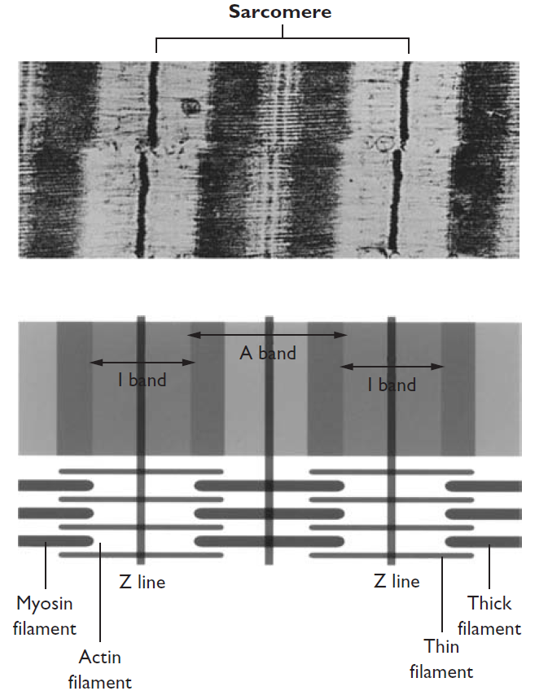 | 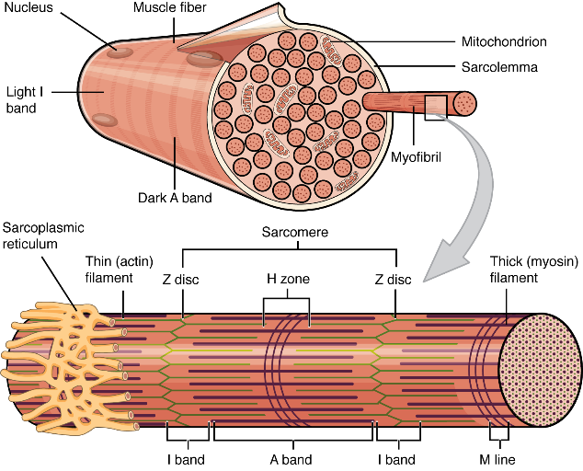
b
Figure 2: a) The sarcoplasm of a muscle fiber contains parallel, threadlike myofibrils, each composed of myosin and actin filaments, b) The sarcomere is composed of alternating dark and light bands that give muscle its striated appearance.

Table 1: How the Structures within the Sarcomeres Got Their Names

During muscle contraction, the thin actin filaments from either end of the sarcomere slide toward each other. As viewed through a microscope, the Z lines move toward the A bands, which maintain their original size, while the I bands narrow and the H zone disappears.
Considerable variation in the length and diameter of muscle fibers within muscles is seen in adults. Some fibers may run the entire length of a muscle, whereas others are much shorter. Skeletal muscle fibers grow in length and diameter from birth to adulthood. Fiber diameter can also be increased by resistance training with few repetitions of large loads in adults of all ages.
Motor Units
Muscle fibers are organized into functional groups of different sizes. Composed of a single motor neuron and all fibers innervated by it, these groups are known as motor units (Figure 3). The axon of each motor neuron subdivides many times so that each individual fiber is supplied with a motor end plate (Figure 4). Typically, there is only one end plate per fiber, although multiple innervation of fibers has been reported in vertebrates other than humans. The fibers of a motor unit may be spread over a several-centimeter area and be interspersed with the fibers of other motor units. Motor units are typically confined to a single muscle and are localized within that muscle. A single mammalian motor unit may contain from less than 100 to nearly 2000 fibers, depending on the type of movements the muscle. Movements that are precisely controlled, such as those of the eyes or fingers, are produced by motor units with small numbers of fibers. Gross, forceful movements, such as those produced by the gastrocnemius (the chief muscle of the calf of the leg), are usually the result of the activity of large motor units.
Figure 3: A motor unit consists of a single neuron and all muscle fibers innervated by that neuron.
Figure 4: Each muscle fiber in a motor unit receives a motor end plate from the motor neuron.
Most skeletal motor units in mammals are composed of twitch-type cells that respond to a single stimulus by developing tension in a twitch like fashion. The tension in a twitch fiber following the stimulus of a single nerve impulse rises to a peak value in less than 100 m sec and then immediately declines.
In the human body, however, motor units are generally activated by a volley of nerve impulses. When rapid, successive impulses activate a fiber already in tension, summation occurs and tension is progressively elevated until a maximum value for that fiber is reached (Figure 5). A fiber repetitively activated so that its maximum tension level is maintained for a time is in tetanus. The tension present during tetanus may be as much as four times peak tension during a single twitch. As tetanus is prolonged, fatigue causes a gradual decline in the level of tension produced.

Figure 5: Tension developed in a muscle fiber (A) in response to a single stimulus, (B) in response to repetitive stimulation, and (C) in response to high-frequency stimulation (tetanus).
Fiber Types
Skeletal muscle fibers exhibit many different structural, histochemical, and behavioral characteristics. Because these differences have direct implications for muscle function, they are of particular interest to many scientists. The fibers of some motor units contract to reach maximum tension more quickly than do others after being stimulated. Based on this distinguishing characteristic, fibers may be divided into the umbrella categories of fast twitch (FT) and slow twitch (ST). It takes FT fibers only about one-seventh the time required by ST fibers to reach peak tension (Figure 6). This difference in time to peak tension is attributed to higher concentrations of myosin-ATPase in FT fibers. The FT fibers are also larger in diameter than ST fibers. Because of these and other differences, FT fibers usually fatigue more quickly than do ST fibers.
Figure 6: Fast-twitch fibers both reach peak tension and relax more quickly than slow-twitch fibers. Note that the twitch tension levels shown are relative to peak tension and not absolute, since FT fibers tend to reach higher peak tensions than ST fibers.
Although intact FT and ST muscles generate approximately the same amount of peak isometric force per cross-sectional area of muscle, individuals with a high percentage of FT fibers are able to generate higher magnitudes of torque and power during movement than are those with more ST fibers.
FT fibers are divided into two categories based on histochemical properties. The first type of FT fiber shares the resistance to fatigue that characterizes ST fibers. The second type of FT fiber is larger in diameter, contains fewer mitochondria, and fatigues more rapidly than the first type (Table 2).

Table 2: Skeletal Muscle Fiber Characteristics

Although all fibers in a motor unit are the same type, most skeletal muscles contain both FT and ST fibers, with the relative amounts varying from muscle to muscle and from individual to individual.
FT fibers are important contributors to a performer’s success in events requiring fast, powerful muscular contraction, such as sprinting and jumping. Endurance events such as distance running, cycling, and swimming require effective functioning of the more fatigue-resistant ST fibers. Using muscle biopsies, researchers have shown that highly successful athletes in events requiring strength and power tend to have unusually high proportions of FT fibers, and that elite endurance athletes usually have abnormally high proportions of ST fibers. As might be expected, in an event such as cycling, the most energetically optimal cycling cadence has been shown to be related to lower-extremity fiber type composition, with a faster pedaling frequency being better for athletes with a higher percentage of FT fibers.
Fiber Architecture
Another variable influencing muscle function is the arrangement of fibers within a muscle. The orientations of fibers within a muscle and the arrangements by which fibers attach to muscle tendons vary considerably among the muscles of the human body. These structural considerations affect the strength of muscular contraction and the range of motion through which a muscle group can move a body segment.
The two umbrella categories of muscle fiber arrangement are termed parallel and pennate. Although numerous subcategories of parallel and pennate fiber arrangements have been proposed, the distinction between these two broad categories is sufficient for discussing biomechanical features. In a parallel fiber arrangement, the fibers are oriented largely in parallel with the longitudinal axis of the muscle (Figure 7). The Sartorius, rectus abdominis, and biceps brachii have parallel fiber orientations. In most parallel-fibered muscles, there are fibers that do not extend the entire length of the muscle, but terminate somewhere in the muscle belly. Such fibers have structural specializations that provide interconnections with neighboring fibers at many points along the fiber’s surface to enable delivery of tension when the fiber is stimulated.
Figure 7
A pennate fiber arrangement is one in which the fibers lie at an angle to the muscle’s longitudinal axis. Each fiber in a pennate muscle attaches to one or more tendons, some of which extend the entire length of the muscle. The fibers of a muscle may exhibit more than one angle of pennation (angle of attachment) to a tendon. The tibialis posterior, rectus femoris, and deltoid muscles have pennate fiber arrangements.
- SKELETAL MUSCLE FUNCTION
When an activated muscle develops tension, the amount of tension present is constant throughout the length of the muscle, as well as in the tendons, and at the sites of the musculotendinous attachments to bone. The tensile force developed by the muscle pulls on the attached bones and creates torque at the joints crossed by the muscle. The magnitude of the torque generated is the product of the muscle force and the force’s moment arm (Figure 8).
Figure 8: Torque (Tm) produced by a muscle at the joint center of rotation is the product of muscle force (Fm) and muscle moment arm (d┴).
In keeping with the laws of vector addition, the net torque present at a joint determines the direction of any resulting movement. The weight of the attached body segment, external forces acting on the body, and tension in any muscle crossing a joint can all generate torques at that joint.

Recruitment of Motor Units
The central nervous system exerts an elaborate system of control that enables matching of the speed and magnitude of muscle contraction to the requirements of the movement so that smooth, delicate, and precise movements can be executed. The neurons that innervate ST motor units generally have low thresholds and are relatively easy to activate, whereas FT motor units are supplied by nerves more difficult to activate. Consequently, the ST fibers are the first to be activated, even when the resulting limb movement is rapid. As the force requirement, speed requirement, or duration of the activity increases, motor units with higher thresholds are progressively activated. Within each fiber type, a continuum of ease of activation exists, and the central nervous system may selectively activate more or fewer motor units.
Change in Muscle Length with Tension Development
When muscular tension produces a torque larger than the resistive torque at a joint, the muscle shortens, causing a change in the angle at the joint. When a muscle shortens, the contraction is concentric, and the resulting joint movement is in the same direction as the net torque generated by the muscles. A single muscle fiber is capable of shortening to approximately one-half of its normal resting length.
Muscles can also develop tension without shortening. If the opposing torque at the joint crossed by the muscle is equal to the torque produced by the muscle (with zero net torque present), muscle length remains unchanged, and no movement occurs at the joint. When muscular tension develops but no change in muscle length occurs, the contraction is isometric.
When opposing joint torque exceeds that produced by tension in a muscle, the muscle lengthens. When a muscle lengthens as it is being stimulated to develop tension, the contraction is eccentric, and the direction of joint motion is opposite that of the net muscle torque.
Concentric: - describing a contraction involving shortening of a muscle.
Isometric: - describing a contraction involving no change in muscle length.
Eccentric: - describing a contraction involving lengthening of a muscle
Roles Assumed by Muscles
An activated muscle can do only one thing: Develop tension. Because one muscle rarely acts in isolation, however, we sometimes speak in terms of the function or role that a given muscle is carrying out when it acts in concert with other muscles crossing the same joint.
When a muscle contracts and causes movement of a body segment at a joint, it is acting as an agonist (role played by a muscle acting to cause a movement).
Muscles with actions opposite those of the agonists can act as antagonists (role played by a muscle acting to slow or stop a movement), or opposers, by developing eccentric tension at the same time that the agonists are causing movement. Agonists and antagonists are typically positioned on opposite sides of a joint.
Another role assumed by muscles involves stabilizing a portion of the body against a particular force. The force may be internal, from tension in other muscles, or external, as provided by the weight of an object being lifted. Stabilizer role played by a muscle acting to stabilize a body part against some other force.
A fourth role assumed by muscles is that of neutralizer (role played by a muscle acting to eliminate an unwanted action produced by an agonist). Neutralizers prevent unwanted accessory actions that normally occur when agonists develop concentric tension.
- FACTORS AFFECTING MUSCULAR FORCE GENERATION
The magnitude of the force generated by muscle is also related to the velocity of muscle shortening, the length of the muscle when it is stimulated, and the period of time since the muscle received a stimulus. Because these factors are significant determiners of muscle force, they have been extensively studied.
Force–Velocity Relationship
The maximal force that a muscle can develop is governed by the velocity of the muscle’s shortening or lengthening, with the relationship respectively shown in the concentric and eccentric zones of the graph in Figure 9.
Figure 9: The force–velocity relationship for muscle tissue. When the resistance (force) is negligible, muscle contracts with maximal velocity. As the load progressively increases, concentric contraction velocity slows to zero at isometric maximum. As the load increases further, the muscle lengthens eccentrically.
Accordingly, the force–velocity relationship does not imply that it is impossible to move a heavy resistance at a fast speed. The stronger the muscle is, the greater the magnitude of maximum isometric tension. This is the maximum amount of force that a muscle can generate before actually lengthening as the resistance is increased. However, the general shape of the force–velocity curve remains the same, regardless of the magnitude of maximum isometric tension.
The force–velocity relationship also does not imply that it is impossible to move a light load at a slow speed. Most activities of daily living require slow, controlled movements of submaximal loads. With submaximal loads, the velocity of muscle shortening is subject to volitional control. Only the number of motor units required are activated.
The force–velocity relationship for muscle loaded beyond the isometric maximum is shown in the top half of Figure 9. Under eccentric conditions, the maximal force a muscle can produce exceeds the isometric maximum by a factor of 1.5–2.0. Achievement of such a high force level, however, appears to require electrical stimulation of the motor neuron. Maximal eccentric forces produced volitionally are similar to the isometric maximum.
Length–Tension Relationship
The amount of maximum isometric tension a muscle is capable of producing is partly dependent on the muscle’s length. In single muscle fibers, isolated muscle preparations, and in vivo human muscles, force generation is at its peak when the muscle is slightly stretched. Conversely, muscle tension development capability is less following muscle shortening. Both the duration of muscle stretch or shortening and the time since stretch or shortening affect force generation capability.
Within the human body, force generation capability increases when the muscle is slightly stretched. Parallel-fibered muscles produce maximum tensions at just over resting length, and pennate-fibered muscles generate maximum tensions at between 120% and 130% of resting length. This phenomenon is due to the contribution of the elastic components of muscle (primarily the SEC), which add to the tension present in the muscle when the muscle is stretched. Figure 10 shows the pattern of maximum tension development as a function of muscle length, with the active contribution of the contractile component and the passive contribution of the SEC and PEC indicated. Research indicates that following eccentric exercise there may be a slight, transient increase in muscle length that impairs force development when joint angle does not place the muscle insufficient stretch.
Figure 10: The total tension present in a stretched muscle is the sum of the active tension provided by the muscle fibers and the passive tension provided by the tendons and muscle membranes.

Stretch-Shortening Cycle
When an actively tensed muscle is stretched just prior to contraction, the resulting contraction is more forceful than in the absence of the pre-stretch. This pattern of eccentric contraction followed immediately by concentric contraction is known as the stretch-shortening cycle (SSC). A muscle can perform substantially more work when it is actively stretched prior to shortening than when it simply contracts.
Electromechanical Delay
When a muscle is stimulated, a brief period elapses before the muscle begins to develop tension (Figure 11). Referred to as electromechanical delay (EMD), this time is believed to be needed for the contractile component of the muscle to stretch the SEC. During this time, muscle laxity is eliminated. Once the SEC is sufficiently stretched, tension development proceeds.
Figure 11: Myoelectric activity (EMG) in the vastus lateralis during isometric knee extension superimposed on a trace of the force output from the leg. Notice that the burst of EMG activity clearly precedes the onset of force production, demonstrating electromechanical delay (EMD).
Researchers have found shorter EMDs produced by muscles with high percentages of FT fibers as compared to muscles with high percentages of ST fibers. Development of higher contraction forces is also associated with shorter EMDs. Factors such as muscle length, contraction type, contraction velocity, and fatigue, however, do not appear to affect EMD. EMD is longer under the following conditions: immediately following passive stretching, several days after eccentric exercise resulting in muscle damage, after a period of endurance training, and when contraction is initiated from a resting state as compared to an activated state. EMD in children is also significantly longer than in adults.
MUSCULAR STRENGTH, POWER, AND ENDURANCE
In practical evaluations of muscular function, the force-generating characteristics of muscle are discussed within the concepts of muscular strength, power, and endurance.
Muscular Strength
In the human body, however, it is not convenient to directly assess the force produced by a given muscle. The most direct assessment of “muscular strength” commonly practiced is a measurement of the maximum torque generated by an entire muscle group at a joint. Muscular strength, then, is measured as a function of the collective force-generating capability of a given functional muscle group. More specifically, muscular strength is the ability of a given muscle group to generate torque at a particular joint.
The tension-generating capability of a muscle is related to its cross-sectional area and its training state. The force generation capability per cross-sectional area of muscle is approximately 90 N/cm².
Muscular Power
Muscular power is therefore the product of muscular force and the velocity of muscle shortening. Maximum power occurs at approximately one-third of maximum velocity and at approximately one third of maximum concentric force (Figure 12). Research indicates that training designed to increase muscular power over a range of resistance occurs most effectively with loads of one-third of one maximum repetition.
Figure 12: The relationships among concentric tension, shortening velocity, and power for muscle.

Because neither muscular force nor the speed of muscle shortening can be directly measured in an intact human being, muscular power is more generally defined as the rate of torque production at a joint, or the product of the net torque and the angular velocity at the joint. Accordingly, muscular power is affected by both muscular strength and movement speed.
Muscular Endurance
Muscular endurance is the ability of the muscle to exert tension over time. The tension may be constant, as when a gymnast performs an iron cross, or may vary cyclically, as during rowing, running, and cycling. The longer the time tension is exerted, the greater the endurance. Although maximum muscular strength and maximum muscular power are relatively specific concepts, muscular endurance is less well understood because the force and speed requirements of the activity dramatically affect the length of time it can be maintained.

Muscle Fatigue
Muscle fatigue has been defined as an exercise-induced reduction in the maximal force capacity of muscle. Fatigability is also the opposite of endurance. The more rapidly a muscle fatigues, the less endurance it has. A complex array of factors affects the rate at which a muscle fatigues, including the type and intensity of exercise, the specific muscle groups involved, and the physical environment in which the activity occurs. Moreover, within a given muscle, fiber type composition and the pattern of motor unit activation play a role in determining the rate at which a muscle fatigues.
Characteristics of muscle fatigue include reduction in muscle force production capability and shortening velocity, as well as prolonged relaxation of motor units between recruitment. High-intensity muscle activity over time also results in prolonged twitch duration and a prolonged sarcolemma action potential of reduced amplitude.
Effect of Muscle Temperature
As body temperature elevates, the speeds of nerve and muscle functions increase. This causes a shift in the force–velocity curve, with a higher value of maximum isometric tension and a higher maximum velocity of shortening possible at any given load (Figure 13). At an elevated temperature, the activation of fewer motor units is needed to sustain a given load (69). The metabolic processes supplying oxygen and removing waste products for the working muscle also quicken with higher body temperatures. These benefits result in increased muscular strength, power, and endurance, and provide the rationale for warming up before an athletic endeavor. Notably, these benefits are independent of any change in the elasticity of the musculotendinous units, as research has demonstrated that the mechanical properties of muscle and tendon are not altered with either heating or cooling over the physiological range.
Figure 13: When muscle temperature is slightly elevated, the force– velocity curve is shifted. This is one benefit of warming up before an athletic endeavor.

