

قــســــــــــم الامــــــــــــــــــــــــــن الــــــــــــــــــــــــــسيبرانــــــــــــــــــــــــــــــــــــي
Department of Cyber Security
Subject:
Object Oriented Programming (OOP)
Class:
Second
Lecturer:
Dr. Abdulkadhem A. Abdulkadhem

Lecture: (1)
Back to Basics: Revisiting Key C++ Principles

Programming is the process of writing instructions for a computer in a certain order to solve a problem.
Special Characters: In C++ , all characters other than listed treated as special characters for example:
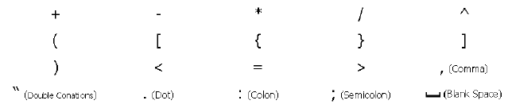

Reserved words cannot be used as variable names or constant. The following words are reserved for use as keywords:
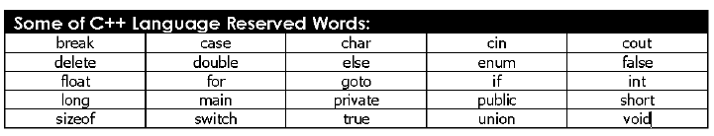

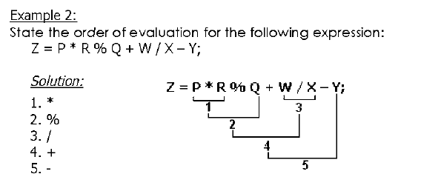

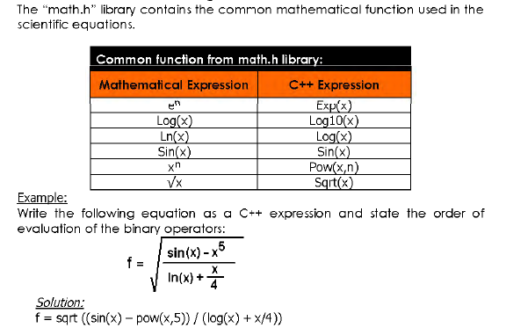
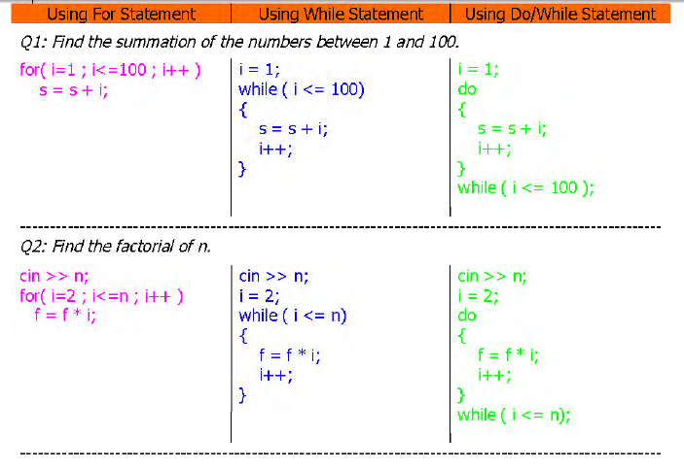
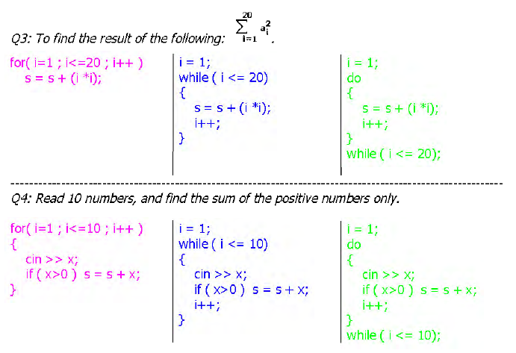
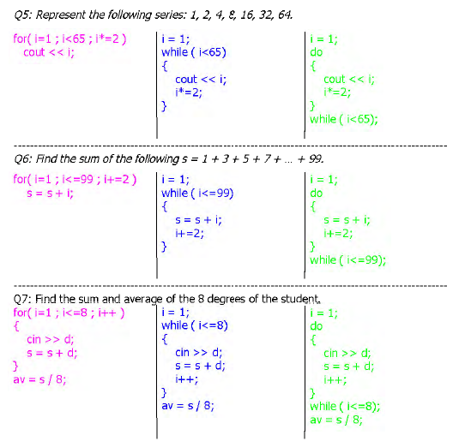
Structures are typically used to group several data items together to form a single entity. It is a collection of variables used to group variables into a single record. Thus a structure (the keyword struct is used in C++) is used. Keyword struct is a data-type, like the following C++ data-types ( int, float, char, etc ... ). This is unlike the array, which all the variables must be the same type. The data items in a structure are called the members of the structure.
