
Basic Biochemistry lecture 1
Dr. Dalya Shakir Obaida

Carbohydrates, also called saccharides (Greek: Saccharon means sugar), are the most abundant biological molecules containing C, H and O, which are they may be defined as ketone derivatives which are combined in the ratio of 1 : 2 : 1, i.e. as (CH2O)n, where n is 3 or more.

Functions of Carbohydrates
Carbohydrates have many important jobs in the body. The simplest form, called monosaccharides, gives us quick energy, and glucose is the most common one used by the body. Besides providing energy, they also help build other important substances.When the body doesn’t need sugar right away, it stores it for later. In animals, sugar is stored as glycogen in the liver and muscles. In plants, it is stored as starch.
If there is too much carbohydrate in the body, it can be turned into fat for long-term storage.
Carbohydrates also have other special uses:
- Ribose is a sugar found in RNA.
- Deoxyribose is found in DNA.
- Galactose is part of lactose, the sugar in milk.
- Mannose helps in making some proteins in the body.
- Fructose, found in fruits, is absorbed easily, processed in the liver, and is also present in semen.

Classification of Carbohydrates
Carbohydrates are grouped based on how many sugar units they have:
- Monosaccharides – simple sugars with one unit (like glucose).
- Disaccharides – made of two sugar units (like sucrose and lactose).
- Oligosaccharides – made of 3 to 10 sugar units.
- Polysaccharides – made of many sugar units (more than 10) joined together (like starch and glycogen).
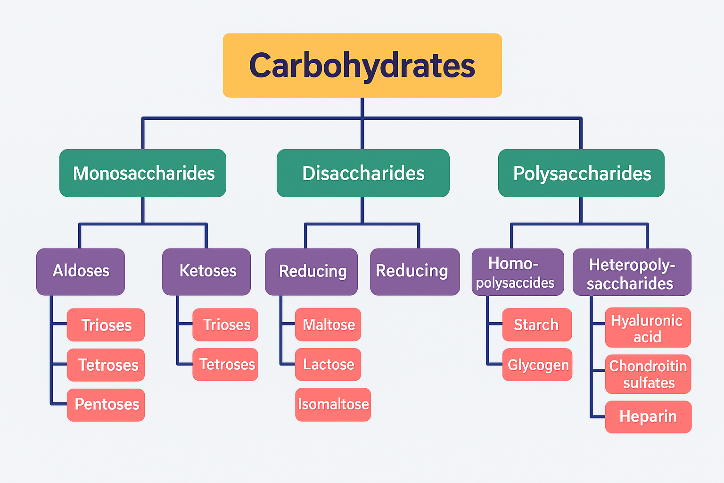

Monosaccharides (Simple Sugars)
Monosaccharides are the simplest form of sugar. They are made from straight chains of carbon atoms with many –OH (hydroxyl) groups and either an aldehyde or a ketone group. These sugars have at least three carbon atoms.
Monosaccharides can join together to form bigger sugars like:
- Disaccharides (2 sugar units)
- Oligosaccharides (a few sugar units)
- Polysaccharides (many sugar units
Monosaccharides are grouped in two main ways:

1. Based on the Type of Carbonyl Group
- Aldoses:
These have an aldehyde group (–CHO) on the first carbon atom.
Example: Glucose
- Ketoses:
These have a ketone group (–CO) on the second carbon atom.
Example: Fructose

2. Based on the Number of Carbon Atoms
Monosaccharides are also named based on how many carbon atoms they have:
- Trioses – 3 carbon atoms:
- Tetroses – 4 carbon atoms:
- Pentoses – 5 carbon atoms
- Hexoses – 6 carbon atoms
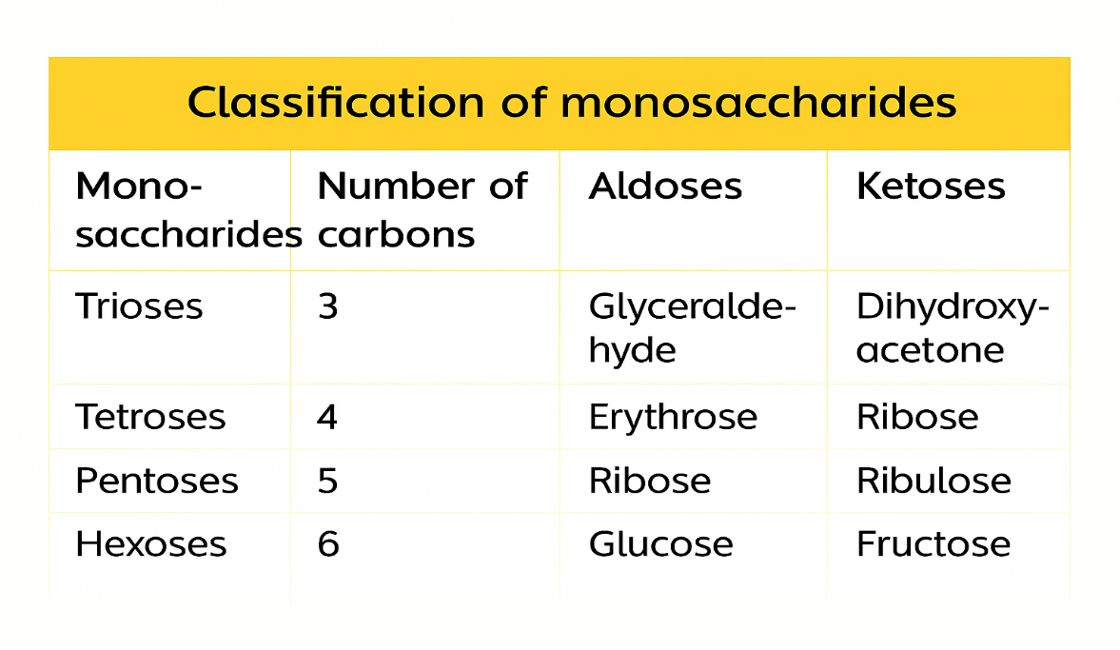
Disaccharides are sugars made of two single sugar units (monosaccharides). These two units can be the same or different and are connected by a glycosidic bond. Common examples include maltose, lactose, and sucrose.
Maltose
Maltose is made of two glucose molecules joined by a special bond called α-1,4-glycosidic bond. It is formed when bigger sugars like starch or glycogen break down. An enzyme called maltase, found in the small intestine, breaks maltose into two glucose molecules.
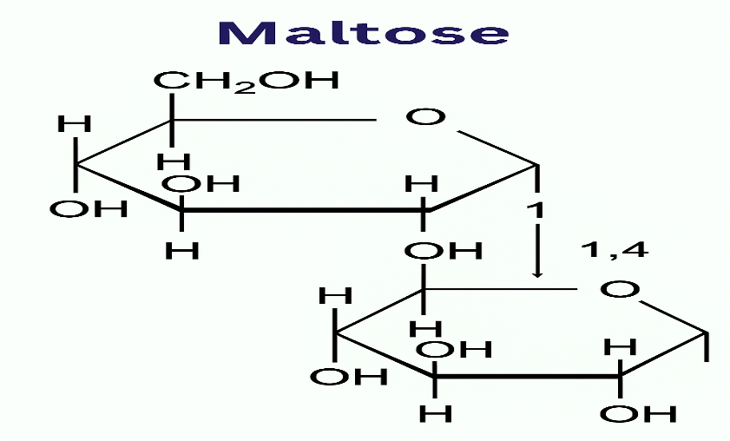
Sucrose (Table Sugar)
Sucrose is a sugar made of two smaller sugars: glucose and fructose. These two are linked together by a bond called an α-1,2-glycosidic bond. Because of this bond, sucrose does not have a free carbonyl group, so it is a non-reducing sugar. Sucrose is also called table sugar, cane sugar, or invert sugar. In the small intestine, an enzyme called sucrase (also known as invertase) breaks sucrose into glucose and fructose.
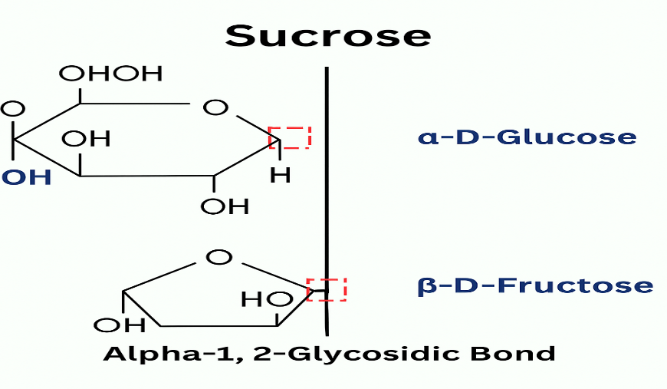
Lactose is a sugar made of two smaller sugars: galactose and glucose. These two are connected by a special bond called an α-1,4-glycosidic bond. Lactose is a reducing sugar and is naturally found in milk, so it is also called milk sugar. In the body, an enzyme called lactase breaks down lactose into glucose and galactose so they can be absorbed.

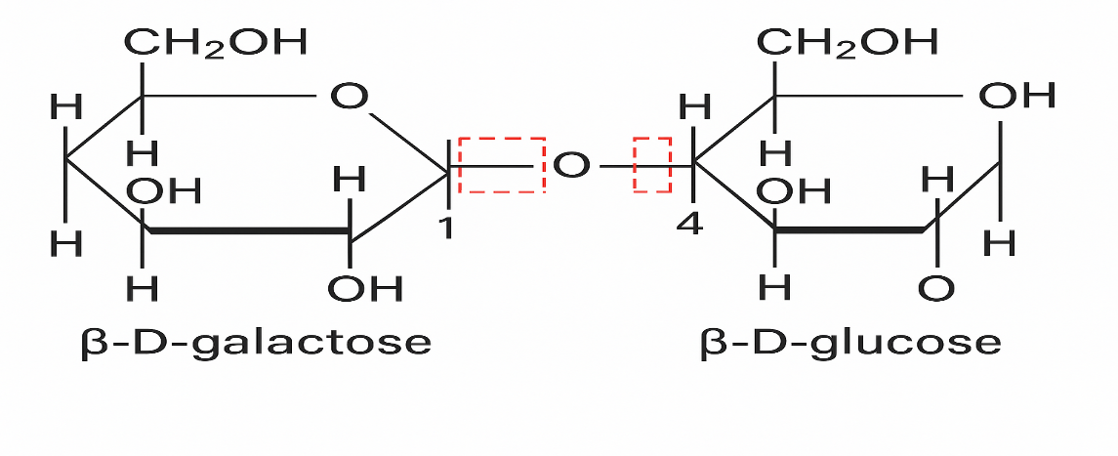

Oligosaccharides
Oligosaccharides are carbohydrates made up of 3 to 10 simple sugar units (monosaccharides) linked together by glycosidic bonds.
Examples are maltotriose and raffinose.Some oligosaccharides help build structures in the body. Most of them cannot be digested by humans.
Polysaccharides
Polysaccharides, also called glycans, are made from a large number of simple sugars joined by glycosidic bonds. They can be either straight chains or branched chains and are divided into two main types:
1. Homopolysaccharides
Also called homoglycans, these are made from the same type of simple sugar units.
- Starch
- Glycogen
- Cellulose (all made from glucose)
- Inulin (made from fructose)

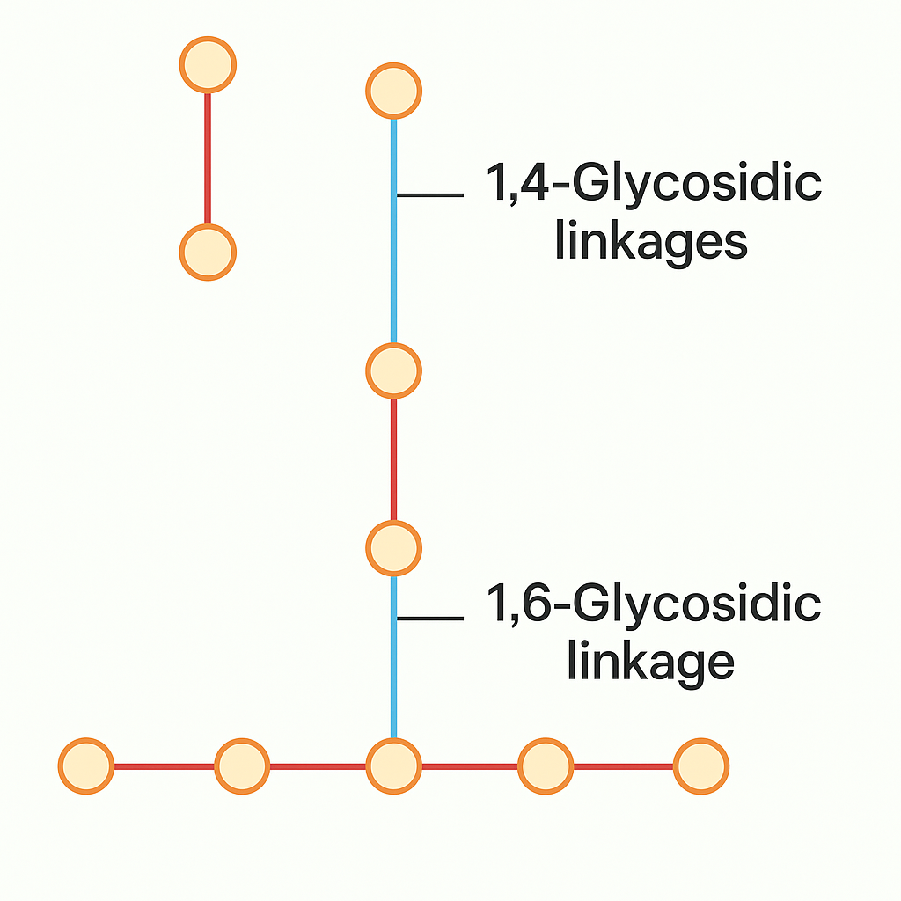

Starch
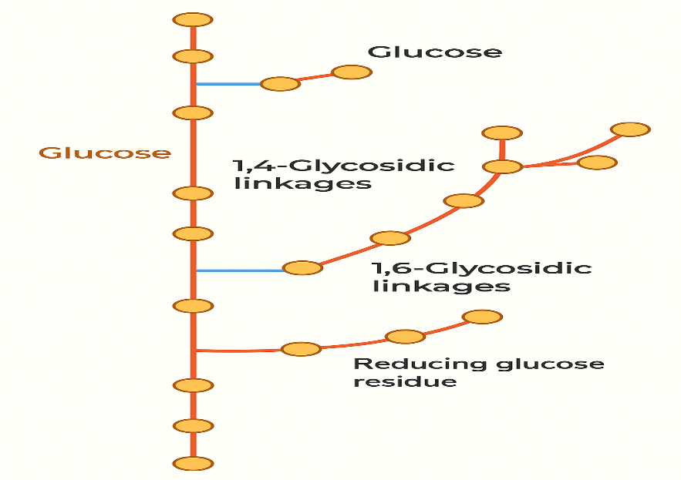
Collagen
Heteropolysaccharides are complex carbohydrates made up of different kinds of simple sugar units. A special group of these is called glycosaminoglycans (GAGs), which were earlier known as mucopolysaccharides. These molecules are large and carry a negative charge. They usually combine with small amounts of protein to form structures called proteoglycans. One well-known example is hyaluronic acid, which is made from repeating pairs of two sugars: D-glucuronic acid and N-acetyl-D-glucosamine.
ISOMERISM IN CARBOHYDRATES
Stereoisomerism refers to molecules with the same chemical formula and structure but that differ in the three-dimensional arrangement of their atoms. This happens when a molecule has either
- a double bond, which prevents rotation
- or a chiral carbon, meaning a carbon atom attached to four different groups.
The presence of chiral carbons in carbohydrates leads to stereoisomerism and gives the compound optical activity, allowing it to rotate plane-polarized light. These include:
- Enantiomers—molecules that are mirror images of each other. In sugars, these mirror-image forms are known as D- and L-forms. The classification depends on the position of the –OH group on the second-to-last carbon in the molecule:
- If the –OH is on the right, it’s called a D-sugar. Human bodies can only use D-sugars for metabolic processes.
- if it’s on the left, it’s an L-sugar.
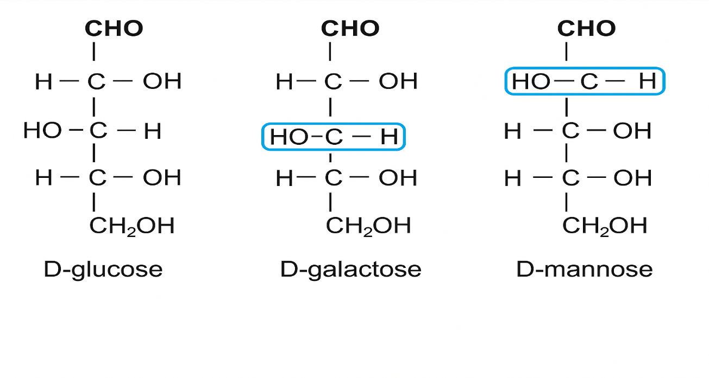
- Anomerism: is a type of isomerism seen in sugars when they are in ring form (not straight chains) in solution.
- Aldose sugars (like glucose) usually form pyranose rings (6-membered).
- Ketose sugars (like fructose) usually form furanose rings (5-membered).
When the sugar forms a ring, the carbon that was part of the carbonyl group (C=O) becomes a new chiral center, called the anomeric carbon:
- In aldoses, it’s carbon 1 (C1).
- In ketoses, it’s carbon 2 (C2).
If two sugars are exactly the same except for the position of the –OH group on the anomeric carbon, they are called anomers. These are labeled as alpha (α) and beta (β) forms.
Examples:
- α-D-glucose and β-D-glucose
- α-D-fructose and β-D-fructose
- Epimerism occurs when two sugar molecules differ in the arrangement of –H and –OH around just one specific carbon atom.
- For example, mannose is an epimer of glucose because they differ only at carbon 2 (C2).
- Likewise, galactose is an epimer of glucose because they differ only at carbon 4 (C4).
These types of sugar isomers are called epimers.

Digestion and Absorption of Carbohydrates

Carbohydrate Digestion:
- Carbohydrate digestion starts in the mouth, where the enzyme salivary amylase begins breaking down starch into smaller units like maltose and shorter polysaccharides.
- Chewing increases saliva production, mixing food with salivary amylase. However, only about 5% of starch is digested here. Once the food reaches the stomach, the acidic environment (low pH) inactivates salivary amylase.
- In the small intestine, the pancreas releases pancreatic amylase through the pancreatic duct.
- Pancreatic amylase continues starch digestion, breaking it down into maltose, isomaltose, dextrins, and both branched and unbranched oligosaccharides.
- Enzymes on the brush border of the small intestine (called disaccharidases) finish the process by converting disaccharides into monosaccharides, which can then be absorbed.
carbohydrate Absorption
All dietary carbohydrates are ultimately absorbed in the small intestinein the form of monosaccharides. This occurs through two main processes:
- Fructose is taken up by facilitated diffusion.
- Glucose and galactose are absorbed through secondary active transport, using the sodium-linked glucose transporter-1 (SGLT-1).
After absorption, these monosaccharides travel through the intestinal mucosal cells located in the villi and enter the liver via the portal vein. In the liver, both galactose and fructose are converted into glucose.

