Enzymes are organic molecules, which are produced in living organisms and increase rate of a biochemical reaction without being utilized in the overall process. These are nondialyzable colloidal particles, which are
thermolabile proteins with highly specific catalytic activity.

CHEMICAL NATURE OF ENZYMES
Almost all enzymes are protein in nature. Enzymes with two or more subunits (polypeptides) are known as oligomeric enzymes.
NOMENCLATURE
Enzymes are, usually, named by the suffix “-ase” with the name of the substrate, or the catalytic action of the enzyme, e.g., lipase (which catalysis the hydrolysis of lipids), fatty acid synthase (which catalyses synthesis of fatty acids), etc. These names are called trivial names.
However, while assigning a trivial name to an enzyme, no systematic rules were followed.
CLASSIFICATION
The International Union of Biochemistry and Molecular Biology (IUBMB) adopted a scheme for a rational system of naming each enzyme and suggested their functional classification. According to IUBMB, each enzyme is assigned a four-digit systematic code, commonly known as the Enzyme Commission number (EC number).
According to the enzyme commission, enzymes are classified into six classes, which include:
1. Oxidoreductases
Oxidoreductases are involved in the oxidation and/or reduction of a substrate, i.e., they catalyze the addition of oxygen, removal of hydrogen, or removal of electrons, include dehydrogenases, oxidases
2. Transferases
Transferases catalyze the transfer of a particular group from one substrate to another. Based on the group being transferred, they are sub-classified as aminotransferases.
3. Hydrolases
Hydrolases catalyze the hydrolysis of a substrate with a molecule of water. According to nature of the group or bond hydrolyzed, hydrolases .
4. Lyases
Lyases catalyze the splitting of a substrate into two products without water. They are sub-classified based on the linkage split, e.g. breakdown of the C–C, C–N or C–S bond, etc. Examples of the class lyases include fumarase, pyruvate decarboxylase.
5. Isomerases
Isomerases convert one isomeric form of a substrate into another
, i.e. they catalyze the isomerization of the substrate. Racemases, epimerases and mutases, etc.
6. Ligases
Ligases catalyze the synthesis of a product from two different substrates. This requires energy, which is coupled to the hydrolysis of a high-energy bond. Its include ligases, which form C–C, C–N or C–S bonds.

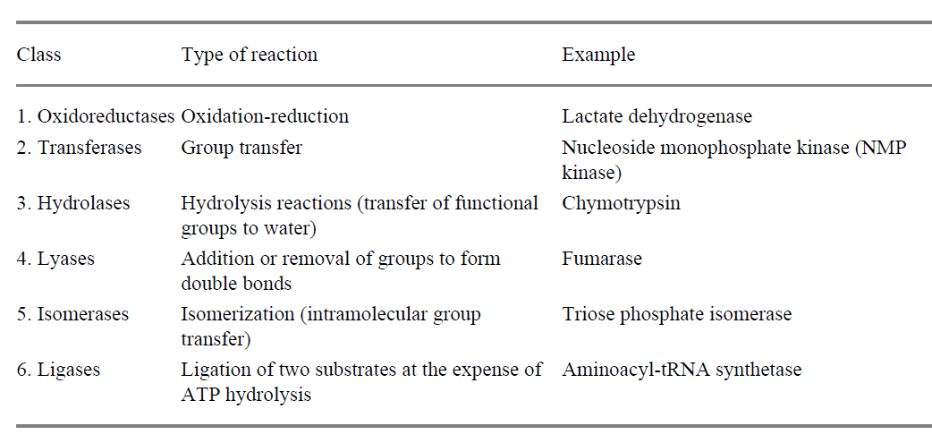
Enzymes Are Powerful and Highly Specific Catalysts
Enzymes accelerate reactions by factors of as much as a million or more . Indeed, most reactions in biological systems do not take place at perceptible rates in the absence of enzymes. Even a reaction as simple as the hydration of carbon dioxide is catalyzed by an enzyme namely, carbonic anhydrase . The transfer of CO2 from the tissues into the blood and then to the alveolar air would be less complete in the absence of this enzyme. In fact, carbonic anhydrase is one of the fastest enzymes known. Each enzyme molecule can hydrate 106 molecules of CO2 per second.
This catalyzed reaction is 107 times as fast as the uncatalyzed one.

MODE OF ACTION OF ENZYMES
There are a few theories explaining the mechanism of action of enzymes. Perhaps each of them tries to view the fact from different perspectives to explain a particular aspect of the action by lowering Activation Energy.

Enzymes lower the energy of activation.
- Activation energy is defined as the energy required to convert all molecules of a reacting substance from the ground state to the transition state.
- Substrates are remaining in an energy trough, and are to be placed at a higher energy level, whereupon spontaneous degradation can occur. Suppose, we ant to make a fire; even if we keep a flame, the wood will not burn
- During enzyme-substrate binding, weak interactions between enzyme and substrate are optimized. This weak binding interaction between enzyme and substrate provides the major driving force for the enzymatic catalysis.
- Enzymes reduce the magnitude of this activation energy. This can be compared to making a tunnel in a mountain, so that the barrier could be lowered .

Lowering of activation energy by enzymes

PROPERTIES OF ENZYMES
- Chemical Nature
Most of the enzymes are protein in nature. They may have one or more than one polypeptide chains and may be referred to as oligomeric enzymes or multi-enzyme complexes.
- Oligomeric Enzymes
These are multimeric proteins, i.e. they have more than one protein subunit, which are biologically active only when associated with each other. These multi-subunit. Enzymes are called oligomeric enzymes. Forexample, phosphorylase, hexokinase and lactate dehydrogenase, each one of which is a tetramer.
Multi-enzyme Complexes
On the other hand, there are some enzymes, which are single polypeptide chains with several catalytic activities. Due to several enzyme activities associated with a single protein, these enzymes are called multienzyme complexes. A multienzyme complex acts on its substrate and catalyses a series of reactions, e.g pyruvate dehydrogenase complex. This enzyme is a multienzyme complex having three different enzyme activities.
.Proenzymes (Zymogens)
Several enzymes are secreted in the inactive form called zymogen or proenzyme (precursor of the enzyme). Zymogen is converted to its active enzyme(zymase) by some activating agent, such as H+, other enzyme or the active form of the zymogen. For pepsinogen (an example, gastric juice secretes zymogen), which is converted to pepsin by H+ of the gastric juice. Once pepsin is formed, it acts on pepsinogen and catalysis its conversion to pepsin. This process is referred to as autocatalysis

Conversion of a proenzyme to active enzyme

- Specificity
Enzymes are highly specific in nature, i.e. they interact with only one or a few substrates and catalyze a specific type of reaction only. The extent of substrate specificity varies from enzyme to enzyme its include:
Absolute Specificity
An enzyme has absolute specificity for its substrate and will not act upon any other substrate, e.g. urease is specific for urea only.
Relative Specificity
An enzyme may be specific either to a particular group or type of bond, e.g. protease (hydrolyzes peptide bond of protein), glycosidase (hydrolyzes glycosidic bond of polysaccharide), esterase (hydrolyzes ester bond of triacylglycerols .
MICHAELIS–MENTEN THEORY
In 1913, Michaelis and Menten put forward the enzyme–substrate complex theory. Accordingly, the enzyme (E) combines with the substrate (S), to form an enzyme-substrate (ES) complex, which immediately breaks down to the enzyme and the product (P) .
E + S E–S Complex → E + P
Alkaline phosphatase hydrolyses a number of phosphate esters including glucose-6-phosphate. The active center of this enzyme contains a serine residue, and the reaction is taking place in the following two steps:
a. E-Serine-OH+Glucose-6-P→E-Serine-O-P+Glucose
b. E-Serine-O-P → E-Serine-OH+Pi
Thus, the overall reaction is
Glucose-6-P → Glucose + Pi
The enzyme substrate complex, E-Serine-O-P, has been isolated in this reaction mixture.
Enzyme substrate complex
FISCHER'S TEMPLATE THEORY
It states that the three-dimensional structure of the enzyme's active site is complementary to the substrate, Thus enzyme and substrate fit each other.The substrate fits on the enzyme, similar to lock and key. The lock can be opened by its key only . However, Fischer envisaged a rigid structure for enzymes, which could not explain the flexibility shown
by enzymes.
Fischer’s template theory

Enzyme and substrate are specific to each other. This is similar to key and lock (Fischer's theory)

KOSHLAND'S INDUCED FIT THEORY
Conformational changes are occurring at the active site of enzymes concomitant with the combination of the enzyme with the substrate. At
First, the substrate binds to a specific part of the enzyme. This leads to more secondary binding and conformational changes. The substrate induces conformational changes in the enzyme, such that precise orientation of catalytic groups is effected. A simplified explanation is that a glove is put on a hand. At first, the glove is in a partially folded position, but hand can enter into it. When the hand is introduced, the glove is further opened. Similarly, conformational changes occur in the enzyme when the substrate is fixed.
When the substrate analog is fixed to the enzyme, some structural alteration may occur; but reaction does not take place due to lack of
proper alignment . Allosteric regulation can also be explained by the hypothesis of Koshland.

Correct alignment of amino acids in the active center of the enzyme
.
Koshland’s induced fit theory
Energy of Activation of Catalyzed and Uncatalyzed Reactions
All chemical reactions have an energy barrier, separating the reactants and the products. This barrier, called the free energy of activation, is the energy difference between the energy of the reactant and high energy intermediates that occurs during the formation of a product .

S ↔ S* ↔ P
[Reactant] [Product]
The peak of free energy activation, represents the transition state, in which the high energy intermediates (S*) are formed during the conversion of a reactant to a product. Due to the effect of activation energy, the rates of unanalyzed chemical reactions are slow.
An enzyme lowers the energy required for activation to the transition state. With an enzyme as a catalyst, the reaction may easily proceed at the normal physiological temperature; otherwise addition.
Active Site of an Enzyme
The active site of an enzyme is the region where substrate binds.
This active site contains specific amino acid residues (binding and catalytic residues) and possess three-dimensional structure. The amino acid residues at the active site of an enzyme have two functions:
- The binding amino acid residues recognize and bind the correct substrate to form enzyme substrate (ES) complex.
- The catalytic residues create a chemical environment that enhances the rate of reaction and ES complex is converted to an enzyme (E), and a product (P).
A change in the primary, secondary, tertiary or quaternary structure may alter the three-dimensionalshape of the active site to reduce its binding and catalytic activity.
Factors Affecting the Enzyme Activity
- pH
- Temperature
- Concentration of substrate
- Concentration of enzyme
  - Effect of pH
Each enzyme has an optimum pH at which their activity will be maximum. Either decreased or increased pH causes the decreased enzyme activity. The bell-shaped curve is obtained when enzyme activity is
plotted against pH.Optimum pH of an enzyme depends upon ionization state of the enzyme as well as its substrate. Change in pH affects ionization state of the enzyme, thereby decreasing the number of active sites. Hence, at extremely low or high pH, enzyme gets denatured. Optimum pH for most of the enzymes is in the neutral range, i.e. around 7.0. However, optimum pH for pepsin is about 2.0 while for the enzymes of the pancreatic juice optimum pH is near 8.0.

The changes in pH may alter:
- The ionization state of the amino acid residues at the active site
- Ionization of residues that are responsible for maintaining the enzyme protein conformation
- May dissociate the apoenzyme from the prosthetic group
- Very high or low pH may denature the enzyme.

Effect of pH on enzyme activity

  - Effect of Temperature
The temperature at which the enzyme activity is more is called optimum temperature. Any strong change in the optimum temperature results in the loss of enzyme activity. Optimum temperature of enzymes in the human body is 37°C.Rate of an enzyme catalyzed reaction increases with increase in temperature of the reaction mixture. Optimum temperature of an enzyme is defined as the temperature at which its activity is maximum. For most of the enzymes, optimum temperature is near body temperature, i.e. 37°C. With rise in temperature of the reaction mixture beyond optimum temperature of the enzyme, being protein, enzyme gets denatured and loses its biological activity. Relationship of enzyme activity to a change in temperature is represented by a bell-shaped curve, peak of which represents an optimum temperature of the enzyme .

Effect of temperature on enzyme activity

  - Substrate Concentration
With a fixed quantity of enzyme, reaction rate is proportional to concentration of the substrate. This is, however, true only up to a certain point, i.e. the point at which its velocity is maximum (Vmax). Further
increase in substrate concentration, beyond this point, will not increase rate of the reaction .
Effect of substrate concentration on enzyme activity
To confirm it, Michaelis and Menten derived a relationship between substrate concentration and reaction velocity by an equation, called Michaelis- Menten equation, which is as follows:
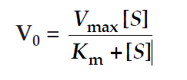
where, V0 is initial reaction velocity, Vmax is maximum velocity of the reaction
[S] is concentration of the substrate and Km is a constant, referred to as Michaelis constant. Km is defined as the substrate concentration at which reaction velocity is half of the maximum velocity, i.e.
Km = Vmax/2.
As substrate concentration is increased, the velocity is also correspondingly increased in the initial phases; but the curve
flattens afterwards. The maximum velocity obtained is called Vmax represents the maximum reaction rate attainable in presence of excess substrate (at substrate saturation level).
Effect of substrate concentration on enzyme activity

Michaelis Constant
According to Michaelis theory, the formation of enzyme– substrate complex is a reversible reaction, while the breakdown of the complex to enzyme + product is irreversible.
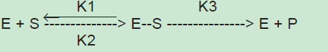
if concentration of substrate is increased, the forward reaction K1 is increased, and so K3 as well as total velocity is correspondingly enhanced. The three different constants may be made into one equation,

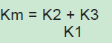

Km is called as Michaelis Constant. It is further shown that
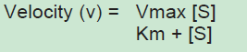
When concentration of substrate is made equal to Km, i.e. When [S] = Km

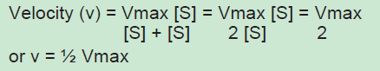
  - Enzyme Concentration
Rate of a reaction or velocity (V) is directly proportional to the enzyme concentration, when sufficient substrate is present. Velocity of reaction is increased proportionately with the concentration of enzyme, provided substrate concentration is unlimited.
Effect of enzyme concentration

