?. ./Characteristics of good technician
Medical laboratory technician requires experience in different technical fields. Individuals employed in this area must use computers and electronics. The skills include general computer hardware, software, and electronics knowledge. Required medical software expertise includes knowledge in Electronic Medical Record (EMR) software, test-routing software, test result distribution software, and laboratory Information System (LIS) software. Knowledge of databases, spreadsheets and word processing programs are often required.
What does a Laboratory Technician do?
1- Prepare and carry out diagnostc laboratory tests
2- Operate and maintain laboratory standard equipment such as centrifuges, titrates , pipetting machines and pH meters.
3- Prepare specimens
4- Supervise experiments as they run.
5- Clean lab equipment and keep it in serviceable condition.
6-Mix compounds during the manufacturing process
How To avoid contamination of Specimen
1- Wear proper protective equipment
Most labs require individuals to follow certain protocols regarding personal protective equipment. Wearing gloves, hairnets, lab coats, and close-toed shoes. This equipment protects both the person wearing it and reduces contamination. Personnel should never reuse disposable gloves and they should always change them when moving between samples to further reduce the risk of contamination
2- Clean and sterilize equipment
Maintaining a sterile work environment is crucial to avoiding contamination. Be sure to thoroughly clean and sterilize every piece of lab equipment regularly. For some pieces of equipment, such as glassware, this may be as frequent as every day.
3- Check your water supply
If all of your samples including your negative control have been contaminated then it could be your water supply. In the lab, deionized water and distilled water are normally used to prevent contamination
4- Use air filters and laminar flow hoods
When you are transferring samples it is critical to work in an environment where the air will not interfere with your sample. You should work in a hood that keeps air moving, preventing microbes in the air from landing. Air filters trap contaminates in the air, keeping your environment sterile.

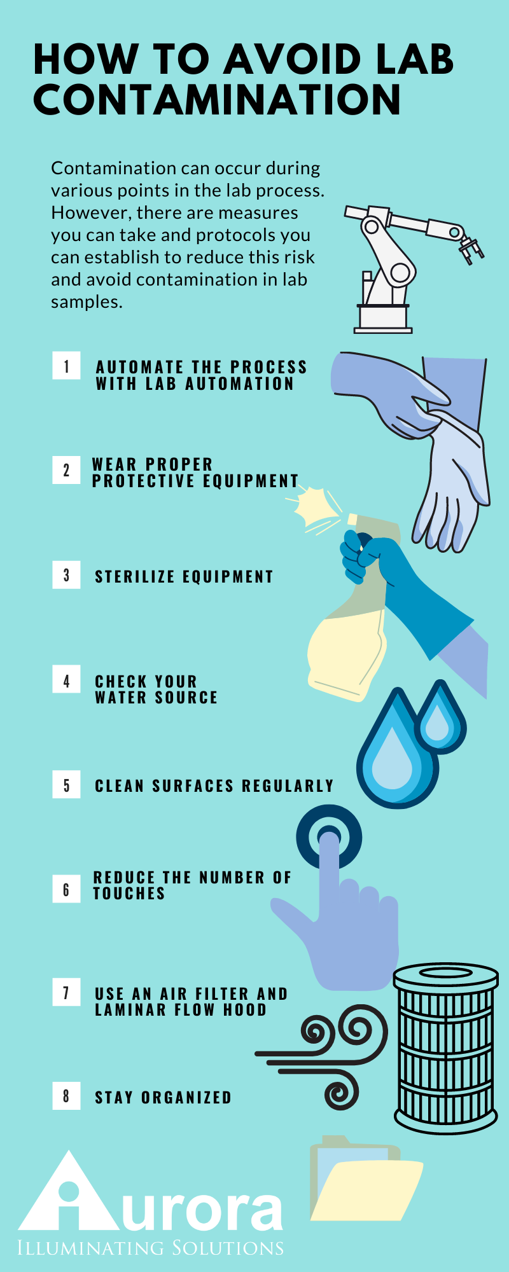

Human Physiology
Specimen collection
Lab. 2

What is Specimen Collection?
Collecting specimens is the process of acquiring tissue or fluids for laboratory
Analysis . Some of the samples collected may include serum samples, virology
swab samples, biopsy and necropsy tissue, cerebrospinal fluid, whole blood
for PCR, and urine samples. Medical Assistants collect these samples and then
place them in specific contain

What is the Purpose of Specimen Collection?
Specimen collection is vital for acquiring an accurateدقيق and timely laboratory test result. To properly collect specimens, they must be obtained through designated containers, correctly labeled, and promptly transported to the lab.
Specimen Collection Procedure

With these steps, you can start to learn more about the process of collecting
specimens. Of course, just like any other skillمهاره , specimen collection requires a
little time and practice to get it right. Remember to follow the rules of your
facility and ask for help whenever necessary.
Specimen Collection Preparation
While most collections don’t require much prep, there are some guidelines
that must be followed. These include reviewing the appropriate information, such as
the indicated specimen type, the volume, the procedure, the collection materials,
patient prep, and storage instructions.

Specimen Collection Steps
Here are some of the general guidelines you should follow when collecting
specimens from a patient:
1- Verifyتحقق the patient’s identityهويه . Some examples of acceptable identifiers
the patient’s name, date of birth, and hospital number
include
2- Acquire a sample from the patient. Treat all biological material as potentially
hazardous and follow your facility’s guidelines.
3- Process the specimen as required by your facility or صاحب العمل employer.
4- Store the specimen. Appropriate storage is critical to maintaining the integrity
of the specimen and, therefore, the test results.

Necessary Equipment for Specimen Collection

Typically, the suggested supplies for specimen collection include but are not
limited to the following items:
Gloves
Hand sanitizer
Specimen container
Body material sample
Incubator
Refrigerator or freezer

Potential Risks or Complications of Specimen Collection

Specimen collection is often safe and relatively painless for patients.
Although there may be pain associated with blood draws, it should not be
significant or cause any lasting damage.

Preparing the Patient.

Provide the patient, in advance, with appropriate collection instructions and information
on fasting, diet, and medication restrictions when indicated for the specific test.

Avoiding Common Problems

Careful attentionالانتباه بحذر to routine procedures can eliminate most of the potential problems
related to specimen collection.

