

قــســــــــــم الامــــــــــــــــــــــــــن الــــــــــــــــــــــــــــــــــــسيبرانــــــــــــــــــــــــــــــــــــي

Department of Cyber Security

Subject:
COMPUTER ORGANIZATION & LOGIC DESIGN

Class:

First
Digital Logic Lab: (1)

Msc :Muntather AL-mussawee

Boolean algebra
Boolean algebra is the mathematics of digital systems. It is important that you understand is principles thoroughly because a basic knowledge of Boolean algebra is indispensable to the study and analysis of logic circuits.
--------------------------------------------------------
Rules of Boolean Algebra

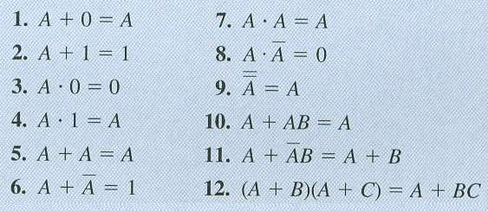

- Rule 1 → A + 0

A |  |  | 0
 | 0 |  | 0 |  | 0
 | 1 |  | 0 |  | 1

- Rule 2 → A + 1

A | 1
1 | 1 | 1
0 | 1 | 1

- Rule 3 → A . 0

A | 0
0 | 0 | 0
1 | 0 | 0

- Rule 4 → A . 1

A | 1
0 | 1 | 0
1 | 1 | 1

- Rule 5 → A + A

A | A
0 | 0 | 0
1 | 1 | 1

- Rule 6 → A + A'

A | Not - A
0 | 1 | 1
1 | 0 | 1

- Rule 7 → A . A

A | A | Not - A
0 | 0 | 0
1 | 1 | 1

- Rule 8 → A . A'

A | Not- A | Not - A
0 | 1 | 0
1 | 0 | 0

- Rule 9 → A''

A | Not- A | Not - A
0 | 1 | 0
1 | 0 | 1

- Rule 10 → A + AB = A

A | B | A*B | A + AB
0 | 0 | 0 | 0
0 | 1 | 0 | 0
1 | 0 | 0 | 1
1 | 1 | 1 | 1

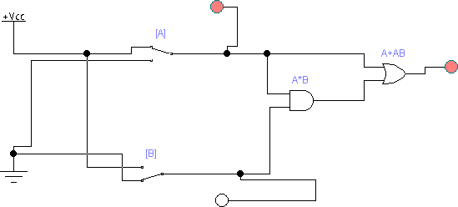

- Rule 11 → A + ĀB = A + B

A | B | Ā | ĀB | A + ĀB | A + B
0 | 0 | 1 | 0 | 0 | 0
0 | 1 | 1 | 1 | 1 | 1
1 | 0 | 0 | 0 | 1 | 1
1 | 1 | 0 | 0 | 1 | 1

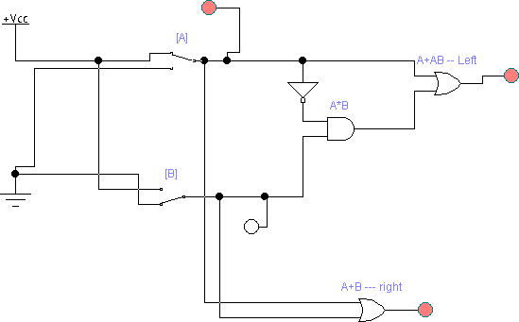

- Rule 12 → (A + B)(A + C) = A + BC
- Proof of the rule
(A + B)(A + C) = AA + AC + BA + BC
= A + AC + BA + BC
= A + BA + BC
= A + BC

- Truth Table

A | B | c | A+B | A+C | (A+B)(A+C) | BC | A + BC
0 | 0 | 0 | 0 | 0 | 0 | 0 | 0
0 | 0 | 1 | 0 | 1 | 0 | 0 | 0
0 | 1 | 0 | 1 | 0 | 0 | 0 | 0
0 | 1 | 1 | 1 | 1 | 1 | 1 | 1
1 | 0 | 0 | 1 | 1 | 1 | 0 | 1
1 | 0 | 1 | 1 | 1 | 1 | 0 | 1
1 | 1 | 0 | 1 | 1 | 1 | 0 | 1
1 | 1 | 1 | 1 | 1 | 1 | 1 | 1

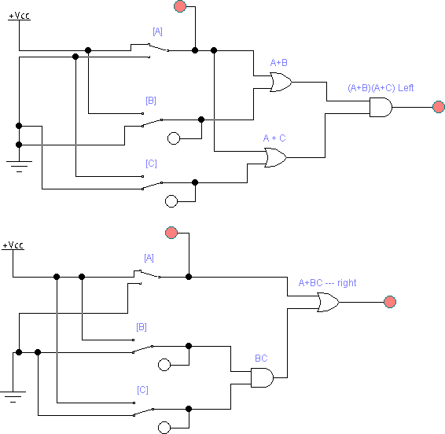

DeMorgan’s Theorems
--------------------------------------------------------
Two of the most important theorems of Boolean algebra were contributed by a great mathematician named DeMorgan. DeMorgan’s theorems are extremely useful in simplifying expressions in which a product of sum of variables is inverted. The two theorems are:
Theorem 1 | Theorem 2
XY = X + Y | X + Y = XY
XYZW | X+Y+Z+W
_ _ _ _  X + Y + Z + W | _ _ _ _  XY Z W

Ex1: -
Sol: -

= X + Y + W + Z
ـــــ_ـــــــــــــــــــــــــــــــــــ

Ex2:- (A + B) + C
Sol: -
ـــــ ــــــــــــــــــــــــ
  - (A + B)C ➔ rule –9 boolean A'' = A
  - (A'' + B")C''
  - (A + B)C

23 = 8 (0---7)

A | B | C | A + B | (A+B)C
0 | 0 | 0 | 0 | 0
0 | 0 | 1 | 0 | 0
0 | 1 | 0 | 1 | 0
0 | 1 | 1 | 1 | 1
1 | 0 | 0 | 1 | 0
1 | 0 | 1 | 1 | 1
1 | 1 | 0 | 1 | 0
1 | 1 | 1 | 1 | 1
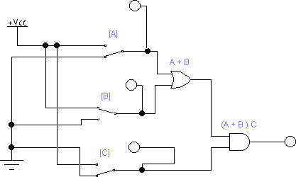

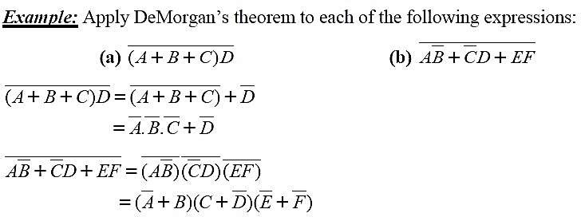

Simplification using Boolean algebra:
Many times in the application of Boolean algebra, we have to reduce a particular expression to its simplest form or change its form to a more convenient one to implement the expression most efficiently. The purpose of simplifying Boolean expression is to use the fewest gates possible to implement a given expression.
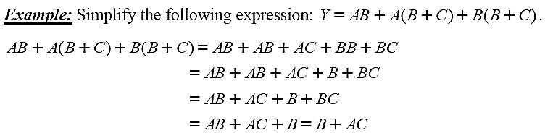

The Sum-of-Product (SOP) form:
When two or more product terms are summed by Boolean addition, the resulting expression is a sum of product (SOP). Some examples are:

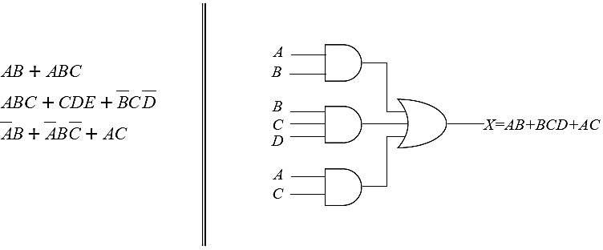

The Product-of-Sum (POS) form:
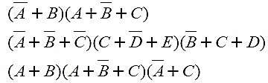
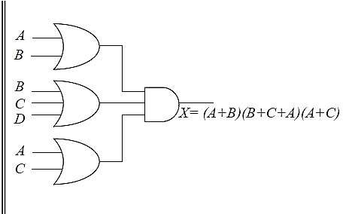
When two or more sum terms are multiplied, the resulting expression is a product of sum (POS). Some examples are:

