Grammar: Modals (Intermediate: Unit 4, 7)
Vocabulary: Permissions and Possibilities
(Intermediate: Unit 4, 7; Upper-Intermediate: Unit 7)
Reading: "Doing the Right Thing" (Intermediate: Unit 4;
Upper-Intermediate: Unit 7 "Getting on Together")
Unit 8
8.1. Starter
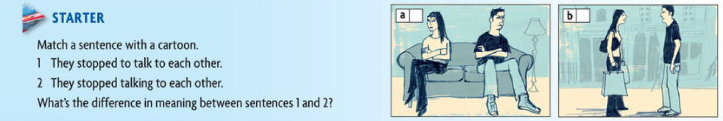
8.1. Answer :
a- 2
b- 1
8.2. Don’t worry MUM !
Verb pattern
Read the following e- mails , What has happened that gives their parents reasons to worry ?
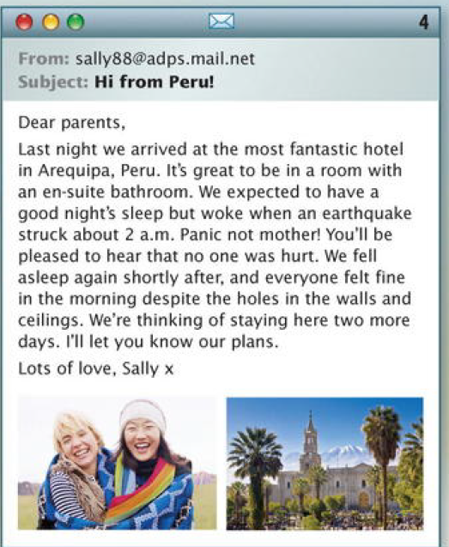 
8.3 Read these sentences , Which verbs or phrases can fill the gap ?
1. Kate didn't ------------ anyone taking the photos.
a- see b- ask c- remember
2. She --------- to climb up to the top bunk bed.
a – wanted b- tried c - remembered
3. She forgot ---------- the hospital.
a mentioning b - to mention c- mention
4 . Dan asked his mum --------------- his Australian friends.
a- put up b- putting up c- to put up
5. His Australian friends --------- to go to London.
a - want b - are hoping c- are looking forward at home.
6. He thinks his mum will make them
a - feel b - to feel c- feeling
7. William ----------- to catch piranha fish.
a - didn't succeed in b - didn't manage c - tried
8 . They stopped. --------------- on the river bank.
a - camping b -to camp c- to spend the night
9. Sally ------------------- having an en-suite bathroom.
a- loved b- wanted c -hoped
10. She is ------------------ staying two more days
a – planning b- looking forward to c- thinking of
8.4. Grammar spot
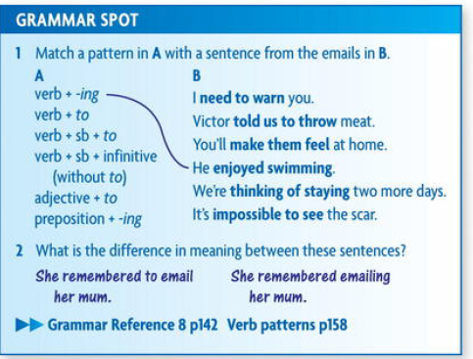
8.5. Listening and Speaking
8.5.1. Fears and Phobia
- Some people have a strange phobias . Listen to Jodie , Gavin , and Meissa talking about their .
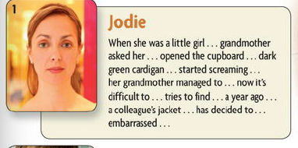 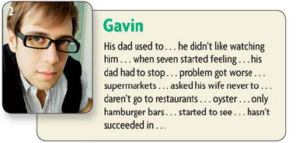 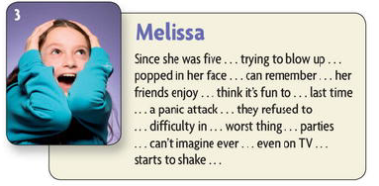
8.5.2. Mat ch the phobias in the chart with their definitions : 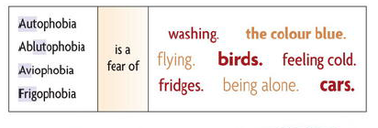

8.6. Reading and Speaking
8.6.1 Two famous leaders , Hannibal Barca and Mao Zedong
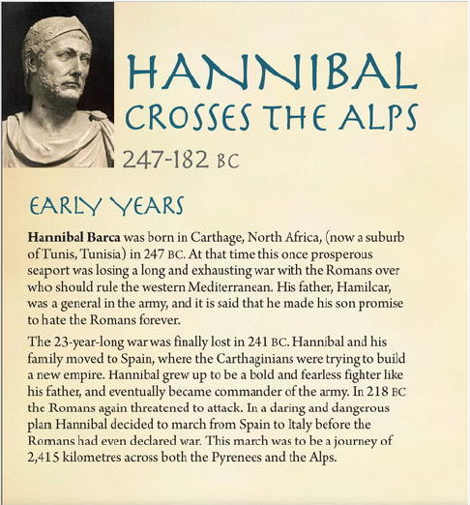
8.6.3. After reading above two texts carefully write the answers of the following questions :
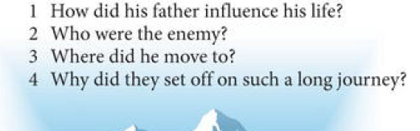

8.7. Vocabulary and Idiom
Body language
- 8.7.1. Which parts of the body do you use to do the following things ?
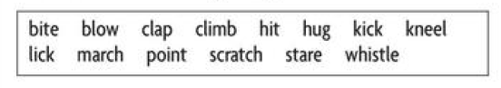
8.7.2. Which verbs in exercise 2 go with these nouns and phrases ?
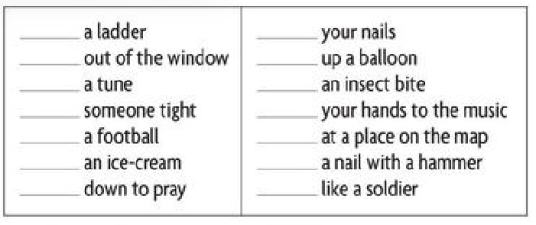
8.8.Every day English
-8.8.1 . Numbers and Travel
Read a loud these numbers , When do we say and ?
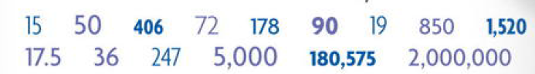
8.8.2 Listen and Check
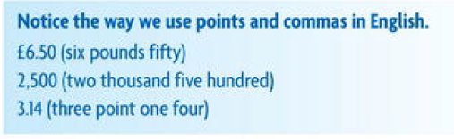
8.8.3 match the question with the numbers?
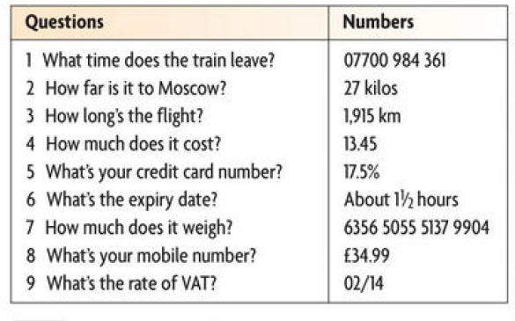

8.9. Homework no. 8
The Verb Patterns – The infinitive and The - ing Form
8.9.1. underline to each base given in bold line ( Infinitive Bases) , the suitable example related to :
1. The infinitive is used after some verbs :
a. We’ve decided to move abroad .
b. I’m trying to phone Pete.
2. Some verbs are followed by a person + the infinitive
a. They sked me to help them
b. He told me to apply for the job.
3. Make and let followed by person + infinitive without to
a. She’ll make you feel welcome
b. I’ll let you know when I’m coming
4. The infinitive is udsed after some adjectives
a. It's impossible to save money
b. it was good to hear your news
8.9.2. Underline to each base given in bold line ( The - ing form) , the suitable example related to :
1. The – ing form is used after some verbs
a. I enjoy reading history boos
b. I don’t mind helping you .
c. He goes fishing at weekends.
2. some verbs are followed by an object + - ing
a. I hate people telling me what to do
b. I can hear someone calling
c. You can’t stop me doing what I want.
3. The – ing form is used after preposition
a. I’m good at finding things
b. He’s afraid of being mugged .
c. I’m looking forward to meeting you .

References
1. 1. New edition , New Head way , Intermediate Student book -
2. Oxford English for electrical and mechanical engineering.

