Grammar: Questions and Negatives (Intermediate: Unit 4)
Vocabulary: Social Interactions (Intermediate: Unit 4)
Reading: "Nothing but the Truth" (Intermediate: Unit 4)
Unit 7
7.1 Starter
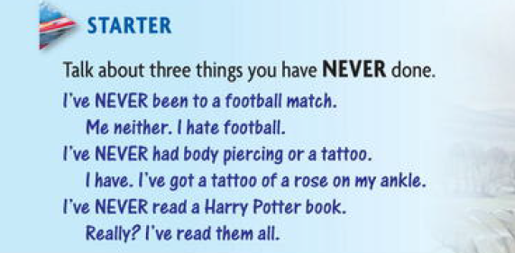

7.1.1 300 million books sold
Do you know anything about the author ?
HARRY POTTER and the Philosopher's Stone (1997)
HARRY POTTER and the Chamber of Secrets (1998)
HARRY POTTER and the Prisoner of Azkaban (1999)
HARRY POTTER and the Goblet of Fire (2000)
HARRY POTTER and the Order of the Phoenix (2003)
HARRY POTTER and the Half-blood Prince (2005)
HARRY POTTER and the Deathly Hallows (2007)
7.2 Using of did , was , has , and have
Complete the questions about J.K. Rowling. Use did, was, has, or have.
1. Where and when ------- she born?
2. When ------- she write her first story? What --------- it about?
3 . What ---------- she doing when she had the idea for Harry Potter?
4. Where --------------- she teach English?
5. When -------- the first Harry Potter book published?
6. How long --------- she been writing the books?
7. How many ----- she written?
8 . How many children--------- she had?
9. How many books ------------ been sold?
10. Which books, ---------- been made into films?
11. How much money -------- she made?
12. How many authors --------- become billionaires?
7.3 Grammar spot no. 1
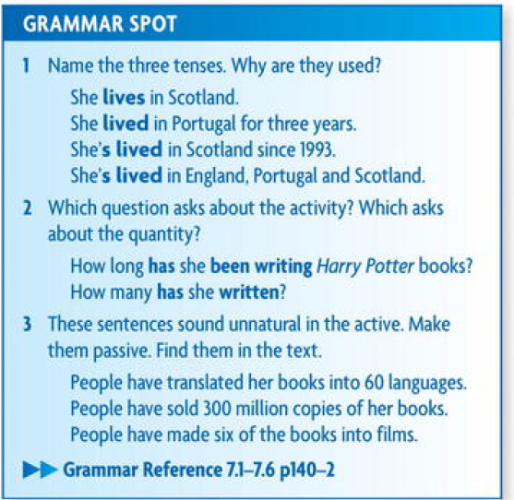
7.4 Exercises
74.1. Where can the words in the box go in these sentences?
Sometimes several words are possible.

1 . I've read that book.
2 . I've been reading an interesting book.
3. Has it been made into a film?
4. He's learned to drive.
5 . The match hasn't finished.
6 Have you been to Morocco?
Compare answers with the class.
7.4.2 Complete the sentences with phrases from the box.
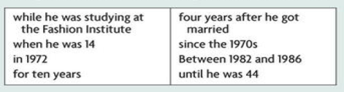
while he was studying at the Fashion Institute
1. His interest in fashion began --------------
2. He met his first wife, Jayne, ---------------
3. The first Calvin Klein jeans were introduced -------------
4. His daughter was born -------------
5. His marriage to Jayne lasted -----------------------
6. He didn't marry again -----------------------
7. He's been designing sportswear --------------------------
8. -----------------he won the same award three times.
7.5 Discussion Grammar
Underline the correct verb form.
1. His plane took off/ has taken off a few minutes ago.
2 . The president has resigned / has been resigned and a new president has elected / has been elected.
3. I work/'ve been working in Dubai since last March. When did you arrive / have you arrived?
4. How many emails have you sent / have you been sending?
5. What did you do / have you been doing in the bathroom? You were/'ve been in there for ages.
6. A huge snowstorm has hit / has been hit New York. Over 40 cms of snow has fallen / has been falling in the past 12 hours. People have advised / have been advised to stay at home.

7.5.1 Reading
7.5.1.1 Read the following two texts
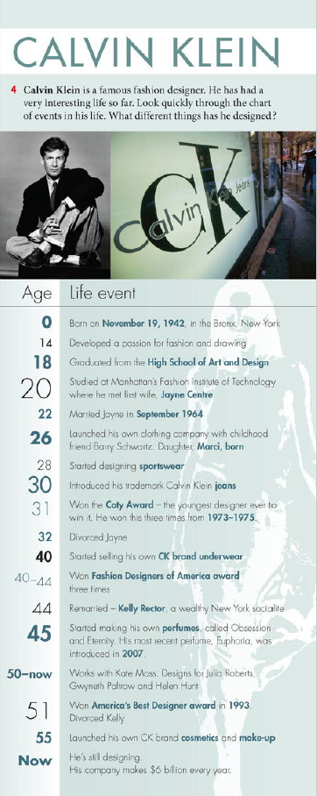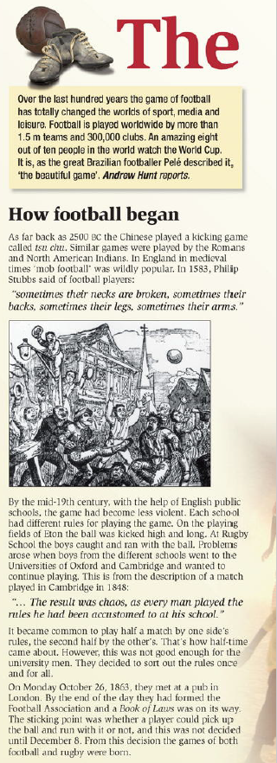

7.5.2 Kalvin Klein – A passion for fashion questions and answers
1. A How long has Calvin Klein been interested in fashion?
B Since he was about 14. When he was a teenager he spent hours sketching women's suits and dresses.
2. A What different kinds of clothes has he designed in his career?
B He's designed sportswear and underwear but he's possibly most famous for his jeans which always have his name on the back pocket.
3. A How many times has he been married and divorced?
B He's been married twice and divorced twice. His first wife was Jayne Centre. He met her when they were both fashion students. His second wife was Kelly Rector - she was a rich New York socialite and photographer.
4. A How many children does he have?
B Just one. A daughter Marci, who is now a successful television producer.
5. A How many awards has he won?
B He's won seven fashion awards altogether. He made history because he won awards for both men's and women's fashions in the same year.
6. A How long has he been making his own perfumes?
B. He's been making Calvin Klein perfumes since the late 80s.
7. A What are they called?
B His first were called Obsession and Eternity. His most recent is called Euphoria. His others include Truth and Crave, which was designed for men.
8. A Which famous people has he worked with and designed for?
B He's worked with the model Kate Moss and designed clothes for many stars including Julia Roberts, Gwyneth Paltrow and Helen Hunt. He's also worked with Brooke Shields, who, aged 15, modelled his jeans with the famous line 'nothing comes between me and my Calvins.
9. A How long has he been selling cosmetics?
B Since the 1990s. These are only sold in the best department stores such as Harrods, in London, and Bloomingdales in New York.

7.5.3. Read How football began. Answer the following questions:
1. What was tsu chu?
2. Which nationalities were the first to play a kind of football? When?
3. What images do you have of 'mob football'? Describe a game.
4. How was the game played at English public schools?
5. What caused chaos when the boys tried to play football at university?
6 .How did the idea of half-time start?
7 .Why is a London pub important to football?
8 What was the 'sticking point?? Which game was also born? Why?
7.6 Spoken English
1 Read the two conversations. What are the two questions with How long?
1. A How long are you here for?
B Just three days. I arrived yesterday and I leave tomorrow.
2. A How long have you been here?
B I've been here a week already. I arrived last Saturday.
Which question refers to past up to the present?
Which question refers to a period around now (past and future)?
2 What is the correct question for these answers?
1. Four more days. We came two days ago.
2 .Since Monday.
3 Until Friday. We're leaving Friday morning.
4. Over half an hour! Where have you been?
5 .We're staying a month altogether.
7.7. Grammar Spot no. 2
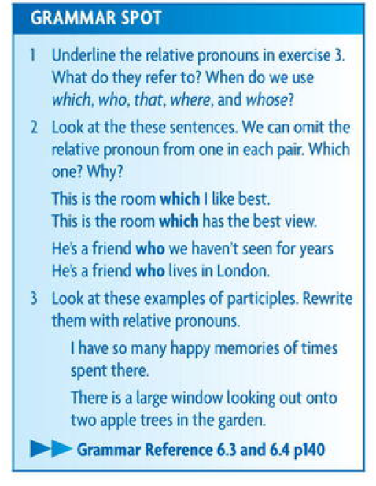
7.7.1 My favorite room
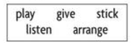
7.7.2 Complete the sentences with a word from the box in the present or past participle.
1. I spend hours in my room ---------------- to music.
2. I have lots of posters ---------------- on the walls.
3 My brother is in his bedroom ------------- on his computer.
4. There are photos of my family. ---------- on my shelves.
5. I also have a colour TV ---------- to me on my last birthday.
7.7.3 Vocabulary And Listening -Things I’m passionate about
Rewrite the sentences using the words in brackets.
1. She likes ice-cream very much. (absolutely adore)
She absolutely adores ice-cream.
2. He likes all water sports. (very keen)
3. I hate opera. (can't bear)
4 . My brother loves playing video games. (crazy about)
5. My sister doesn't really like any sports. (not that keen)
6 . I don't like people who always talk about themselves. (can't stand)
7. My mum likes going to musicals. (very fond)
8. I quite like green tea but I prefer English breakfast tea. (don't mind)
9 . The thing I hate most is tidying my room. (loathe)
10. I don't hate my job but it's time I applied for another one. (quite like)
7. 8 Home work no. 7
7.8.1 Part one - Maglev Train - Magnetic levitation train-
A MAGLEV (magnetic levitation) train does not run along a track in the normal way. Instead, magnetic fields lift it above the track, so that the train 'floats' along.
- Because they have no wheels, axles, suspension, dampers, or brakes, Maglev vehicles are light and compact. They are also pollution-free, as no fuel is burned within the train, and cheap to maintain.
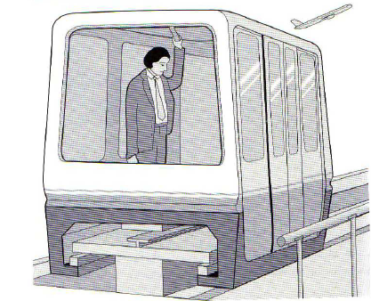
- The Maglev system at Birmingham Airport carries passengers from the terminal to the railway station and the National Exhibition Centre. The cars are made of lightweight fiber glass, carried on an aluminum chassis.
All the electrical equipment which powers the cars
is situated under the floors or the seats. Each car
can take 32 passengers and their luggage, up to a
weight of 3 tons. The trains travel at a maximum
- speed of 42 km/h. A concrete guideway above
the ground supports a T-shaped track for the
two-car Maglev trains. The train is lifted from the track by magnetic attraction. This is the force by which two opposite magnetic poles attract each other (just as two of the same poles repel each other). Powerful electromagnets at each corner of the train exert a pulling force which lifts the train upwards so that it floats 15 mm above the track. As people get on and off, the weight of the train varies. It may drop closer to the track than the required 15 mm, or rise further from it.
- To keep it at an even distance from the track, the force is varied by a microprocessor. Each train is driven by an electric motor called a linear induction motor. Electromagnetic windings, or coils, on the train generate a magnetic field in which the magnetic poles shift along the train.
- The field induces electric current in the track, which in turn generates its own magnetic field. The two fields in the track and the train interact so that the shifting field pulls the floating train along the track.
Make a list of both the advantages and disadvantages of the Maglev train to fill below table . You may use the above text to help you .
Order | Advantages | Disadvantages
1
2
3
4
7.8.2 Part 2 : Study the following diagrams . What will be the results of bellow actions as in solved example
Action ; Two magnets are held together with opposite poles facing
Result: They will attracted

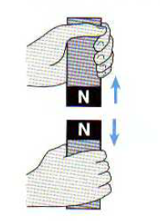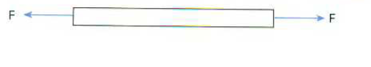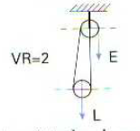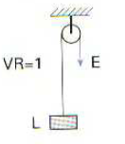
Fig. 1 Fig.2 Fig. 3 Fig. 4
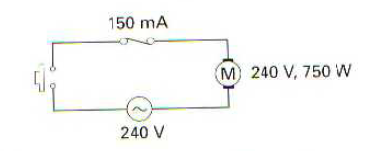 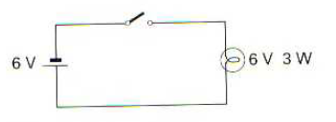 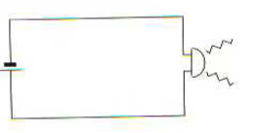
Fig. 5 Fig. 6 Fig. 7
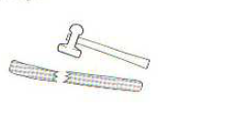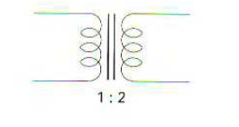
Fig. 8 Fig. 9 Fig. 10
Fill bellow table by the suitable results as in above example:
Figure’s number | Action | Result
Fig.1 | Two magnets are held together with like poles facing.
Fig.2 | A steel bar is subjected to tensile forces.
Fig. 3 | We move the effort by one meter.
Fig.4 | We move the effort by 50 centimeters.
Fig.5 | The switch is pressed.
Fig.6 | The switch is closed.
Fig. 7 | The circuit is broken.
Fig.8 | 120 V ac is applied across the primary.
Fig.9 | We apply an impact load to a brittle body.  .
Fig.10 | We apply 24 V ac to the transformer  Primary

References :
1. New edition , New Head way , Intermediate Student book -
2. ENGLISH FOR ENGINEERING
3. Oxford English for electrical and mechanical engineering.

Answers of this Chapter :
Answers of 7.2
1. Where and when was she born?
She was born near Bristol, in England, in 1965.
2. When did she write her first story? What was it about?
She wrote her first story when she was six. It was about a rabbit with measles.
3. What was she doing when she had the idea for Harry Potter?
She was travelling by train between Manchester and London.
4. Where did she teach English?
In Portugal.
5. When was the first Harry Potter book published?
In 1997.
6. How long has she been writing the books?
For nearly 20 years.
7. How many has she written?
Seven.
8. How many children has she had?
Three.
9. How many books have been sold?
Over 300 million copies.
10. Which books have been made into films?
The first six.
11. How much money has she made?
She's made over £600 million.
12. How many authors have become billionaires?
Only one her.
- Answers to 7.5 – Discussion Grammar
1 . His plane took off a few minutes ago.
2. The president has resigned and a new president has been elected.
3. I've been working in Dubai since last March. When did you arrive?
4. How many emails have you sent?
5. What have you been doing in the bathroom? You've been in there for ages.
6. A huge snowstorm has hit New York. Over 40 cms of snow has fallen in the past 12 hours. People have been advised to stay at home.
7.6 Answers of Spoken English
Spoken English
1. A How long are you here for?
B Four more days. We came two days ago.
2. A How long have you been here?
B Since Monday.
3. A How long are you here for?
B Until Friday. We're leaving Friday morning.
4. A How long have you been here?
B Over half an hour! Where have you been?
5 . A How long are you here for?
B We're staying a month altogether.

