

Computer Fundamentals
Lecture 4
Input and output devices

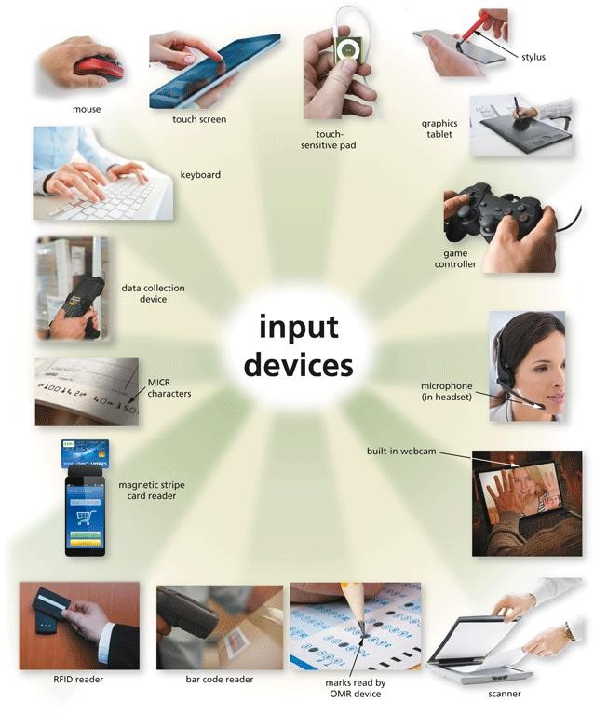
What Is Input?
- Input refers to any data and instructions entered into the memory of a computer.

Commonly used input methods include:
What Is Input?




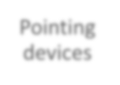






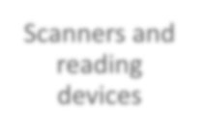

Keyboard
Pointing
devices

Touch screens

Pen input

Motion input

Voice input

Video input
Scanners and reading devices

A keyboard is an input device that contains keys users press to enter
Keyboards
data and instructions into a computer or mobile device

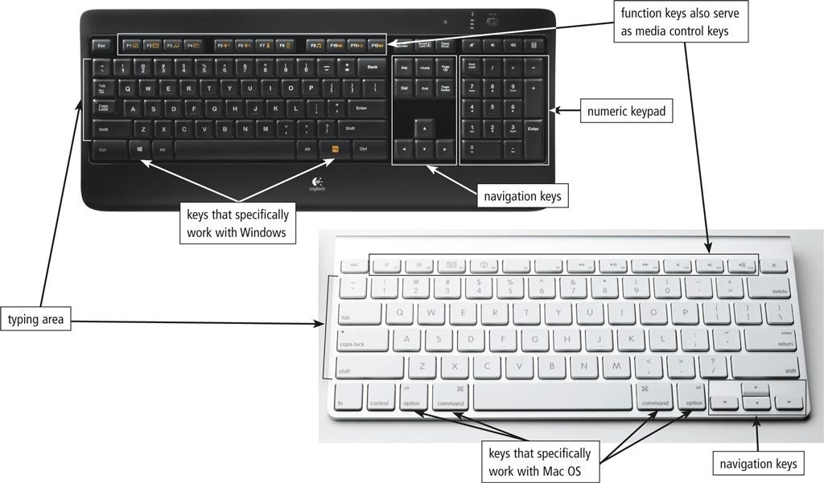

Most desktop computer keyboards have…
Keyboards

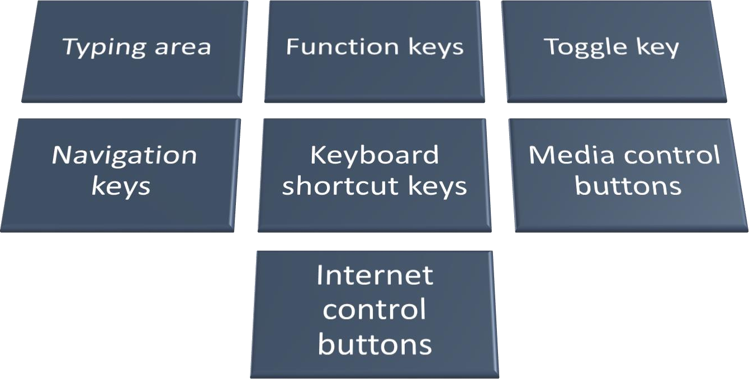

There are a variety of keyboard options for computers and mobile devices
Keyboards

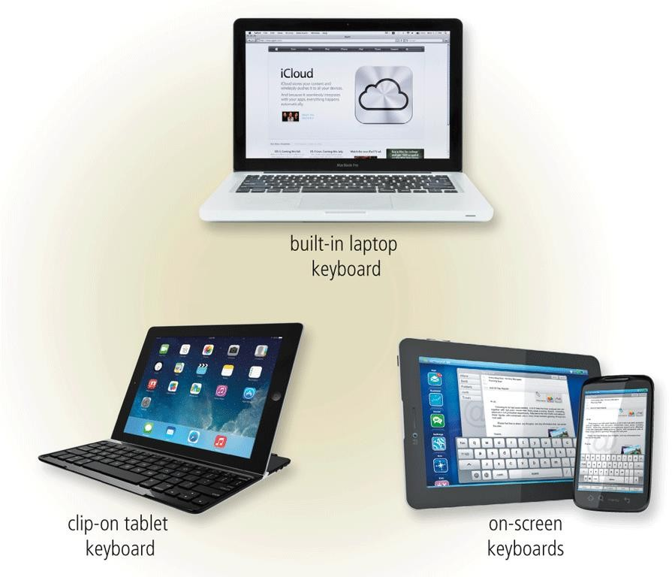

An ergonomic keyboard has a design that reduces the chance of repetitive strain injuries of wrist and hand
Keyboards
Ergonomics incorporates comfort, efficiency, and safety in the design of the workplace
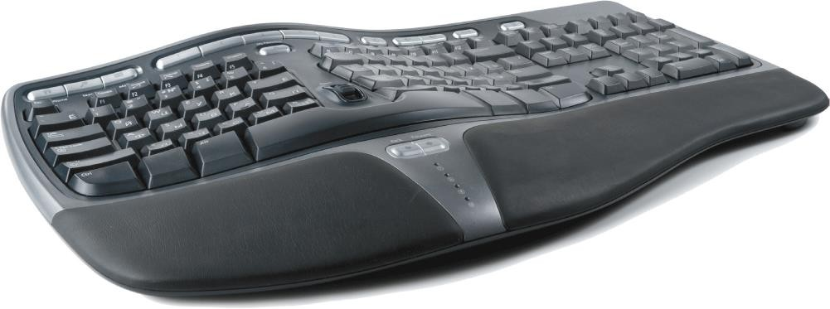

Pointing Devices

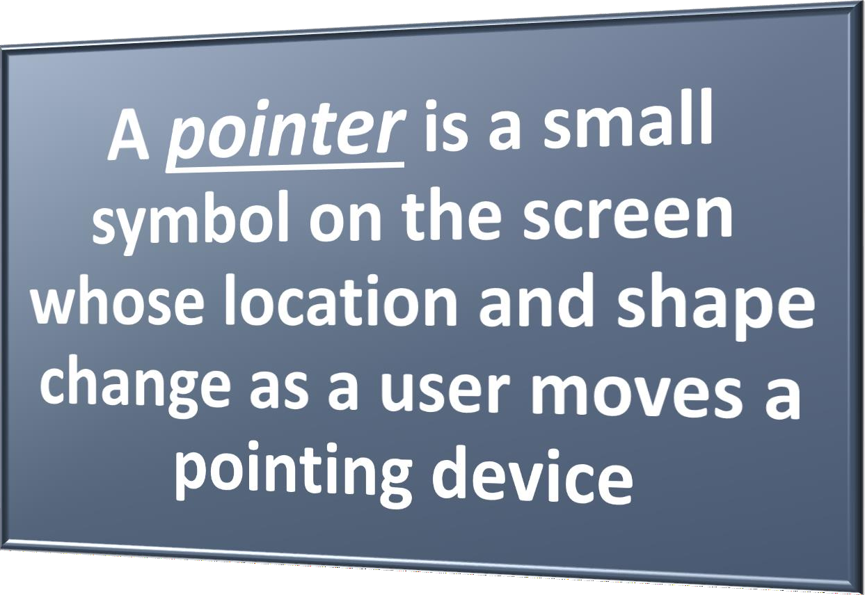

A mouse is a pointing device that fits under the palm of your hand comfortably
Pointing Devices
- Optical mouse, laser mouse, and touch mouse

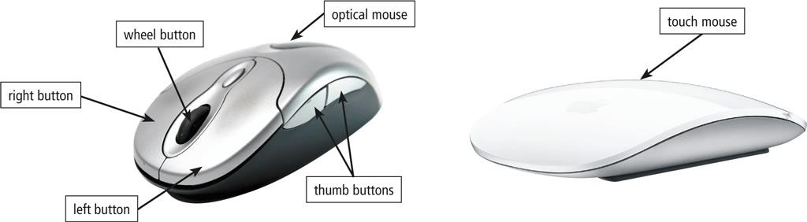

Pointing Devices


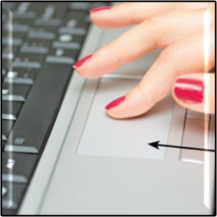

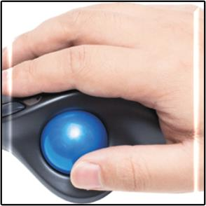
  - A touchpad is a small, flat, rectangular pointing device that is sensitive to pressure and motion
Touchpad
Trackball
  - A trackball is a stationary pointing device with a ball on its top or side

A touch screen is a touch-sensitive display
Touch Screens

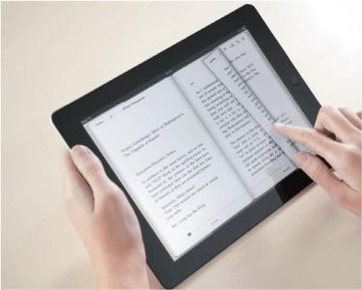

With pen input, you touch a stylus or digital pen on a flat surface to write, draw, or make selections
Pen Input

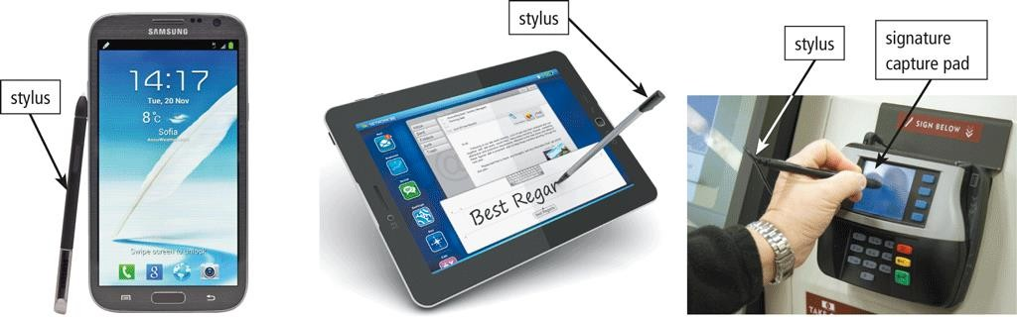

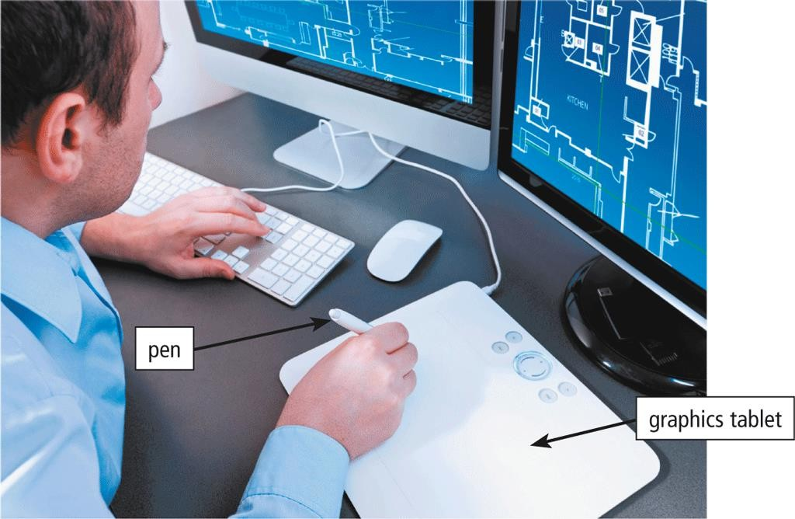
- A graphics tablet, also called a digitizer, is an electronic plastic board that detects and converts movements of a style or digital pen into signals that are sent to the computer
Pen Input

With motion input, sometimes called gesture recognition, users can guide on-screen elements using air gestures
Motion, Voice, and Video Input
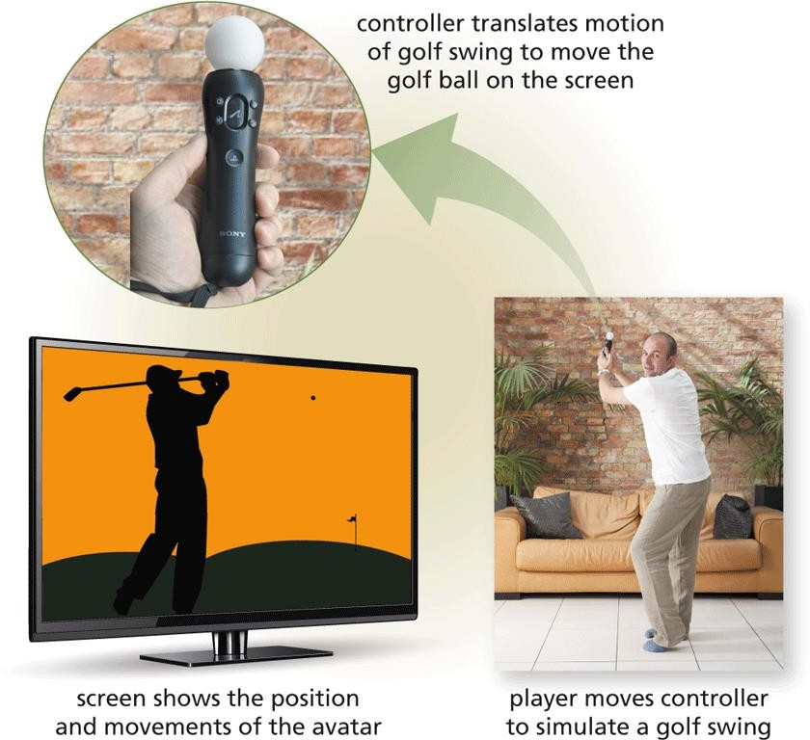

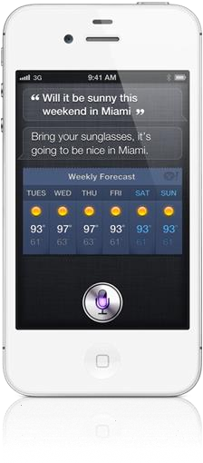
Motion, Voice, and Video Input
- Voice input is the process of entering input by speaking into a microphone
- Voice recognition, also called speech recognition, is the computer or mobile device’s capability of distinguishing spoken words

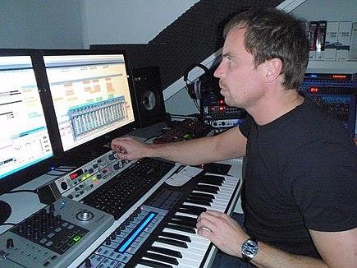
Motion, Voice, and Video Input
- Audio input is the process of entering any sound into the computer such as speech, music, and sound effects
- Music production software allows users to record, compose, mix, and edit music and sounds

Video input is the process of capturing full-motion images and storing
Motion, Voice, and Video Input
them on a computer or mobile device’s storage medium
Record video on a digital video
(DV) camera
Transfer video to a
computer or mobile device

A webcam is a type of DV camera that enables a user to:
Motion, Voice, and Video Input






Capture video and still images
Send email messages with video attachments
Broadcast live images or video over the Internet

Conduct videoconferences

Make video calls

A videoconference is a meeting that connects two or more people located in different geographic locations.
Motion, Voice, and Video Input


A scanner is a light-sensing input device that reads printed text and images and then converts the results into a form the computer can process
Scanners and Reading Devices
- Unlike a copy machine, a flatbed scanner creates a digital file of the document in memory instead of producing a physical paper copy.

Scanners and Reading Devices

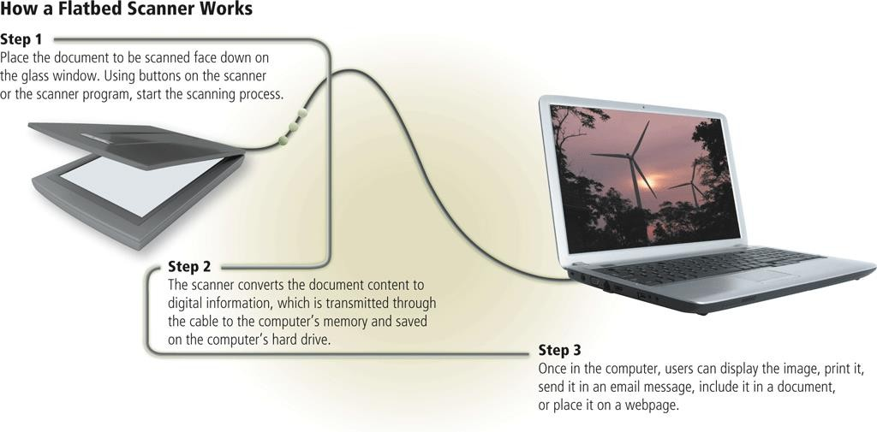

An optical reader is a device that uses a light source to scan characters, marks, and codes and then converts them into digital data that a computer can process
Scanners and Reading Devices
- Optical character recognition (OCR)
- Optical mark recognition (OMR)

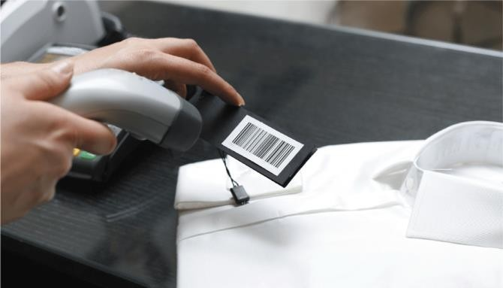
  - A bar code reader, also called a bar code scanner uses laser beams to read bar codes
Scanners and Reading Devices
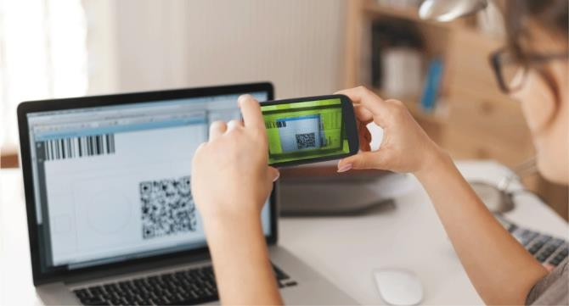
  - A QR code stores information in both a vertical and horizontal direction

RFID (radio frequency identification) uses radio signals to
Scanners and Reading Devices
communicate with a tag placed in or attached to an object
An RFID reader reads information on the tag via radio waves RFID can track:



Tracking times of runners in a marathon
Tracking location of people and other items

Checking lift
tickets of skiers

Managing
inventory
Gauging temperature and pressure of tires on a vehicle

Checking out library books

Providing access to rooms or buildings

Managing purchases
Tracking payment as vehicles pass through booths on tollway systems

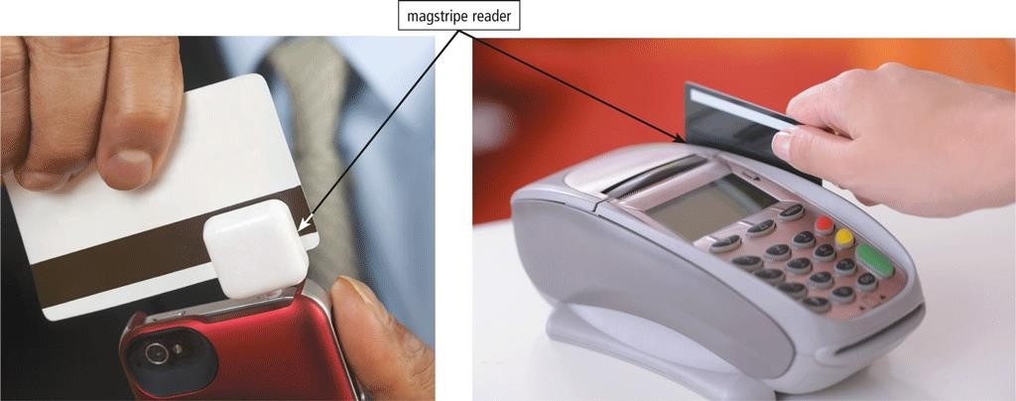
Magstripe readers read the magnetic stripe on the back of cards such as:
Scanners and Reading Devices


Credit cards
Entertainment cards
Bank cards
Identification cards
Other similar cards

MICR (magnetic ink character recognition) devices read text printed
Scanners and Reading Devices
with magnetized ink
An MICR reader converts MICR characters into a form the computer can process
Banking industry uses MICR for check processing
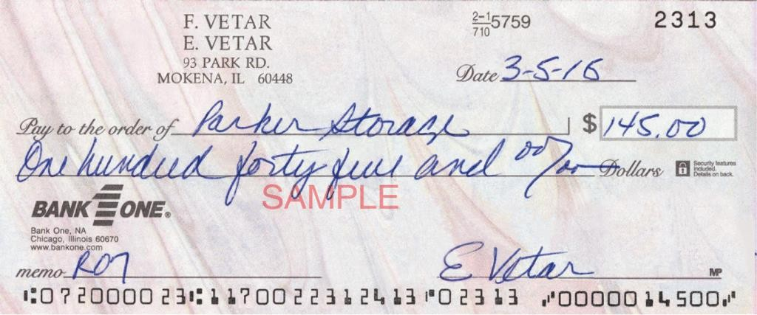

A data collection device obtains data directly at the location where the transaction or event takes place
Scanners and Reading Devices
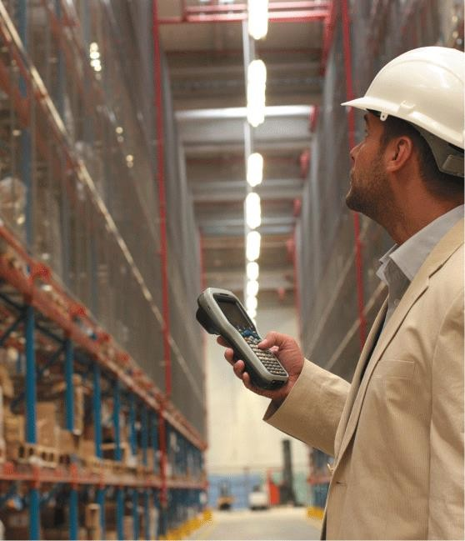

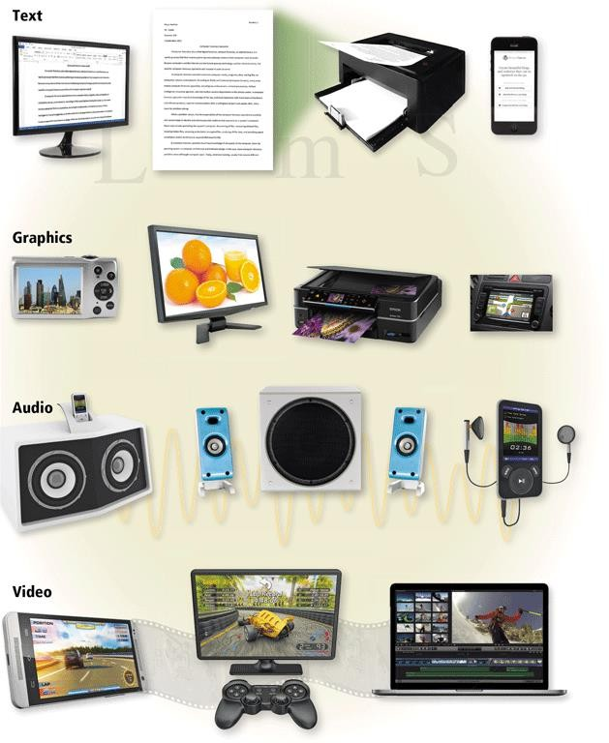
What Is Output?
- Output is data that has been processed into a useful form

A display visually conveys text, graphics, and video information
Displays
A monitor is a display that is packaged as a separate peripheral device
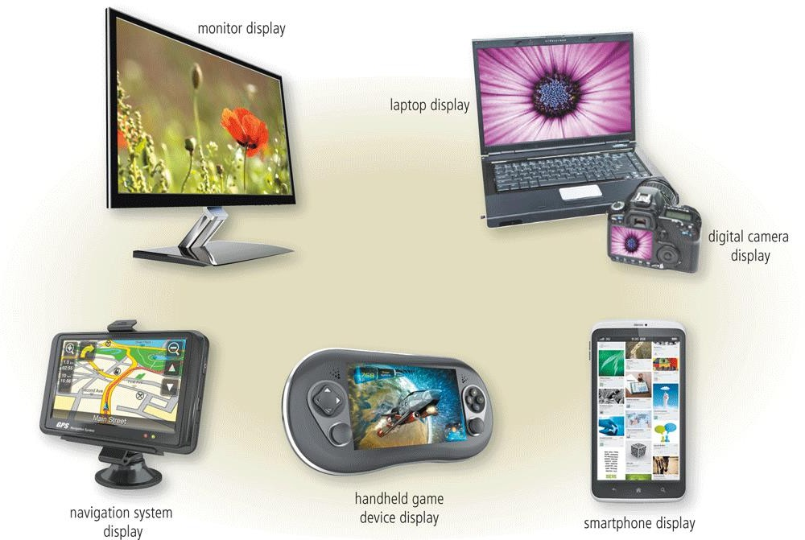
  - LCD monitor

The quality of a display depends primarily on its:
Displays




Resolution

Response time

Brightness

Dot pitch

Contrast ratio

Today’s monitors use a digital signal to produce a picture
Displays
To display the highest quality images, the monitor should plug into:
  - A DVI port
  - An HDMI port
  - A DisplayPort

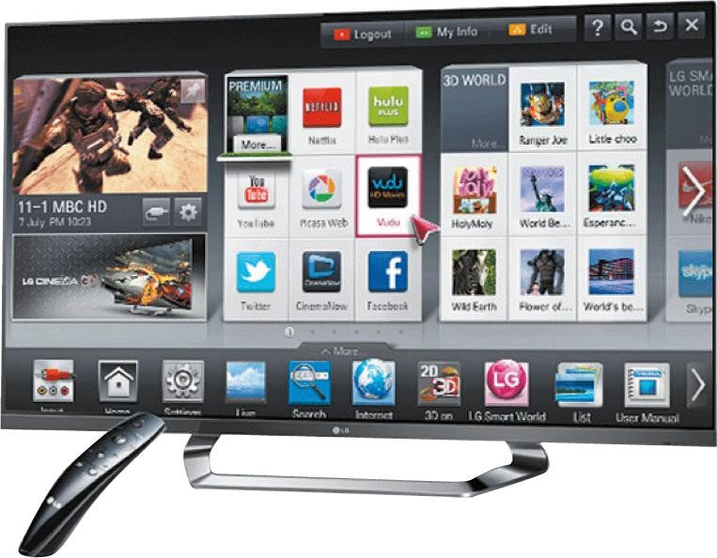
- Home users sometimes use a digital television (DTV) as a display
Displays
- HDTV is the most advanced form of digital television
- A Smart TV is an Internet-enabled HDTV

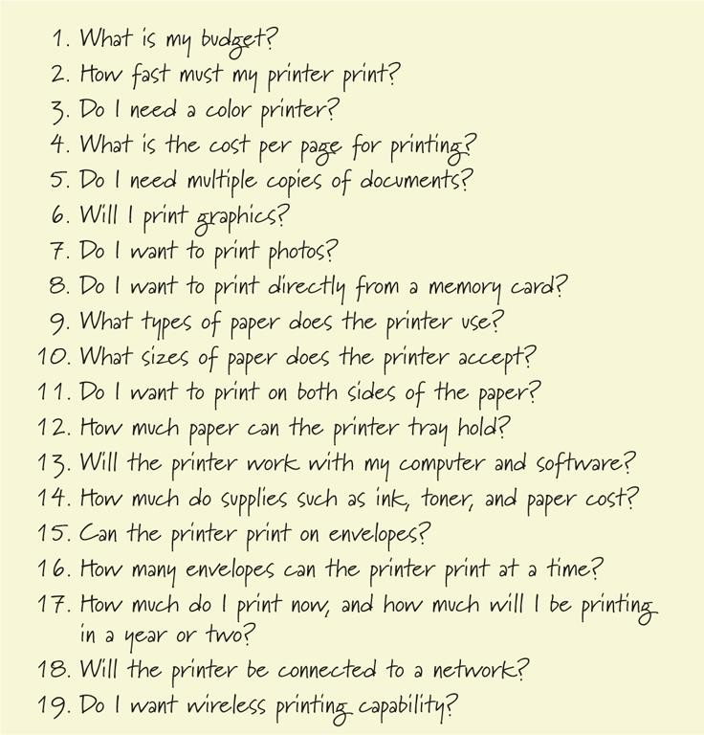
Printers
- A printer

produces text and graphics on a physical medium
- Before purchasing a printer, ask yourself a series of questions

A nonimpact printer forms characters and graphics on a piece of paper without actually contacting the paper
Printers















Ink-jet
printers
All-in-one
printers
Laser printers
Photo
printers
Thermal
printers
Mobile printers
Label printers
Large-format printers
Plotters

An ink-jet printer forms characters and graphics by spraying tiny drops of liquid ink onto a piece of paper
Printers
  - Color or black-and-white
  - Speed is measured by the number of pages per minute (ppm) it
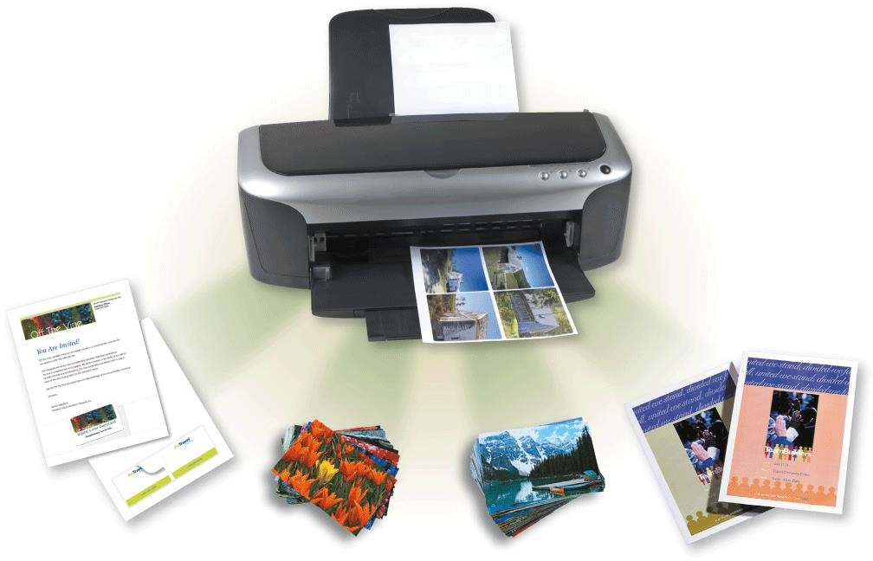
can print


Printers
A photo printer produces lab- quality photos
- Many use ink-jet technology
- PictBridge allows you to print photos directly from a digital camera
- Print from a memory card

Printers

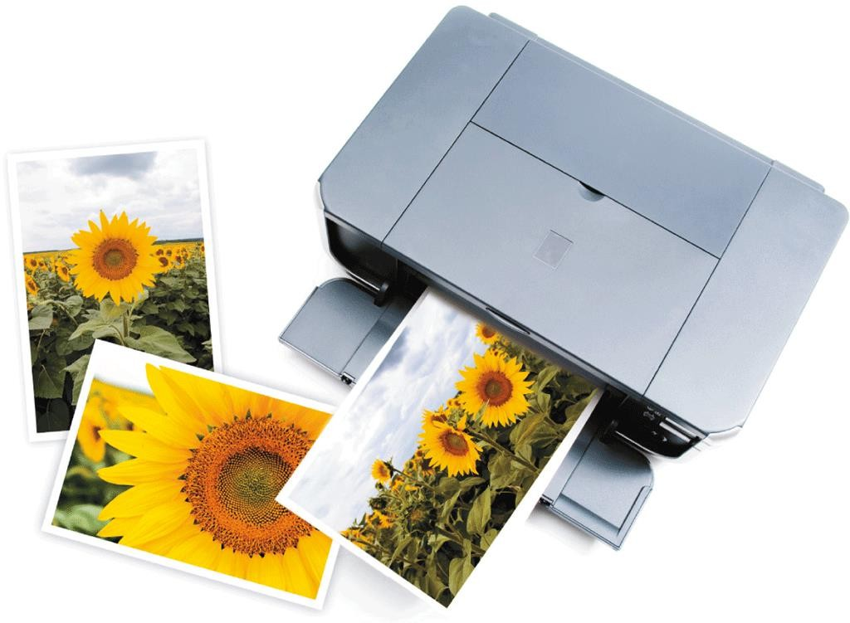

Printers

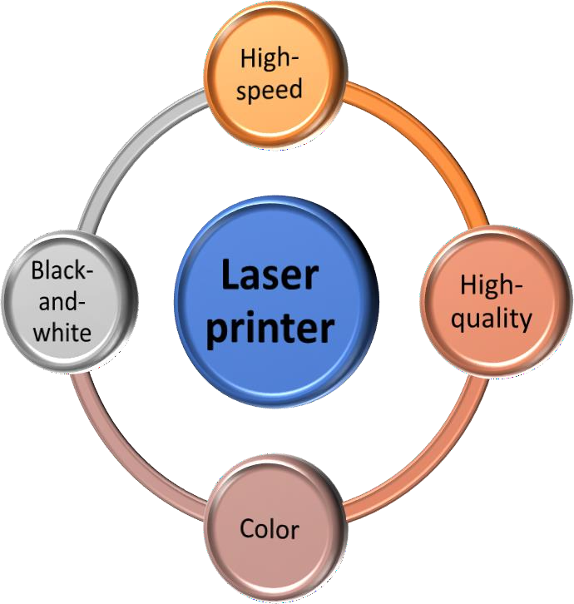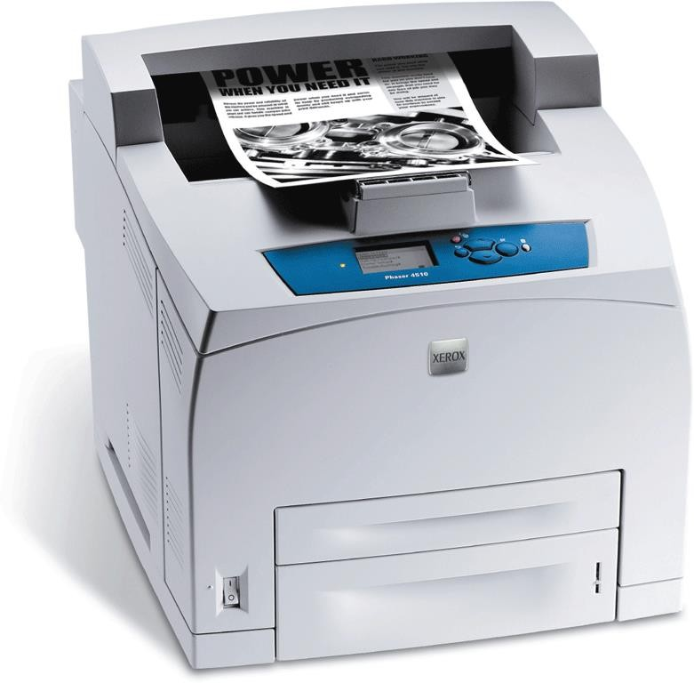

An all-in-one printer is a single device that prints, scans, copies, and in some cases, faxes
Printers
  - Also called a multifunction printer

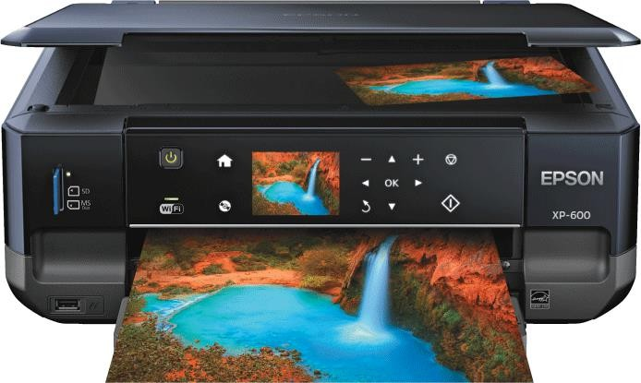

A 3-D printer uses a process called additive manufacturing to create an object by adding material to a three-dimensional object, one horizontal layer at a time
Printers
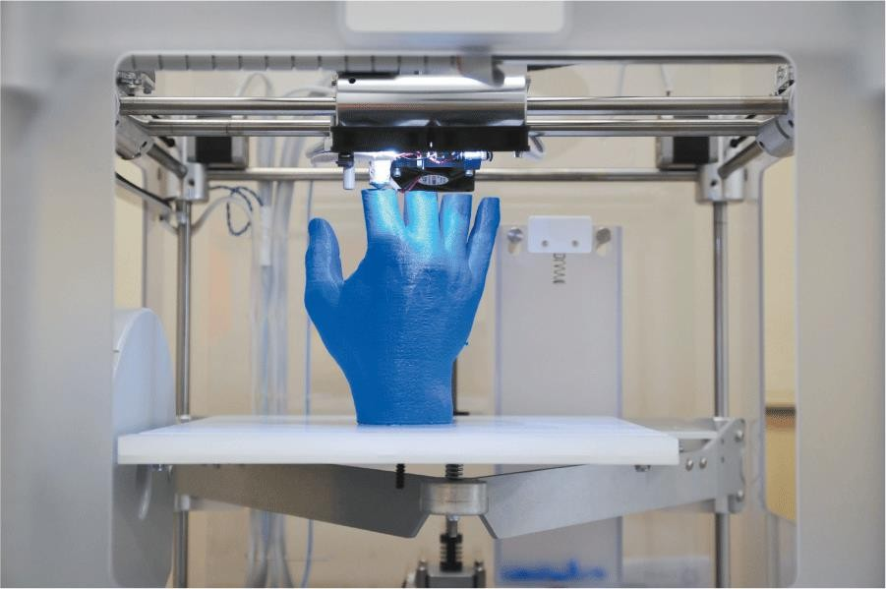

Al-Mustaqbal University, College of Engineering & 42

Printers

43
A thermal printer generates images by pushing electrically heated pins against the heat-sensitive paper

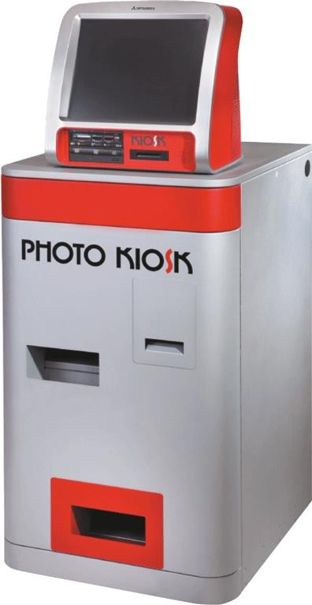
Dye- sublimation printer
Al-Mustaqbal University, College of Engineering &

A mobile printer is a small, lightweight, battery-powered printer that allows a mobile user to print from a mobile device
Printers

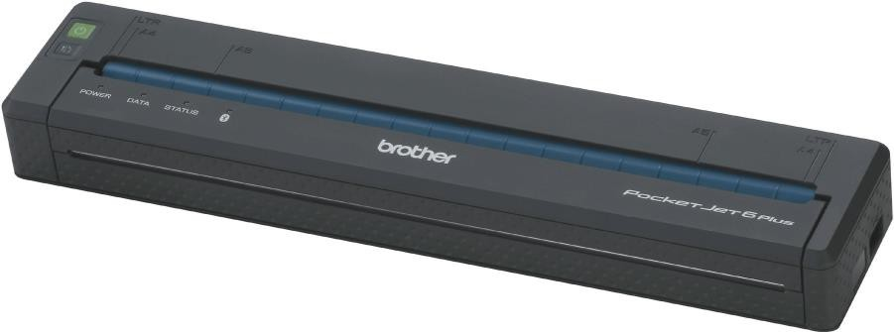

A label printer is a small printer that prints on an adhesive-type material that can be placed on a variety of items
Printers
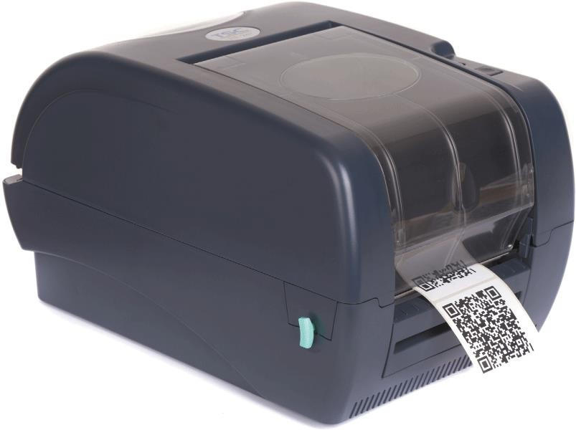

Plotters are used to produce high-quality drawings
Printers
Large-format printers create photo-realistic quality color prints

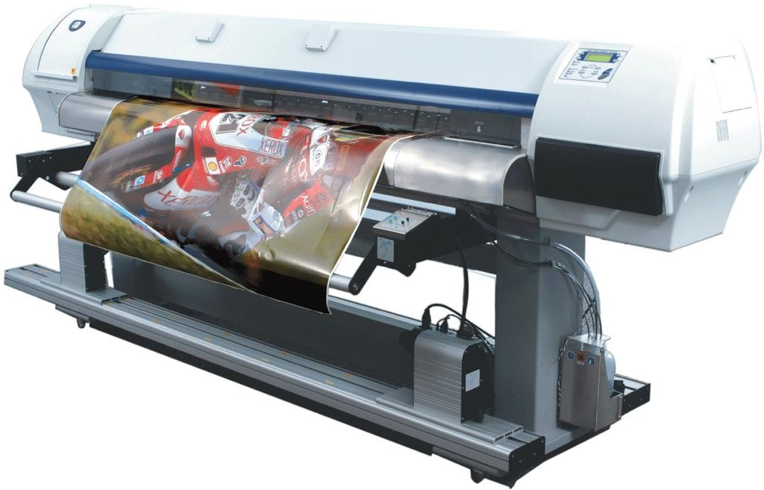

Impact printers form characters and graphics on a piece of paper by striking a mechanism against an inked ribbon that physically contacts the paper
Printers
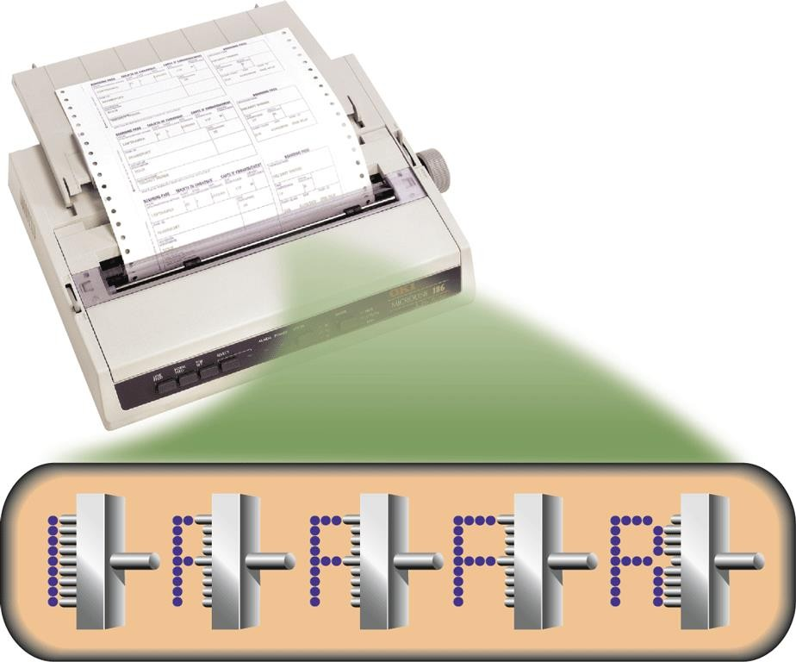

Many users attach surround sound speakers or speaker systems to their computers, game consoles, and mobile devices to generate higher-quality sounds
Other Output Devices

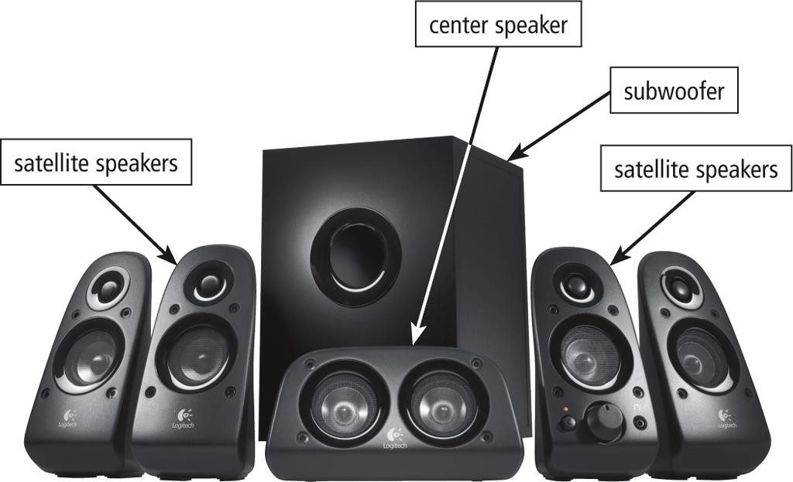


- Headphones are speakers that cover or are placed outside of the ear
Other Output Devices
- Earbuds (also called earphones) rest inside the ear canal

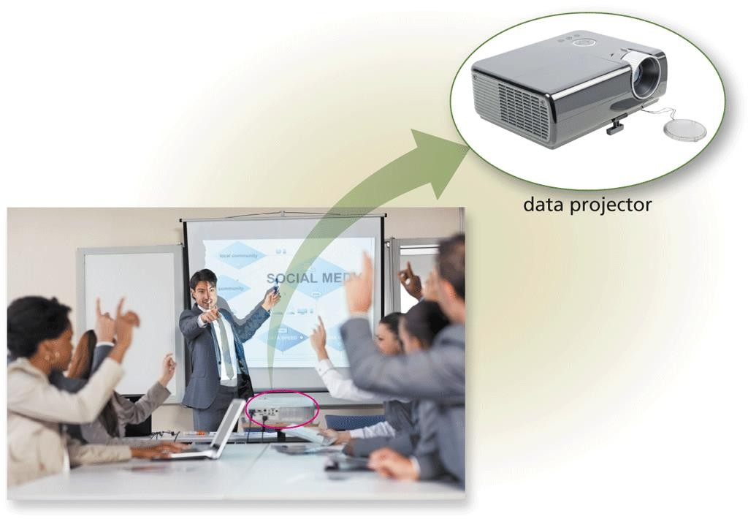
- A data projector is a device that projects the text and images displaying on a computer or mobile device screen on a larger screen so that an audience can see the image clearly
Other Output Devices

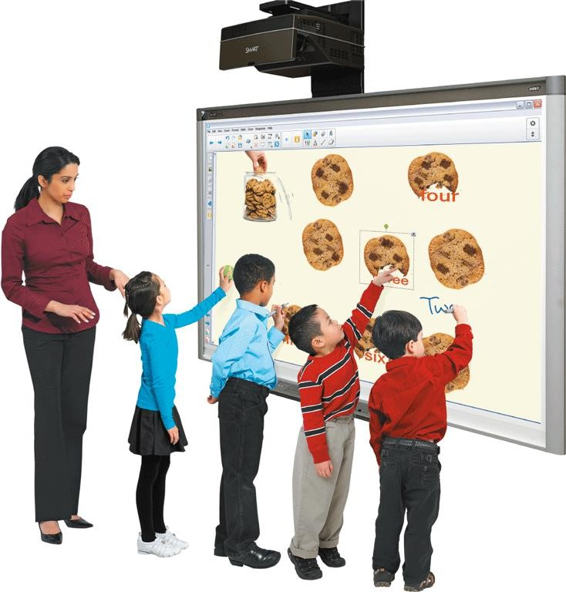
- An interactive whiteboard is a touch- sensitive device, resembling a dry-erase board, that displays the image on a connected computer screen
Other Output Devices

Joysticks, wheels, gamepads, and motion-sensing game controllers can be considered output devices when they include force feedback
Other Output Devices
  - Technology that sends resistance to the device in response to
actions of the user

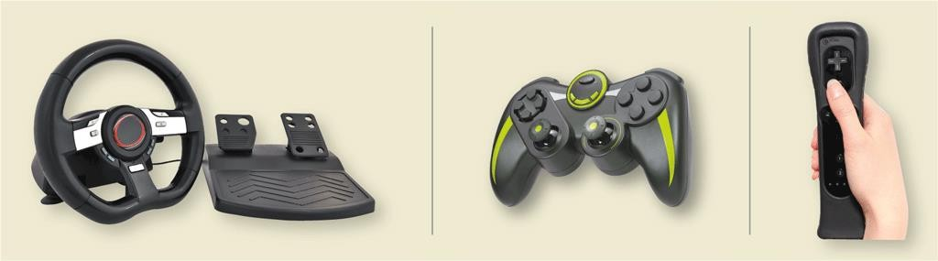

Assistive Technology Input and Output

Head-mounted pointer Braille printer
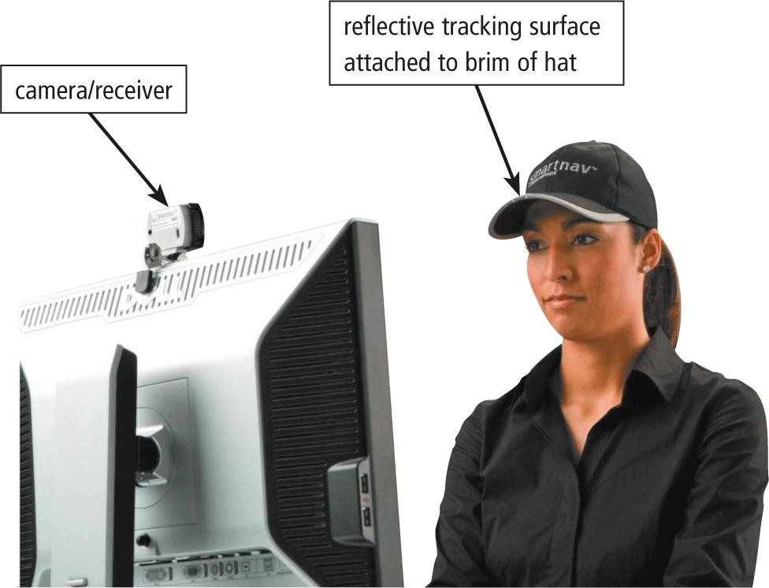
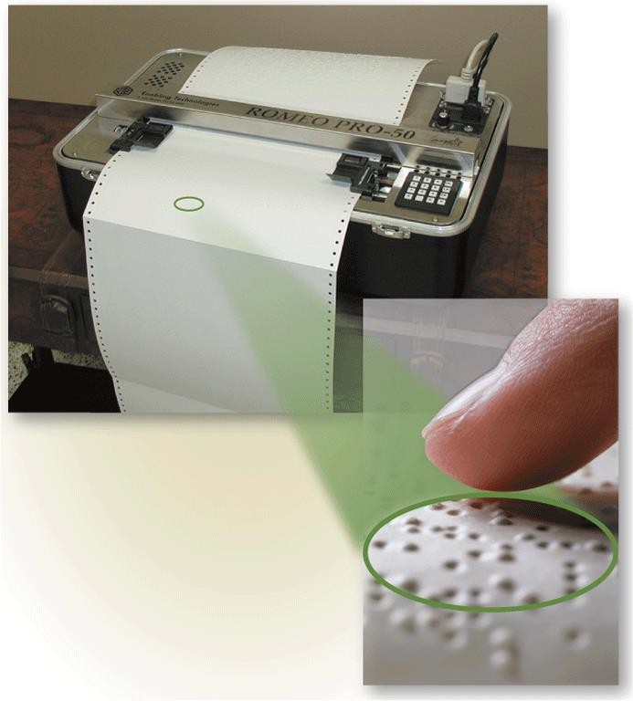

THANK YOU

