2-Ac Bridge and Their Application: The ac bridge is a natural outgrowth of the dc bridge and in its basic form consists of four bridge arms, a source of excitation, and a null ac detector. For measurements at low frequencies, the power line may serve as the source of excitation; but at higher frequencies an oscillator generally supplies the excitation voltage. The null ac detector in its cheapest effective form consists of a pair of headphones or may be oscilloscope. The balance condition is reached when the detector response is zero or indicates null.
Then VAC = 0 and VZ1 = VZ2

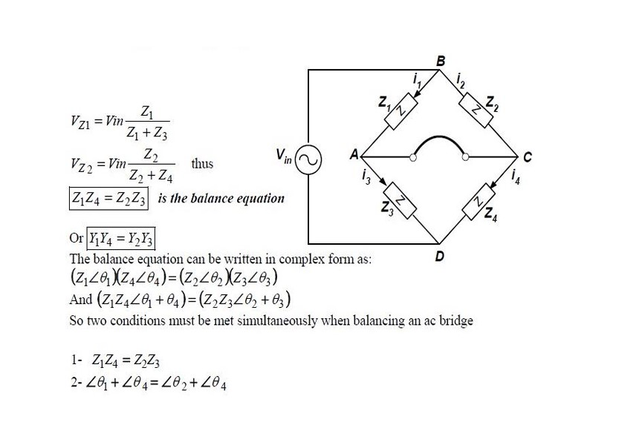

Review on AC Impedance
Alternating Current (AC) Impedance, denoted by ‘Z’, represents the opposition to the flow of AC current in an electrical circuit.
It’s a complex value comprised of real and imaginary parts, namely resistance ‘R’ and reactance ‘X’, respectively.
The AC impedance formula is represented as:
Z = R + j X
where:
‘Z’ is the total impedance of the circuit,
‘R’ is the resistive (real) component, and
‘X’ is the reactive (imaginary) component. Here, ‘j’ represents the imaginary unit in electrical engineering, equivalent to the square root of -1.

Furthermore, in AC circuits involving inductors and capacitors, the reactive component can be broken down into inductive reactance (XL) and capacitive reactance (XC).

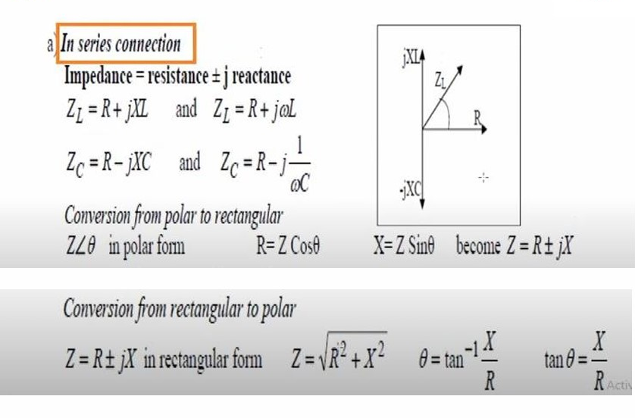
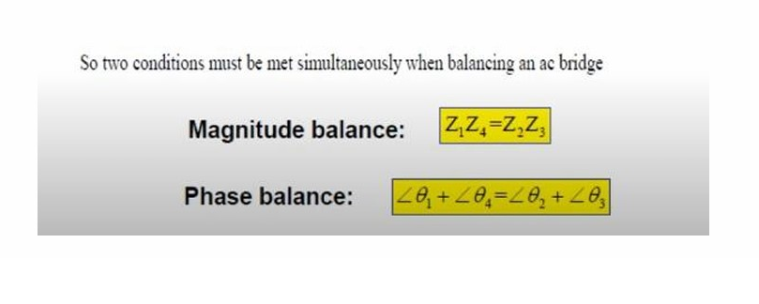
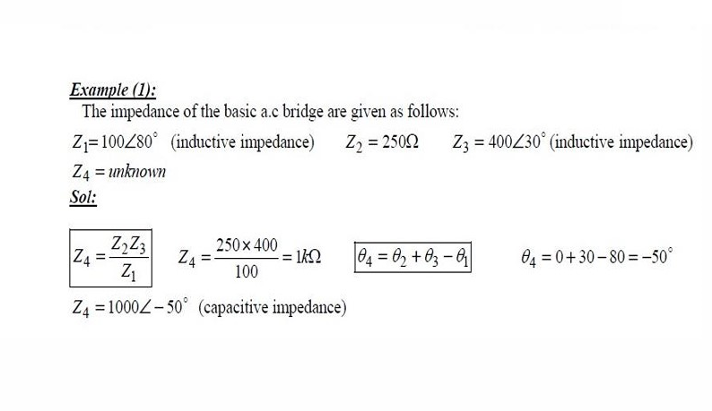
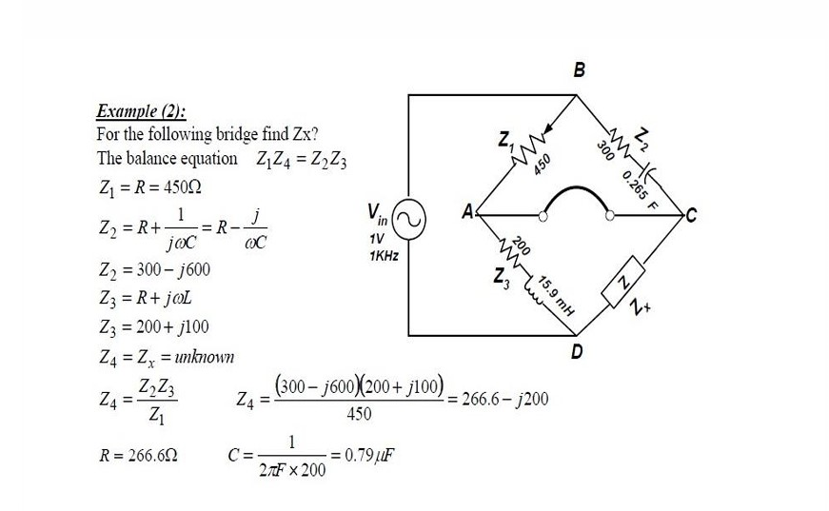

Comparison Bridge:
There are two types of Comparison Bridge, Namely
1. Capacitance Comparison Bridge
2. Inductance Comparison Bridge

- Capacitance Comparison Bridge:
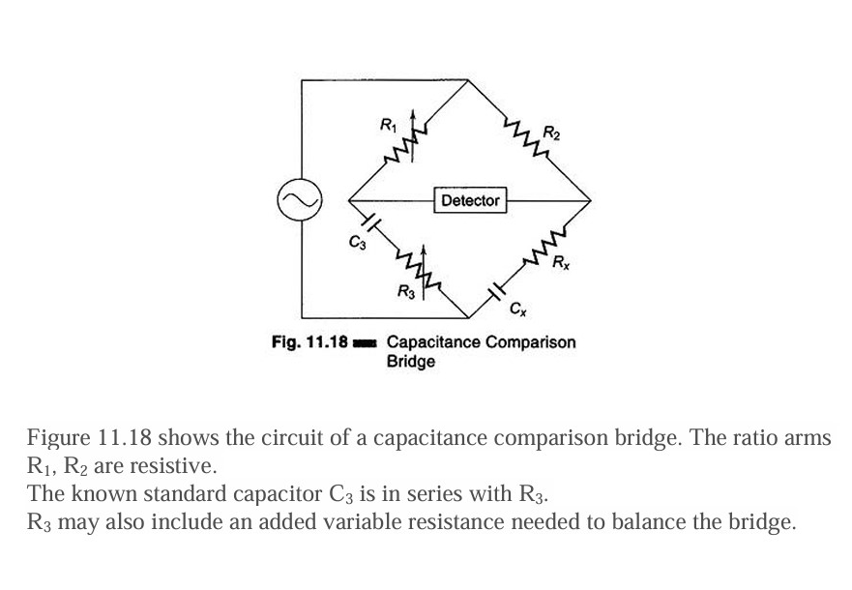

Cx is the unknown capacitor and Rx is the small leakage resistance of the capacitor. In this case an unknown capacitor is compared with a standard capacitor and the value of the former, along with its leakage resistance, is obtained. Hence.

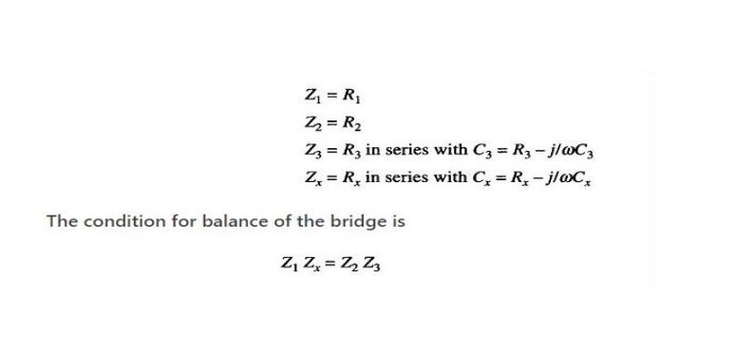
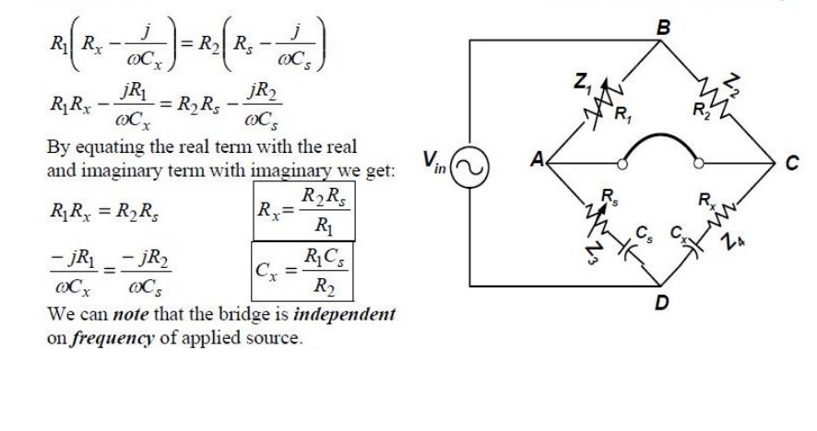

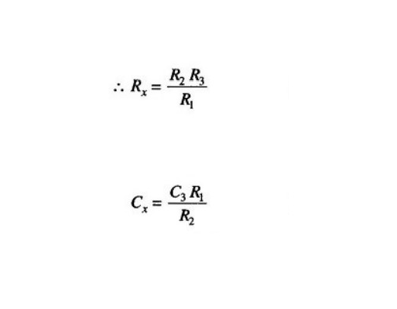

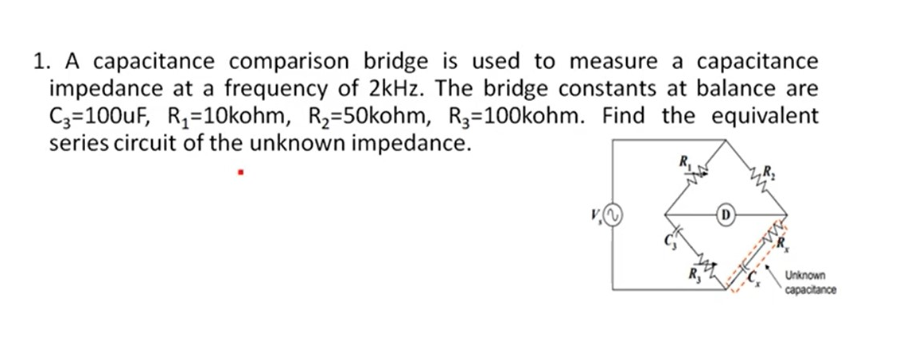

2.Inductance Comparison Bridge:
Figure 11.20 gives a schematic diagram of an inductance comparison
bridges. In this, values of the unknown inductance Lx and its internal
resistance Rx are obtained by comparison with the standard inductor and
resistance, i.e. L3 and R3

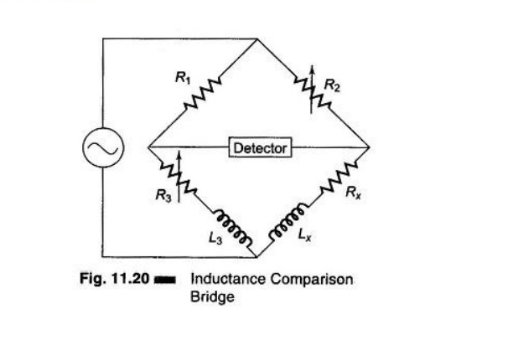

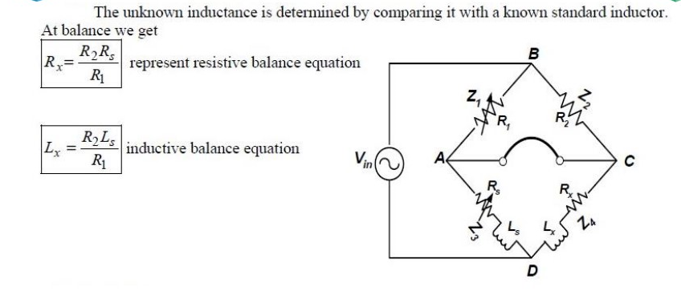

2\An Inductance Comparison Bridge is used to measure an unknown inductive impedance at a frequency of 3 kHz. The bridge constants at balance are:
- L₃ = 50 mH
- R₁ = 5 kΩ
- R₂ = 20 kΩ
- R₃ = 40 kΩ
Find the equivalent series circuit of the unknown impedance.

Required:
Determine the equivalent series values of the unknown inductor:
- Lₓ (unknown inductance)
- Rₓ (series resistance of the unknown inductor)

