Dental Implantology
Dental implant: is a device made of alloplastic (foreign) material implanted into
the jaw bone beneath the mucosal layer to support a fixed or removable dental
prosthesis
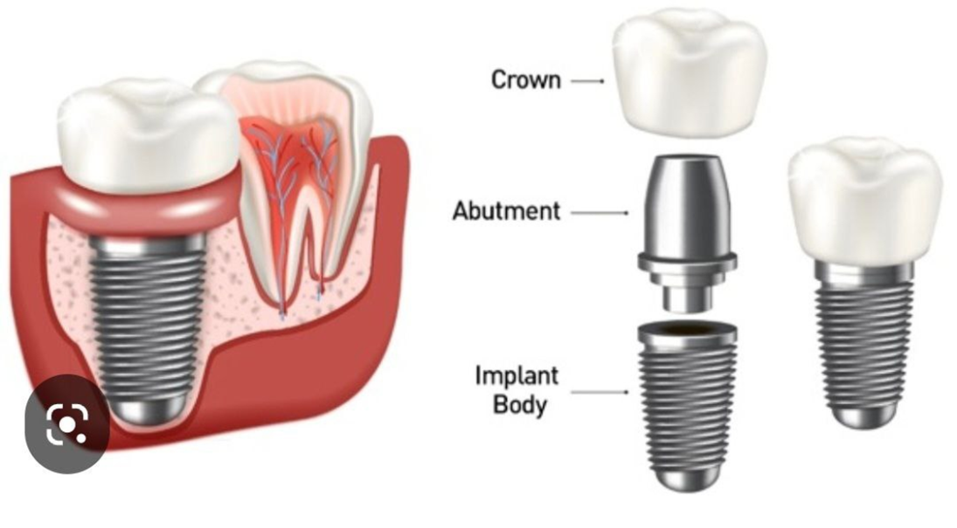
Imaging plays an important part in dental implant procedures
The imaging modalities vary from standard projections to more complex
radiographic techniques
**Standard projections include intra-oral (periapical, occlusal) and extra-oral
(panoramic, lateral oblique radiographs.
More **complex imaging techniques includes computed tomography (CT), and cone
beam computed tomography (CBCT)
Multiple factors influence the selection of radiographic techniques for a particular
case including cost, availability, radiation exposure, and patient's anatomy

The goals of imaging are
1. To measure bone height and width (bone dimensions)
2. To assess bone quality
3. To determine the long axis of alveolar bone
4. To identify and localize internal anatomy
5. To detect any underlying pathology

INTRAORAL RADIOGRAPHY
Intraoral radiography used is either periapical or occlusal radiography
It is usually done to determine the vertical height of bone
Intraoral radiography is recommended for the use of single-tooth implants

***The disadvantages of intraoral periapical radiography
-There is limited area of exposure; it can be used only in case of single-tooth
implant
• -There is foreshortening and elongation of the image which results due to
anatomical variation
-It is very difficult to reproduce the same image as the technique is not
Standardized

PANORAMIC RADIOGRAPH
In comparison with the intraoral radiography, panoramic radiography has got
advantage of broader visualization of the image
But in case of panoramic radiography, sharpness and resolution is less
Panoramic radiography is also helpful in estimation of bone height and position
of inferior nerve canal. It is usually indicated when implant is planned for
more than one teeth
***Disadvantages with the panoramic radiography
It has got image size distortion (magnification)
Dimensional accuracy in the case of panoramic radiography is also limited
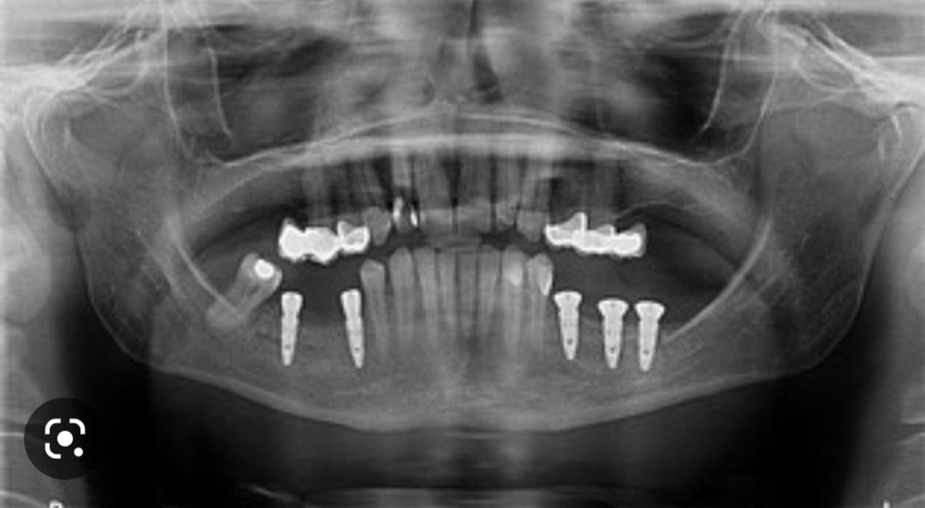

CBCT imaging in dental implant
CBCT is the most accurate radiographic means for dental implant planning
It allows for complete 3D evaluation of bone architecture with high accuracy and
can be used for standardized estimation of bone quality
According to the available literature, CBCT imaging is not required in cases
1. in which the clinical examination reveals sufficient bone height and width
2. Where standard radiographic examination reveals adequate bone height and
space for implant placement
Imaging modality is useful in three phases
Phase 1 Pre-prosthetic implant imaging
Imaging in this phase determines the quantity, quality, angulation of bone, relationship
of critical structures to prospective implant sites and the presence or absence of disease at the proposed surgical site.
Phase 2 Surgical and interventional implant imaging
Imaging in this phase evaluates the
surgical sites during and immediately after surgery, assists in the optimal
positioning and orientation of dental implants, it also ensures appropriate
abutment positioning
Phase 3 Post-prosthetic implant imaging
This phase started after placement of the prosthesis and continues as long as
the implant remains in the jaw
Imaging in this phase provides long term evaluation of the prognosis of the dental implant. So it will show any defect in the implant's position and function including crestal bone level around implant . It also helps to routinely assess the bone adjacent to the dental implant to note any changes in bone volume
