Lecture 10 Dental Equipment Technologies Dr.Muna Merza
Dental-Arch Trimmer
Dental-Arch Trimmer Machine
This dental-arch trimmer optimizes the model-making process improving quality and reliability during the fabrication of sectioned models. Saving more than 60% in time.
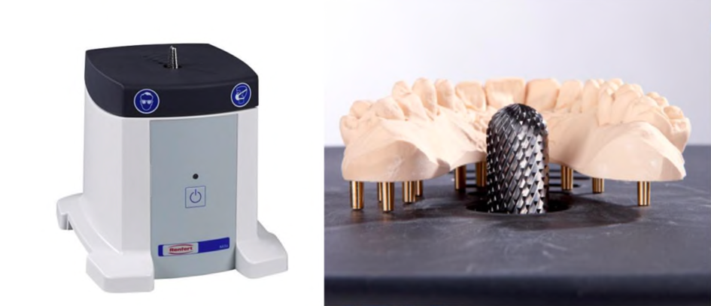
Used: Only use the unit for trimming dental stone or resin dental arches. And used in the crown and bridge lab.
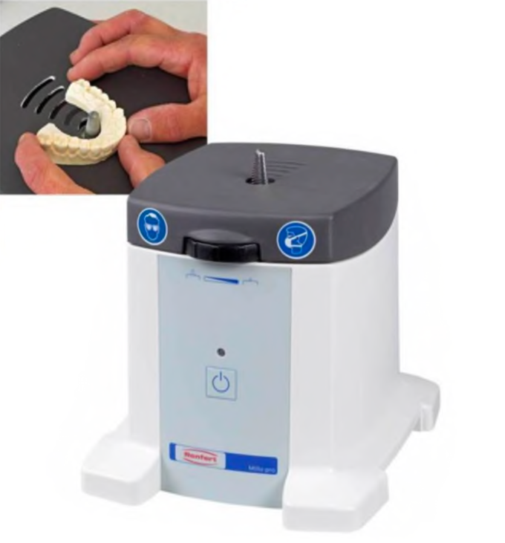
Parts:
A. ON/OFF button
B. ON/OFF LED display
C. Height adjustment.
D. Connector for extractor
E. Plug-in socket for connecting an extractor.
F. Safety cut-out
G. Cuter bur.
H. Mains cable
I. Workable
G
