

قــســــــــــم الأمــــــــــــــــــــــــــن الــــــــــــــــــــــــــــــــــــسيبرانــــــــــــــــــــــــــــــــــــي
Department of Cyber Security
Subject:
MICROPROCESSORS
Lecture: (1)
introduction to microprocessor

Class: Second

Lecturer: M.Sc.Muntather AL-mussawee

Definition of a Microprocessor

A microprocessor is an electronic chip that contains the central

processing unit (CPU) responsible for executing calculations and

controlling other components within a system. It acts as the "brain" of a

computer, processing data and executing instructions.

History of the Microprocessor

▪ First Microprocessor: The first commercially available

microprocessor, the Intel 4004, was developed in 1971. It was a

4-bit processor designed for basic data processing.

▪ Technological Evolution: Following the 4004, more advanced

processors emerged, such as the Intel 8008 (1972) and Intel 8080

(1974), contributing to the development of personal computers.

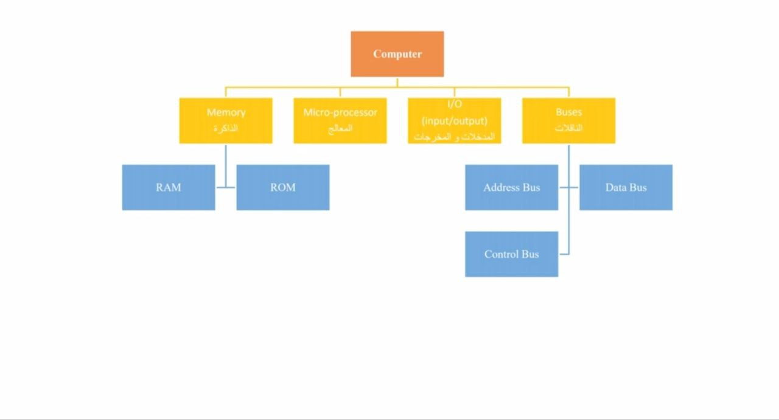

Types of Microprocessors

1. General-Purpose Processors:

▪ Examples include Intel and AMD processors used in desktops and

laptops.

2. Embedded Processors

▪ Used in specialized devices like home appliances, control systems,

and medical devices.

3. Digital Signal Processors (DSP)

▪ Used for processing audio and visual signals, commonly found in

mobile phones and audio devices.

4. Multi-Core Processors:

▪ These contain multiple cores within the same chip, allowing for

more efficient multitasking.

5. Graphics Processing Units (GPUs):

▪ Specialized for graphics rendering and complex computations,

such as those produced by NVIDIA and AMD Radeon

Applications

Personal Computers: Where the microprocessor executes software

and provides user interfaces.

Mobile Devices: Such as smartphones and tablets.

Smart Appliances: Like smart refrigerators and home security

devices. Industrial Applications: In automation and control systems.

The Processor Consists Of

A microprocessor, often referred to as a CPU (Central Processing

Unit), consists of several key components that work together to

execute instructions and process data. Here's a breakdown of its main

components:

1. Arithmetic Logic Unit (ALU)

Performs arithmetic operations (such as addition and subtraction) and

logical operations (such as AND and OR).

2. Control Unit (CU)

Manages the flow of data within the processor and interprets

instructions, directing the ALU and other components to operate

according to commands.

3. Registers

Small, fast memory locations within the processor used to temporarily

store data, such as intermediate results of instructions

4. Cache Memory

o Used to store frequently accessed data and instructions, improving

processor performance by reducing access time to the main

memory.

5. Buses

o Communication pathways that transfer data between different parts

of the microprocessor, including data, address, and control buses.

6. Input/Output Units (1/0 Units)

o Manage communication between the processor and external

devices, such as keyboards and displays.

7. Internal Logic

o Includes the circuits that organize operations within the processor,

such as timing circuits and other logical circuits

CLASSIFICATION OF MICROPROCESSORS:

Based on their specification, application and architecture

microprocessors are classified. Based on size of data bus

• 4-bit microprocessor

• 8-bit microprocessor

16-bit microprocessor

• 32-bit microprocessor

The processor consists of two parts:

1- Software: Software consists of three modules:

A- The control and transfer unit is responsible for exchanging

information between the parts of the processor itself.

b- The bus communication unit is responsible for exchanging

information between the processor and other parts of the computer.

c- The arithmetic and logic unit, which is responsible for processing

digital data.

2- hardware

