

قــســــــــــم الأمــــــــــــــــــــــــــن الــــــــــــــــــــــــــــــــــــسيبرانــــــــــــــــــــــــــــــــــــي
Department of Cyber Security
Subject:
MICROPROCESSORS
Lecture: (3)
8086 Internal Architecture
Class: Second

Lecturer: M.Sc.Muntather AL-mussawee

8086 Microprocessor

▪ It is a 16-bit Microprocessor (up). It's ALU, internal registers

works with 16 bit binary word.

▪ 8086 has a 20 bit address bus can access up to = 1 MB memory

locations.

▪ 8086 has a 16 bit data bus. It can read or write data to a

memory/port either 16 bits or 8 bit at a time.

▪ It can support up to 64K I/O ports.

▪ Frequency range of 8086 is 6-10 MHz.

▪ It has multiplexed address and data bus ADO- AD15 and A16-

A19.

▪ It can pre-fetch up to 6 instruction bytes from memory and queues

them in order to speed up instruction execution.

▪ It requires +5V power supply.

▪ A 40 pin dual in line package.

▪ 8086 is designed to operate in two modes, Minimum mode and

Maximum mode.

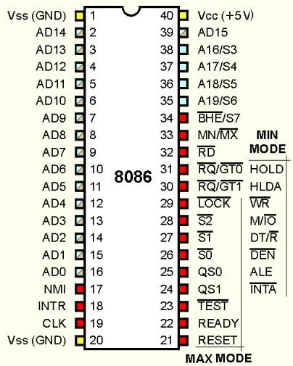

8086 Internal Architecture:

Fig shows a block diagram of the 8086 internal architecture. It is

internally divided into two separate functional units. These are the Bus

Interface Unit (BIU) and the Execution Unit (EU). These two functional

units independently, and it operate parallel at the same time

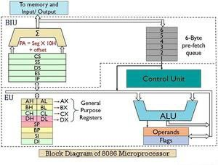

(BIU): Fetches instruction, reads and writes data, and computes the

20-bit address.

(EU): Decode and executes the instruction using the 16-bit ALU.

BUS INTERFACE UNIT (BIU):

This unit consists of 4 sub-units which are:

1. Instruction queue.

2. Segment registers.

3. Instruction pointer.

4. Address adder.

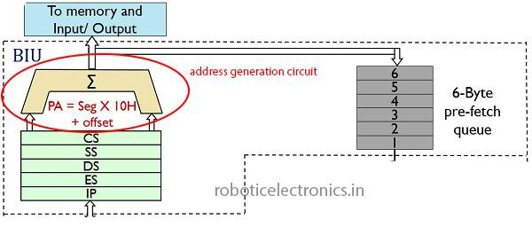

BUS INTERFACE UNIT (BIU) is responsible of the following:

▪ full 16 bit bidirectional data bus and 20 bit address bus.

▪ connects the microprocessor to external devices. Instruction

fetching.

▪ Reading and writing data of data operands for memory

▪ . Inputting/outputting data for input/output peripherals.

▪ functions related to instruction and data acquisition.

▪ The BIU uses a mechanism known as an instruction stream queue

to implement pipeline architecture.

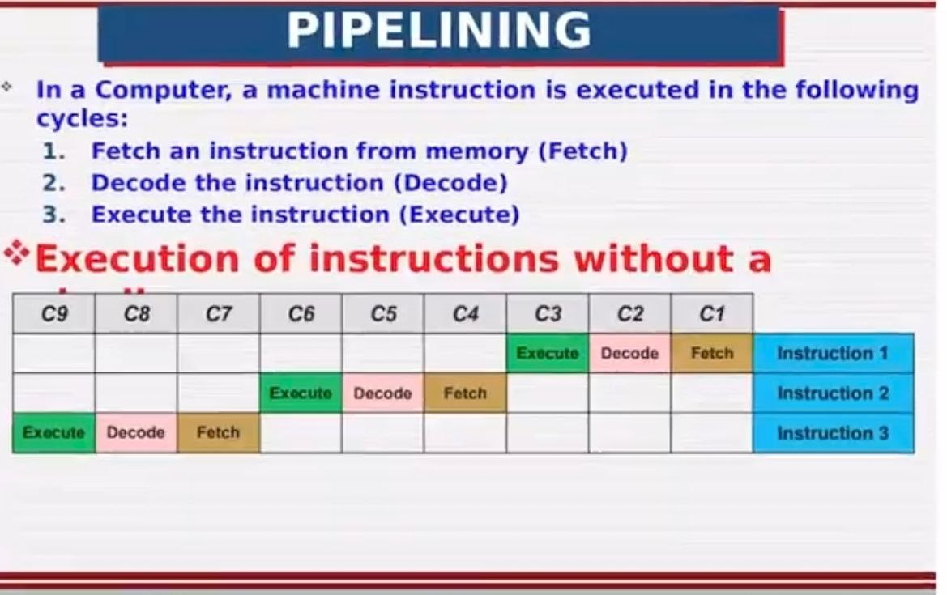



Execution Unit (EU):

This unit consists of 7 sub-units which are:

1. Control unite.

2. Instruction decoder.

3. Arithmetic and logical unit (ALU).

4. General register.

5. Flag register.

6. Pointers.

7. Index registers.

Execution Unit (EU) is responsible of the following:

▪ The Execution unit is responsible for decoding and executing all

instructions

▪ . It performs various arithmetic and logic operation over the data

using unit (ALU).

▪ It coordinate of all other units of the processor using control unit.

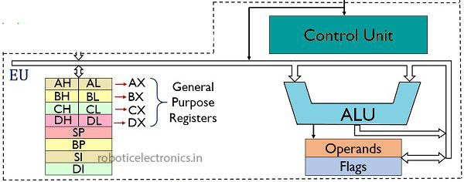

The EU mechanism as follows:

1. EU extracts instructions from top of queue in BIU.

2. Decode the instruction.

3. Generates operands if necessary.

4. Passes operands to BIU and requests it to perform read or write bus

cycles to memory or 1/0.

5. Perform the operation specified by the instruction on operands.

6. Branch or jump instruction

