Grammar: Future Forms (Intermediate: Unit 5)
Vocabulary: Plans and Predictions (Intermediate: Unit 5)
Reading: "On the Move" (Intermediate: Unit 5)
Unit 6 What matters to me
6.1 Starter
6.1.1 Think of someone
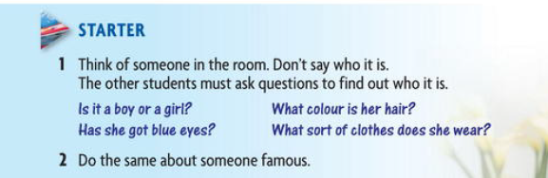
6.1. 2. Description – Information question
- Match a question with the answer
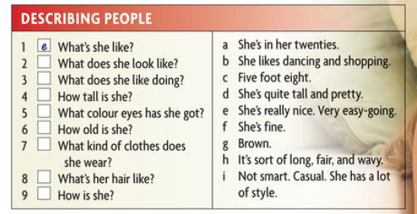
6.2. Grammar Spot
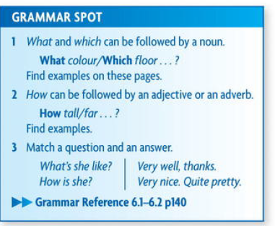
6.3. Excersizes
6.3.1. under line the correct answer
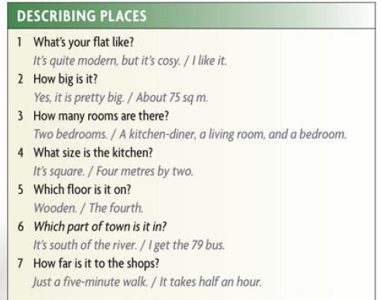
Answers :
1. What's your flat like?
It's quite modern, but it's cosy.
2. How big is it?
About 75 sq m.
3. How many rooms are there?
A kitchen-diner, a living room, and a bedroom.
4. What size is the kitchen?
Four metres by two.
5. Which floor is it on?
The fourth.
6 Which part of town is it in?
It's south of the river.
7 . How far is it to the shops?
Just a five-minute walk.
6.3.2. look at the questions for describing things . Put a word from the box into each question.
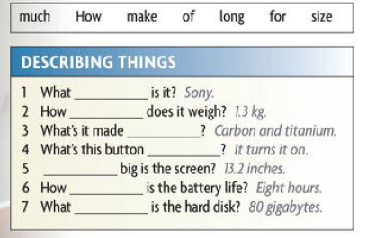
Answers :
1. What make is it? Sony.
2. How much does it weigh? 1.3 kg.
3. What's it made of? Carbon and titanium.
4 . What's this button for? It turns it on.
5. How big is the screen? 13.2 inches.
6. How long is the battery life? Eight hour
7. What size is the hard disk? 80 gigabytes.
6.3.3 How does these words end in the adverts ?
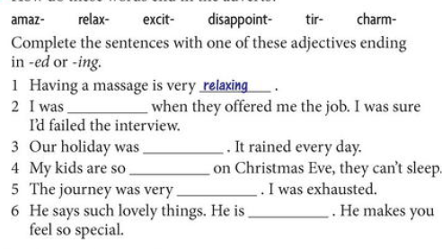
6.3.4 Some verbs and adverbs often go together
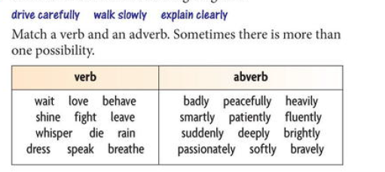
6.3.5. Adverbs that don’t end in – ly
Complete the sentences with an adverb from the box
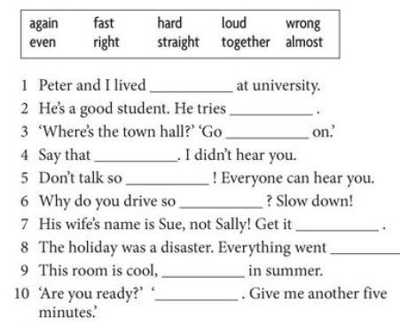
6.4. The Heart of the home – Kitchen -
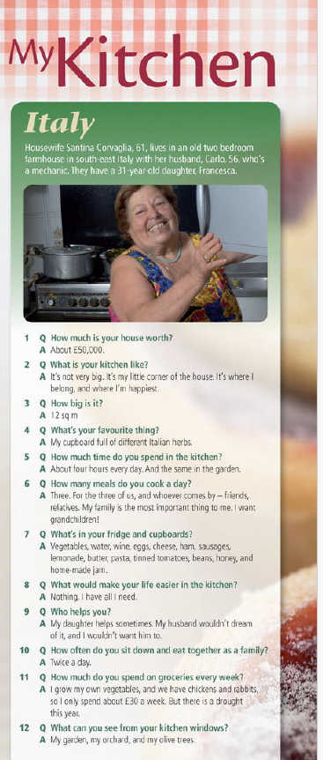
6.5. Every day English
- In a department store
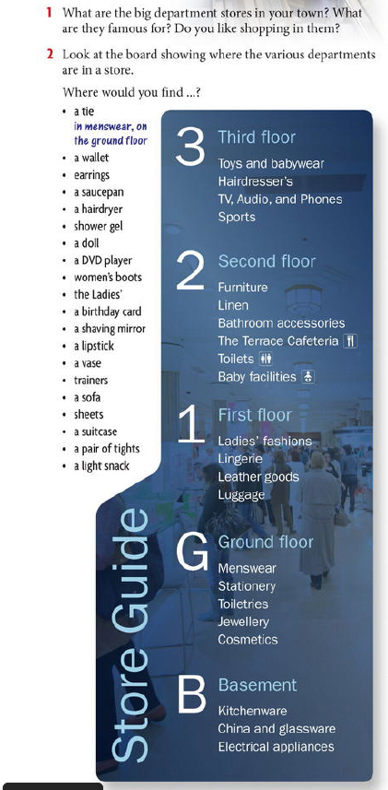
Answers :
1 . A. Morning!
B. Hello. I'd like to try on these shoes, please.
A. Certainly, sir. What size do you take?
B . Nine. That's 41, isn't it?
A. Uh, no, I think you'll find 43 would be mor comfortable, sir.
2. A. Have you got these football shorts for age 10-11?
B. I'm afraid that's all we have. We've sold out that size.
A. Will you be getting any more in?
B . We should be getting a delivery by the end of the week.
3. A. Do you have any sofas like this in stock?
B. No, Madam. They all have to be ordered.
A . How long does delivery take?
B. It all depends, but on average about eight weeks.
4. A. Yes, madam?
B. I'd like this fruit bowl, please.
A. Certainly. Is it a present?
B. Yes, it is.
A. Would you like me to gift wrap it?
B. Ooh, that would be lovely! Thank you so much!
5. A. I like this.
B. How does it feel?
A. Really good. I love the colour, but the size is wrong. It doesn't fit me. It's too tight.
B. Shame. It really suits you. What's it made of?
A. Cashmere. It's so soft.
6. A. Yes, sir?
B. I'll have this coffee maker, please.
A. Certainly. Have you got a store card?
B. No, just a debit card.
A. That's fine. Uh... PIN number, please.
Keep your receipt. That's your guarantee.
B. How long is it guaranteed for?
A. For a year.

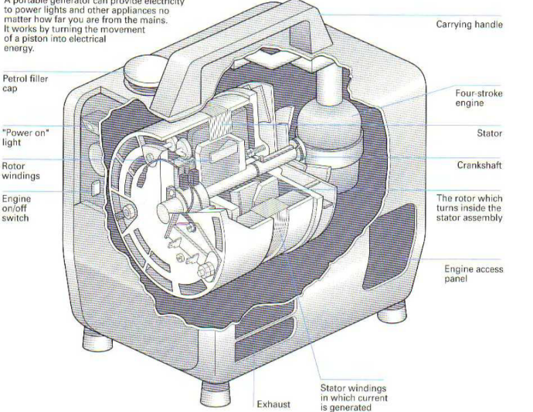
6.6. Homework no. 6
6.6.1. Portable Generator – Read the following text about portable generator
Although most electricity comes from power stations,
power can also be generated by far smaller means.
Nowadays, electricity generators can be small enough
to hold in the hand.
Portable generators are made up of two main parts:
an engine, which powers the equipment, and an
alternator, which converts motion into electricity.
The engine shown (apposite Fig. ) runs on petrol. It is started by pulling a cord. This creates a spark inside which ignites the fuel mixture.
In a typical four-stroke engine, when the piston descends, the air
Inlet valve opens and a mixture of air and petrol is sucked in through a carburettor.
The valve closes, the piston rises on the compression stroke and a spark within the upper chamber ignites the mixture. This mini- explosion pushes the piston back down, and as it rises again the fumes formed by the ignition are forced out through the exhaust valve.
This cycle is repeated many times per second. The moving piston makes the crankshaft rotate at great speed. The crankshaft extends directly to an alternator, which consists of two main sets of windings-coils of insulated copper wire wound closely around an iron core. One set, called stator windings, is in a fixed position and shaped like a broad ring. The other set, the armature windings, is wound on the rotor which is fixed to the rotating crankshaft. The rotor makes about 3,000 revolutions per 25 minute.
The rotor is magnetized and as it spins round, electricity is generated in the stator windings through the process of electromagnetic induction. The electric current is fed to the output terminals or sockets.

6.6.2 Link these causes with the effects in below table
Cause | Effect
1. The piston moves down the cylinder. | A. This creates a partial vacuum.
2. The piston creates a vacuum. | B. This draws in fuel from the carburettor.
3 . The piston moves up the cylinder. | C. This compresses the mixture.
4 . The gas expands quickly | D. This pushes the piston down.
5. The piston moves up and down. | E. This rotates the crankshaft.
6 . The crankshaft spins round. | F. This turns the rotor at 3,000 rpm.
7 . The armature of the alternator rotates. | G. This induces a current in the stator windings.
8. The alternator runs at a steady 3,000 rpm. | H. This generates around 700 watts.

6.6.3 Put the correct order with the help of the diagram the first one has been done
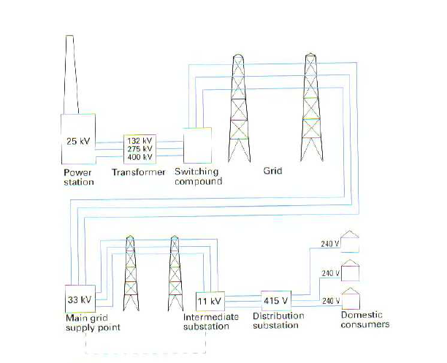a. It is fed to distribution substations.
b It is stepped up by a transformer to high voltages for long-distance distribution.
c. It is distributed via the grid to supply points.
d . It is distributed to the domestic consumer.
e. Electricity is generated at the power station at 25 kV.
f. It passes via the switching compound to the grid.
g. It is distributed via overhead or underground cables to intermediate substations.
References : المصادر
1. New head way – Intermediate
2. Oxford for Engineers

