Grammar: Present Perfect (Intermediate: Unit 1, 3)
Vocabulary: Experiences and Achievements (Intermediate: Unit 1, 3)
Reading: "Present Perfect Stories" (Intermediate: Unit 1, 3)
Unit 5 – Our Changing World
5.1. Starter
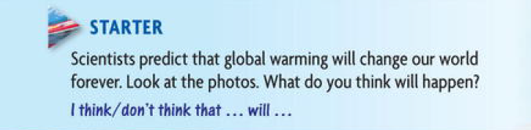
5.1.1 What will happen
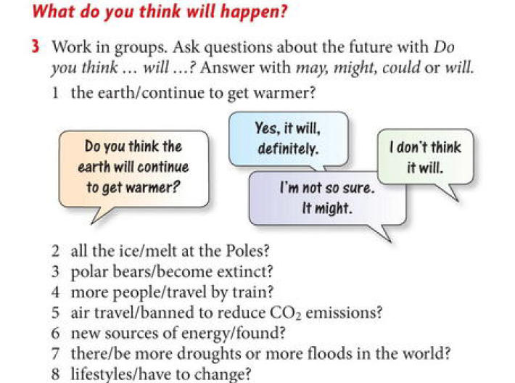
5.1.2 Answers
1 . A. Do you think the earth will continue to get warmer?
B. Yes, I do. The more I read about it, the more I think it will. A few years ago I wasn't so sure.
2. A. Do you think all the ice will melt at the Poles?
B. Well, I don't think all the ice will melt, but a lot has melted already. Do you know a new island near Greenland has just appeared? They thought it was part of the mainland but it was just an ice bridge and it melted. It's called Warming Island. A good name, don't you think?
3. A . Do you think polar bears will become extinct?
B. I think they might. They only live in the Arctic and I read that the ice there has decreased by 14% since the 1970s.
4. A. Do you think more people will travel by train?
B . Definitely. I think lots more people will choose train travel when they can, especially across Europe. Of course it won't always be possible to.
5. A. Do you think that air travel will be banned to reduce CO: emissions?
B. Well, I think it could become much more expensive to travel by air but I don't think it'll be banned.
6. A. Do you think new sources of energy will be found?
B . I hope so. Some people say nuclear energy is the only answer but I think this could cause more problems. Actually, I like wind farms, they look amazing. But I know some people hate them.
7. A. Do you think there'll be more droughts or more floods in the world?
B. I don't really know. There might be both droughts and floods. I think parts of London may be flooded - there's already a barrier across the River Thames to stop flooding.
8. A. Do you think our lifestyles will have to change?
B. Definitely. They're already changing. We're told all the time to do things like drive smaller cars, use cleaner petrol, and recycle our rubbish. That worries me a lot - the amount of rubbish we make.
5.2. Grammar Spot
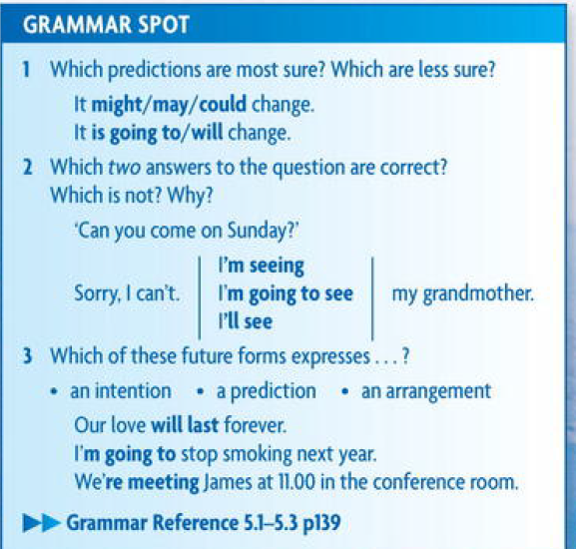
5.3 Discussing Grammar
5.3.1 Work in groups to choose the correct verb form of the following :
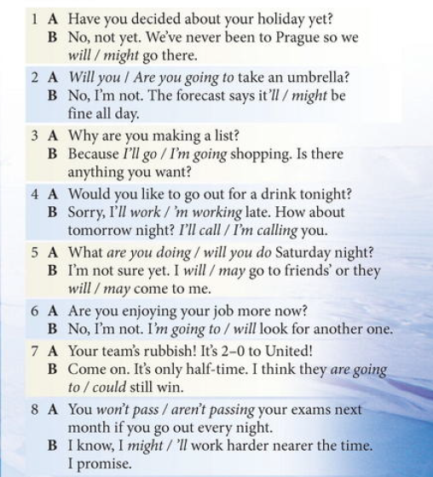
5.3.2 Answers
Discussing grammar

1 A . Have you decided about your holiday yet?
B . No, not yet. We've never been to Prague so we might go there.
2 .A . Are you going to take an umbrella?
B . No, I'm not. The forecast says it'll be fine all day.
3 . A. Why are you making a list?
B. Because I'm going shopping. Is there anything you want?
4. A. Would you like to go out for a drink tonight?
B . Sorry, I'm working late. Um, how about tomorrow night? I'll call you.
5. A What are you doing Saturday night?
B. I'm not sure yet. I may go to friends' or they may come to me.
6. A .Are you enjoying your job more now?
B .No, I'm not. I'm going to look for another one.
7 .A .Your team's rubbish! It's 2.0 to United!
B. Come on. It's only half-time. I think they could still win.
8 . A. You won't pass your exams next month if go out every night.
B. I know, I'll work harder nearer the time. I promise.
5.4. Listening and Speaking
5.4.1 Rocket Man
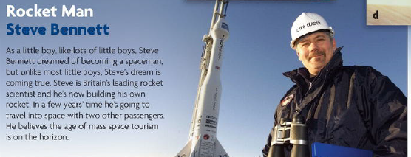
5.4.2 Spoken English – Pretty -
1. Look at how Steve uses pretty in the interview.
I kept it pretty quiet...
That's pretty much where the human race needs to be.
2. The adverb pretty is often used in informal, spoken English. It means 'not a lot but 'more than a little.
She's pretty nice.
The weather was pretty bad.
3 .Work with a partner. Ask the questions and reply including pretty in the answer.
1. A. Did your team win?
B. No, but they played well, all the same.
2 . A. You haven't lost your mobile phone again!
B .No, no. I'm sure it's in my bag somewhere.
3. A. Do you enjoy skiing?
B. I do, but I'm hopeless at it.
4. A. What do you think of my English?
B. I think it's good.
5.5. Life in 2060

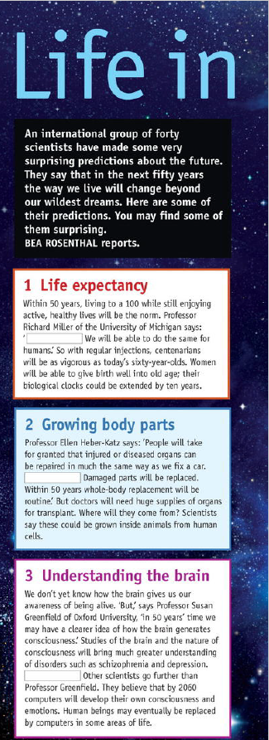
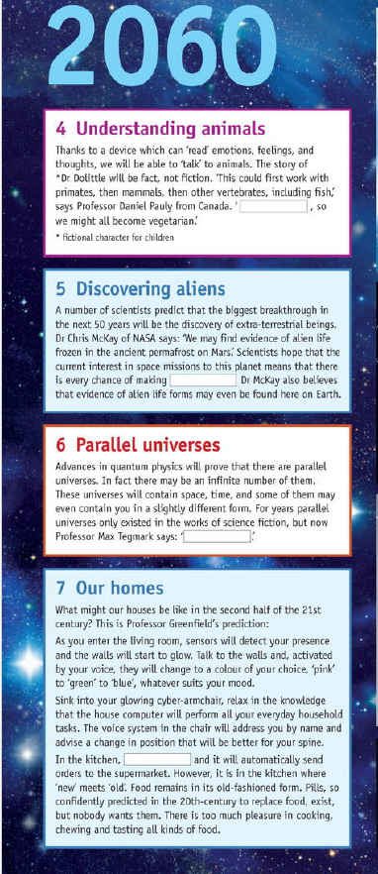
5.5.2. Answer with true or False for the following
1. Women will be able to give
birth aged 100.
2. It will be possible to replace all the
parts of the body.
3 Animal parts will
be used for transplantation.
4 Scientists think that computers
won't ever do the work of the
human brain.
5 .Scientists believe that if we can talk
To animals, we won't want to
eat them.
6 . Alien life has already been found
On Mars.
7 . There could be an infinite number
Of other universes.
8 .The walls in your house will change
colour to suit your mood.
9 Your armchair will help you do your
housework. 10 Pills will replace food.

5.6. Vocabulary and Pronunciation
5.6.1. Words building – Suffix and Prefix
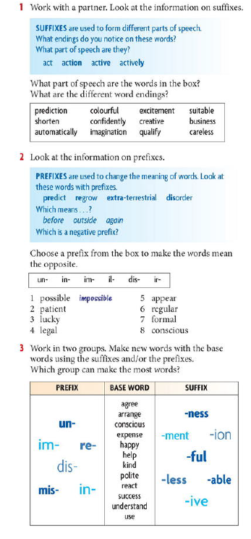
5.6.2 Complete the sentences with the words from table of exercise 3 above
1. Bob and Jan don't get on at all. They dis --------
about everything.
2. Money doesn't always lead to h ---------- ness.
3 . My aunt says today's kids are all rude and im 4 Thanks for your advice, it was really h
I really appreciate your k--------- ness.
5. My dad is u---------- less at fixing his computer.
I always have to help him.
6 . Please don't mis -------------- me. I didn't mean to be
Un -------- , I'm really sorry.
7 . Timmy fell off his bike and hit his head. He was un ---------- for a few hours.
8 . What was your wife's re -------- ion when she heard you'd won the lottery?
5.7. Home work no. 5
5.7.1. Read the following text about Refrigerator
- Refrigeration preserves food by lowering its temperature. It slows down the growth and reproduction of micro-organisms such as bacteria and the action of enzymes which cause food to rot.
- Refrigeration is based on three principles. Firstly, if a liquid is 5 heated, it changes to a gas or vapour. When this gas is cooled, it changes back into a liquid. Secondly, if a gas is allowed to expand, it cools down. If a gas is compressed, it heats up. Thirdly, lowering the pressure around a liquid helps it to boil.
- To keep the refrigerator at a constant low temperature, heat must 10 be transferred from the inside of the cabinet to the outside. A refrigerant is used to do this. It is circulated around the fridge, where it undergoes changes in pressure and temperature and changes from a liquid to a gas and back again.
- One common refrigerant is a compound of carbon, chlorine, and 15 fluorine known as R12. This has a very low boiling point: -29°C. At normal room temperature (about 20°C) the liquid quickly turns into gas. However, newer refrigerants which are less harmful to the environment, such as KLEA 134a, are gradually replacing R12.
- The refrigeration process begins in the compressor. This 20 compresses the gas so that it heats up. It then pumps the gas into a condenser, a long tube in the shape of a zigzag. As the warm gas passes through the condenser, it heats the surroundings and cools down. By the time it leaves the condenser, it has condensed back into a liquid.
- Liquid leaving the condenser has to flow down a very narrow tube (a capillary tube). This prevents liquid from leaving the condenser too quickly, and keeps it at a high pressure.
As the liquid passes from the narrow capillary tube to the larger tubes of the evaporator, the pressure quickly drops. The liquid 30 turns to vapour, which expands and cools. The cold vapour absorbs heat from the fridge. It is then sucked back into the compressor and the process begins again.
- The compressor is switched on and off by a thermostat, a device that regulates temperature, so that the food is not over-frozen.
5.7.2 Link each action in the column A to the result in column B to describe an important engineering principals
A Action | B Result
a liquid is heated | it heats up
a gas is cooled | there is an equal and opposite  reaction
a gas expands | it changes to a gas
a gas is compressed | it extends in proportion to the force it is transmitted equally throughout the fluid
a force is applied to a body | a current is induced in the wire git cools down
a current passes through a wire | a force is applied to a spring fixed at one end
a wire cuts a magnetic field | it sets up a magnetic field around the wire
pressure is applied to the surface of an enclosed fluid | it changes to a liquid
5.7.3 Each of the verbs in column A has a related noun ending with – er or – or in column B . Complete the blanks .
A Verbs | B Nouns
Refrigerate | Refrigerator
Condense
 | Evaporator
Compress
Resist
 | charger
Generate
Conduct
 | exchanger
Radiate
Control

