Unit 3
Grammar: Present Continuous (Intermediate: Unit 2)
Vocabulary: Actions and Activities (Intermediate: Unit 2)
Reading: "Simple or Continuous?" (Intermediate: Unit 2)
3.1 : Starter
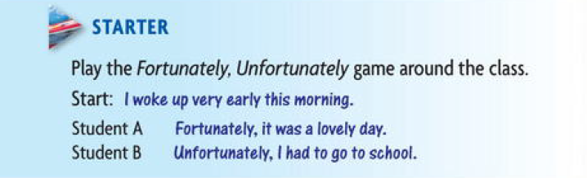
3.2. Grammar – past and present tense-
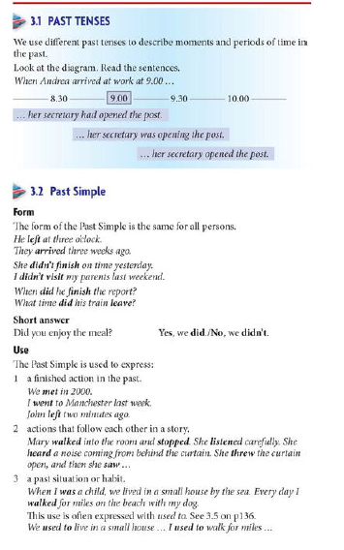

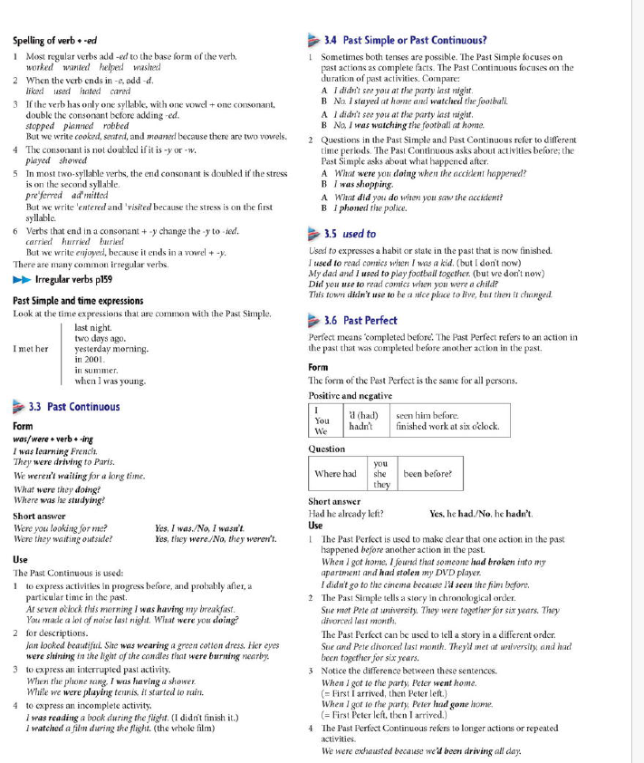

3.2 .1 Past tense
Read the following notes about painter Vincent Van Gogh and complete the questions about his life
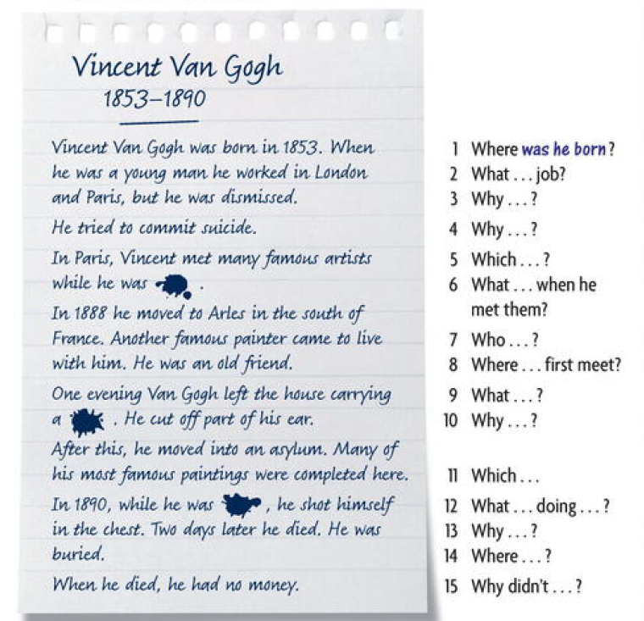
Answers “
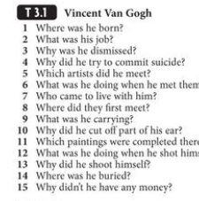
3.2.2 Read the following text about Vincent Van Gogh and answer the questions in 3.2.1 above
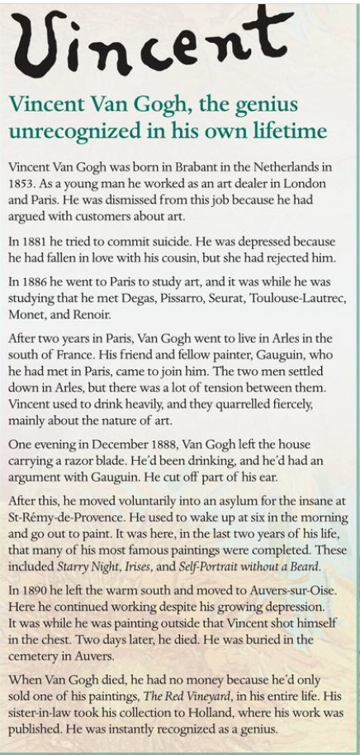

Questions and Answers
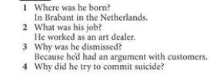
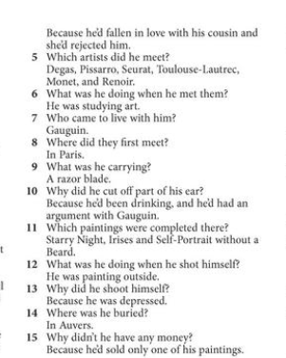
3.3 Grammar Spot
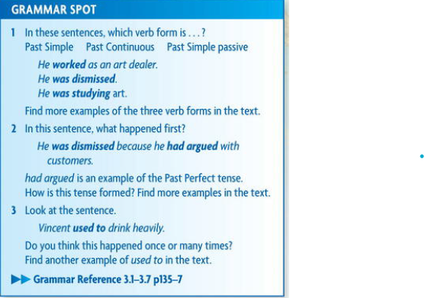
3.4.Vocabulary – Spelling and pronunciation
Read these words aloud , Which two wards rhyme ?
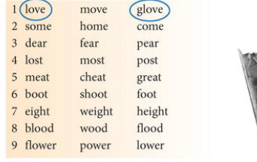
3.5 Romeo and Juliet
3.5.1 read the following two texts
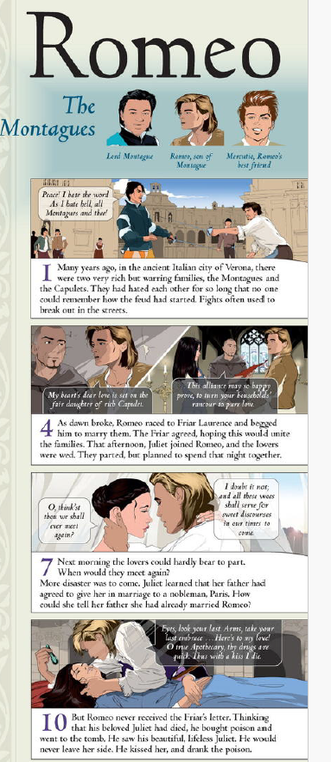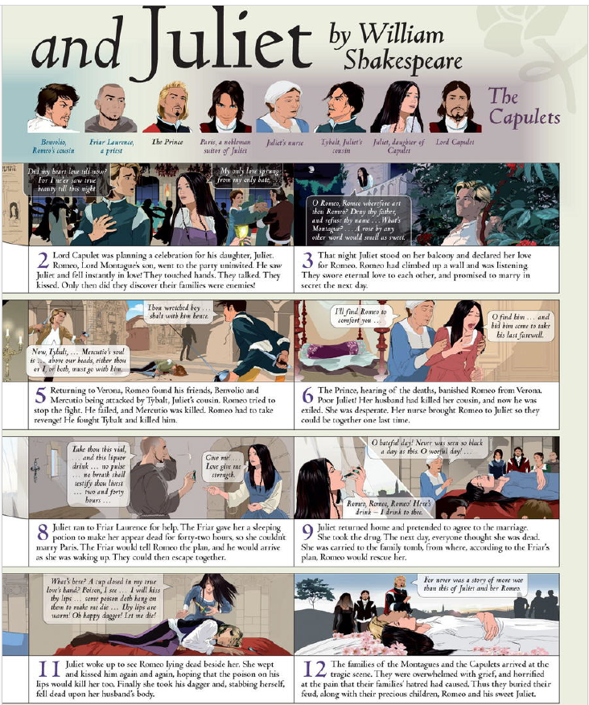
3.5.2 Answer the following questions
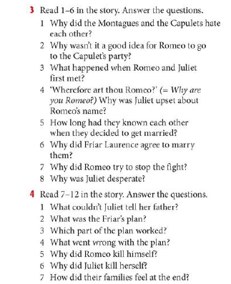
3.6 Writing
- Complete the lines using the wards in the box
As soon As When , So , But
However , Who , Before , While , During ,

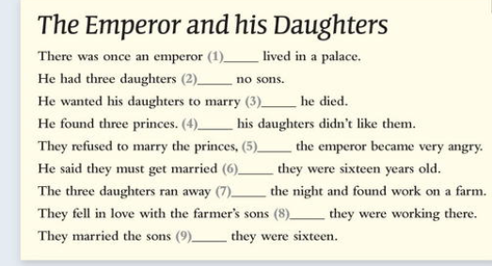
Answers :
1. Who
2. But
3. Before
4. However
5. So
6. As soon as
7. During
8. When
9. While

3.7. Every day English
3.7.1 - Read the conversation , what about which two people agree with each other ?
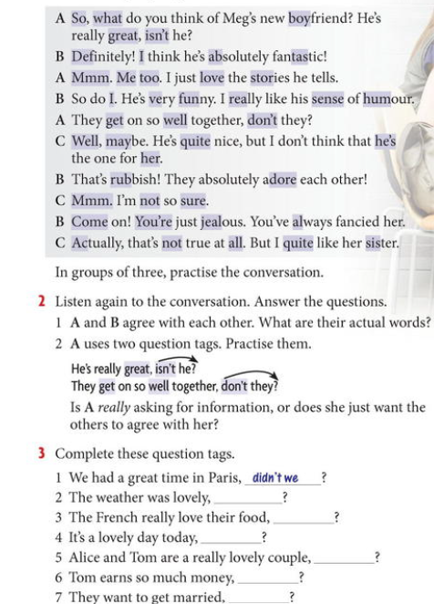

3.7.2 find another words in the exercise in 3.7.1
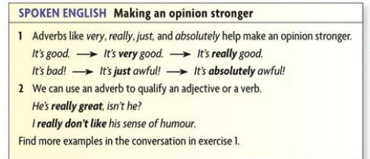
3.8 Homework no. 3 – Safety in the Work
3.8.1
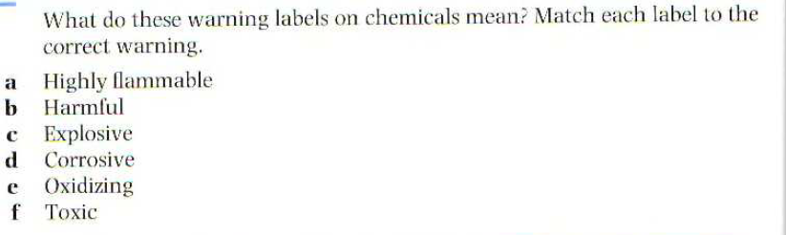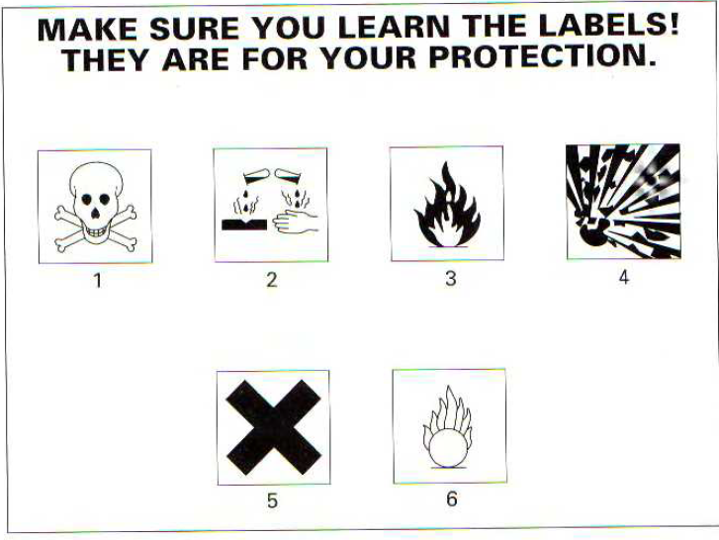
3.8.2 . Accident investigation
Whenever an accident occurs that results in an injury (medical case), damage of equipment and material, or both, prompt accident investigation by the immediate manager is required. A written preliminary investigation will be completed by the end of the particular shift or business day on which the accident occurred.
In no event should there be a delay of more than 24 hours. Failure to comply with this requirement may subject the immediate manager to disciplinary action up to and including discharge.
Without adequate accident investigation data the Company may be subjected to costs, claims, and legal action for which it has no defense. As a minimum, the preliminary accident investigation report will include the following:
1.. Name, occupation, and sex of injured worker.
2. Place and date/time of accident.
3. Description of how the accident happened.
4. Immediate causes of the accident - unsafe acts and unsafe conditions.
5. Contributing causes - manager safety performance, level of worker training, inadequate job procedure, poor protective maintenance, etc.
6. Witness(es) - name and department.
7. Corrective action taken –when.
The employee who was injured and any employee(s) who witnessed the incident should be separately interviewed as soon as possible. A copy of the report must be submitted to the Manager - Human Resources for review. Another copy of the report is to be retained for a period of not less than the injured employee's length of employment plus five (5)
Read above text and answer the following
1. Who is this document for?
a. machine operatives
b. managers
с. all employees
d. injured employees
2 . Who wrote this document?
a . trade union representative
b , technician
с manager
d . medical staff
3. What is the writer's intention?
a. to prevent accidents
b . to ensure speedy help for injured employees
c . to protect the company
d . to warn about dangers

