Lecture two: Anticoagulants used in hematology laboratory
Anticoagulants are the Chemical substances that prevent the blood from clotting when mixed with inappropriate concentration with the Blood Specimen. Anticoagulant materials in the laboratory Uses:
Every anticoagulant is added in fixed proportion to blood
-They used for obtain plasma.
-Its uses only in vitro (outside of the body).
-They are toxic
Action: their act to stop blood-clotting mechanism in vitro.
Common Anticoagulant Materials
The common anticoagulant materials, which used in the daily lab’s work for hematological purposes, some are the following:
- EDTA= (Ethtylene diamine tetra-acetic acid)
- Sodium Citrate: (Na3C6H507.2H20)
- Buffered citrate (sodium citrate and citric acid)
- Heparin. And Wintroub
- Oxalates
- Sodium floride
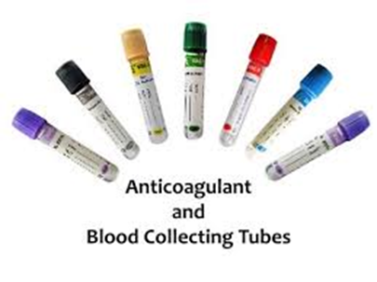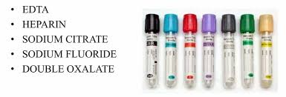

VARIOUS TYPES OF ANTICOAGULANTS WITH VACUTAINER COLOR CODES

1.EDTA – ETHYLENE DIAMMINE TETRAACETIC ACID
EDTA Is a standard hematology anticoagulant because of its
- very effective and complete anticoagulation
- lack of effect on the size (morphology) or number of blood cells in the specimen.

Mechanism of action of EDTA : This anticoagulant removes free calcium ions, which is essential for coagulation by chelating them .It is effective when used as about 1.2 mg/ml of blood.

Advantages of EDTA
- It gives better preservation to the cellular morphology of blood cells when observed even after 3 hours of blood collection.
- It can be used for platelets counting as it inhibits the clumping of platelets.
- Uses of EDTA : Following tests are commonly done by using EDTA as an anticoagulant –
- Complete Blood Count (CBC),
- PBS ,
- Platelet count,
- Red cell Indices, Hemoglobin estimation, Hematocrit or Packed Cell Volume estimation Differential Leukocyte Count,
- ESR by wintrobes method
- and HbA1C test

Disadvantages of EDTA
- Not used for coagulation studies because it destroys factor V and VIII.(as it chalets calcium)
- Occurs Platelets sataletism with neutrophils
- Occurs Platelet aggregation
- Excess of EDTA in the blood may lead to shrinkage of RBCs & WBCs. , degenerative changes in the blood cells,decrease in Packed Cell Volume (PCV) & Increase in MCHC (Mean Cell Hemoglobin Concentration).
- It activates naturally occurring anti-platelet auto-antibodies which cause the platelet adherence to Neutrophils.

2. TRI-SODIUM CITRATE
Sodium Citrate Chemical Action:
-The anticoagulant removes the free Calcium ions by binding to them to form calcium citrate complex.
Sodium Citrate USES OR ( Advantiges):
- The anticoagulant of choice in coagulation studies. PT, TT and PTT
- ESR by Westergren Method
Sodium Citrate Disadvantiges:
Citrated blood cannot be used for Packed Cell Volume (PCV), Hemoglobin (Hb) Estimation, Total Leukocyte Count TLC, and Differential Leukocyte Count (DLC) because citrate is used as a solution and it alters the concentration of blood.

3. BIOLOGICAL / NATURAL ANTICOAGULANT – HEPARIN
- an excellent natural anticoagulant
- sources extracted from mammalian liver or pancreas.
- more expensive than the artificial ones and has a temporary effect of only 24/ hours.
- Prevents clotting by inactivating thrombin, thus preventing conversion of fibrinogen to fibrin.
- used in the proportion of 0.1-0.2mg of the dry salt for 1ml of blood.
- Heparin does not alter the size of the red cells;
- The heparinized blood specimen is commonly used to Blood sample without hemolysis , blood gases especially the Arterial Blood Gas Analysis, Erythrocyte Sedimentation Rate (ESR), Red cell enzyme estimation , Packed Cell Volume (PCV), Osmotic Fragility Test (OFT), Immunophenotyping and other Hematological tests
- Not recommended for cell counting because of its clumping effect on platelets leucocytes

4. OXALATES
They can be used as Single oxalates as Sodium Oxalate or Potassium Oxalate or Ammonium oxalate but are commonly used as Double Oxalates because when used alone the Potassium oxalate, when used at a concentration of 2mg/ml of blood causes the Shrinkage of Red Blood Cells (RBCs) whereas the Ammonium oxalate may cause the Swelling of Red blood cells when used at concentration of 2mg/ml.

Oxalates – Mechanism of Action
It acts as a chelating agent and binds with the calcium ions present in the blood and forms insoluble precipitates of Calcium Oxalates.
Remember that the Potassium oxalate and Ammonium Oxalate should be used in a ratio 2:3 and at a concentration of 2mg/ml of blood.

Uses of Oxalates : It can be used for the Blood chemistry, Packed cell volume (PCV), Erythrocyte Sedimentation Rate (ESR), Total Leukocyte Count (TLC), Specific gravity etc.
- SODIUM FLUORIDE:

It is the anticoagulant of choice for the estimation of blood sugar.

