Spirochetes
The spirochetes are long, slender, helically coiled, spiral, or corkscrew shaped bacilli. T. pallidum has an outer sheath. Inside the sheath is the outer membrane, which contains peptidoglycan and maintains the structural integrity of the organisms. Endoflagella (axial filaments) are the flagella-like organelles in the periplasmic space coated by the outer membrane. The endoflagella begin at each end of the organism and wind around it, extending to and overlappingيتشابك at the midpoint. Inside the endoflagella is the inner membrane (cytoplasmic membrane) that provides osmotic stability and covers the protoplasmic cylinder. A series of cytoplasmic tubules (body fibrils) are inside the cell near the inner membrane. Treponemes reproduce by transverse fission.

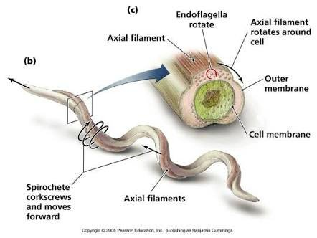

TREPONEMA PALLIDUM AND SYPHILIS
Morphology and Identification
A. Typical Organisms: T. pallidum are slender spirals measuring about 0.2 μm in width and 5–15 μm in length. The spiral coils are regularly spaced at a distance of 1 μm from one another. The organisms are actively motile, rotating steadilyتدور بثبات around their endoflagella even after attaching to cells by their tapered endsنهايات مستدقة. The long axis of the spiral is ordinarily straight but may sometimes bendينحني so that the organism forms a complete circle for moments at a time, returning then to its normal straight position. The spirals are so thin that they are not readily seen unless immunofluorescent stain or dark-field illumination is used. They do not stain well with aniline dyes, but they can be seen in tissues when stained by a silver impregnation method.
B. Culture Pathogenic T. pallidum has never been cultured continuously on artificial media, in fertile eggs, or in tissue culture.
In proper suspending fluids and in the presence of reducing substances, T. pallidum may remain motile for 3–6 days at 25°C. In whole blood or plasma stored at 4°C, organisms remain viable for at least 24 hours, which is of potential importance in blood transfusions.
Antigenic Structure:
- The outer membrane
- The peptidoglycan–cytoplasmic membrane complex.
- Membrane proteins are present that contain covalently bound lipids at their amino terminals.
- The lipids appear to anchor the proteins to the cytoplasmic or outer membranes.
- The endoflagella are in the periplasmic space.
- T. pallidum has hyaluronidase.
- The endoflagella are composed of three core proteins that are homologous to other bacterial flagellin proteins plus an unrelated sheath protein.
- Cardiolipin is an important component of the treponemal antigens.

Pathogenesis, Pathology, and Clinical Findings
Acquired Syphilis:
- Natural infection with T. pallidum is limited to the human host.
- Human infection is usually transmitted by sexual contact, and the infectious lesion is on the skin or mucous membranes of genitalia.
- T. pallidum can probably penetrate intact mucous membranes, or the organisms may enter through a break in the epidermis.
- Spirochetes multiply locally at the site of entry, and some spread to nearby lymph nodes and then reach the bloodstream. Within 2–10 weeks after infection, a papule develops at the site of infection and breaks down to form an ulcer with a clean, hard base (“hard chancre”). e. t. c.
B. Congenital Syphilis A pregnant woman with syphilis can transmit T. pallidum to the fetus through the placenta beginning in the 10th–15th weeks of gestation.
Diagnostic Laboratory Tests
A. Specimens: Specimens include tissue fluid expressed from early surface lesions for demonstration of spirochetes by either dark-field microscopy or immunofluorescence; such specimens can also be tested by nucleic acid amplification. Blood can be obtained for serologic tests; cerebrospinal fluid (CSF) is useful for Venereal Disease Research Laboratory.
B. Dark-Field Examination A drop of tissue fluid or exudate is placed on a slide, and a coverslip is pressed over it to make a thin layer.
C. Immunofluorescence Tissue fluid or exudate is spread on a glass slide, air-dried, and sent to the laboratory.
D. Serologic Tests for Syphilis These tests use either nontreponemal or treponemal antigens.

