Klebsiella
The genus was originally divided into 3 main species based on biochemical reactions. Today, 7 species with demonstrated similarities in DNA homology are known. These are (1) Klebsiella pneumoniae, (2) Klebsiella ozaenae, (3) Klebsiella rhinoscleromatis, (4) Klebsiella oxytoca, (5) Klebsiella planticola, (6) Klebsiella terrigena, and (7) Klebsiella ornithinolytica
Klebsiella pneumoniae
General characteristics:
- K. pneumoniae is typically colonizes human mucosal surfaces of the oropharynx and gastrointestinal (GI) tract. It is recorded to be associated with pneumonia in the alcoholic and diabetic patient population. K. pneumoniae is also a well-known cause of community-acquired pneumonia.
- It is mostly commonly isolated Gram-negative, non-motile bacteria possesses a polysaccharide capsule, which protects against phagocytosis and antibiotics and makes the colonies moist and mucoid. has a distinctive “yeasty” odor.
Antigenic Structure
Members of the genus Klebsiella form large capsules consisting of polysaccharides (K antigens) covering the somatic (O or H) antigens and can be identified by capsular swelling tests with specific antisera.
Cultural and biochemical characteristics
Klebsiella species exhibit mucoid growth, large polysaccharide capsules Table 3.1 and Figure 3.1, and lack of motility, and they usually give positive test results for lysine decarboxylase and citrate. Klebsiella, species usually give positive Voges-Proskauer reactions Table 3.2.
Table 3.1 Cultural Characteristics of Klebsiella pneumoniae on some laboratory media
Cultural Characteristics | Nutrient Agar Medium (NAM) | MacConkey Agar medium | Blood Agar Medium | EMB Agar medium
Shape | Circular | Circular | Circular | Circular
Size | 2-3 mm | 2-3 mm | 2-3 mm | 2-3 mm
Elevation | Dome-shaped | Convex | Dome-shaped | Convex
Surface | Mucoid | Mucoid | Mucoid | Mucoid
Color | Greyish white | Pink – Red | Greyish white | Pink – Purple
Structure | Translucent–Opaque | Opaque | Translucent–Opaque | Translucent–Opaque
Hemolysis | ----- | ----- | γ-Hemolysis (Non-hemolytic) | -----

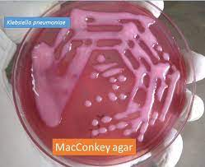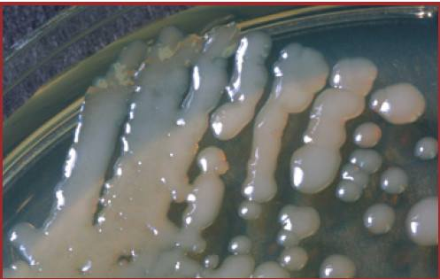
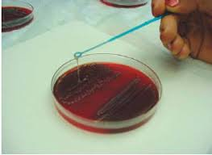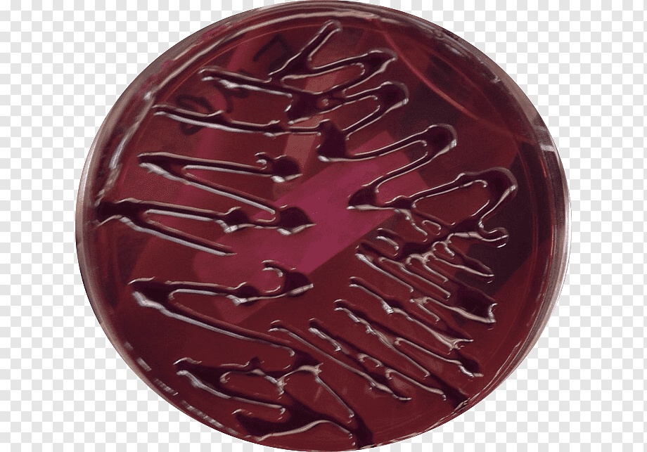
Figure 3.1 Klebsiella pneumoniae Growing on MacConkey, Nutrient, Blood and Eiosin Methylene Blue agar plates respectively.
Table 3.2 Biochemical tests of Klebsiella pneumoniae
Characteristics | Klebsiella pneumoniae
Capsule | +ve
Catalase | +ve
Citrate | +ve
Gelatin Hydrolysis | -ve
Gram Staining | -ve
H₂S | -ve
Indole | -ve
Motility | -ve
MR (Methyl Red) | -ve
Nitrate Reduction | +ve
Oxidase | -ve
Pigment | -ve
Shape | Rod
Spore | -ve
TSIA (Triple Sugar Iron Agar) | A/A
Urease | +ve
VP (Voges Proskauer) | +ve

Pathogenesis and Clinical Findings
Klebsiella species are present in the nasopharynx and feces of about 5% of normal individuals. The most commonly isolates species are K. pneumoniae and K. oxytoca. While K. pneumoniae may be isolated more frequently than K. oxytoca by clinical laboratories, both species are important human pathogens.
- K. pneumoniae can produce a lobar pneumonia, the production of “currant jelly” sputum.
- Klebsiella species also cause urinary tract infections, wound and soft tissue infections, and bacteremia/sepsis.
- K. pneumoniae has emerged as a cause of community-acquired pyogenic liver abscess.
- Klebsiella species responsible for hospital-acquired infections.
- Klebsiella granulomatis (formerly Calymmatobacterium granulomatis) causes a chronic genital ulcerative disease, and is thought to be a sexually transmitted disease.

Proteus, Morganella and Providencia
- Normal flora of the GI tract (except Providencia).
- Non-lactose ferment
- All motile, with Proteus swarming (Figure 3.2) motility with peritrichous flagella, non-spore forming,
- Phenylalanine Deaminase Test Positive (PA⁺Phenylalanine Agar)
- Lysine deamination ⁺ (LIA (Lysine Iron Agar) Lysine Iron Agar (LIA) is used to differentiate enteric bacilli based on their ability to decarboxylate or deaminate lysine and produce hydrogen sulfide (H₂S). LIA also is used in combination with Triple Sugar Iron Agar to identify members of Salmonella and Shigella R/A)
- Urease production was positive for most members and it's strongly ⁺ for Proteus
- TSI variable for every genus
- Indole test positive except P. mirabilis is -ve
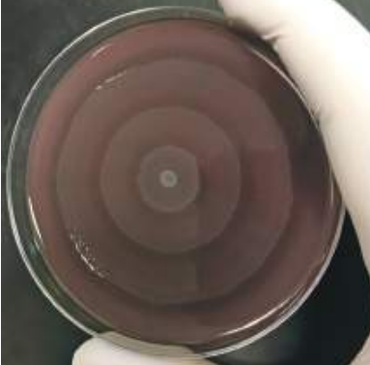
Proteus species
- P. mirabilis and P. vulgaris are widely recognized human pathogens.
- The spot-indole test is useful for differentiation between the two most common Proteus species: is P. vulgaris indole positive, whereas P. mirabilis is negative.
- Isolated from urine, wounds, and ear and rarely from bacteremia
- Both produce swarming (Rauss phenomenon) colonies on non-selective media and have a distinctive “burned chocolate” odor
Figure 3.2 Swarming phenominon of Proteus species
- Both are strongly urease positive
- Both are phenylalanine deaminase positive

The swarming of Proteus can be inhibited by:
- Increasing the concentration of agar from 1-2% to 6%.
- Incorporation of sodium azide, boric acid, or chloral hydrate in the medium.
- The addition of growth inhibitors like sulphonamides to the medium.
- Addition of Teepol (a surface-active agent), which is present in Teepol Lactose agar medium.
Table 3.3: Culture Characteristics of Proteus vulgaris
Cultural Characteristics | Nutrient Agar Medium (NAM) | MacConkey Agar medium | Blood Agar Medium | EMB Agar medium
Shape | Irregular (due to swarming) | Circular | Irregular (due to swarming) | Circular
Size | 1-2 mm | 2-3 mm | 1-2 mm | 2-3 mm
Elevation | Effuse | Low Convex | Effuse | Effuse
Surface | Glistening | Smooth | Glistening | Glistening
Color | Greyish white | Colorless or Pale colored | Greyish white | Colorless
Structure | Translucent | Transparent | Translucent –Opaque | Transparent
Hemolysis | ----- | ----- | γ-Hemolysis (Non-hemolytic) | -----

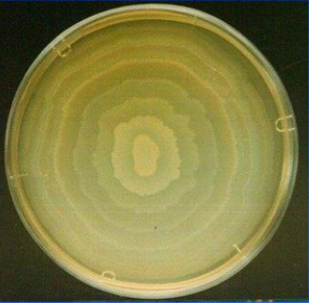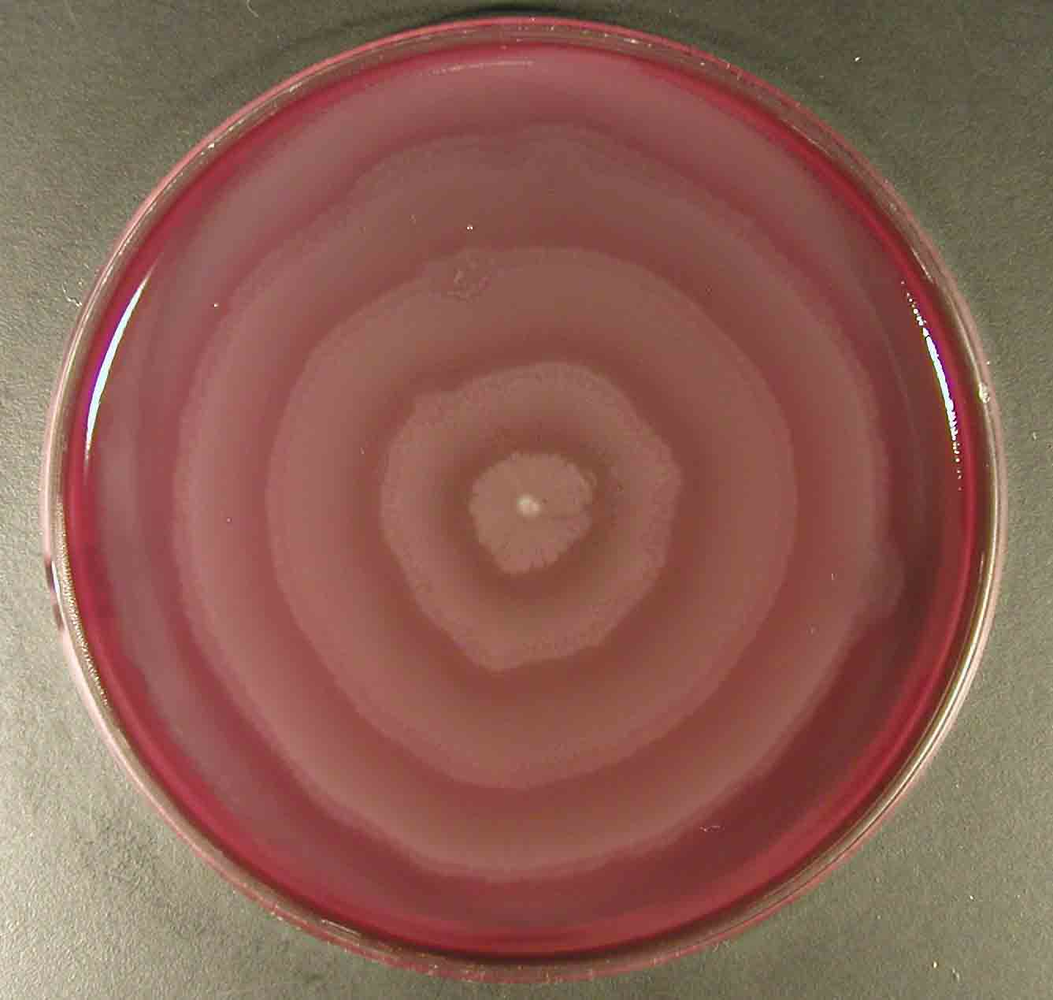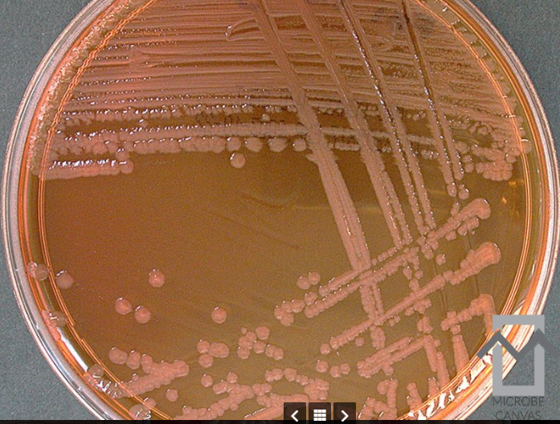
https://www.slideserve.com/yardley-carver/shigella-proteus
https://www.med.muni.cz/mikroblg/atlas/atlas/bacteriology/proteus/atlas_en.html
https://microbe-canvas.com/Bacteria/gram-negative-rods/facultative-anaerobic-3/catalase-positive-3/oxidase-negative/colistin-resistant/proteus-vulgaris.html
Antigenic Structure
The Proteus possess thermostable, somatic (O), and thermolabile flagellar (H) antigens upon which, several serotypes have been recognized.
Pathogenicity and Pathogenesis
The two species to most commonly produce infections in humans are P. mirabilis and P. vulgaris. Both species produce urease, resulting in rapid hydrolysis of urea with liberation of ammonia.
- Thus, in urinary tract infections with Proteus species, the urine becomes alkaline, promoting stone formation and making acidification virtually impossible.
- The rapid motility of Proteus may also contribute to its invasion of the urinary tract.
- P. mirabilis causes urinary tract infections and occasionally other infections, such as bloodstream infection (frequently secondary due to a UTI) and respiratory tract infections.
- P. vulgaris is probably more frequently implicated in wound and soft tissue infections than UTIs.
Biochemical tests and identification
Basic Characteristics | Properties (Proteus mirabilis)
Capsule | Negative (-ve)
Catalase | Positive (+ve)
Citrate | Positive (+ve)
Flagella | Positive (+ve)
Gas from Glucose | Positive (+ve)
Gelatin Hydrolysis | Positive (+ve)
Gram Staining | Negative (-ve)
H₂S | Positive (+ve)
Indole | Negative (-ve)
Motility | Positive (+ve)
MR (Methyl Red) | Positive (+ve)
Nitrate Reduction | Positive (+ve)
Oxidase | Negative (-ve)
Pigment | Negative (-ve)
Shape | Rods
Spore | Negative (-ve)
Urease | Positive (+ve)
VP (Voges Proskauer) | Negative (-ve)
Fermentation of
Glucose | Positive (+ve)
Lactose | Negative (-ve)
Enzymatic Reactions
Acetate Utilization | Negative (-ve)
Esculin Hydrolysis | Negative (-ve)
Lipase | Positive (+ve)
Lysine decarboxylases | Negative (-ve)
Phenylalanine Deaminase | Positive (+ve)
Tryptophan Deaminase | Negative (-ve)

