Lecture 11 Dental Equipment Technologies Dr.Muna Merza
Polymerization devices

This equipment used to acrylic polymerization, it divided into two types:
- The first type used with acrylic heat and self polymerization such as Ivomate. It is used in crown & bridge, acrylic lab, or orthodontic lab
- The second type used with heat acrylic to help it to reach complete polymerization by applied wet heating on the acrylic metal flask, such as a water bath or microwave oven.

- Water bath oven
It used only with hot cure acrylic to help it to reach complete polymerization by applying wet heating on the acrylic metal flask. Large boiling out unit made from high- quality steel. Also suitable for processing in boiling water. Temperature is thermostatically controlled. The Curing of the acrylic resin with this device about 3-12 hours and 30°C - 100°C

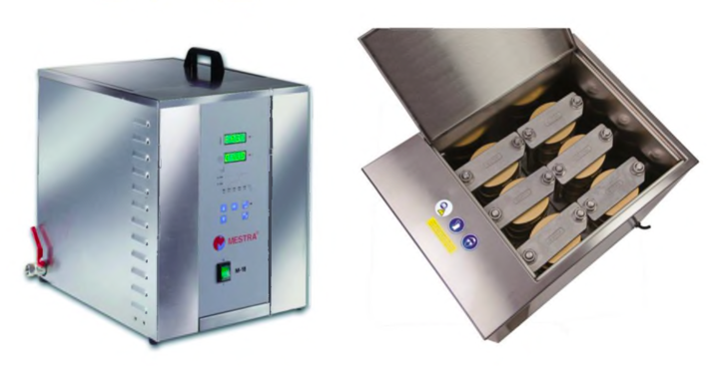
Parts of the water bath according to external view:
1) Cover.
2) Synoptic display.
3) Keyboard.
4) Main Switch.
5) Drainage tap.
6) Circuit breaker.
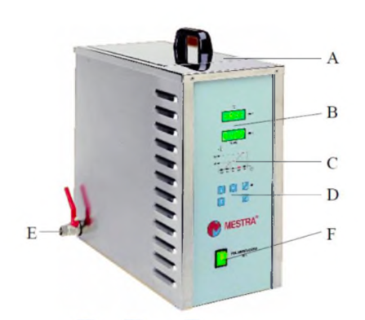

Parts of the water bath according to internal view:
1. Tank container: it is a deep container cover with water put on it the flask and made from stainless steel.
2. Heater: it lies under the container used for heating water according to uses.

Parts of the Keyboard of the water bath device:
1) Temperature display.
2) Time display.
3) Element control lamp.
4) Time-up lamp.
5) Start-stop key.
6) On lamp.
7) Display mode.
8) Down key.
9) Up key.
10) Function key.
11) Step indicator lamps.
12) Temperature lamps
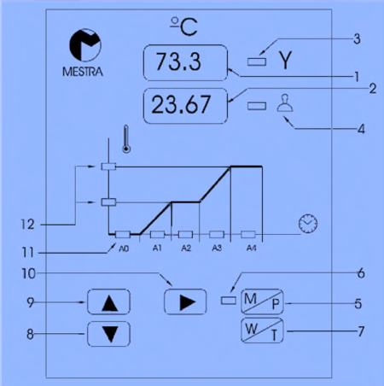
- Ivomat oven
It is used in crown & bridge, acrylic lab, or orthodontic lab. Furthermore, it can also be used for the polymerization of heat or cold-curing resins

• Types of Ivomat oven:
- Manual Ivomat oven.
- Electric Ivomat oven.

1) Manual Ivomat oven.
Manual Ivomat oven is a practical stainless steel pneumatic polymerizing kettle, used mainly to polymerize dentures and associated items in dentistry. To get the best performance from the unit.

• Parts of Manual Ivomat oven:
A. Safety valve 1
B. Air inlet
C. Pressure gange
D. Sliding bolt
E. Connector
F. Safety valve 2
G. Kettle
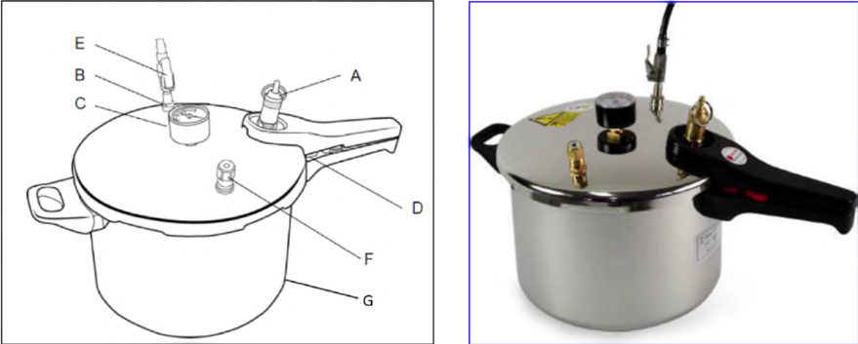

2) Electric Ivomat oven.
is an electric device used for pressurized polymerizer which incorporates a control panel to program a sequence of polymerization temperatures and time, according to the user.

• Parts of Electric Ivomat oven:
1) Air filter control
2) Safety lever
3) Bold knob
4) Pressure chamber lid
5) Pressure chamber
6) Thermostat
7) Manometer
8) Timer
9) Mains switch
10) Pilot lamp
11) Polymerization container lid
12) Alligator clips
13) Polymerization container
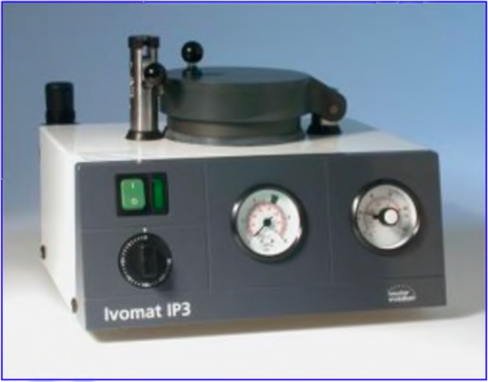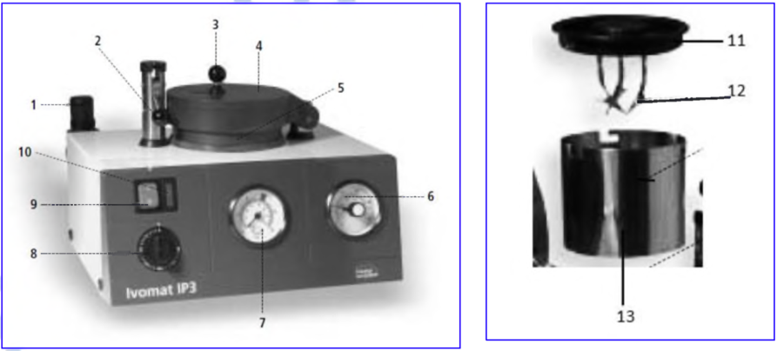

Notes:
• Material-specific pressure regulation
• Temperature can be individually set from +30°C to +120°C for about 10 – 30 minutes.
• The water container is automatically emptied after polymerization has been completed.

3. Microwave Oven
A microwave oven can be used to generate heat inside the resin (used to acrylic polymerization). They are electromagnetic waves produced by a generator called a magnetron Microwave oven does not pass-through metal, conventional metallic flasks cannot be used when heating acrylic resin. Consequently, it is used with a fiber-reinforced plastic flask They are used for processing of maxillofacial prosthesis, processing of complete denture, relining of a denture base, and for the repair of dentures The Curing of the acrylic resin with this device about 3- 12 minutes and 100 watt - 800 watt.
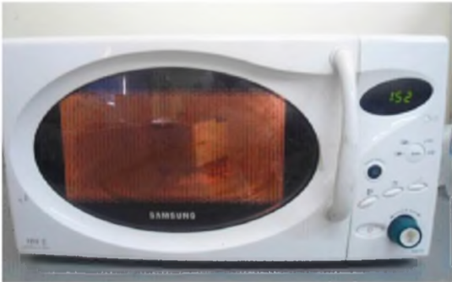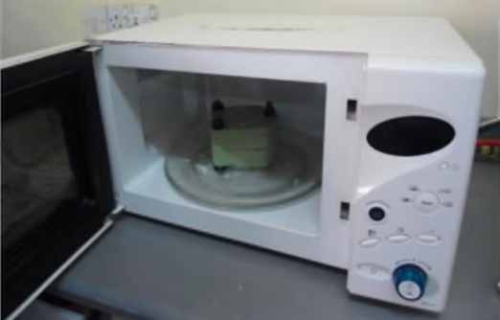

• Parts of a microwave oven:
A. Control panel included (display, temperature, control times & temperatures and start of operation with added 30 seconds according to users, and open & close device).
B. Turntable shaft.
C. Turntable ring assembly
D. Glass tray
E. Observation window
F. Door assembly
G. Safety interlock system

