1

Departement communication

Lecturer: assiss.prof mohmad mahdi abbass alsaeed
Date 4//2/2025

……………………………………………………………………………………………………………………………

Mohmad mahdi alsaeed
Assis.prof.

Future tense, skill of reading and writing

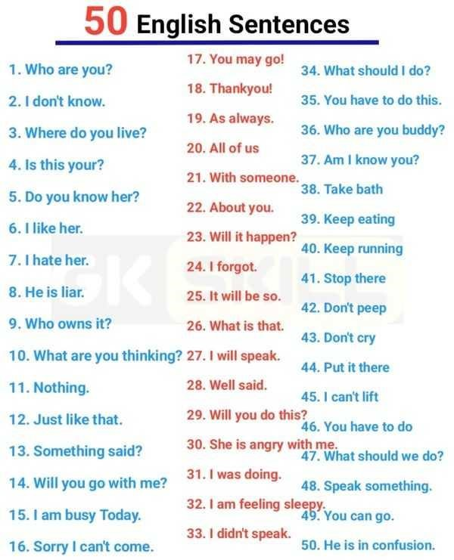

1)future simple :
Modal + form (v1

للتعبير عن الفعل في المستقبل القريب
He will go to Babylon to see the old town.

2) future continuous :
Modal +verb to be(be) + ing form
للتعبير عن الاستمرارية في الفعل في المستقبل

It will be raining tomorrow at 9 O’clock.

We shall be learning English tomorrow morning.

3) future perfect tense :

Modal +verb to have (have) +P.P.

We shall have received our salary by the end of this month.

4)future perfect continuous tense :
Modal +verb to have(have) +been +ing form

Ex:
Next june,ahmed will have been teaching in this college for 10 years.

