1

Electronic Circuit

Lecture 4 (${ 6}^{th }\& 7 and 8$ Week)

Power Amplifier

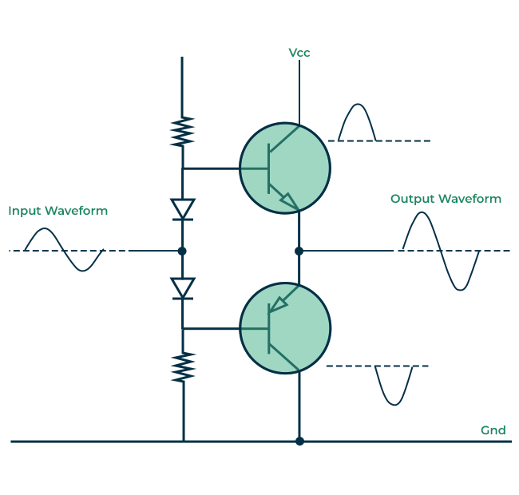

  - Introduction
An amplifier receives a signal from some pickup transducer or other input source and provides a larger version of the signal to some output device or to another amplifier stage. An input transducer signal is generally small (a few millivolts from a cassette or CD input, or a few microvolts from an antenna) and needs to be amplified sufficiently to operate an output device (speaker or other power-handling device). In small-signal amplifiers, the main factors are usually amplification linearity and magnitude of gain. Since signal voltage and current are small in a small-signal amplifier, the amount of power-handling capacity and power efficiency are of little concern. A voltage amplifier provides voltage amplification primarily to increase the voltage of the input signal. Large-signal or power amplifiers, on the other hand, primarily provide sufficient power to an output load to drive a speaker or other power device, typically a few watts to tens of watts.
يشبه هذا النوع من المضخمات الانواع السابقة التي تمت دراستها في المحاضرات السابقة لكن التطبيقات التي يستخدم بها هذا النوع من المضخمات تختلف عن الانواع السابقة التي كانت تتعامل مع الاشارات الصغيرة وعلية فان القدرة الخارجة او مدى التكبير يكون صغير بطبيعة الحال (1واط, 2 واط). لكن في هذا النوع من المكبرات تكون القدرة اعلى بكثير ولذلك سميت بمكبرات القدرة او مكبرات الاشارات الكبيرة وتقسم الى عدة اصناف حيث سيتم دراسات اغلب الاصناف.

1.2. AMPLIFIERS TYPES
One method used to categorize amplifiers is by class. Basically, amplifier classes represent the amount the output signal varies over one cycle of operation for a

full cycle of input signal. A brief description of amplifier classes is provided next.
Class A: The output signal varies for a full 360° of the input signal. Figure 12.1 a shows that this requires the Q -point to be biased at a level so that at least half the signal swing of the output may vary up and down without going to a high enough voltage to be limited by the supply voltage level or too low to approach the lower supply level, or 0 V in this description.
بالامكان التمييز بين اصناف المكبرات من خلال موقع نقطة التشغيل على خط الحمل. حيث ان المحور العمودي يمثل التيار والمحور الافقي يمثل فرق الجهد بين الباعث والجامع وخط الحمل هو الخط الواصل بين المحور العمودي والافقي ونقطة التقاطع بين قيمة التيار وفرق الجهد تمثل نقطة التشغيل ويلاحظ ان التغيير الحاصل في قيمة نقطة التشغيل نتيجة تغير قيمة التيار وفرق الجهد يكون على استقامة واحدة ومحددة بخط الحمل.
يكون المكبر من النوع الاول اذا كانت نقطة التشغيل ضمن المنطقة الفعالة للتشغيل وبعيدة عن منطقة التشبع او القطع اما اذا كانت خارج المنطقة الفعالة وموجودة على نقطة القطع عندها يكون المكبر من النوع الثاني واذا كانت داخل منطقة القطع يكون من النوع الثالث وهكذا عند تغير مموقع نقطة التشغيل يتغير نوع المكبر.
Class B: A class B circuit provides an output signal varying over one-half the input signal cycle, or for 180° of signal, as shown in Fig. 12.1 b. The dc bias point for class B is at 0 V, with the output then varying from this bias point for a half-cycle. Obviously, the output is not a faithful reproduction of the input if only one half-cycle is present.
Two class B operations one to provide output on the positive-output half-cycle and another to provide operation on the negative-output half-cycle are

necessary. The combined half-cycles then provide an output for a full 360° of operation. This type of connection is referred to as push pull operation, which is
discussed later in this chapter. Note that class B operation by itself creates a very distorted output signal since reproduction of the input takes place for only 180° of the output signal swing
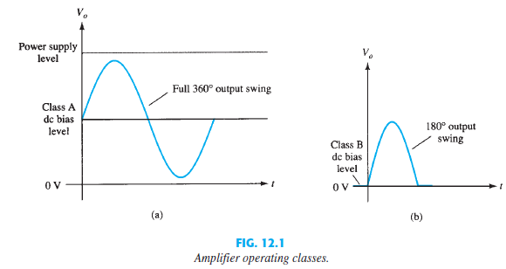

Class AB: A n amplifier may be biased at a dc level above the zero-base-current level of class B and above one-half the supply voltage level of class A; this bias condition is class AB. Class AB operation still requires a push pull connection to achieve a full output cycle, but the dc bias level is usually closer to the zero-base-current level for better power efficiency, as described shortly. For class AB operation, the output signal swing occurs between 180° and 360° and is neither class A nor class B operation.

Class C: The output of a class C amplifier is biased for operation at less than 180° of the cycle and will operate only with a tuned (resonant) circuit, which provides a full cycle of operation for the tuned or resonant frequency. This operating class is therefore used in special areas of tuned circuits, such as radio or communications.
Class D: This operating class is a form of amplifier operation using pulse (digital) signals, which are on for a short interval and off for a longer interval. Using digital techniques makes it possible to obtain a signal that varies over the full cycle (using sample and-hold circuitry) to recreate the output from many
pieces of input signal. The major advantage of class D operation is that the amplifier is “on” (using power) only for short intervals and the overall efficiency can practically be very high, as described next.
Amplifier Efficiency
The power efficiency of an amplifier, defined as the ratio of power output to power input, improves (gets higher) going from class A to class D. In general terms, we see that a class A amplifier, with dc bias at one-half the supply voltage level, uses a good amount of power to maintain bias, even with no input signal applied. This results in very poor efficiency, especially with small input signals, when very little ac power is delivered to the load. In fact, the maximum
efficiency of a class A circuit, occurring for the largest output voltage and current swing, is only 25% with a direct or series-fed load connection and 50% with a transformer connection to the load. Class B operation, with no dc bias power for no input signal, can be shown to provide a maximum efficiency that

reaches 78.5%. Class D operation can achieve power efficiency over 90% and provides the most efficient operation of all the operating classes. Since class AB falls between class A and class B in bias, it also falls between their efficiency ratings between 25% (or 50%) and 78.5%. T able 1 2.1 summarizes the operation of the various amplifier classes. This table provides a relative comparison of the output cycle operation and power efficiency for the various class types. In class B operation, a push pull connection is obtained using either a transformer coupling
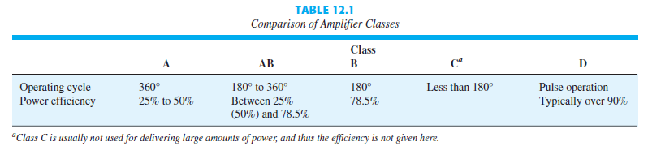
Class C is usually not used for delivering large amounts of power, and thus the
efficiency is not given here. or by using complementary (or quasi-complementary)boperation with npn and pnp transistors to provide operation on opposite-polarity cycles. Although transformer operation can provide opposite-cycle signals, the transformer itself is quite large in many applications. A transformer less circuit using complementary transistors provides the same operation in a much smaller package

