Lecture 5 Dental Equipment Technologies Dr.Muna Merza
Dental Pliers

Dental pliers

It is an instrument used for wire bending and adjustment of the wire (i.e., for construction the clasps in removable partial denture and springs in orthodontic appliances.
The parts of the pliers are the handle & the beak.

Types of pliers:
There are many types of pliers, but the commonly used ones are:
- Universal pliers: these are used for all wire bending with exception of the formation of the loop the beaks are stout, tapered, and rectangular in section or coils.

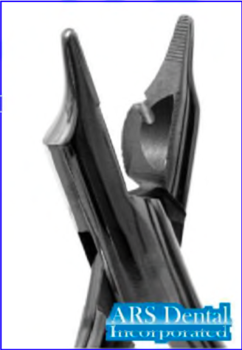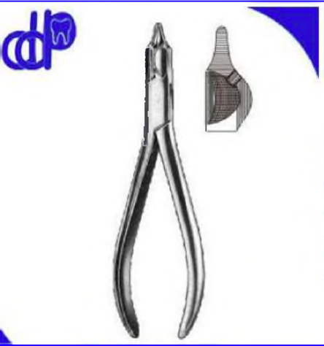

- Loop-forming pliers: these have a round and tapered beak. A round which loops or coil of various sizes may be formed.

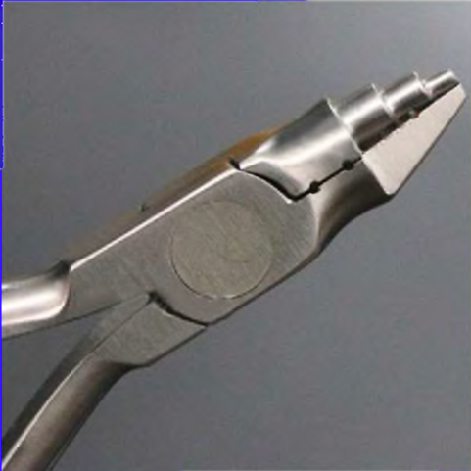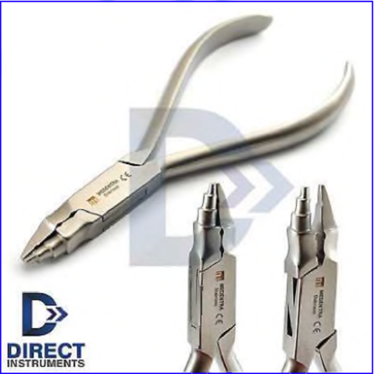

- Hollow - chop pliers: used for making bends in wires, these pliers have one beak round and other hollowed.

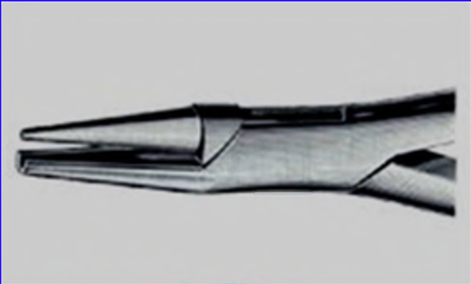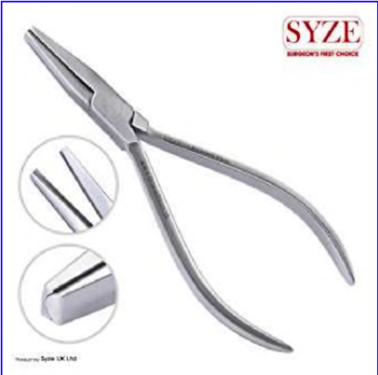

- Three head pliers: have three heads. Used for the construction of zig-zag in shape

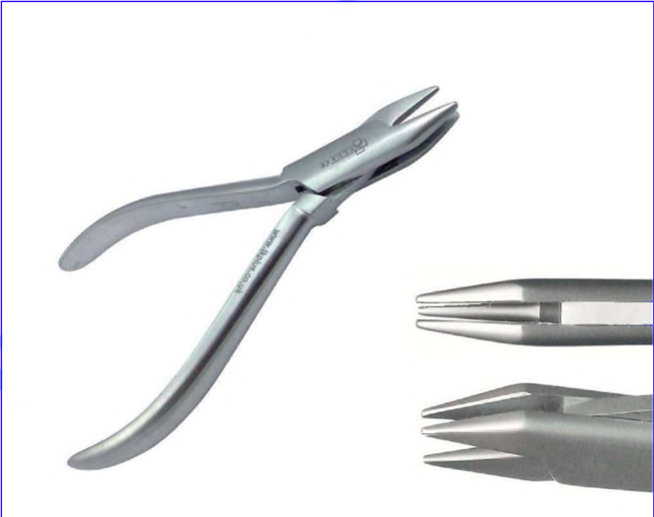

- Adams pliers: these have two straight and triangular beaks, or one straight beak and other rounded beak used for the construction of Adams clasp in the orthodontic, and have two types:

- Square-ended pliers, used in the bending of orthodontic stainless-steel wire.

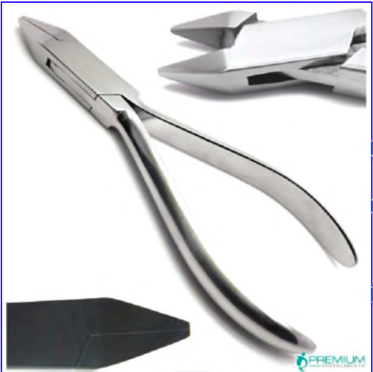

- Square- and round-ended pliers, used in the forming of springs and curves in orthodontic wires.

