Grammar: Present Simple (Intermediate: Unit 2)
Vocabulary: Common Activities (Intermediate: Unit 2)
Reading: "Get Happy!" (Intermediate: Unit 2)
Unit 2
2.1 Grammar Spot
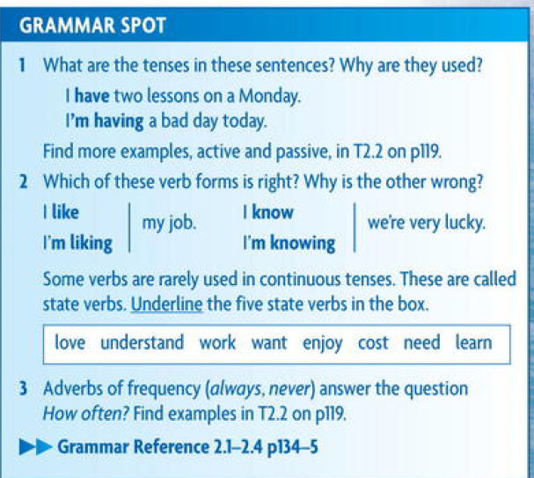
2.1.1.Present Simple :
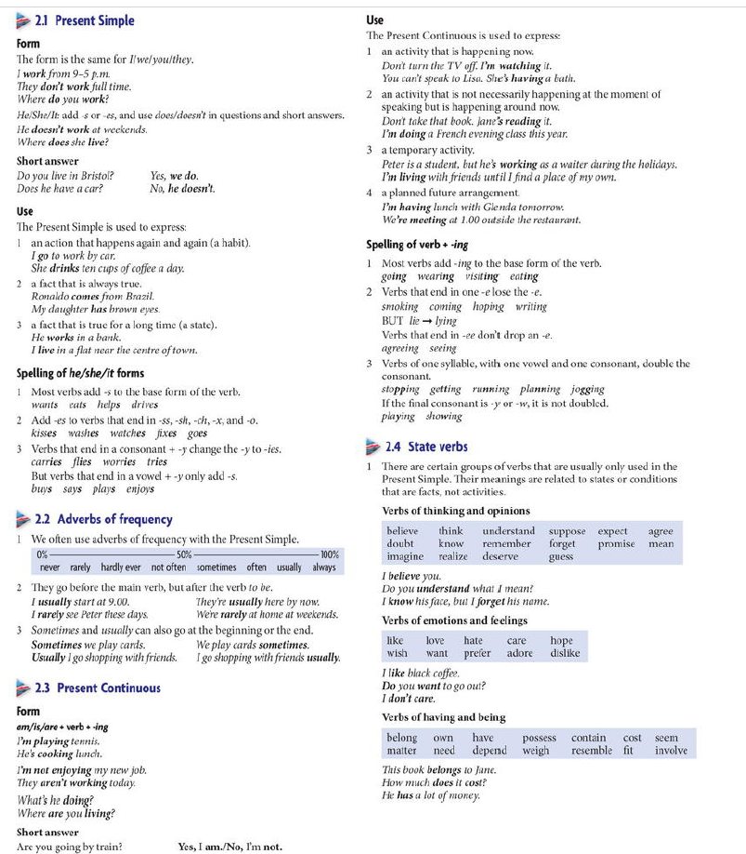

2.1..2
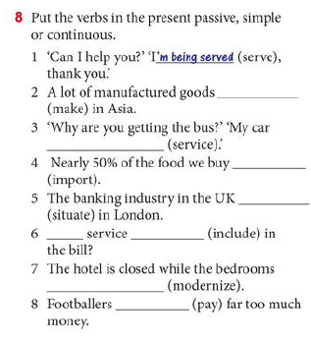
2.3 Reading , making Questions and Answers
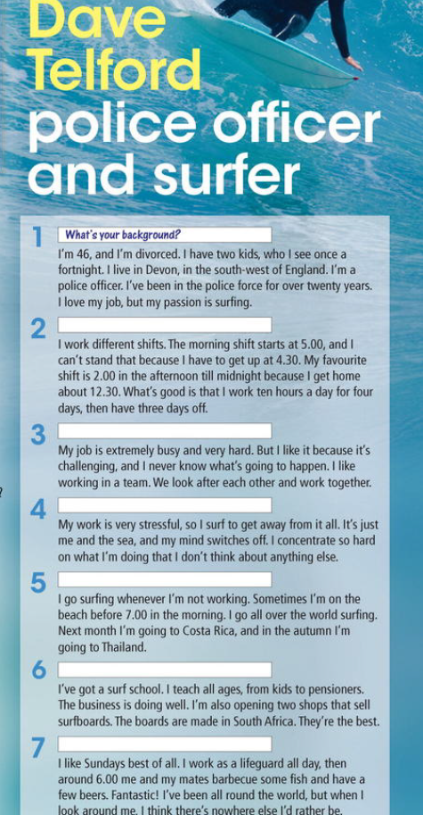

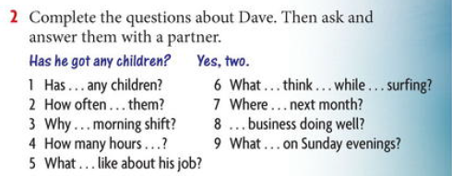
Answers :
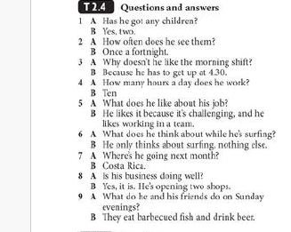
2.4 In the Office

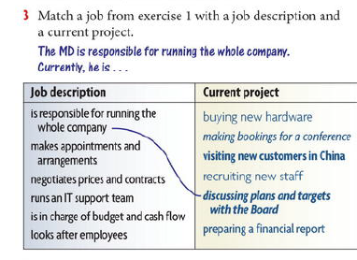
Answers
Is responsible for running the whole company | Discussing plans and targets with the boards
Makes appointments and arrangements | Making booking for conference
Negotiating the prices and contracts | Visiting new customers in China
Runs an IT support team | Buying new hardware
Is in charge of budget and cash flow | Preparing financial report
looks after employees | Recruiting new staff

2.5 Reading and Speaking
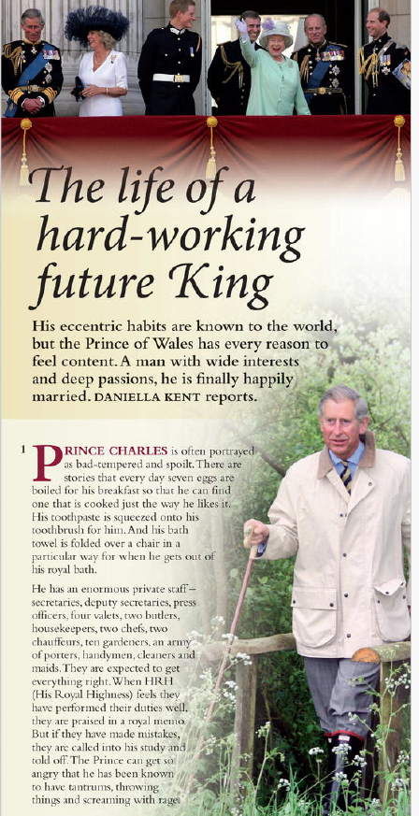
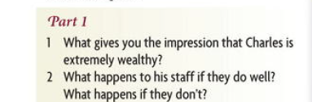
Answers :
1. He has a enormous private staff – secretaries , deputy secretaries, two chefs , two chauffeurs , ten gardeners, cleaners and maids.
2.
- If his staff doing well they will praised in the royal memo.
- If his staff have making mistakes , they will called into his study and told off . the prince can get so angry , have tantrum s and throwing things and screaming.
-

2.6.1. activities
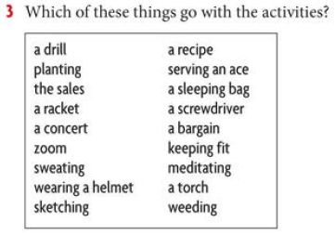
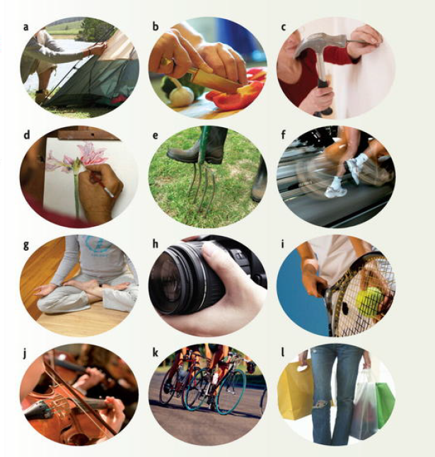

Answers
A drill – c
Planting – e
a Racket – i
a concert – j
zoom – h
sketching – d
the sales - l
meditating – g
a sleeping bag – a
weeding – b
Sweating – f
keeping fit - k
2.6.2. Cooking
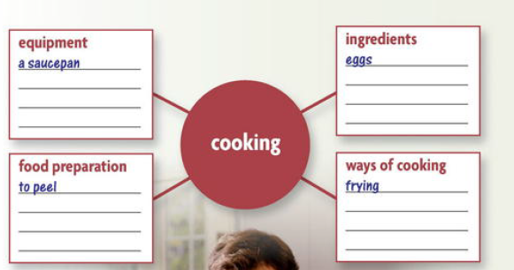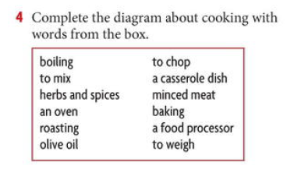
Answers :
Equipment
A saucepan
An oven
A casserole dish
A food processer
Food preparation
To peel
To mix
To chop
To weigh
Ingredients
Eggs
Minced meat
Olive oil
Ways of cooking
frying
Boiling
Baking
roasting

2.7 . Every day English
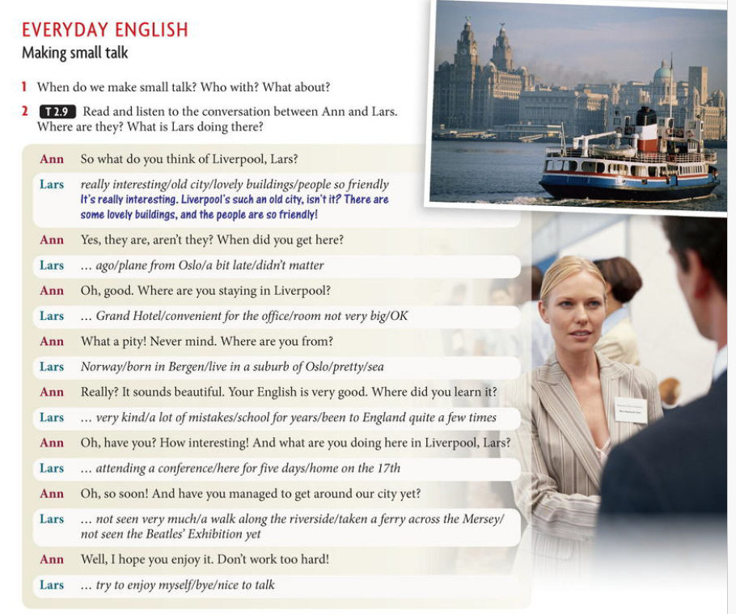
Answers :
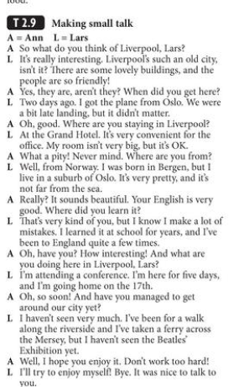
2.8: Writing( Letters and E- mail )
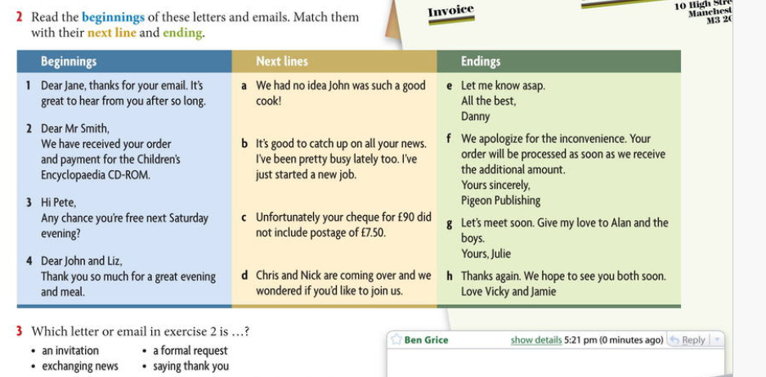
Answers:
1-d- g
2- c- f
3- b- e
4- a- h

2.9. Homework – Electric Motors -
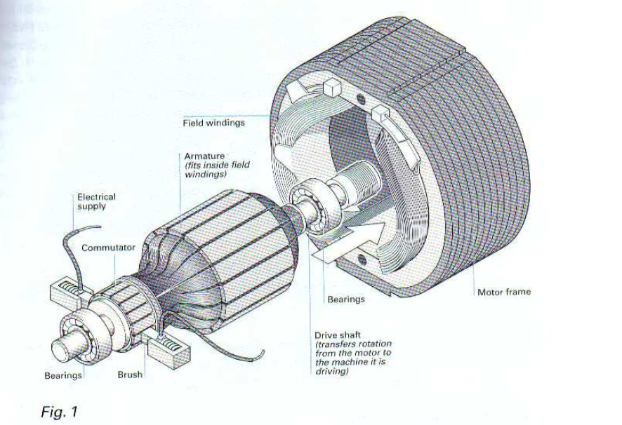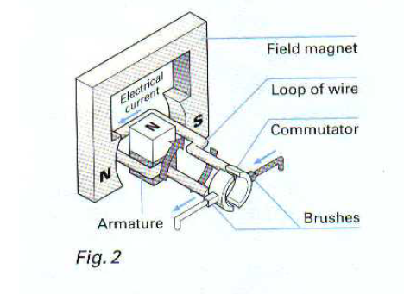
Match the paragraph below

