Grammar: Auxiliary Verbs (Intermediate: Unit 1) , Vocabulary: Everyday Expressions (Intermediate: Unit 1) . Reading: "It's a Wonderful World!" (Intermediate: Unit 1)
Writing: Basic sentences using auxiliary verbs (Intermediate: Unit 1)
Unit 1
1.1- Starter
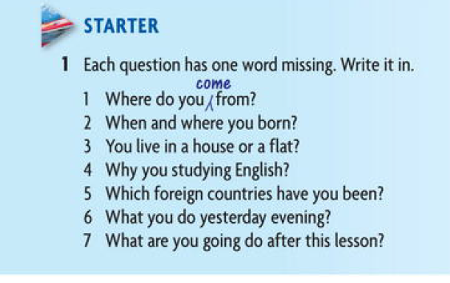
Answers :
1. Where do you come from?
2. When and where you are born?
3. Do you live in a house or a flat?
4. Why you are studying English ?
5. Which foreign countries have you been visited?
6. What do you do yesterday evening?
7. What are you going to do after this lesson?
1.2- Grammar Spot
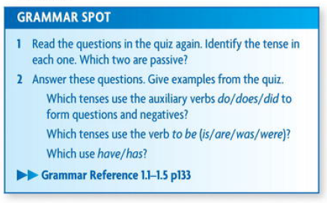
1.2.1 Auxiliary Verbs
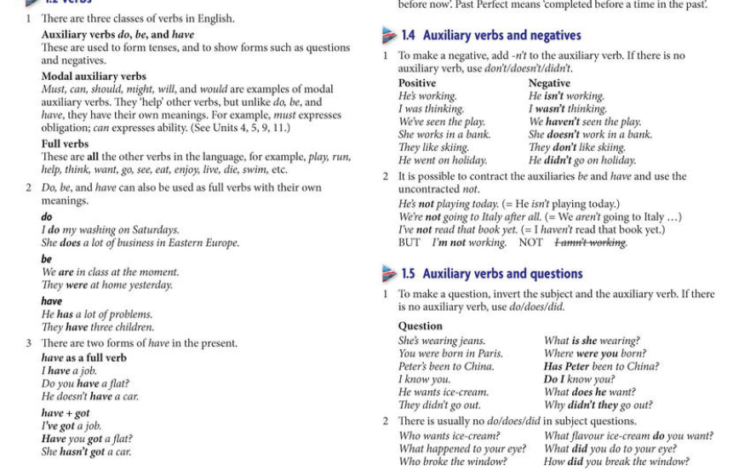

1.2.2 Our World
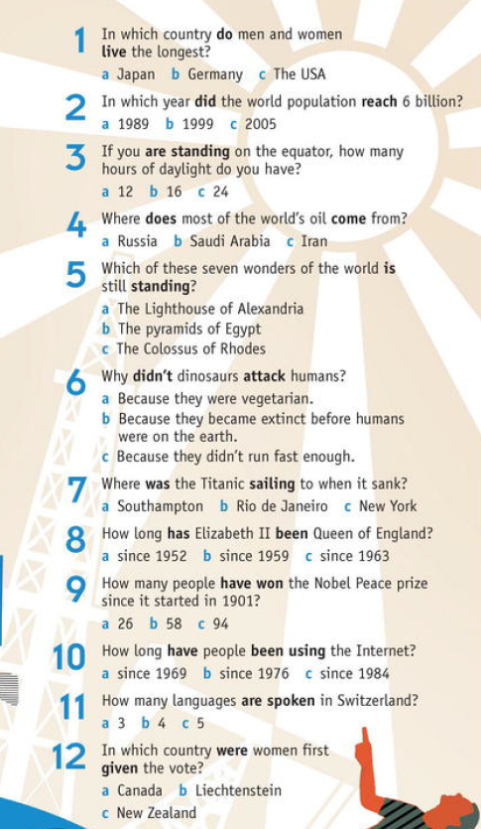
Answers :
1. A 2. B 3. a 4. B
5. B 6. B 7. C 8. a
9. C 10. a 11.b 12. c

1.3 Writing
- Read the following letter and correct the mistakes with the help of below symbols
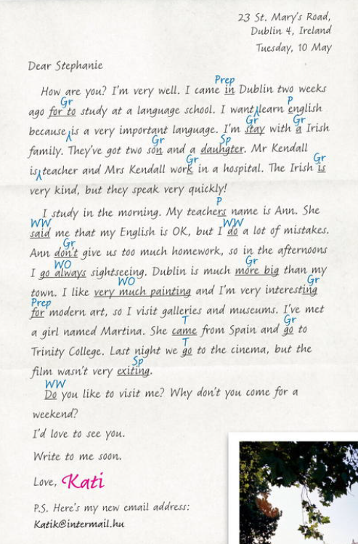

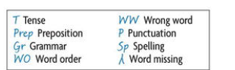

1.4 Reading and Speaking


1.5 Vocabulary
Match from below tables texts the words that meet the meaning in above high- lighted words ?
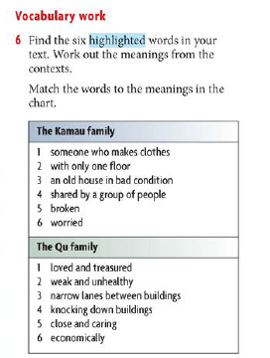
1.6. Every day English
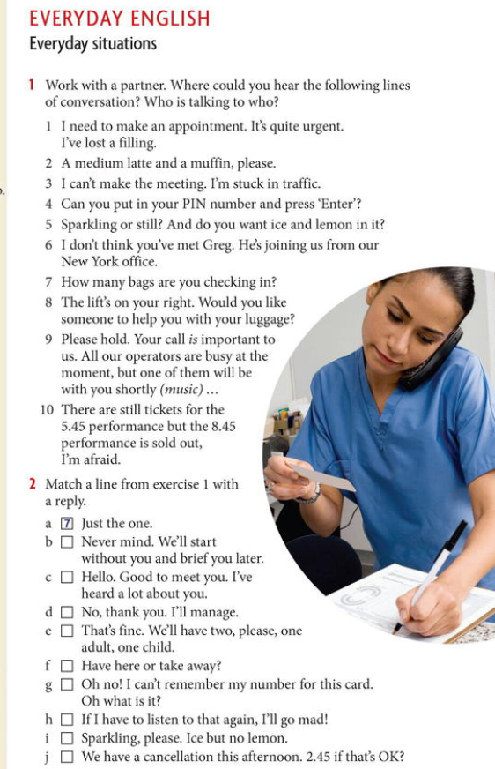 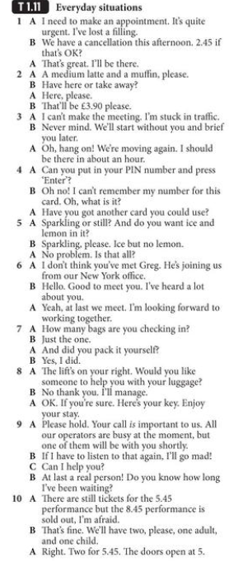

Answers :
a-7 b- 3 c- 6 d- 8
e- 10 f- 2 g- 4 h-9
i- 5 j- 1

1.7 Homework no.1
1.7.1 Word formation
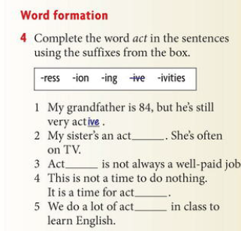
1.7.2 Words that go together
