Biology Foransic avidance
First class Prof. Dr. Dina M.R.Alkhafaf

Biosafety and Risk group
Biosafety barriers in labs
1-Primary barriers
-Physical barriers or personal protictive equipment for lab workers including gloves, masks, lab coat and respirators.
-Safety equipmentincluding biological safety cabinets (BSCs), enclosed cantainers. The BSC is principal equipment used to provide containment of infectious splashes or aerosols generated microbiological procedures.
2-Secondary barriers
Including structural entities of the lab that making the work environment safer against infection such as sinks for hand washing , special air ventiations and sterilization equipment , separation of the laboratory work area from administrative areas and public access , decontamination facilities (ex: autoclaves).

The World Health Organization (WHO) Risk group classification
Classification of infective microorganisms by risk group:
-Risk Group 1 (RG1): ( Low individual and low community risk) : These microorganisms are unlikely to cause disease ex: Escherichia coli.
-Risk Group 2 (RG2): (moderate individual risk, low community risk): a pathogen that can cause human or animal disease but is unlikely to be a serious hazard to laboratory workers , the community , livestock or the environment.
-Risk Group 3 (RG3): (High individual risk , low or moderate community risk): a pathogen that usually causes serious human or animal disease but does not ordinarily spread from one infected individual to another (ex: Mycobacterium tuberculosis)
-Risk Group 4(RG4): (High individual and community risk): a pathogen that usually causes serious human or animal disease and that can be readily transmitted from one individual to another, directly or indirectly (ex: Ebola virus).

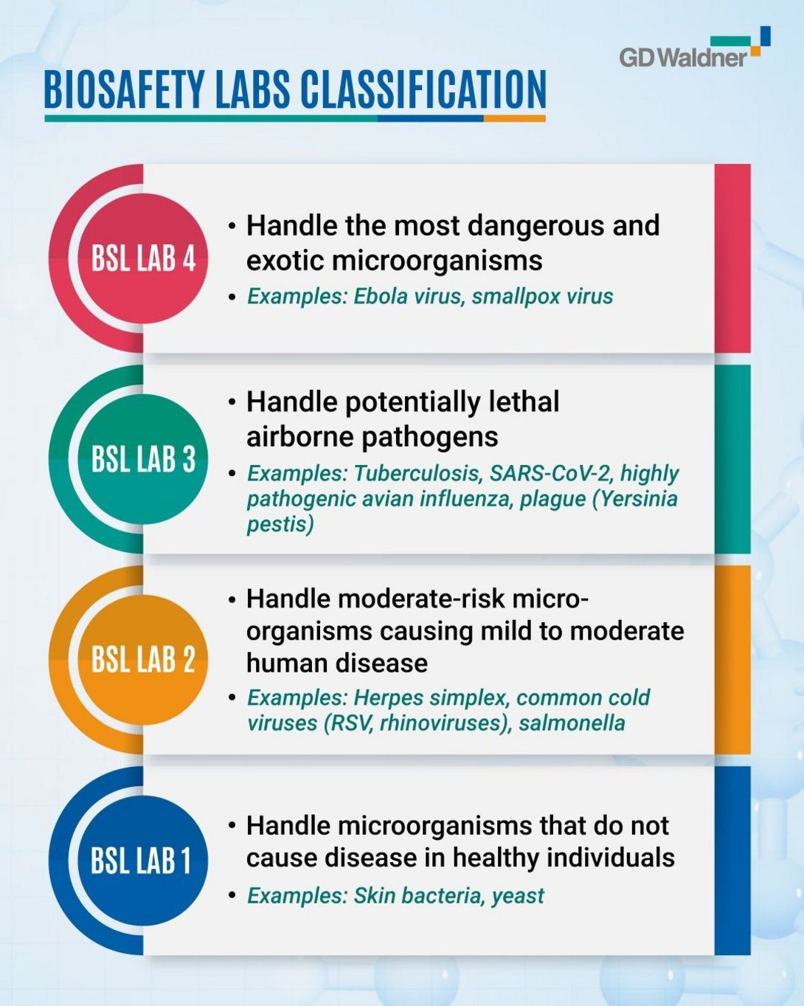

Biosafety levels
Biosafety is the application of safety precautions that reduce the risk of exposure in the laboratory to a potentially infections microbe and limit contamination of the work environment.
There are four biosafety levels designated by the center for disease control (CDC) that include BSL-1, BSL-2, BSL-3 and BSL-4. As figuer above.

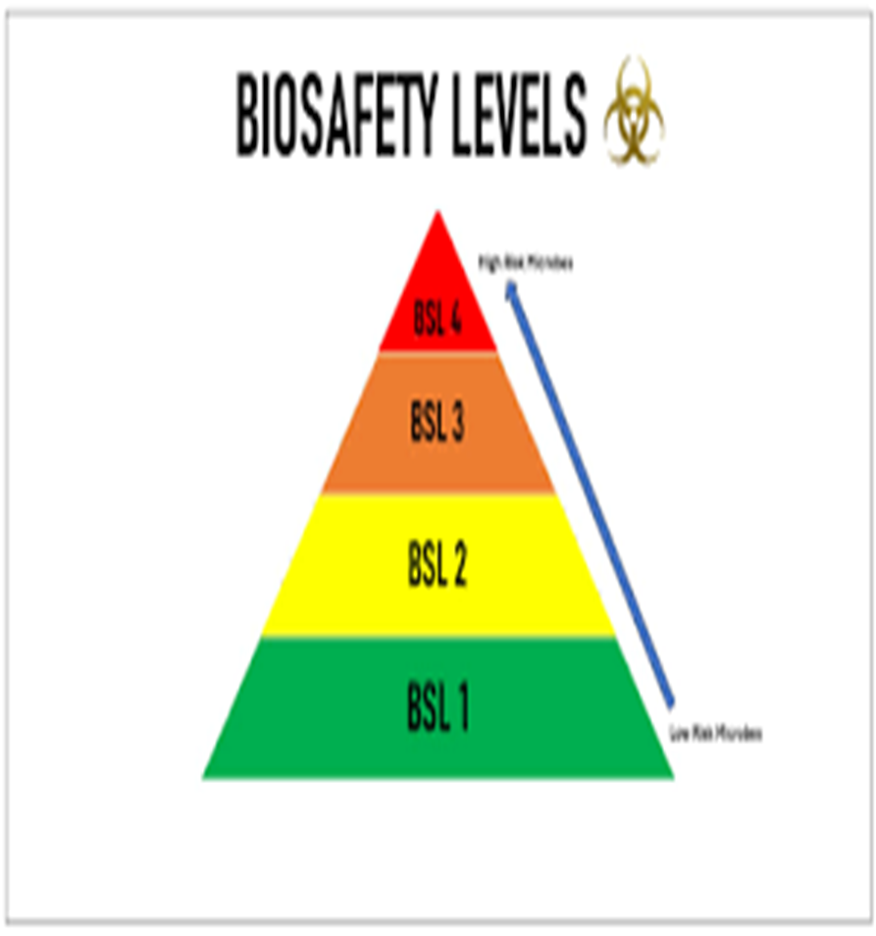

Important Definitions
A hazard is any source of potential damage , harm or adverse health effects on something or someone. These source includes : microorganisms , toxins and allergens derived from these organisms.
Also allargens and toxins derived from insects , animals and plants are considered as hazards.
Risk is the chance or probability that a person will be harmed or experience an adverse health effect if exposed to a hazard. It may also apply harmful effects on the environment.
For example: the risk of developing cancer from smoking cigarettes could be expressed as cigarette smokers are 12 times more likely to die of lung cancer than non-smokers.

Biohazard materials
-Viruses -Bacteria
-Fungi -Chlamydiae/Rickettsiae
-Prions -Recombinant DNA
-Trangenic plant and animals
-Brain tissue from demented (mad) patients
-Animals that are potential reservoirs of zoonotic diseases
-Viral vectors.
Threat: situation or activity that could cause harm
Biosecurity: Are measures that are taken to stop the spread or introduction of harmful organisms. These measures are put by bioscience laboratories to prevent the use of dangerous pathogens and toxins.
Biosafety: Are the containment principles, technologies and practice that are implemented to prevent unintenional exposure to hazards .
Whereas biosafety aims at protecting public health and environment from accidental exposure to biological agents , biosecurity deals with the prevent the prevrntation of misuse through loss , theft , diversion or intentional release of pathogens , toxins and any other biological materials.
Decontamination (Sterilization): Reduction of viable biological agents or other hazadous materials on a surface or object(s) to a predefined level by chemical and/or physical means.
Bioethics:The study of the ethical and moral implications of biological discoveries, biomedical advances, and their applications as in the fields of genetic engineering and drug research.
Bioterrorism: The use of biological agent for terrorist purposes

Key Elements of Effective Management System
The concept of improvmenet through a cycle of planning, implementing, reviewing and improving process to achieves the goals.
This is often referred to as the " Plan – Do – Check – Act" principle.
Plan: includes identification of hazards and risks as well as establishment of goals.
Do: includes train ing and operational issues.
Check: measure/ monitor performance against the goals.
Act: on the bases of review to make necessary changes.

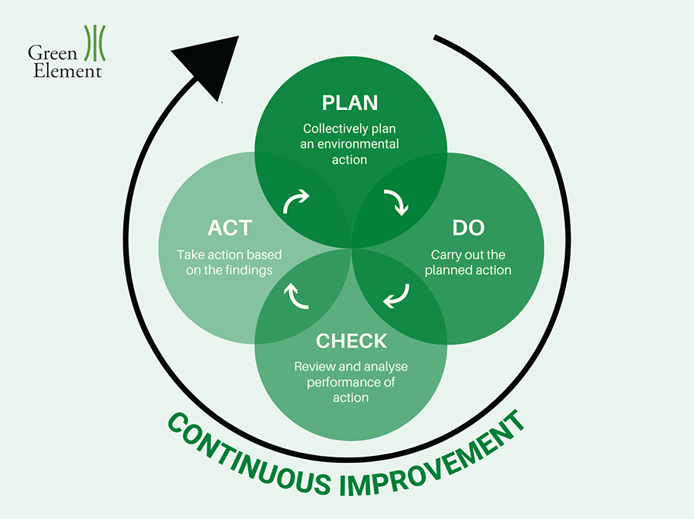

Universal Safety Precautions
1- Consider all the specimens collected from blood- borne infection as potentially infectious.
2-All specimens should be placed in a leak – proof container for transport.
3-Use glove while handing all specimens, especially when there is a contact with the body such as blood and cerbrospinal fluid.
4-Use a face mask with glasses and lab coat.
Cover cuts or abrasions occurring over skin with water proof bandage.
5-Decontaminate the labortory work surface immediately in case of spillage of blood or any other body fluids.
6-All sharps should be collected and disposed away properly.
7- Never pipette by mouth, use mechanical pipetting device.
8- There should always be a system working efficiently for management of hospital generated waste.
9-It is advisable for the laboratory personnel to be vaccinated against hepatitis B and C.
10-Not permitted in laboratories : eating, drinking, storing food, smoking, handling contact lenses.

