Outline
- Arm
  - Anterior Compartment
  - Posterior Compartment
- Cubital Fossa
- Brachial Art.
- Periarticular Arterial Anastomoses of the Elbow Region
- Veins of Arm
- Clinical Correlation

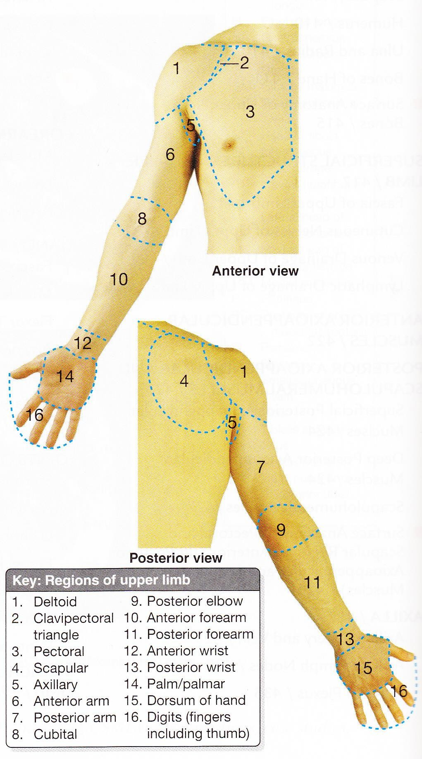
Arm
- Upper limb (UL) consists of 4 segments:
Deltoid 1
region 3 Pectoral
region

Anterior view
Scapular
4 1 region

Posterior view
6
- Shoulder
- Arm
- Forearm
- Hand

Arm
7
  - 1st segment of UL.
  - Extends from shoulder to elbow.
  - Consists of:
- Anterior region of arm (6)
- Posterior region of arm (7)

Anatomical neck
Humerus

Greater tubercle
Intertubercular
groove
Head Lesser
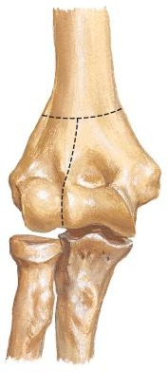
tubercle
Surgical
neck

Radial
fossa Coronoid
fossa

Deltoid
tuberosity

Lateral supra- condylar ridge
Capitulum

Head of radius
Anterior
View
Medial supra- condylar ridge

Trochlea


Coronoid process
Right elbow

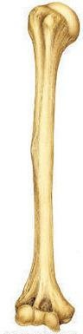
Lateral epicondyle
Medial epicondyle

Head
Greater
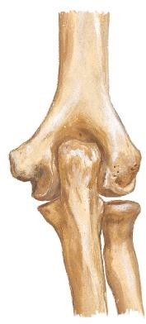
tubercle
Medial
epicondyle
Olecranon
fossa
Olecranon
Humerus

Anatomical
neck
Surgical neck

Radial groove

Deltoid tuberosity
Posterior View

Olecranon
fossa

Trochlea
Right elbow

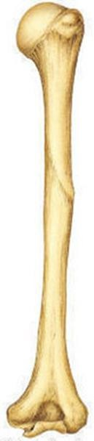

Olecranon Trochlear notch
Ulna
Coronoid process

Ulnar tuberosity

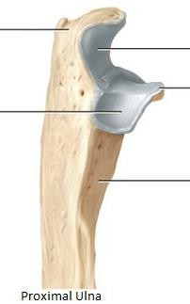
Olecranon Trochlear notch
Anterior View of Ulna
Coronoid

Radial
notch
process

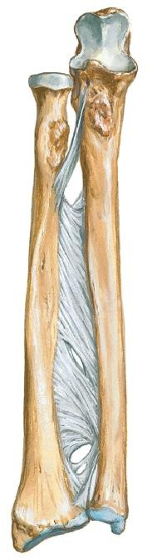

Lateral View of proximal ulna
Head of ulna Styloid process

Anterior View of Radius
Radius

Head
Neck Radial
tuberosity

Inferior View of Distal
End of Radius & Ulna

Ulnar notch
Ulna
Radius

Interosseous
border

Interosseous membrane

For scaphoid

For lunate

Styloid process

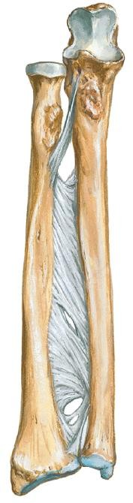
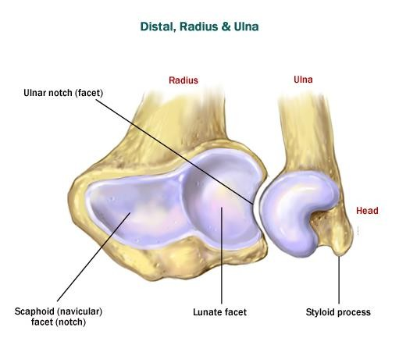
Styloid process

Arm

- Muscles in arm & forearm can be grouped into compartments
- Muscles in same compartment have similar:
- Function
- Innervation (with some exceptions)
  - Muscles in arm divided into 2 compartments by humerus & medial & lateral intermuscular septae:
- Anterior (flexor)
- Posterior (extensor)

Anterior compartment

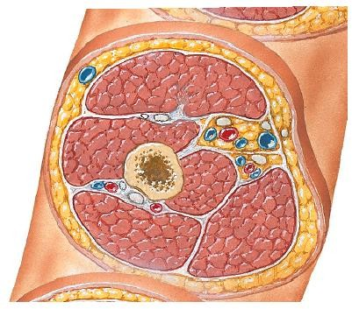
Lat. IM septum
Posterior
compartment

Medial IM septum


Middle Cross-section of Arm

Anterior Compartment of Arm

3 muscles:
- Biceps brachii
- Coracobrachialis
- Brachialis

Action:
    - Flexion of forearm at elbow joint

Innervation:

Brachialis

Coraco-
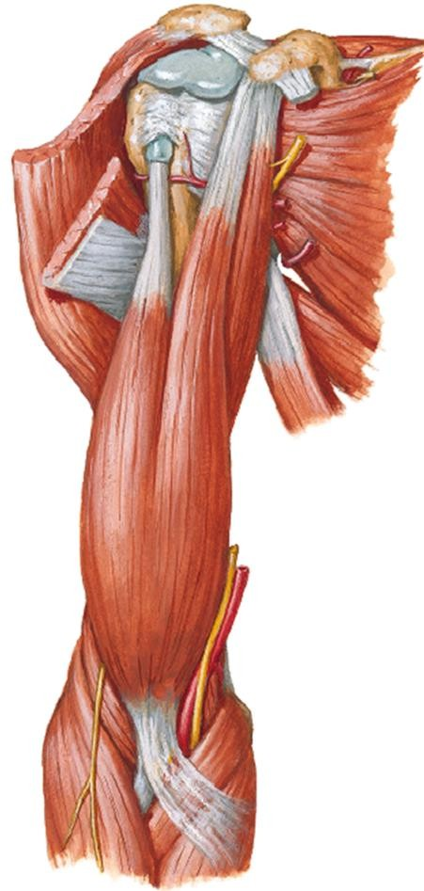
brachialis

Biceps brachii

    - Musculocutaneous nerve
Anterior View

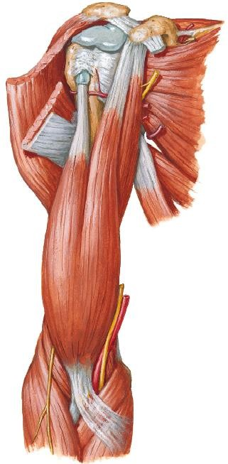

1) Biceps Brachii

Long
 | Short head | Long head
PA | Coracoid process (scapula) | Supraglenoid tubercle (scapula)
DA | - Radial tuberosity (via  biceps tendon)  - Fascia of forearm (via  bicipital aponeurosis)
Act- ion | - Supinates forearm (elbow flexed 90˚, forearm pronated- drive screw)  - Flexes forearm

head

Biceps tendon
Coracoid process

Biceps brachii
Anterior View

Bicipital
aponeurosis

1) Biceps Brachii

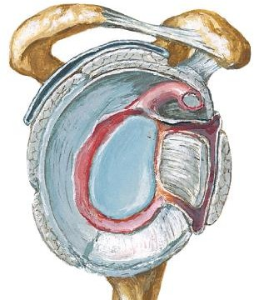
Tendon of Long Head

Cavity of gleno- humeral joint
Enter cavity of glenohumeral joint (GHj) & surrounded by synovial membrane
Supraglenoid tubercle (scapula)
Tendon of long head of biceps

Lateral view
Transverse humeral ligament

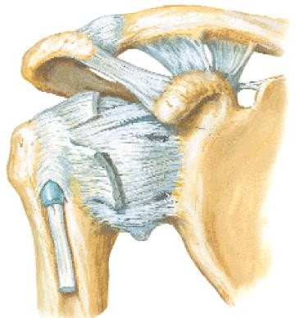
Tendon of long head of biceps
Anterior
View
Descend in intertubercular groove of humerus (held by transverse humeral ligament) & exit GHj
Cross head of humerus

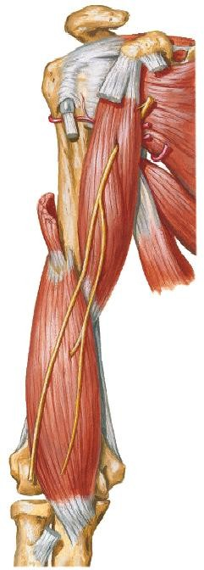
2) Brachialis
  - Location – Deep to biceps brachii

Humerus
PA | Distal ½ of ant. Surface of humerus
DA | Coronoid process & ulnar tuberosity (ulna)
Action | Flexes forearm.  Most powerful  flexor

Brachialis
Anterior View

3) Coracobrachialis
  - Location – superomedial part of arm
  - Pierced by musculocutaneous n.
Coracoid process

Musculo-
PA | Coracoid process (scapula)
DA | Middle of medial humerus
Action | Flex & adduct arm (at shoulder jt)

cutaneous n.

Coraco-
brachialis

Anterior View

Anterior Compartment of Arm

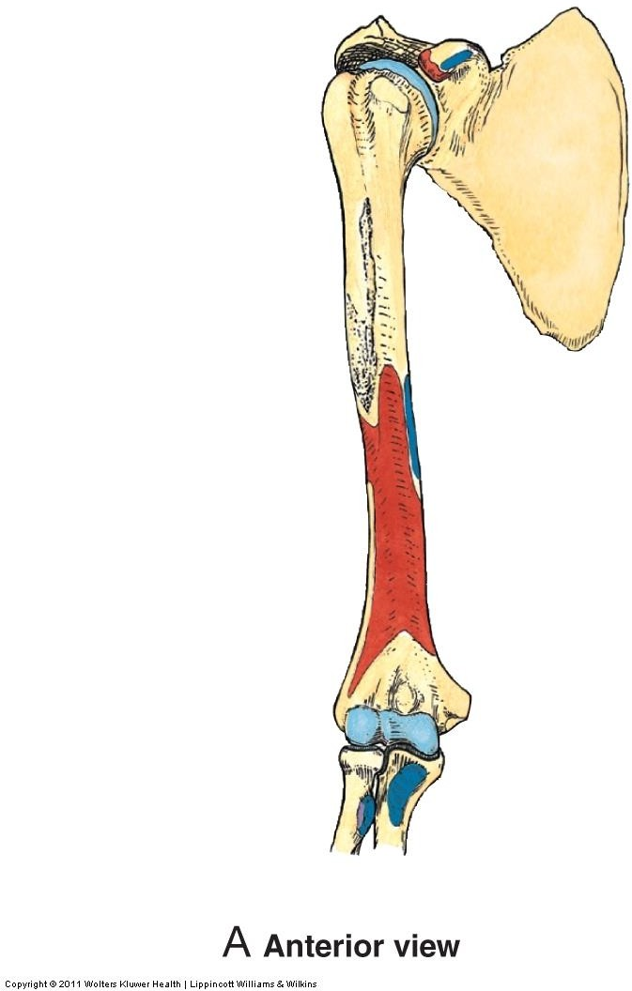
Coraco- brachialis

Brachialis
Anterior View

Posterior Compartment of Arm

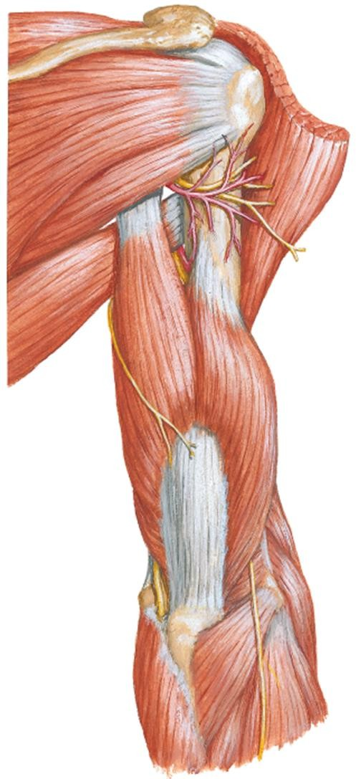
2 muscles:
- Triceps brachii
- Anconeus

Action:
    - Extension of forearm at elbow joint

Innervation:
    - Radial nerve

Anconeus

Triceps brachii

Posterior View

1) Triceps Brachii

Long
 | Long head | Lateral head | Medial head
PA | Infra- glenoid tubercle (scapula) | Sup. To radial groove on post. surface humerus | Inf. To radial groove on post. surface humerus
DA | Olecranon (ulna)
Act-  ion | Extend forearm

head

Olecranon
Lateral
head

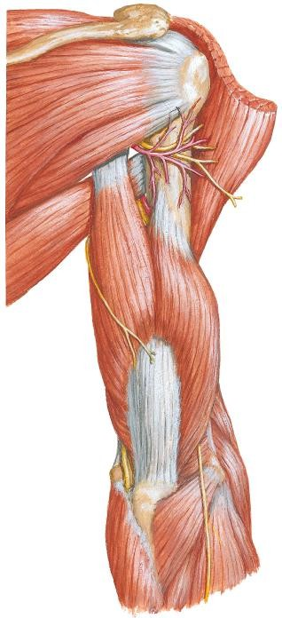
Posterior View

1) Triceps Brachii

  - Medial head is deep to long & lateral head

Long head Radial nerve
Lateral head

Medial head

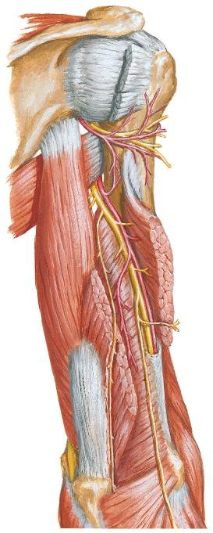

Posterior
View

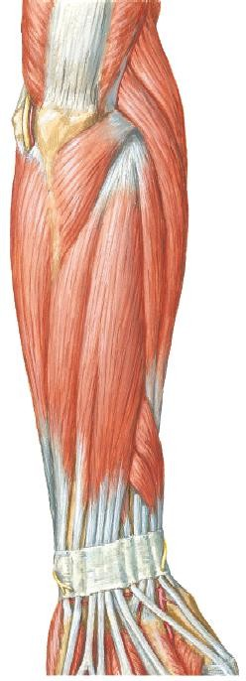
Postero- lateral View
2) Anconeus
  - Small triangular muscle
  - Location – posterolateral aspect of
elbow
Anconeus

PA | Lateral epicondyle (humerus)
DA | Superior part of post. surface of ulna
Action | - Assist triceps in extending forearm  - Stabilize elbow joint

Cubital Fossa

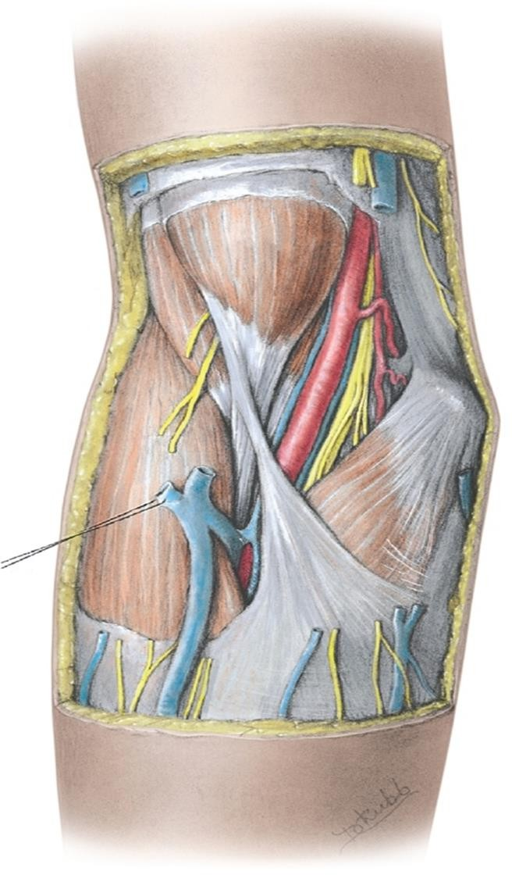
Anterior
View
Cubital Fossa
- Space filled with fat

Location:
  - Anterior to distal part of humerus & elbow joint
- Shape - ∆
- 3 boundaries:
- Superior boundary
- Medial boundary
- Lateral boundary

- Floor
- Roof

Cubital Fossa

Superior Boundary
  - An imaginary line connecting medial & lateral epicondyles (humerus)

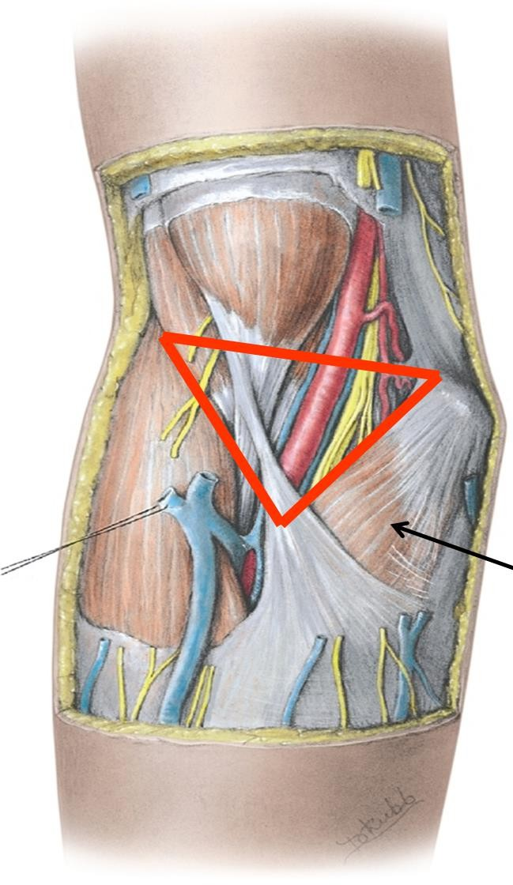
Medial
epi-
S condyle

Medial Boundary
  - Pronator teres

Lateral Boundary
  - Brachioradialis
L
Brachio-
radialis

M

Pronator teres

Anterior View

Cubital Fossa

​Floor

- Brachialis

- Supinator

Brachialis

Biceps
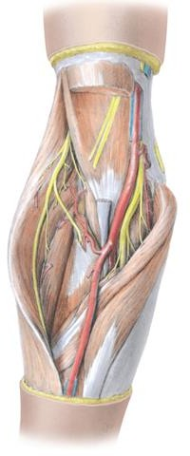
brachii

Supinator

Anterior View

Cubital Fossa

Roof

- Brachial, antebrachial fascia & bicipital aponeurosis

Subcutaneous tissue
  - Median cubital vein
  - Medial & lateral cutaneous nerves of forearm

Skin
Skin

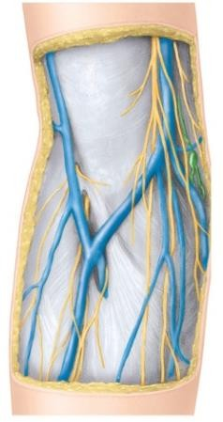
Brachial fascia

Lat.
Cutaneous
n. forearm

Ante- brachial fascia
Anterior View
Sub- cutaneous tissue
Medial
Cutaneous
n. forearm

Median cubital v

Bicipital apo- neurosis

Cubital Fossa

Contents (from lateral to medial)
- Radial n.
  - Beneath brachioradialis
  - Divides into superficial &
deep br.

Tendon of biceps brachii
- Brachial art. (& accompanying veins)
  - Terminal part of brachial art. & commencement of its terminal branches

Median n.

Radial n.
Deep br. Super-
ficial br.

Median
n.

Brachial
a.
Ulnar a. Radial a.

Anterior View

Brachial Artery

Brachial Artery

- Main arterial supply to arm

- Continuation of axillary art.

- Begins at inferior border of

teres major

- From medial side of upper part of arm, it runs inferolaterally in the medial bicipital groove to the cubital fossa

- Accompanies median n. In
the middle of the arm, median
n. crosses brachial art., from lateral to medial side

Median n.

Teres major

Brachial a.

Median n. crosses brachial a.
Anterior View

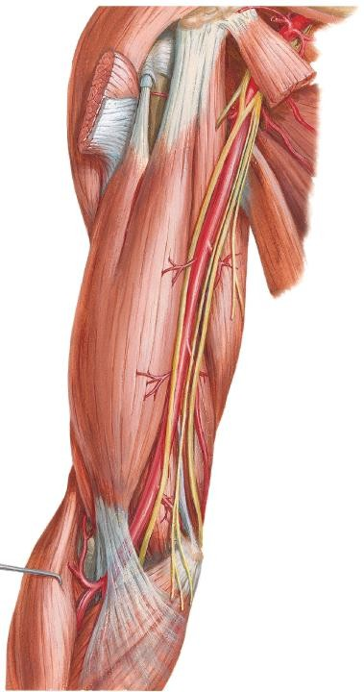

Brachial Artery

Relations in the Upper ARM:

- Laterally
  - Biceps & median n.

Medially
  - Upper part of arm - medial cutaneous nerve of arm & ulnar n.
  - Lower part of arm – median nerve

Posteriorly
  - triceps, radial n.
Coraco- brachialis

Biceps

Brachial a.

Ulnar n.

Triceps

Brachialis
Anterior
View

Brachial Artery

Relations in the Cubital Fossa:
- Laterally
  - tendon of biceps

Medially
  - Median n.

Posteriorly
  - Brachialis

Anteriorly
  - Bicipital aponeurosis
  - Median cubital vein
  - Fascia & skin

Coraco- brachialis

Biceps

Brachial a.

Ulnar n.

Triceps

Brachialis
Anterior
View

Brachial Artery
- In the cubital fossa, it is covered by bicipital aponeurosis & median cubital vein (anterior relations)

- Ends by dividing into radial & ulnar arteries in cubital fossa

Main branches:
- Deep artery of the arm
- Humeral nutrient a.
- Superior & inferior ulnar collateral arteries

Anterior View

Radial a.

Deep a. of arm
Sup. ulnar
collat. a.

- terminal branches - ulnar & radial art
Bicipital
aponeurosis

Brachial Artery

Deep art. of arm
  - Profunda brachii art.
  - The first & largest branch
  - Accompanies radial nerve
  - Passes posteriorly through lower triangular space – descends along radial groove of humerus
  - Terminates by dividing into middle & radial collateral art.s (participate in the periarticular arterial anastomoses of the elbow region)

Radial n.
Middle collat. a.

Posterior View

Deep a. of arm

Radial collat. a.

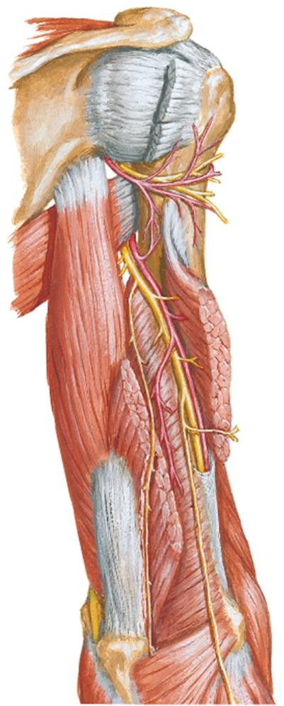

Periarticular Arterial Anastomoses
of the Elbow Region

  - Anastomoses around the elbow
joint exists between br.s of brachial
a. & br.s of radial & ulnar a.s:

Branches of brachial a.:
  - Middle & radial collateral a.s (br.s of deep artery of arm)
  - Superior & inferior ulnar collateral a.s (br.s of brachial a.)

Branches of radial & ulnar a.s. Recurrent br.s from the:
  - Radial art – radial recurrent a.

Middle
collat. a.
Radial
collat. a.

Sup. ulnar collat. a.
Inf. ulnar collat. a.

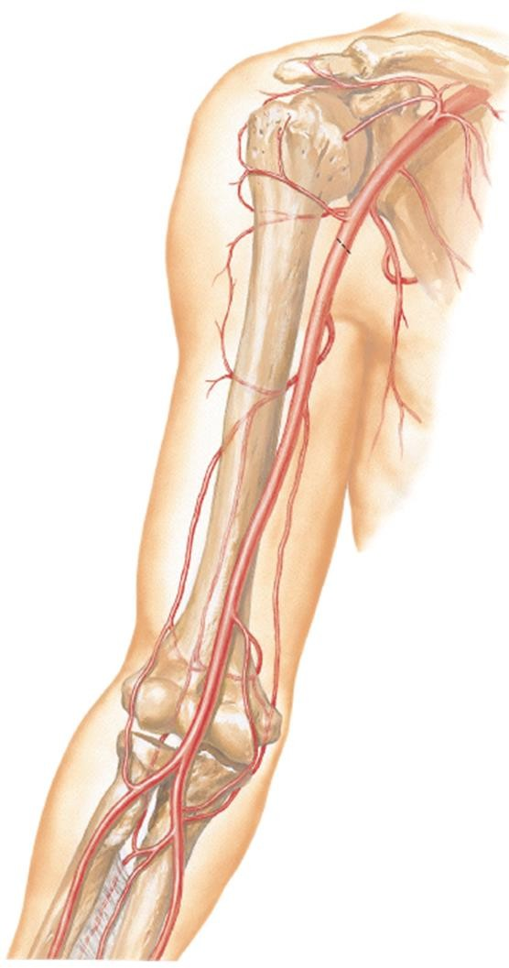

  - Ulnar art – ant. & post. ulnar recurrent art.s & recurrent interosseous a.
Radial a.
Anterior View

Veins of Arm

Veins of Arm

- 2 sets of veins of the arms:

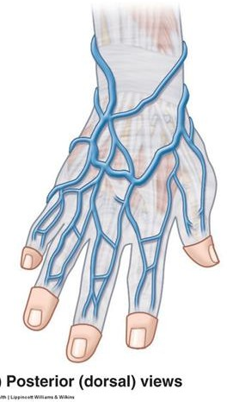
Superficial Veins (SVs)
  - In subcutaneous tissue
  - 2 main SVs – cephalic & basilic v.s
  - Originate from dorsal venous network (DVN) on the dorsum of hand

Deep veins (DVs)
  - Paired. Accompany arteries as venae
comitantes & having similar names
- SVs & DVs anastomose freely with each
other via perforating veins
- Have valves

Dorsal Venous Network

Superficial Veins of Upper Limb

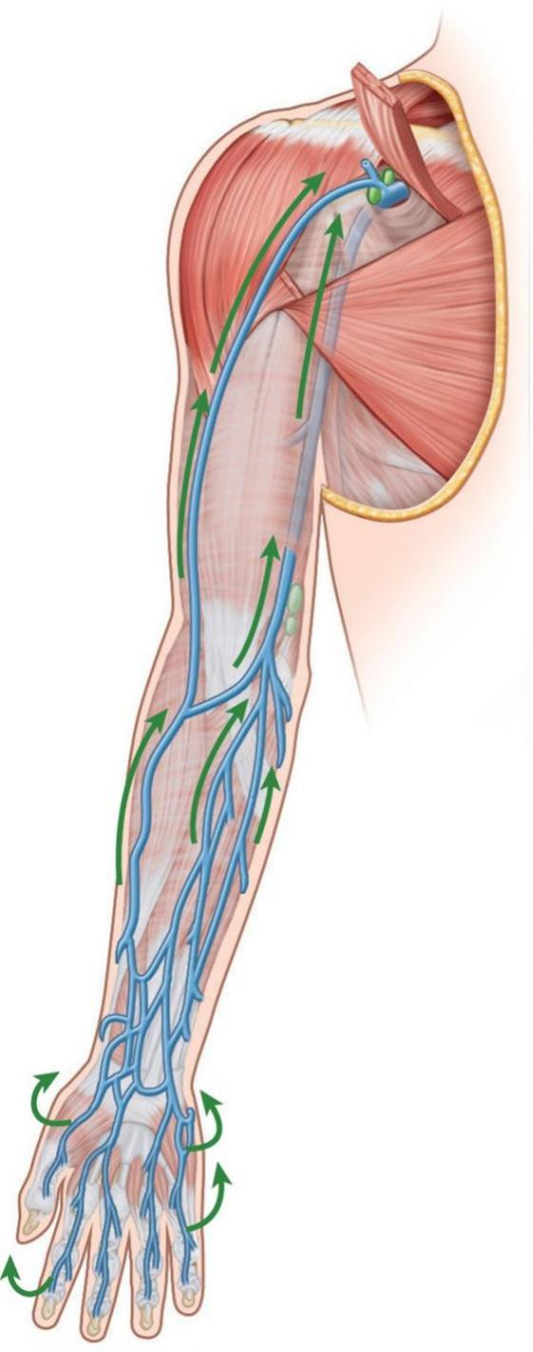
Cephalic vein
From lateral end of DVN
Ascends along lateral border
of wrist

Cephalic v.
Anterolateral surface of
forearm & arm

Ascend between deltoid &
pectoralis major (in
deltopectoral groove)
Enters clavipectoral triangle
Join axillary vein
Palmar View

Superficial Veins of Upper Limb – Cephalic Vein

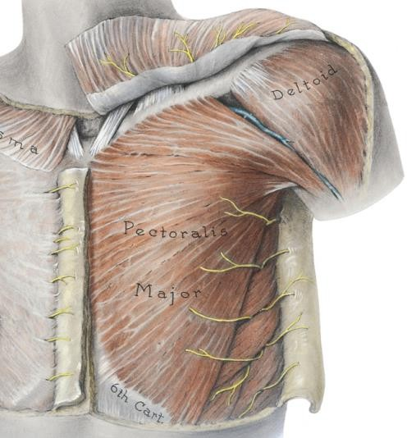
- Between pectoralis major & deltoid is deltopectoral groove.

- Superiorly, groove widens into triangular-shaped space - deltopectoral (clavipectoral) triangle. Cephalic vein enters it & pierces fascia beneath it.
Deltopectoral triangle
Deltoid

Cephalic v.

Delto- pectoral groove

Pectoralis major
Anterior view

Superficial Veins of Upper Limb
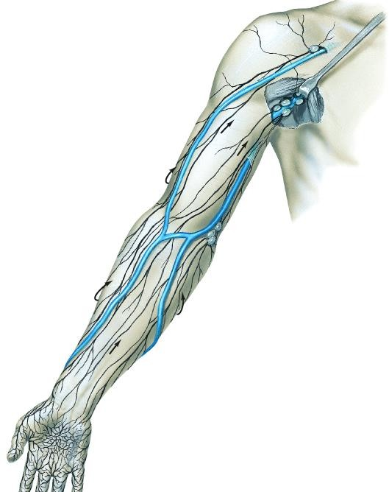

Basilic vein
Basilic v.
Median cubital v. passes obliquely across cubital fossa, joining the cephalic & basilic v.s
Palmar View
From medial end of DVN
Ascends along medial side of
forearm & arm
Pierce brachial fascia at lower part of arm
Ascend towards axilla
Merges with brachial v. to form
axillary v.

Clinical Correlation
Supracondylar Fractures of the Humerus

Supracondylar Humerus Fracture
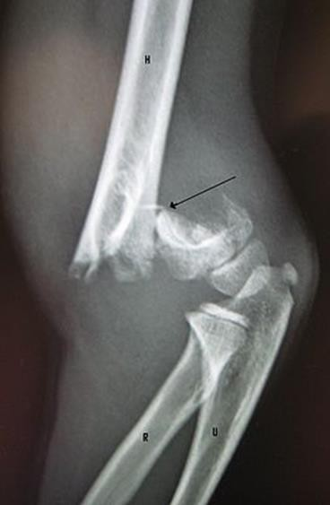
- Most common type of elbow injury in children (more common in children because thinner cortex in children)

- Occurs more frequent in children after a fall on an outstretched hand

- The most common complication associated with displaced supracondylar fractures is neuropraxia

- The median nerve, specifically the anterior interosseous nerve (52%) and radial nerve (32%) are most frequently injured - due to stretching or compression of the nerve

Supracondylar Fractures of the Humerus
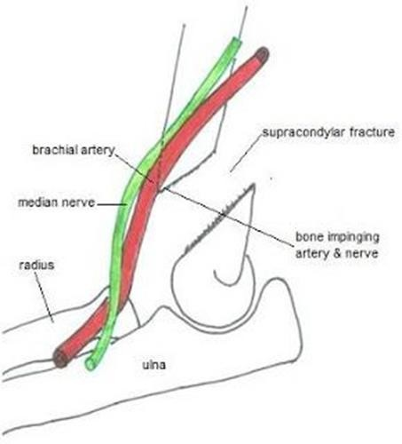
- Vascular injury can also occur in supracondylar fractures
- Brachial a. can be:
  - stretched or kinked (occluded) over the displaced bone fragments
  - partially lacerated or transected
- Arterial anastomosis around the elbow provide important collateral circulation if the occlusion is gradual, temporary & partial.
- Ulnar & radial art.s will still receive sufficient blood from deep art. of arm through anastomosis around the elbow

Supraepicondylar Humerus Fracture
- Sudden, complete occlusion or laceration of brachial a. can result in ischaemia of muscles in forearm

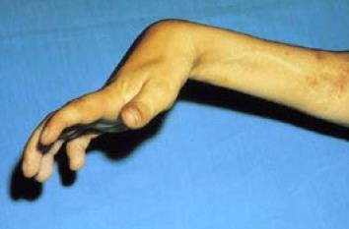
- Collateral circulation cannot compensate for the sudden occlusion

- Muscles can only tolerate up to 6 hours of ischaemia → necrosis of muscles → fibrous scar tissue replaces necrotic tissue → fibrous tissue of involved muscles contracts
→ muscle shorten permanently →

flexion deformity - flexion of wrist

- Ischaemic compartment syndrome /
Volkmann or ischaemic contracture

Example Essay Questions
  - Describe the anterior and posterior compartments of arm. Describe the muscles present within each compartment with regards to their innervation and action

  - Describe the brachial artery with regards to its origin, course, relations in the arm and cubital fossa and branches

  - Briefly describe the location, boundaries and contents of the cubital fossa

References

    - Clinically Oriented Anatomy. 7th edition. 2014. Keith L. Moore, Anne M. R. Agur & Arthur F. Dally. Lippincott Williams & Wilkins.

    - Atlas of Human Anatomy. 4th edition. 2006. Frank H. Netter. Saunders Elsevier.

    - Clinical Anatomy by Regions. 9th edition. 2012. Richard
S. Snell. Lippincott Williams & Wilkins.

