Forearm
Dr. Fazlina Kasim Department of Anatomy fazlinakb@usm.my

Outline
- Forearm
  - Anterior Compartment
  - Posterior Compartment
- Muscles in Anterior Compartment of Forearm
- Superficial layer
- Intermediate layer
- Deep layer
- Muscles in Posterior Compartment of Forearm
- Superficial Layer
- Deep Layer
- Arteries - Radial & ulnar arteries
- Periarticular Arterial Anastomoses of the Elbow Region
- Extensor Retinaculum
- Clinical Correlation

Forearm

- Extends from elbow to
wrist

- Surrounded by deep fascia of forearm (antebrachial fascia)
Lateral intermuscular septum

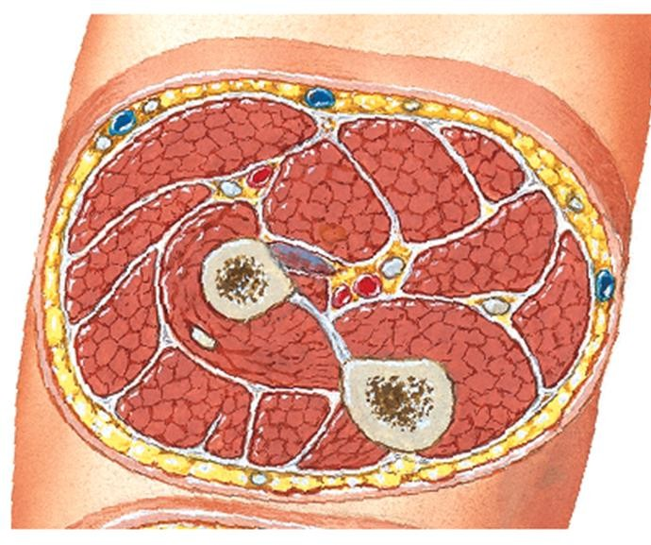

Radius
Anterior

- Divided into 2 compartments by:
Interosseous membrane

- lateral intermuscular
septum
- Radius
- interosseous membrane
- ulna

Deep fascia of forearm
Inferior View of Transverse
Section of Proximal Right Forearm

Ulna
Posterior

Forearm

  - 2 compartments:
compartment
Posterior
compartment
Inferior View of Transverse
Section of Proximal Right Forearm
Posterior
Anterior

Ant. compartment
- Post. compartment

  - The proximal parts of anterior compartment does not lie strictly anteriorly & vice versa
Anterior

Forearm

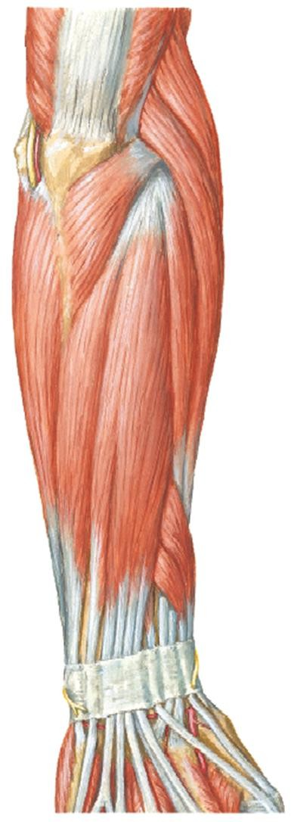

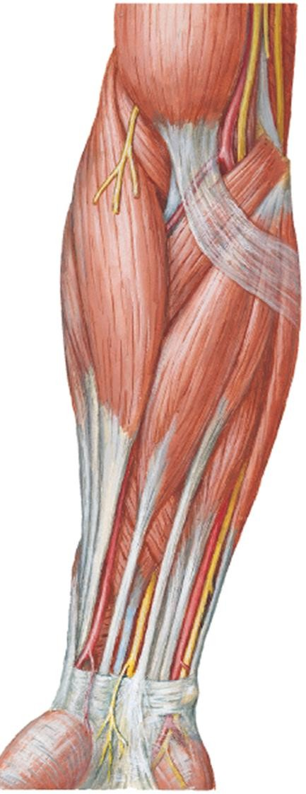
Proximal part of:
- Anterior
compartment lies anteromedially
- Posterior compartment lies posterolaterally

  - Muscles mainly act on:

Wrist joint
(radiocarpal joint)

Joints of fingers
(MCP & IP joints)

Radio-ulnar joint

Post. Com- part- ment

Ant. Com- part-
ment Post.
Com- part- ment

Anterior view
Posterior view

Movements of Hand & Fingers

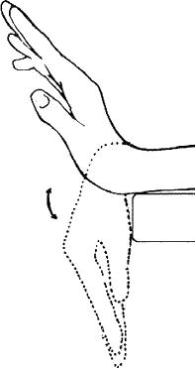
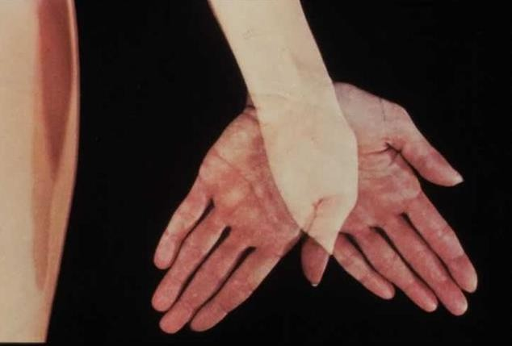
Extension

Flexion

ADDuction ABDuction
ADDuction & ABDuction of Hand

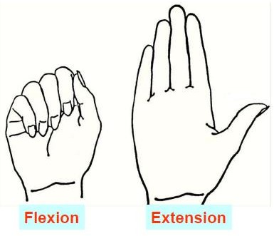

Flexion & Extension
of HAnd
Flexion Extension
Flexion & Extension
of Fingers

Movements of Thumb

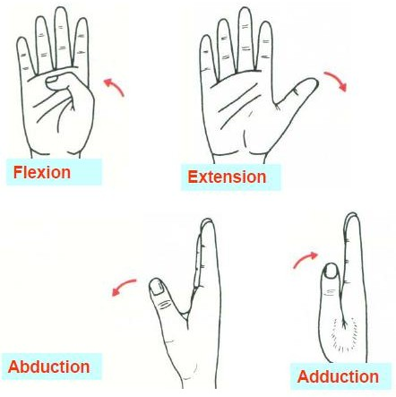
Flexion – Extension
  - Movement parallel to plane of palm

ABDuction - ADDuction
  - Movement at right angles to plane of palm

Anterior Compartment of Forearm
- Flexor-pronator compartment
Muscles of Ant.
Compartment of Forearm

- 8 muscles. Divided into 3 layers based on its location

Main action:
- PT
- FCR
- PL
- FCU
1)
Superficial Layer
3) Deep Layer
2) Inter- mediate Layer
- Flex hand at wrist jt
- Flex fingers at MCP &
IP jts
- Pronate forearm at RUJ
- FDP
- FPL
- PQ
1) FDS

  - Blood supply – ulnar & radial arteries

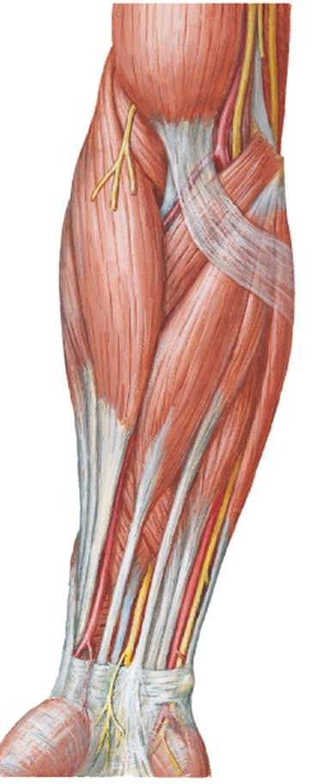
    - The proximal attachment of all muscles in anterior compartment is the medial epicondyle of humerus (common flexor origin (CFO)) EXCept for deep layer muscles
Muscles of anterior compartment of forearm

    - All muscles cross the elbow joint EXCept the 3 muscles in the deep layer (attach to anterior aspects of radius & ulna).

Medial epicondyle of humerus

Anterior
Compartment

- All muscles supplied by median nerve except for 1 ½ muscles:
  - FCU
  - Medial part of FDP

- Deep layer muscles are supplied by a branch of median nerve – anterior interosseous nerve.

Supplied by ulnar nerve

FCU

FDP

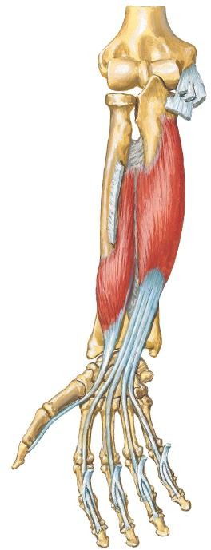

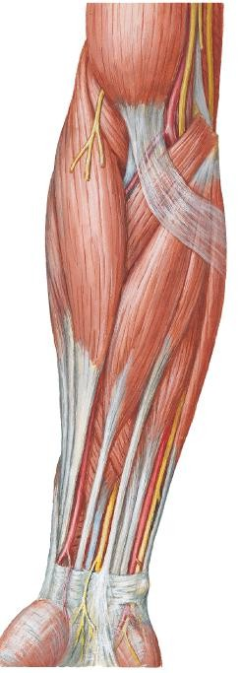

Anterior view

Superficial Layer

Superficial Layer

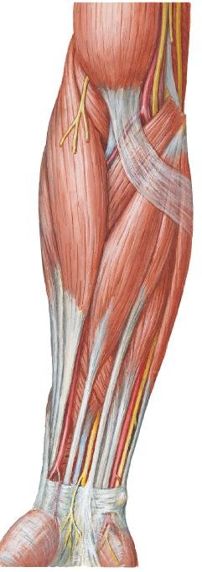

Pronator
teres

FCR PL
FCU
- The superficial muscles consist of (from medial to lateral):
- Flexor carpi ulnaris (FCU)
- Palmaris Longus (PL)
- Flexor carpi radialis (FCR)
- Pronator teres (PT)

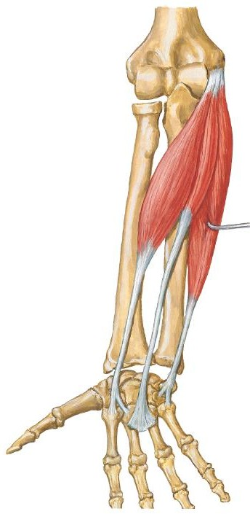
Anterior
view
1) Flexor Carpi Ulnaris
  - Most medial muscle of superficial
layer muscles

FCU
 | Humeral head | Ulnar head
PA | Medial epicondyle of humerus (common flexor origin) | Olecranon & posterior ulna
DA | - Pisiform  - Hook of hamate  - Base of 5th metacarpal
Act-  ion | Flexes & ADDucts hand



Ulnar
1) Flexor Carpi Ulnaris
nerve

    - After ulnar nerve pass posterior to medial epicondyle of humerus, it enters anterior part of forearm by passing between 2 heads of FCU.
Medial epicondyle of humerus

Olecranon

FCU

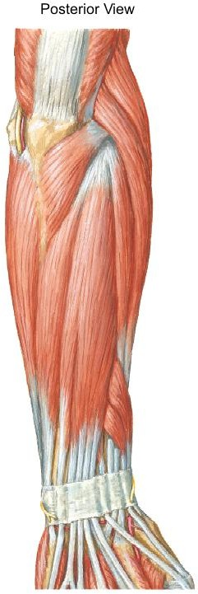

Posterior view

1) Flexor Carpi Ulnaris
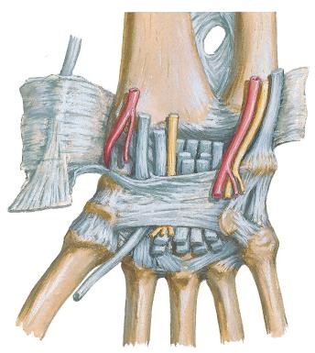
FCU tendon is a landmark for ulnar artery & nerve. Ulnar artery and nerve is lateral to FCU tendon
FCU tendon
Ulnar artery
Palmar carpal ligament
Ulnar nerve
Flexor retinaculum

Palmar view



2) Palmaris Longus

- Absent in 14% of people.
- PL has a short belly & a long

tendon

Palmaris
Proximal attachment | Medial epicondyle of humerus (common flexor origin)
Distal attachment | Flexor retinaculum and palmar aponeurosis
Action | Flexes hand at wrist joint

longus

Anterior
view

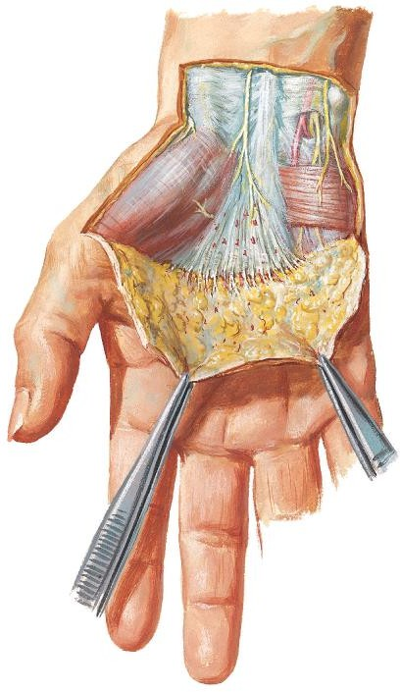
Palmar view
Palmar aponeurosis
Palmar carpal ligament
Palmaris longus tendon
2)
Palmaris Longus

PL tendon passes superficial to the flexor retinaculum and attaches to it and the palmar aponeurosis.

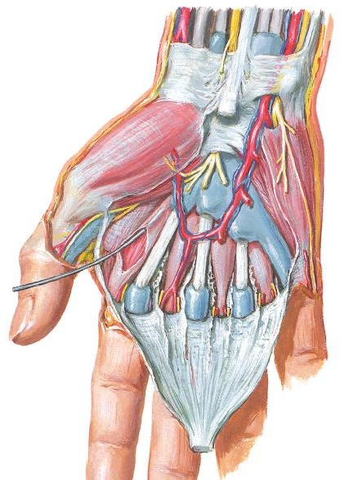
Flexor retinaculum
PL tendon
Median nerve
2)
Palmaris Longus

- PL tendon is a landmark for median nerve.

- Median nerve is inferolateral to PL tendon.

Anterior view

FCR
Anterior view
3) Flexor Carpi Radialis

  - FCR is lateral to PL

Proximal attachment | Medial epicondyle of humerus (common flexor origin)
Distal attachment | Base of 2nd & 3rd  metacarpal
Action | Flexes & ABDucts hand

3) Flexor Carpi Radialis

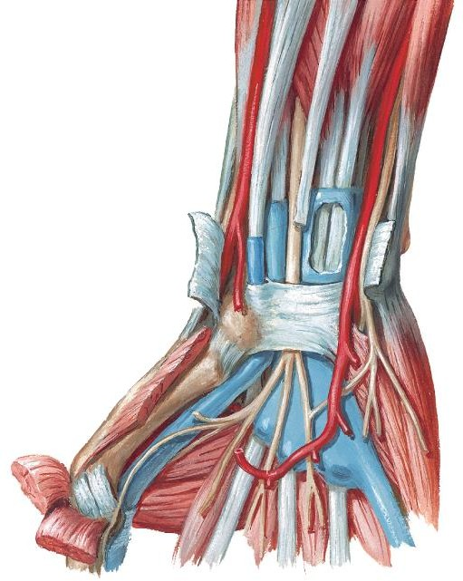
Radial artery
- FCR tendon is a good landmark for radial artery.

- Radial artery lies
lateral to FCR tendon.

- FCR tendon in its synovial sheath passes through a canal in the lateral part of the flexor retinaculum.

FCR tendon Flexor retinaculum

Wrist – palmar view

3) Flexor Carpi Radialis

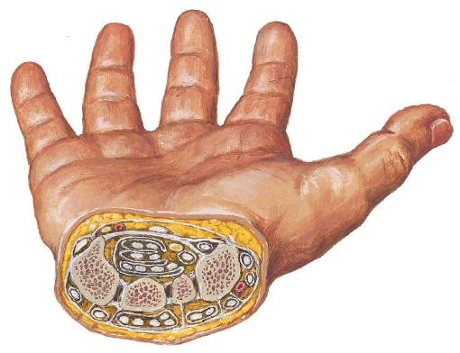
Flexor retinaculum FCR tendon
The canal is bounded by:
- Laterally
  - a groove in the trapezium
- Medially
  - Flexor retinaculum that splits into 2 slips (attach to margins of groove)

Trapezium

Cross section of wrist

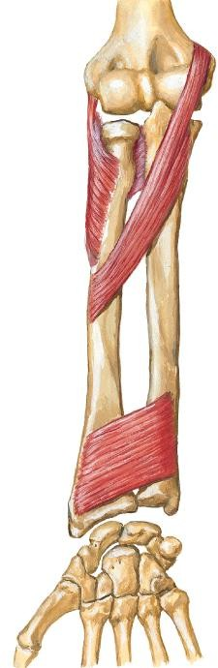
4) Pronator Teres
  - Most lateral muscle of
superficial layer muscles

Pronator teres
 | Humeral head | Ulnar head
PA | Medial epicondyle of humerus (common flexor origin) | Coronoid process (ulna)
DA | Midshaft of radius
Act-  ion | Pronates forearm at radio-  ulnar joint

Anterior view

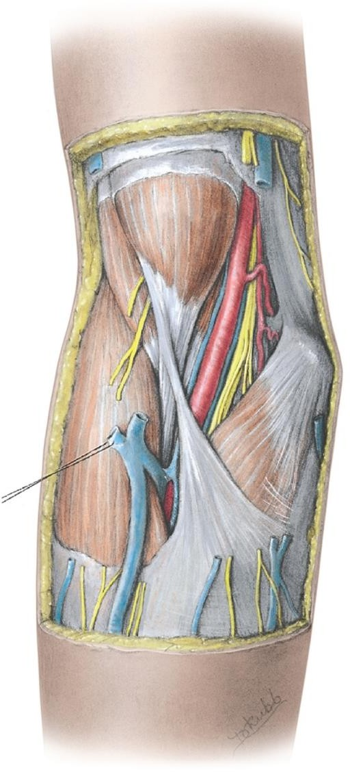
Pronator teres
4) Pronator
Teres

The lateral border of pronator teres forms the medial boundary of the cubital fossa

Anterior view

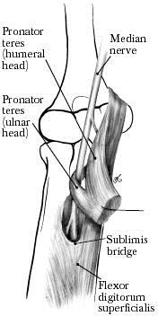
Anterior view
4) Pronator Teres

    - Median nerve leave cubital fossa & enters forearm by passing between the 2 heads of pronator teres.

Intermediate Layer

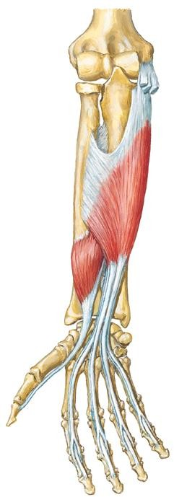
1) Flexor Digitorum Superficialis

FDS
 | Humero-ulnar head | Radial head
PA | - Medial epicondyle of humerus (common flexor origin)  - Coronoid process (ulna) | Oblique line of radius
DA | Base of middle phalanges of medial 4  fingers
Act- ion | Flexes:  - Middle phalanges at PIPJs of medial  4 fingers  - Proximal phalanges at MCPJs  - Hand at wrist joint

Site of common flexor origin – medial epicondyle
The superficial & intermediate muscles are located anteromedially because arise mainly from common flexor attachment.

Pronator teres

FCR

PT

FCR
PL

FCU

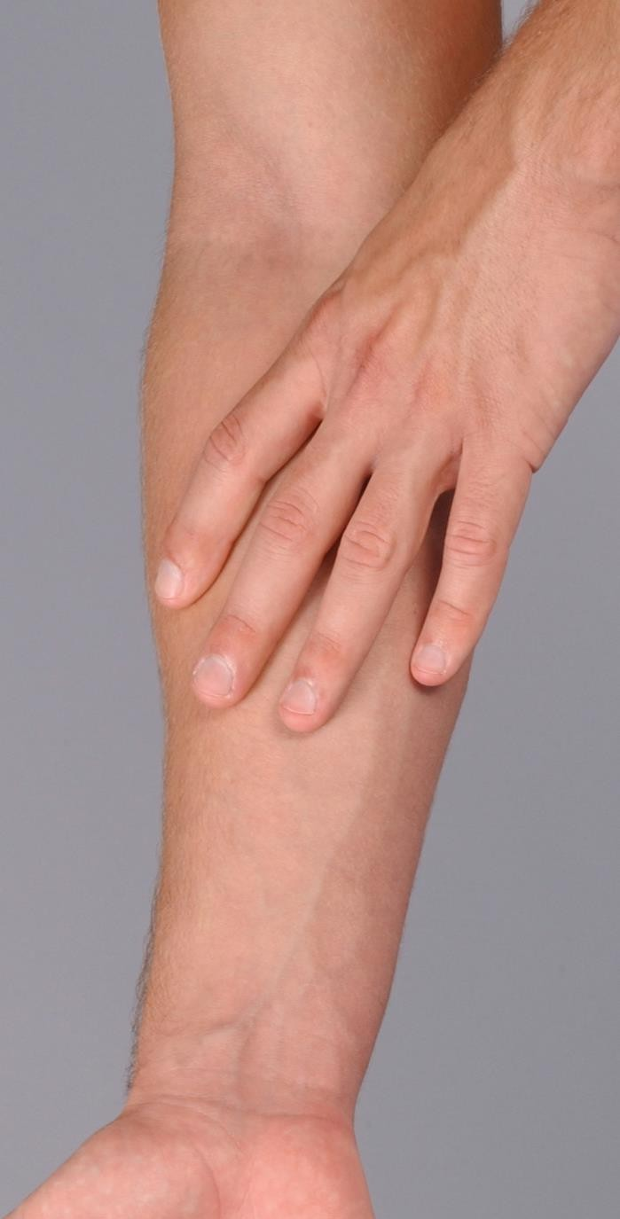
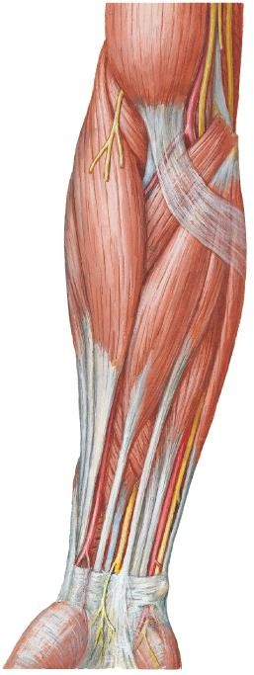

PL

FCU

Deep Layer
- The fascial plane between intermediate & deep layer of muscles is the neurovascular plane of the anterior compartment.
- Blood vessels & nerves course within it.

Anterior view
FDS (cut)
FDP
1) Flexor Digitorum Profundus

PA | - Anterior surface of  ulna  - Anterior surface of interosseous membrane
DA | Base of distal phalanges of medial 4 fingers

Anterior view
FDP
1) Flexor Digitorum Profundus
Innervat-  ion | - Medial part – ulnar  nerve  - Lateral part – anterior interosseous nerve (median nerve)
Action | Flexes:  - Distal phalanges at DIPJ & middle phalanges at PIPj of medial 4 fingers  - Proximal phalanges at  MCPJ  - Hand at wrist joint

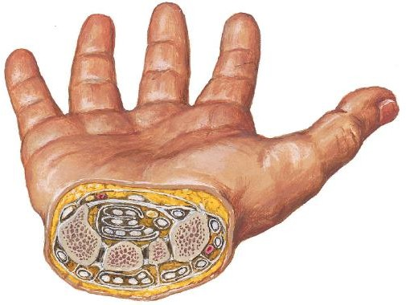
4 FDP tendons posterior to the 4 FDS tendons in common synovial sheath
FDS & FDP
tendons in a synovial common flexor sheath
Flexor retinaculum
Near the wrist, its 4 tendons in common synovial sheath (with the 4 tendons of FDS) pass deep to flexor retinaculum, through the carpal tunnel to reach the fingers.

1) Flexor Digitorum Profundus

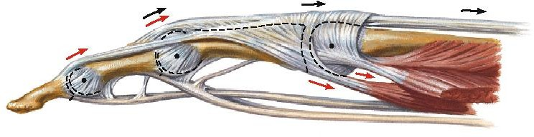
FDP tendon
FDS
tendon
Each FDP tendon passes through a split in the overlying FDS tendon.
Superficialis splits into 2 to permit profundus to pass through

Lateral view

Anterior view
FPL
FDP
2) Flexor Pollicis Longus

•
•
•
Pollex = thumb
FPL = the long flexor of thumb Lateral to the FDP

PA | Anterior surface of radius & interosseous  membrane
DA | Base of distal phalanx of thumb

Anterior view
FPL
FDP
2) Flexor Pollicis Longus

Innervat- ion | Anterior interosseous nerve (median nerve)
Action | Flexes:  - Distal phalanx of  thumb at IPJ  - Proximal phalanx at MCPJ  - 1st metacarpal at carpometacarpal jt (CMCJ)

Median nerve

FPL tendon in its synovial sheath passes deep to the flexor retinaculum, lateral to the common flexor sheath.
FPL tendon in its synovial sheath

Anterior view
3) Pronator Quadratus
- Quadratus = quadrangular
- Deepest muscle
- Lies proximal to wrist joint

Pronator quadratus
PA | Distal ¼ ulna
DA | Distal ¼ radius
Innervat- ion | Anterior interosseous nerve (median nerve)
Action | Pronates forearm at radio-ulnar joint

 | Proximal  attachment | Distal attachment | Innervation | Action
Superficial Layer
Pronator Teres | CFO & Coronoid  process (ulna) | Mid-radius | Median nerve | Pronates forearm
FCR | CFO | Base of 2nd & 3rd metacarpal | Median nerve | Flexes & abducts hand at wrist joint
Palmaris Longus | CFO | Flexor retinaculum & palmar aponeurosis | Median nerve | Flexes hand at wrist joint
FCU | CFO & Olecranon & posterior ulna | Pisiform, hook of hamate & base of 5th metacarpal | Ulnar nerve | Flexes & adducts hand at wrist joint
Intermediate Layer
FDS | CFO, coronoid process & oblique line (radius) | Middle phalanges of medial 4 digits | Median nerve | Flexes PIP joints of medial 4 digits, MCP Joint & wrist
Deep Layer
FDP | Anterior surface of ulna & interosseous membrane | Distal phalanges of medial 4 digits | Lateral ½ - (AIN) median nerve  Medial ½ - ulnar nerve | Flexes DIP joints of medial 4 digits, MCP Joint & wrist
FPL | Anterior surface of radius & interosseous membrane | Distal phalanx of thumb | Anterior interosseous nerve (median nerve) | Flexes IP & MCP joints of thumb
Pronator Quadratus | Distal ¼ ulna | Distal ¼ radius | Anterior interosseous nerve (median nerve) | Pronates forearm

Posterior Compartment of Forearm

- Extensor-supinator compartment
- Total 11 muscles
- All muscles cross wrist joint except BR & supinator. All muscles are extensors EXCept BR & supinator

Innervated by radial nerve
(directly or by its branches)

Main action:
- Extensor of hand at wrist joint (RCJ) EXCept brachioradialis
- Extensor of fingers at IPJs &
MCPJs
Inferior View of Transverse Section of Proximal Right Forearm
- Supinator of forearm at RUJ

Anterior

U

Posterior
compartment
Posterior




2) Deep layer
Muscles
- Supinator
- Extensor indices (EI)
- Outcropping Muscles of Deep Layer
  - ABDuctor pollicis longus (ABD PL)
  - Extensor pollicis longus (EPL)
  - Extensor pollicis brevis (EPB)
1) Superficial Layer

- Brachioradialis
- Ext. carpi radialis longus (ECRL)
- Ext. carpi radialis brevis (ECRB)
- Extensor Digitorum (ED)
- Ext. digiti minimi (EDM)
- Ext. carpi ulnaris (ECU)

- All muscles attach to common extensor origin (CEO) = lateral epicondyle of humerus EXCept:
Superficial Layer

BR
  - ECRL

Innervation:
  - Radial nerve supplies the 2 most superficial & lateral muscles – BR & ECRL
  - The rest of the muscles in the superficial layer are supplied by deep branch of radial nerve (post. Interosseous nerve)
BR ECRL

Posterior View

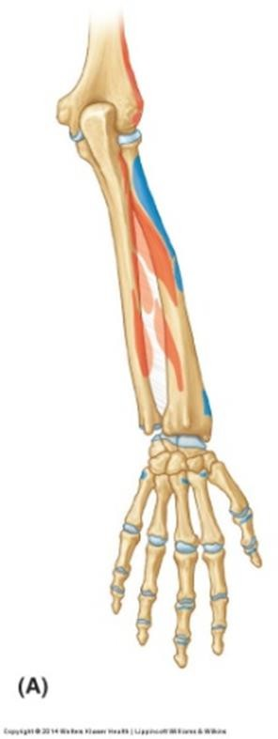
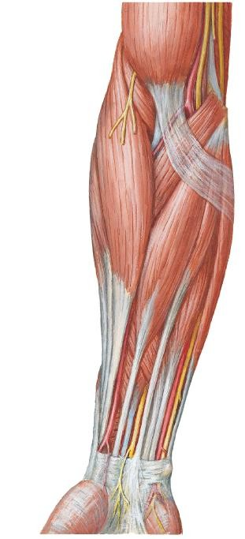
- Location – at anterolateral surface of forearm
BR
Posterior View
Anterior View
1) Brachioradialis
- Forms lateral boundary of

cubital fossa
- Overlies radial nerve & art

PA | Latera supracondylar  ridge (humerus)
DA | Distal end of radius (lateral surface)
Act- ion | Flexes forearm

Location:
Extensor Carpi Radialis Longus & Brevis
  - Part of ECRL is deep to BR
  - Part of ECRB deep to ECRL
BR ECRL
ECRB

Posterior View
 | ECRL | ECRB
PA | Lateral supracondylar ridge (humerus) | Lateral epicondyle (humerus)  CEO
DA | Base of 2nd metacarpal (dorsal aspect) | Base of 3rd metacarpal (dorsal aspect)
Act- ion | - At wrist joint  - Extend hand  - ABDuct hand

- ECRL & ECRB tendon distally covered by tendons of ABD PL & EPB
2 & 3) Extensor Carpi Radialis Longus & Brevis

- ECRL & ECRB together in a common tendinuous sheath pass under the extensor retinaculum

Extensor Retinaculum
ABD PL

EPB
ECRB

ECRL

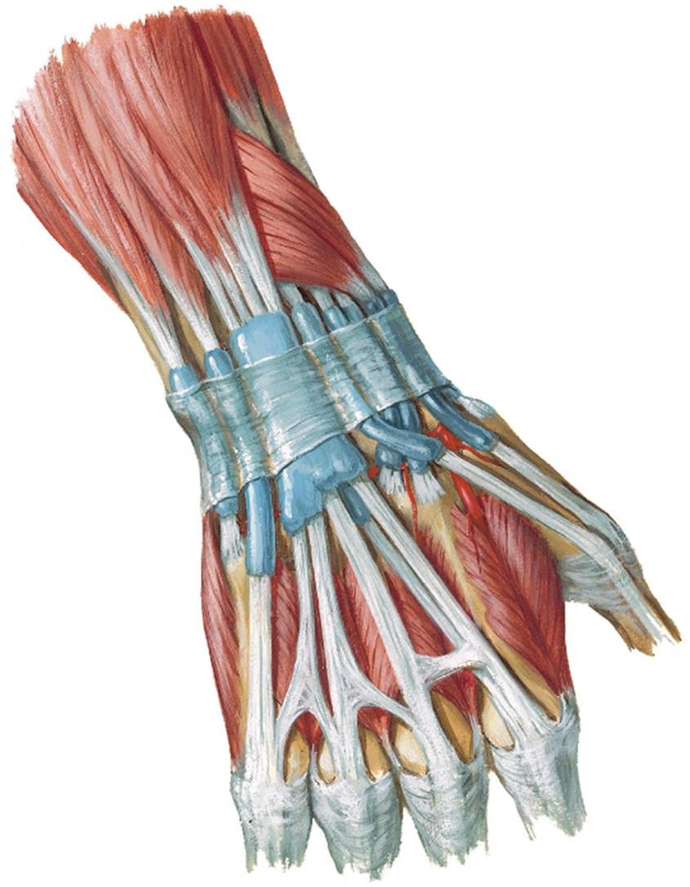

Posterior View

ED
EDM
- Extensor Digitorum &
- Extensor Digiti Minimi
Posterior View
- ED occupies most of post. surface of forearm
- EDM partially attached to ED

 | ED | EDM
PA | Lateral epicondyle (humerus) CEO
DA | Extensor expansions of:
DA | Medial 4 fingers | Little finger (5th finger)
Act- ion | Extends at MCPJ & IPJs
Act- ion | Medial 4 fingers | Little finger

4) ED & 5) EDM
Posterior View

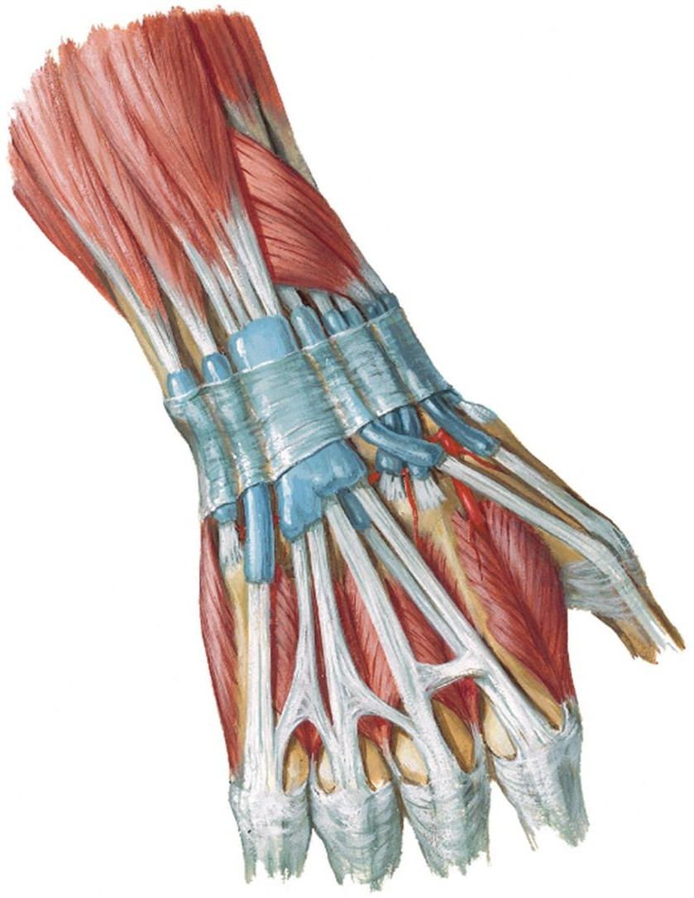
- Proximal to wrist,
- 4 tendons of ED
- tendon of extensor indices, EI (muscle of deep layer)
  - in a common synovial sheath → together pass deep to extensor retinaculum

- Tendon of EDM runs through a separate compartment beneath extensor retinaculum, then it divides into 2 slips

EDM
ED

EDM
ED

Extensor
Retinaculum

EI

ED & EDM

- On dorsum of hand, proximal to MCP jt of medial 4 fingers, adjacent tendons of ED & EDM are interconnected by 3 intertendinous connections

- Intertendinous connections restrict independent extension of middle & ring fingers

EDM

Intertendinous
connections
ED

Extensor
Posterior View
Retinaculum

EI

Tendon of Extensor Digitorum – Extensor Expansion
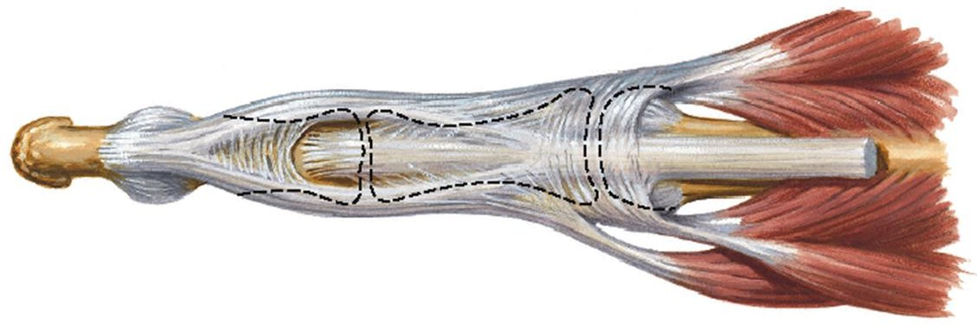
Lateral band
Central band
Dorsal View
IOM
ED

Lumbrical
- Over each medial 4 fingers, each ED tendon divides into:

1 central (median) band
  - Attach to base of middle phalanx

2 lateral bands
  - Attach to base of distal phalanx
  - Joined by tendon of interossei & lumbrical muscles
IOM

- Tendon of ED expands (flatten) forming a triangular aponeurosis =

extensor expansion

Tendon of ED - Extensor Expansion
Base
IOM
ED

Dorsal View
Lumbrical
IOM

- Dorsal digital expansion
- Triangular in shape.

Parts – Base, Sides & Apex

- Base
  - Covers head of metacarpal & MCPJT
  - The corners of the base are attached to palmar ligt (MCPJ) & joined by tendon of interosseous (IOM) & lumbrical muscles

Tendon of ED - Extensor Expansion

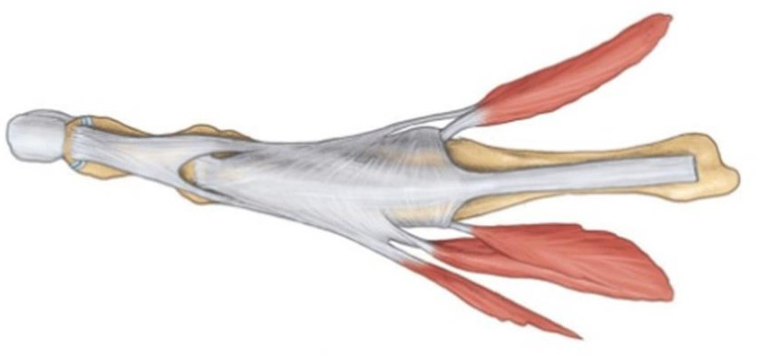
ED
Base
IOM
Lumbrical
IOM
Dorsal View

Sides
  - Lateral side – thickened by tendon of interossei & lumbrical muscles
  - Medial side – thickened by tendon of interossei only

- Apex at base of distal phalanx

- Location – on medial border of forearm (pos surface)
t.
CU
ECU
Posterior View
6) Extensor Carpi Ulnaris
- Passes through a separate compartment beneath extensor retinaculum

F
 | Humeral head | Ulnar head
PA | Lateral epicondyle  (humerus) CEO | Posterior  ulna
DA | Base of 5th metacarpal (dorsal)
Act- ion | - Extends hand with ECRL & ECRB  - ADDucts hand with FCU

2) Deep layer
Muscles
1) Superficial Layer

  - Supinator
  - ABDuctor pollicis longus
  - Extensor pollicis longus (EPL)
  - Extensor pollicis brevis (EPB)
  - Extensor indices (EI)

Outcropping
Muscles

- PA of all deep layer muscles are post. surface of radius, ulna & interosseous membrane EXCept supinator
- Muscles in the deep layer are supplied by deep branch of radial nerve (posterior interosseous nerve)

1) Supinator

- Location – Lies deep in cubital fossa. Forms floor of cubital fossa
- Envelops the neck & proximal radius

Supinator

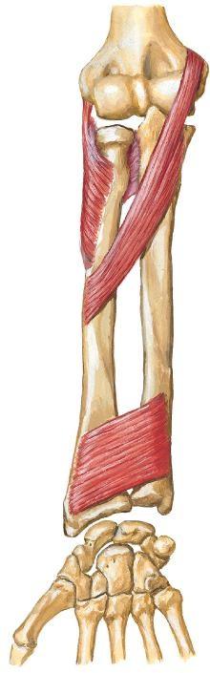
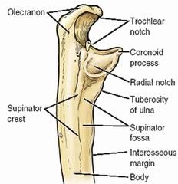
Anterior View
Lateral View

PA | - Lateral epicondyle (humerus) CEO  - Anular ligament  - Supinator crest of ulna
DA | Proximal radius
Act- ion | Supinates forearm (forearm extended)

1) Supinator

- Forms floor of cubital fossa

- Pierced by deep branch of radial n. (post. interosseous nerve)

Radial n.
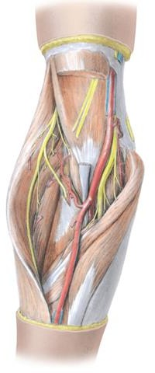
Deep br. Super-
ficial br.

Supinator
Anterior
View

3) Outcropping Muscles

- Consist of 3 muscles:
  - ABDuctor pollicis longus (ABD PL)
  - Extensor pollicis longus (EPL)
  - Extensor pollicis brevis (EPB)

- These muscles act on the thumb

- Location – deep to superficial layer muscle

- They become superficial by emerging (‘crop out’) in lateral part of forearm, between ECRB & ED
Posterior
View

ED

ECRB ABD PL
EPB
EPL

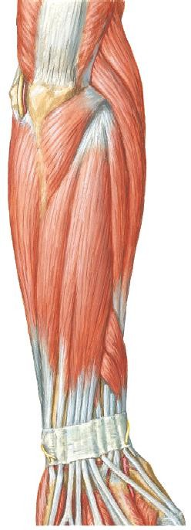

3) Outcropping Muscles

ABDuctor Pollicis Longus (ABD PL)
  - Lies just distal to supinator
  - Most lateral of the outcropping muscles

Supinator

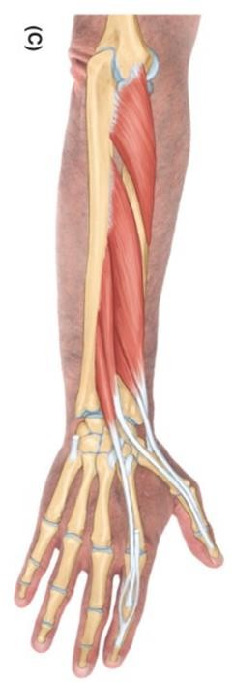

ABD PL
PA | - Proximal ulna & radius (posterior surface )  - Interosseous membrane
DA | Base of 1st metacarpal
Act- ion | Acts on thumb at CMC jt:  - ABDucts (with ABD PB)  - Extends thumb with extensor pollicis muscles

Posterior View

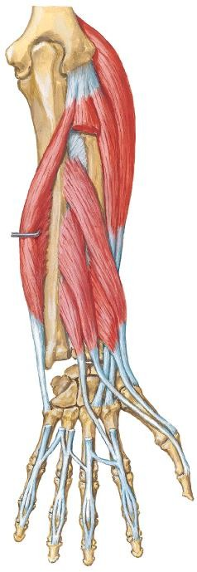
3) Outcropping Muscles

Extensor Pollicis Brevis (EPB)
Posterior View
  - Short muscle. Lies distal to ABD PL
  - Its tendon lies medial to ABD PL tendon
  - Passes deep to extensor retinaculum with
ABD PL tendon

ABD PL EPB
PA | - Distal radius (posterior surface)  - Interosseous membrane
DA | Base of proximal phalanx of thumb  (dorsal)
Act-  ion | Extends:  - Proximal phalanx of thumb at  MCP jt  - Extend 1st metacarpal at CMC jt

EPL
EPB
Posterior View
3) Outcropping Muscles

Extensor Pollicis Longus (EPL)

- Muscle is medial to EPB.

PA | - Posterior surface of ulna  - Interosseous membrane
DA | Base of distal phalanx of thumb (dorsal)
Act- ion | Extends:  - Distal phalanx of thumb at IPJ  - MCPJ & CMCJ of thumb

Outcropping Muscle - 3) Extensor Pollicis Longus

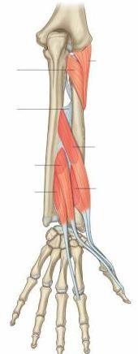
- EPL tendon passes deep to extensor retinaculum in its own compartment
Posterior
View

- Passes medial to dorsal tubercle of radius, thus creating a gap between tendon of EPB & EPL – anatomical snuff box

EPL

Dorsal
tubercle

  - Has a narrow belly
ED
U
EPL
EI
Posterior
View
5) Extensor Indices (EI)
  - Medial to extensor pollicis longus, EPL
  - Most medial muscle of deep layer

EC
PA | - Distal ulna (posterior surface)  - Interosseous  membrane
DA | Extensor expansion of index finger (joins ED tendon to index finger)
Act-  ion | Extend index finger


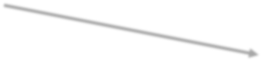
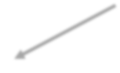

Physiological Subdivision of Muscles
2) Act on Wrist
- ED
- EDM
- EI
4) Act on Medial 4 Fingers
- EPL
- EPB
- ABD
PL
3) Act on Thumb

- BR
- Supinator
1) Act on Elbow & RUJ
- ECRL
- ECRB
- ECU

Extensor Retinaculum
- A thickening of deep fascia of forearm (antebrachial fascia)

- Attached to distal ends radius & ulna (posterior surface)

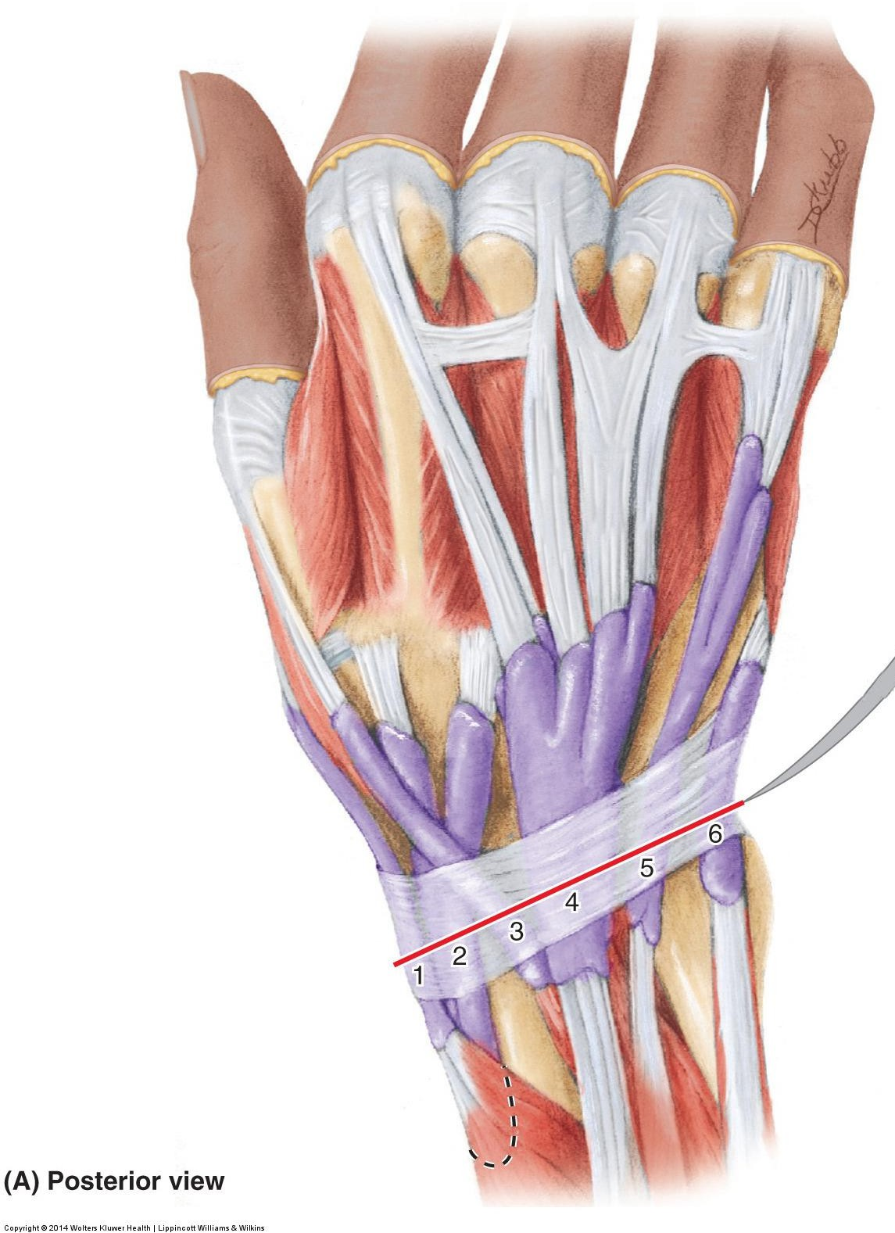
- Function – Holds tendons of extensor muscles in place. Prevents bowstringing of extensor tendons when hand is extended at wrist joint

Extensor
Retinaculum
Posterior
View

Extensor Retinaculum

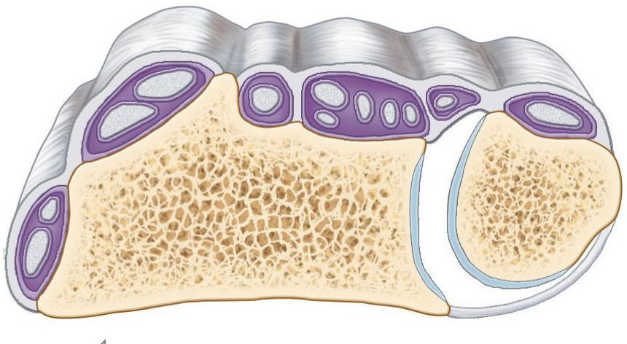
  - Form 6 osseofibrous tunnels providing passage for tendons of 9 extensor muscles (from lateral to medial):
Radius
6
3
2
5
4
- ABD PL & EPB
1
- ECRL & ECRB
- EPL
- ED & EI
- EDM
- ECU
Oblique transverse section at wrist

Arteries of Forearm
  - Ulnar artery
  - Radial artery

1) Ulnar artery

- One of the terminal branches of brachial artery in cubital fossa.

- Leaves cubital fossa by passing deep to pronator teres

- Descends inferiorly in between FDS & FDP muscle (in neurovascular plane).
Brachial art.

Ulnar art.
Pronator
teres

FDS

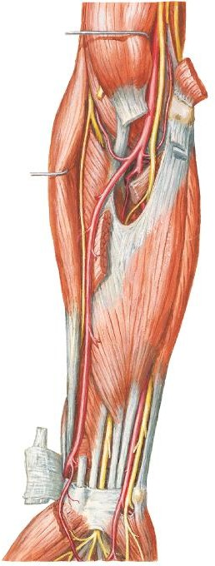

Anterior view

1) Ulnar artery

- Crossed by median nerve
- Reaches medial side of
forearm.
- Passes superficial to flexor retinaculum at wrist lateral to ulnar nerve.
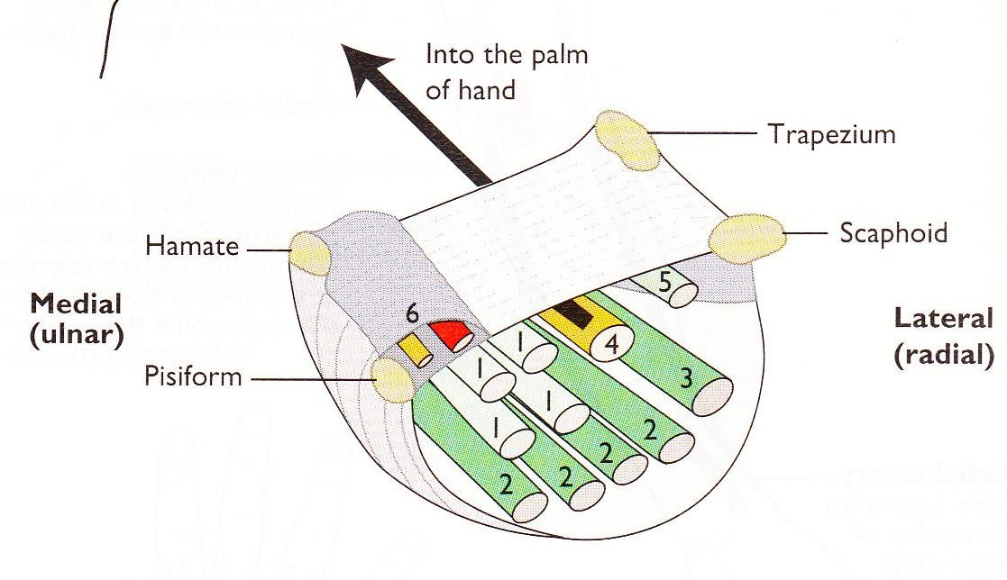
- Passes through ulnar (Guyon) canal to enter hand.

Ulnar art.

Median n.

Ulnar artery
Ulnar nerve

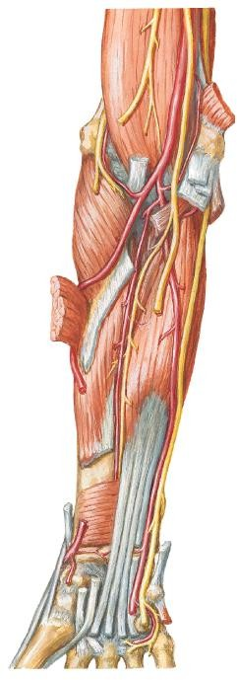

Anterior view

Anterior & Posterior Ulnar Recurrent Arteries
  - Participate in periarticular anastomosis of the elbow.
Deep a. of arm

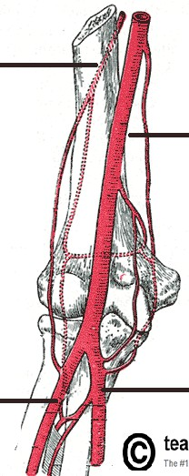
Common Interosseous Artery
Brachial
a.
Ant. &
post. ulnar recur- rent a.
Ulnar
a.
Common interosseous a.
Anterior view
Branches of Ulnar Artery in Forearm
  - A short branch
  - Divides into anterior & posterior interosseous art.s

Radial a.
Post. inter-
osseous a.

Ant. interosseous a.

Branches of Common Interosseous Artery

a. Anterior Interosseous Artery
- Descends anterior to interosseous membrane.
- Lateral to the ANT. interosseous branch of median nerve
Ulnar
art.
Branches of Ulnar Artery in Forearm

Common inter- osseous a.

ANT. inter- osseous a.

ANT.
ulnar recurrent art.

POST. ulnar recurrent art.

Anterior view

Branches of Ulnar Artery in Forearm

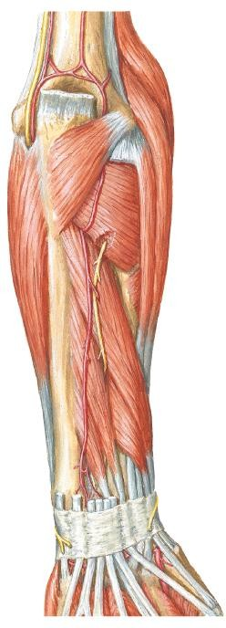
- Branches of Common Interosseous Artery

- Posterior Interosseous
Artery
- Passes posterior to interosseous membrane.
- Gives rise to recurrent interosseous artery that participates in periarticular anastomosis of the elbow.
Posterior view

Recurrent interosseous art.

Post. interosseous art.

2) Radial artery

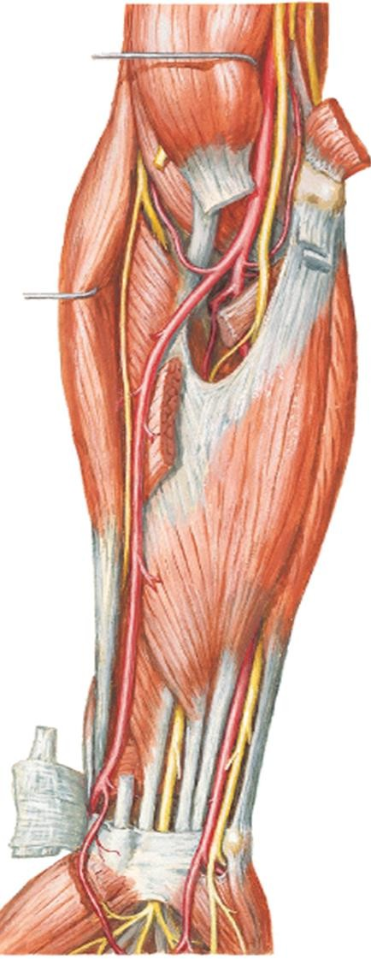
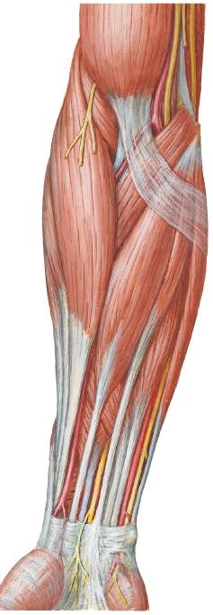
- One of the terminal branches of brachial artery in cubital fossa.

- From cubital fossa, it descends laterally deep to brachioradialis.

- At middle 1/3 of forearm, it is medial to superficial branch of radial nerve
Radial artery

BR

Radial artery

Super- ficial br. Radial n.

Radial artery

Anterior view

2) Radial artery

  - At distal forearm, it becomes superficial (covered only by skin & fascia) & becomes lateral to FCR tendon.
Radial artery

BR

Radial artery

Radial artery

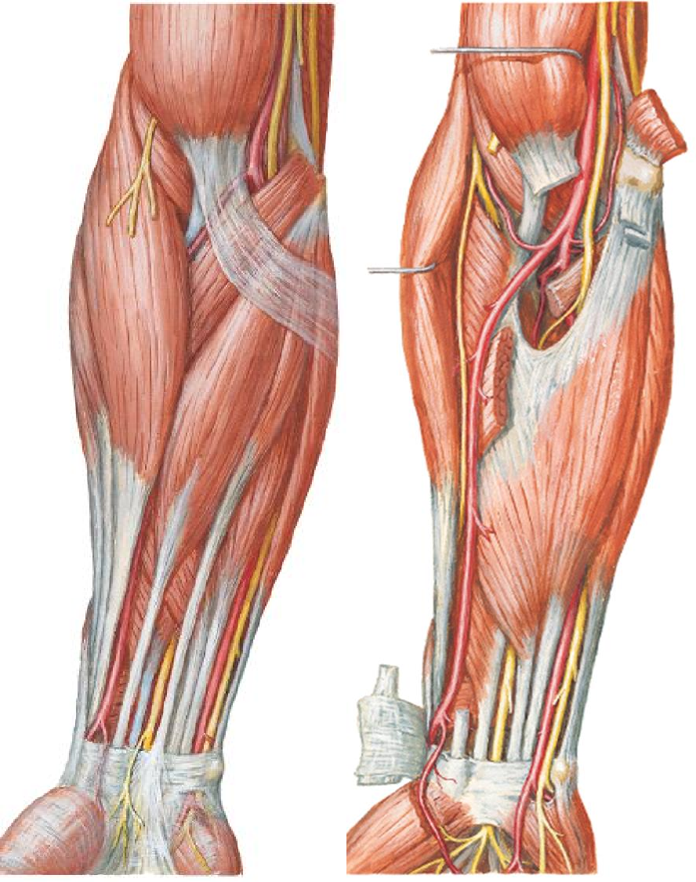

FCR
Anterior view
tendon

- It curves around lateral side of wrist.
2) Radial artery
Radial artery in anatomical snuffbox

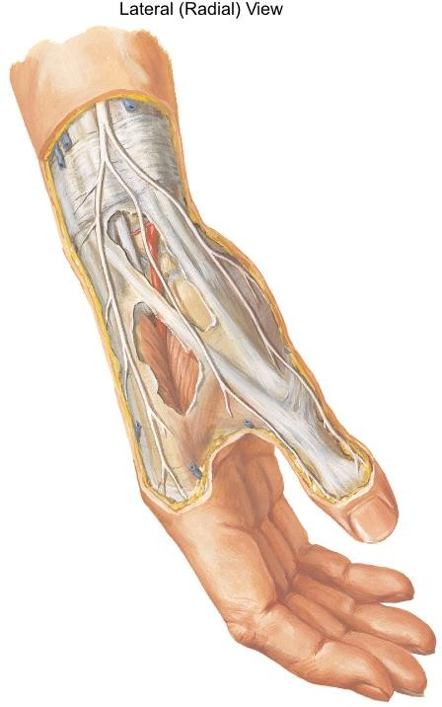
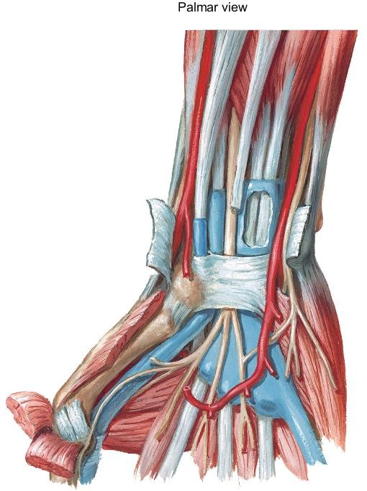
Radial a.

- Crosses the floor of the anatomical snuff box

- Reach dorsum
of hand

Branches of Radial Artery in Forearm

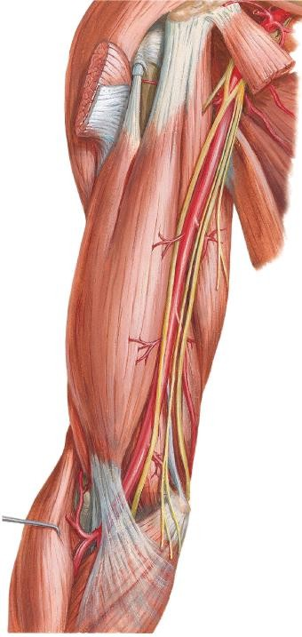
Radial recurrent artery
    - Arises just distal to the elbow.
    - Participate in periarticular anastomosis of the elbow
    - Anastomose with the radial collateral artery (a branch of deep artery of arm).

Radial recurrent
art.
Radial
Anterior view
art.

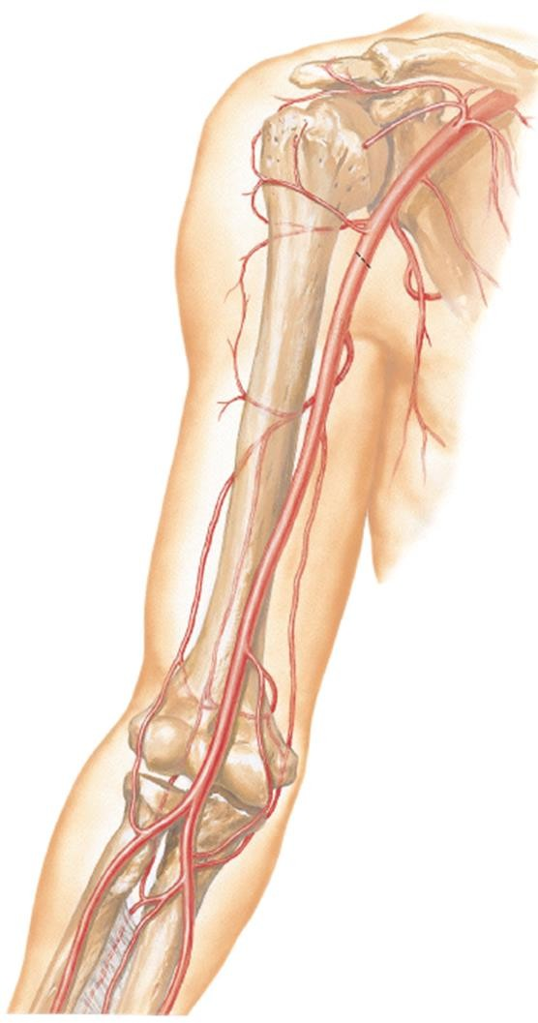

Anastomoses around the elbow joint exists between
Periarticular Arterial Anastomoses
of the Elbow Region
Anterior View
br.s of brachial a., deep art. of arm, radial & ulnar a.s:
Middle collat. a.
Branches of brachial a. | Branches of ulnar a. | Branches of radial a.
Middle collateral a. | Recurrent interosseous  a. (RIA)
Radial collateral a. |  | Radial recurrent a.
Sup. ulnar  collateral a. | Post. Ulnar  recurrent a.
Inf. ulnar collateral a | Ant. Ulnar recurrent a.

Radial
collat. a.

RIA RRA

Sup. ulnar collat. a.
Inf. ulnar collat. a.

AURA PURA

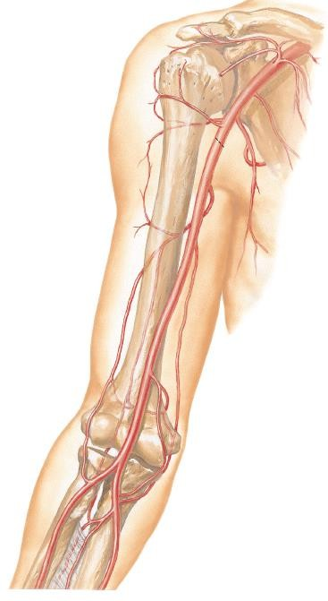
Posterior
interosseous artery
Anterior ulnar recurrent artery
Recurrent interosseous artery

Anterior
view

Brachial artery

Radial recurrent artery
Ulnar artery
Superior ulnar collateral artery
Common interosseous artery
Inferior ulnar collateral
artery

Anterior interosseous artery
Posterior ulnar recurrent artery

 | ARTERIES
 | Ulnar artery | Radial artery
Descends in  forearm | Descends medially between  FDS & FDP. | Descends laterally deep  to brachioradialis.
 | Crossed by median nerve. | -
At distal forearm | Becomes superficial. Lateral to ulnar nerve. | Superficial. Lateral to FCR tendon.
Accompanied by | Ulnar nerve. | -
Enters hand | By passing through ulnar canal (Guyon’s canal). | Winds around lateral aspect of wrist to cross the floor of the anatomical snuff box.

Supracondylar Humerus Fracture
- Sudden, complete occlusion or laceration of brachial a. can result in ischaemia of muscles in forearm

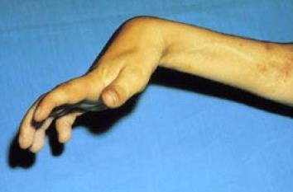
- Collateral circulation cannot compensate for the sudden occlusion

- Can lead to necrosis of muscles in forearm → fibrous scar tissue replaces necrotic tissue → affected muscles shorten permanently → flexion deformity - flexion of fingers & wrist

- Ischaemic compartment syndrome
(Volkmann or ischaemic contracture)

Supracondylar Humerus Fracture
- Muscle in deep layer of anterior compartment of forearm is most prone to a compartment syndrome because radial & ulnar artery runs in the neurovascular plane

- Tsuge has classified deformities of Volkmann ischaemic contracture into 3 types:
  - The mild (localised) type
  - The moderate (classic) type
  - The severe type

The Mild Type
  - The flexors are involved and the extensors are spared
  - Clinically, there is flexion contracture of the fingers. Sometimes the thumb is involved

Supracondylar Humerus Fracture

The moderate (classic) type
  - the flexors of the fingers, thumb and wrist are involved.
The extensors are spared.
  - Clinically, there is flexion contracture of all fingers and wrist

The severe type
  - the flexors of the fingers, thumb and wrist are involved,
and the extensors are involved partially.
  - Clinically, the wrist joint is flexed, the MCPJ is extended & the IPJs are flexed

Example Essay Questions
- Describe the anterior compartment of forearm. Describe the muscles present within this compartment with regards to their innervation and action

- Describe the posterior compartment of forearm. Describe the muscles present within this compartment with regards to their innervation and action

- Describe the radial & ulnar artery and their branches

References

  - Clinically Oriented Anatomy. 7th edition. 2014. Keith L. Moore, Anne M. R. Agur & Arthur F. Dally. Lippincott Williams & Wilkins.

  - Atlas of Human Anatomy. 4th edition. 2006. Frank H. Netter. Saunders Elsevier.

  - Clinical Anatomy by Regions. 9th edition. 2012. Richard
S. Snell. Lippincott Williams & Wilkins.

