

Fluid Mechanics

References
1. Dr. Atheer Zaki Mohsin , Al-Furat Al-Awsat Technical University
2. A Text Book of Fluid Mechanics and Hydraulic Machines, by Rajput, 1998
3. Fluid Mechanics, by Streeter & Wylie,1983,1979
4. Fluid Mechanics With Engineering Applications , by Daugherty, 1989

Asst. Lec. Safa Ali Hussein

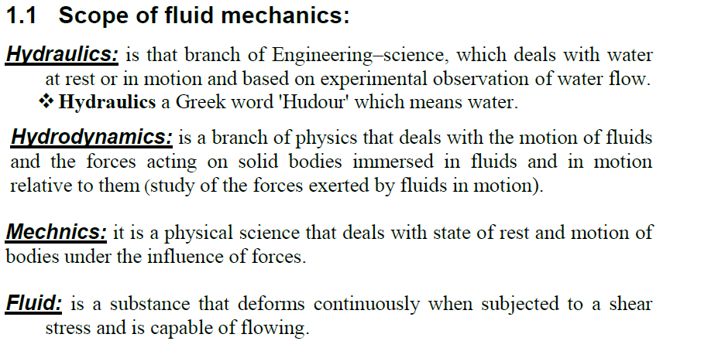
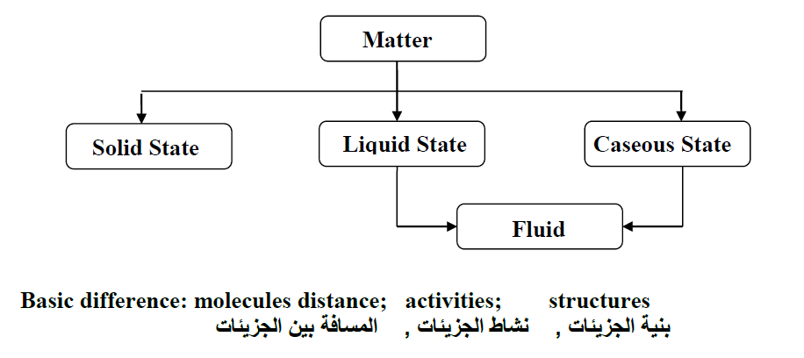

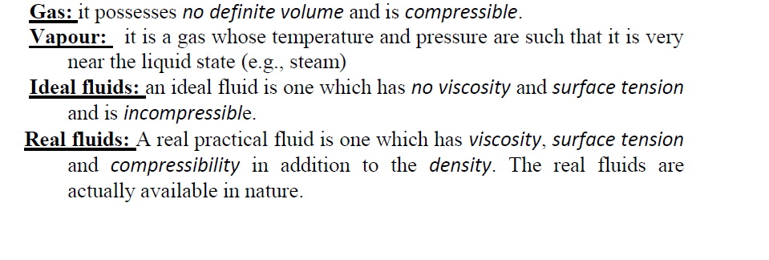
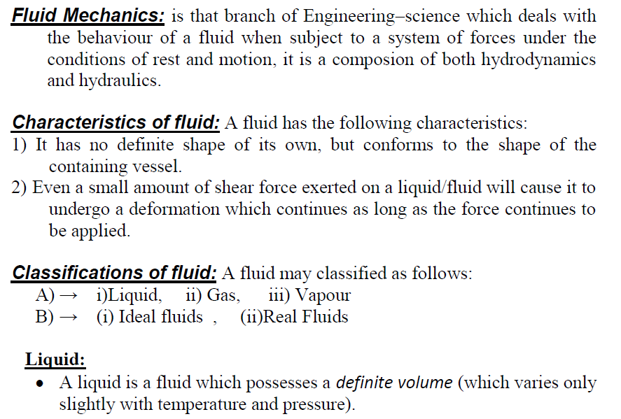

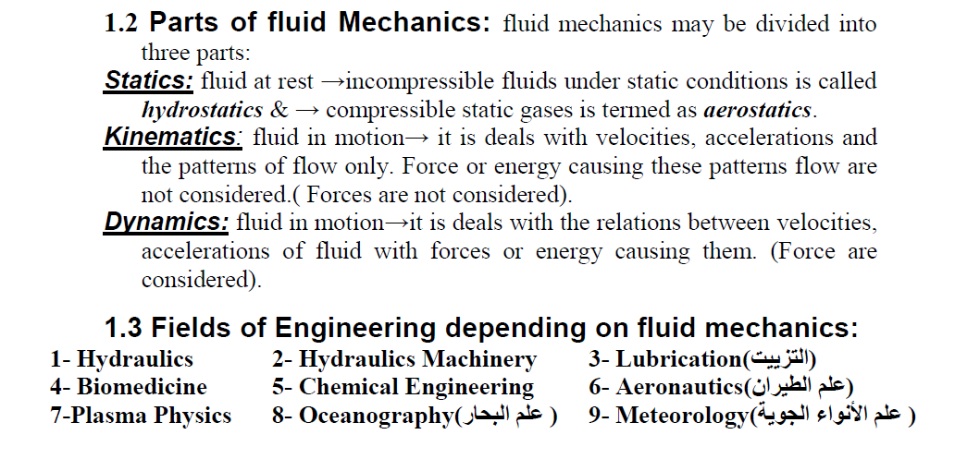
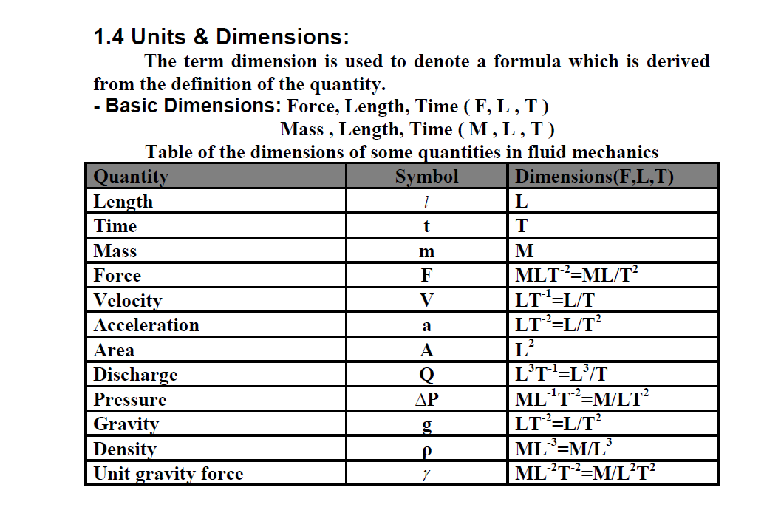
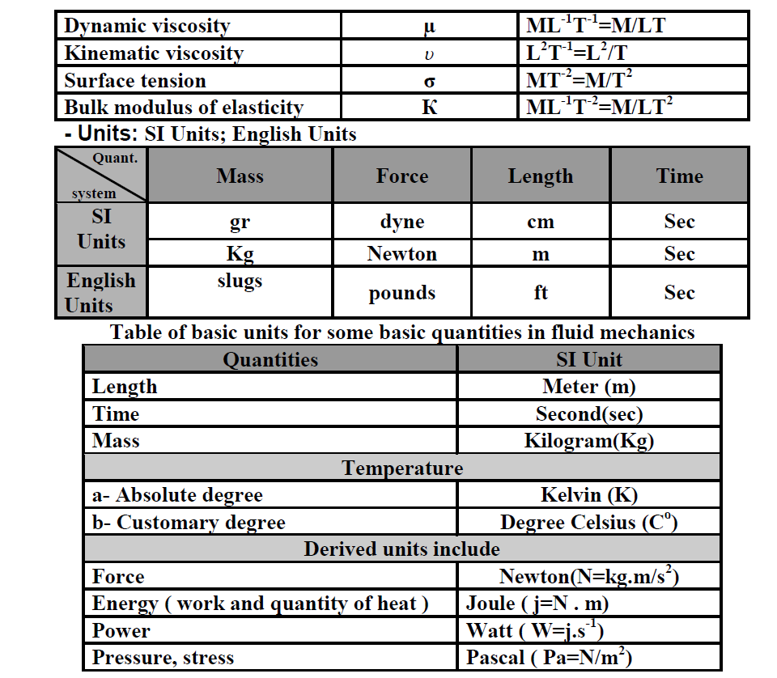

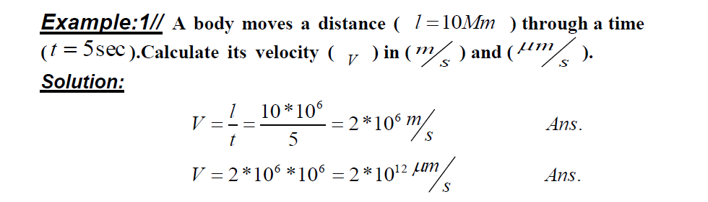

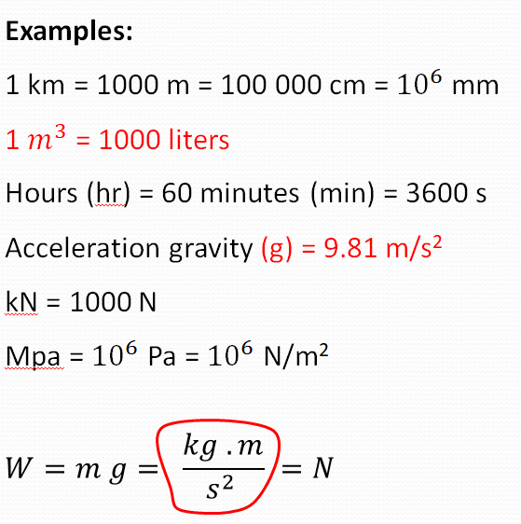
2//

