


Analysis and Design of

Reinforced Concrete Structures



Presentation Overview

- Building system primary functions
- Types of load
- RC structural systems
- RC structural members

2

Basic Building System Functions

Support gravity loads for strength and serviceability during:
- Normal use (service) conditions
- Maximum considered use conditions
- Environmental loading of varying intensities

3

Vertical deflection (sag) Lateral deflection (sway)

Dead, Live, etc.
Wind or earthquakes

Performanc Based Design Control displacements within acceptable limits during service loading, factored loaded, and varying intensities of environmental loading
4

Types of Load

Gravity: Lateral

Dead Live
Wind Earthquake

Impact Soil lateral pressure

Snow Rain/floods
Thermal Centrifugal



RC Structural Systems

  - Floor Systems
  - Lateral Load Systems

Floor Systems

- Flat plate
- Flat slab (w/ drop panels and/or capitals)
- One-way joist system
- Two-way waffle system





Flat Plate Floor System
Slab-column frame system in two-way bending

Plan Elevation

8

Flat Plate Floor System

Advantages:
- Simple construction
- Flat ceilings (reduced finishing costs)
- Low story heights due to shallow floors

Typical Applications:
- Short-to-medium spans with light loading
- For LL=50 psi, 15’ - 30’ spans
- For LL=100 psi, 15’ – 25’ spans

9




Plan Elevation

10

Advantages:
- Same as flat plate system, plus
  - Increased gravity and lateral load resistance
  - Increased torsional resistance
  - Decreased slab edge displacements

Typical Applications:
- Same as flat plate systems

11


Flat Plate w/Beams Floor System
Two-way bending

Gravity and lateral load frames

12

Flat Plate w/Beams Floor System

Advantages:
- Increased gravity and lateral load resistance
- Simple construction
- Flat ceilings (reduced finishing costs)

Typical Applications:
- Medium spans with light loading
- For LL=50 psi, 25’ - 30’ spans
- For LL=100 psi, 20’ – 30’ spans

13

Flat Slab Floor System
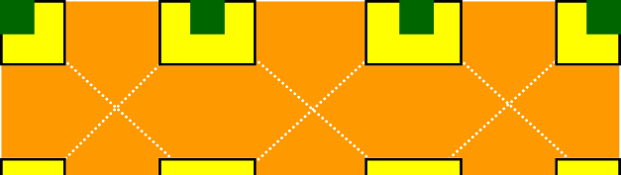
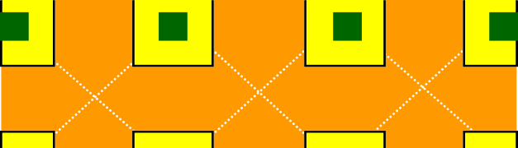

Flat plate with drop panels,shear capitals, and/or column capitals

Plan Elevation

14

Flat Slab Floor System

Advantages:
- Reduced slab displacements
- Increased slab shear resistance
- Relatively flat ceilings (reduced finishing costs)
- Low story heights due to shallow floors

Typical Applications:
- Medium spans with moderate to heavy loading
- For LL=50 psi, 30’ – 35’ spans
- For LL=100 psi, 25’ – 35’ spans

15

One-Way Joist Floor System
Rib (joist) slab : (One-way bending)

2D gravity or lateral frames
2D lateral frames

Floor joists, type

16

One-Way Joist Floor System
Rib (joist) slab with beams: (One-way bending)

Lateral space frame

Floor joists, type

17

One-Way Joist Floor System
Typical Joist
Top of Slab

Width varies 4”, 6” or larger
8-24” for 30” Modules
16-24” for 53” Modules
1:12 Slope, type 14-24” for 66” Modules .

- 2’ or 3’ cc. – Joists

  - 4’ or 6’ cc. – Skip joists
  - 5’ or 6’ cc – Wide-module joists

One-Way Joist Floor System

Advantages:
- Longer spans with heavy loads
- Reduced dead load due to voids

- Electrical,
mechanical etc.
can be placed between voids

- Good vibration resistance

Typical Applications:
- Medium-to-long spans with heavy loading
- For 30” modules, 35’ – 40’ spans
- For 53” & 66” modules, 35’ – 50’ spans

Two-Way Joist Floor System
Waffle slab : (Two-way bending)

2D lateral frames

Waffle pans, type

20

Two-Way Joist Floor System

Advantages:
- Longer spans with heavy loads
- Reduced dead load due to voids

- Electrical,
mechanical etc.
can be placed in voids

- Good vibration resistance
- Attractive Ceiling

Typical Applications:
- Long spans with heavy loading
- For 3’, 4’, and 5’ modules, 40’ – 50’ spans and beyond

Floor System Effective Cost
(PCA 2000)

100
Live Load, psf

Flat Plate
Flat Slab
One-way joist

50

25 30 35 50

