

Department of biology

((Invertebrates ))
2 stage

Lab -1-

Electronic Microscope

By
Duha Abd Al ameer

Electron microscope
Electron microscope (EM) is a type of microscope that uses electrons to create an
image of the target. It has much higher magnification or resolving power than a normal light microscope.

Principle working
An electron microscope uses an 'electron beam' to produce the image of the object
and magnification is obtained by 'electromagnetic fields'; unlike light or
optical microscopes, in which 'light waves' are used to produce the image and
magnification is obtained by a system of 'optical lenses,

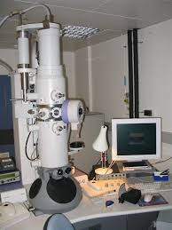
Electron microscope

Parts of an electron microscope
1-Electron gun
2-Electron magnetic lenses
a-condenser lens
b-Objective lens
c-Projector lens
3-Fluorescent screen
4- Camera
5-Deflation device
6-Voltage measuring device

Types of Electron microscope
The major types of Electron Microscopes are as follow
A. Transmission electron microscope (TEM).
used to view thin specimens (tissue sections, molecules, etc) through
which electrons can pass generating a projection image.
B. Scanning electron microscope (SEM).
scans a focused electron beam over a surface to create an image. The
electrons in the beam interact with the sample, producing various signals
that can be used to obtain information about the surface topography and
composition

.
C. Reflection electron microscope (REM).
Is now well established as a technique for the study of the structure of
surfaces of crystals

