Lec two : Body tissues and Membrane
Histology : Is the science that study the structure of cells and tissues
The cell: Is the smallest structural and functional unit in the body
Tissues: are groups of cells that are similar in structure and function
There are four basic tissue types:
- The Epithelial tissue: covering
- The Connective tissue: support
- The Nervous tissue: control
- The Muscular tissue : movement
: this Found in different areas : 1.The Epithelial tissue
- Body coverings
- Body linings
- Glandular tissue
ITS Functions :Protection , Absorption , Filtration and Secretion
Classification of Epithelium: SIMPLE AND STRATIFIED
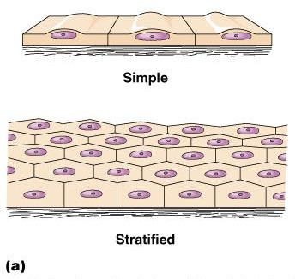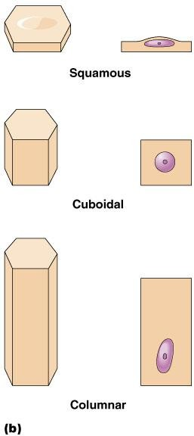
  - Simple : single layer of cells;
Types of Simple Epithelium
  - Simple squamous epithelial tissue.
  - Simple cuboidal epithelial tissue.
  - Simple columnar epithelial tissue.
  - peudostratified columnar epithelial tissue
  - Stratified : layers of cells; common in areas where protection is needed like the skin

2.Stratified epithelial tissue: Types of Stratified Epithelium
- Stratified squamous epithelial tissue.
- Stratified cuboidal epithelial tissue.
- Stratified columnar epithelial tissue.
- Transitional epithelial
- Simple squamous epithelial tissue: Single layer of flat cells Usually forms membranes , Lines body cavities Lines lungs and capillaries
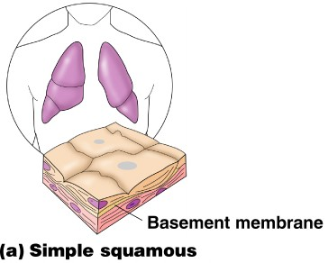
B.Simple cuboidal epithelial tissue. Single layer of cube-like cells Common in glands and their ducts
Forms walls of kidney tubules also Covers the ovaries.
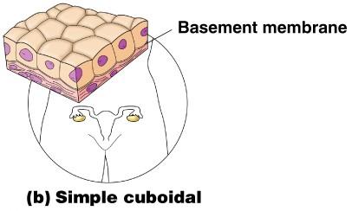
- Simple columnar epithelial tissue
Single layer of tall cells Often includes goblet cells, which produce mucus Lines digestive tract
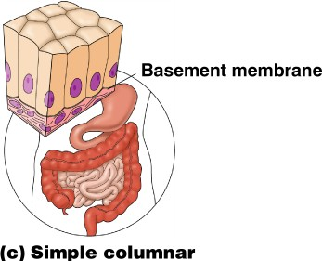
Peudostratified columnar epithelial tissue : Single layer, but some cells are shorter than others , Often looks like a double cell
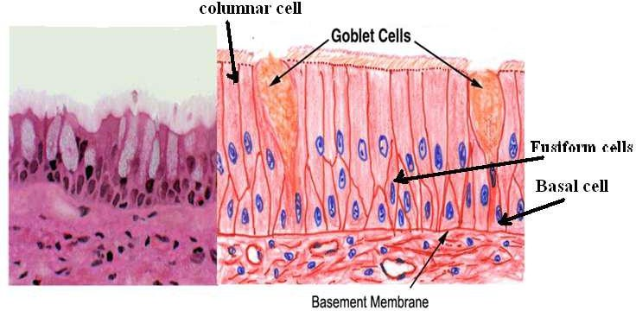
layer , Sometimes ciliated, such as in the respiratory tract
Stratified epithelial tissue :- Composed of more than one layer based on basement membrane , classified to :-
A. Stratified squamous epithelial tissue.
There are two types of stratified squamous epithelial tissue:
- -Non keratinized squamous epithelial tissue which is covering moist cavities such as mouth , esophagus , pharynx …..etc.
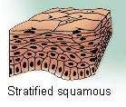
- Keratinized squamous epithelial tissue found on exposed surface of the body such as the skin .
Stratified cuboidal epithelial tissue B.
The surface layer cuboidal in shape , found in the large excretory ducts in the salivary glands and pancreas .
C. Stratified columnar epithelial tissue
Is found in the fornix of conjunctiva while the ciliated Stratified columnar epithelial tissue is found in the larynx .
D.Transitional epithelial tissue
Is found exclusively in the passages of the urinary system .
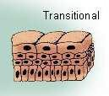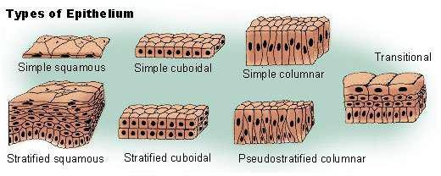

Glandular tissue : cells or parenchyma of the glands developed from epithelial tissue , according to the methods of secreted products of gland the glandular epithelial tissues classified to :
A-Exocrine glands(excrete their product into ducts )like skin
B- Endocrine glands(secret their products direct into circulatory system) C-Mixed glands (like pancreas)
A- Exocrine gland :have a secretory portion which contains the cells specialized for secretion and ducts which transport the secretion out of the gland .According to the way the secretory products leave the cell
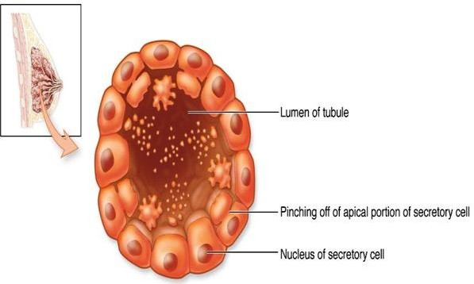
- Apocrine ; the secretory products is typically a large lipid droplet and is discharged together with some of the apical cytoplasm Example; Mammary glands
- Merocrine / Eccrine: secrete product usually containing proteins by means of exocytosis at the apical end of the secretory cells Example; (e.g. salivary glands)
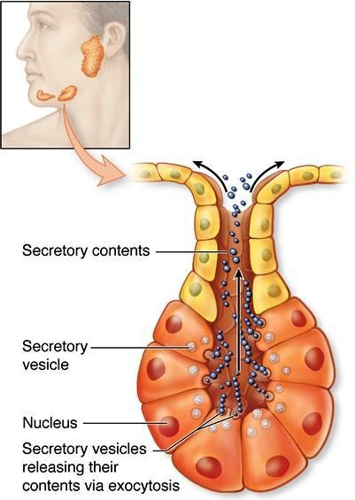
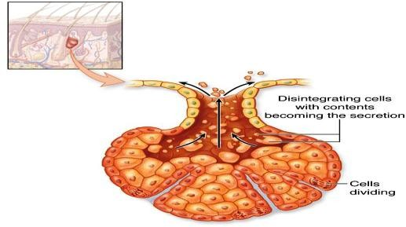
- Holocrine : the cell filling with secretory product and then the whole cell being disrupted and shed .EG: Sebaceous glands of skin.
B. ENDOCRINE GLANDS
- Endocrine glands have not any ducts - ductless
- Their specific products – hormones are released directly into the bloodstream . The major endocrine glands include:
Pituitary,Hypothalamus thyroid,Parathyroid,Adrenal,Pancreas,Ovary (females), Testis (males)
Connective tissue
Connective tissue is the most abundant and the most widely distributed of the tissues. Connective tissues perform a variety of functions including support and protection. All connective tissue consists of three main components: fibers, ground substance and cells.
Connective Tissue Fibers:
  - Collagen Fibers
  - Elastic Fibers
  - Reticular Fibers
Connective Tissue Types
1. Loose CT: Adipose CT
2. Dense CT: Regular and irregular
3. Spescialized : bone , cartilage, areolar , Reticular:
1- Loose connective tissue: has a relatively large proportion of ground substance or cells, The fibers are very few. E.g Adipose, or fat tissue,.
2- Dense connective tissue: It has thicker, denser fibers and fewer cells. E.g( tendons and ligaments) There are 2 types of dense connective tissue: regular, and irregular

1.Dense Regular Connective Tissue :The collagen fibers are bundled in parallel fashion.
2. Dense Irregular Connective Tissue :This tissue has fibers that are not arranged in parallel bundles ., such as the capsules of the kidneys and adrenal glands.
3.Specialized Connective Tissue: This type CT found in Skeletal tissues (cartilage and bone) and vascular or fluid tissues (blood and lymph).
- BONE , osseous CT : Composed of
- Bone cells in lacunae (cavitie
- Hard matrix of calcium salts
- Large numbers of collagen fibers
- Used to protect and support body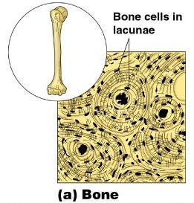
- Cartilage Connective Tissue: Types includes include hyaline , elastic and fibrocartilage
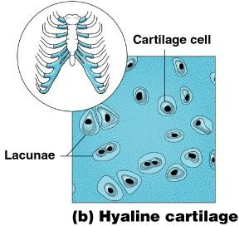
A.Hyaline cartilage ; Most common cartilage Composed of Abundant collagen fibers Rubbery matrix, Example fetal skeleton
B.Elastic cartilage : Provides elasticity , Example: the external ear
C.Fibrocartilage: Highly compressible Example: forms cushion-like discs between vertebrae

- Areolar CT: Most widely distributed connective tissue Soft, pliable tissue , Contains all fiber types,Can soak up excess fluids
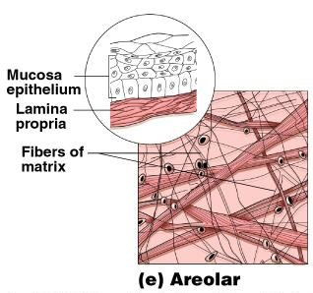
- Reticular Connective Tissue: lymphoid organs Lymph nodes , Spleen and Bone marrow.
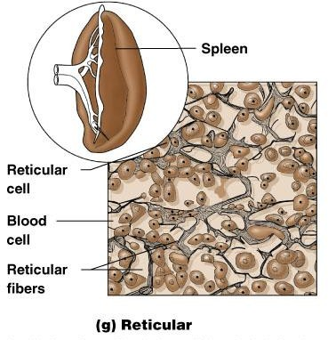
MuscleTissue : Function is to produce movement
Three types Skeletal muscle , Cardiac muscle and Smooth muscle
Nervous Tissue : Neurons and nerve support cells , Function is to send impulses to other areas of the body, irritability and conductivity
