First lecture: Physiology:
It’s the science that seeks to explain the physical and chemical mechanisms that are responsible for the origin, development, and progression of life .


Types of physiology fields:
- Viral physiology.
- Bacterial physiology.
- Cellular physiology.
- Plant physiology.
- Invertebrate physiology.
- Vertebrate physiology.
- Mammalian physiology.
- Human physiology.

Human Physiology:
The science that attempts to explain the specific characteristics and mechanisms of the human body that make it a living being.

Cell physiology:
The basic living unit of the body is the cell. Each organ is an aggregate of many different cells held together by intercellular supporting structures.
Each type of cell is specially adapted to perform one or a few particular functions.

General functions of the cells:
The main functions of the cells are: 1-Absorption.
- Digestion.
- Respiration.
- Biosynthesis.
- Excretion., 6-Secretion.
- Movement.
- Homeostasis.
- Reproduction.
.

Cell membrane :
1- Cell Membrane:
The cell membrane (also called the plasma membrane) envelops the cell and is thin, pliable, elastic structure only 7.5 to 10 nanometers thick.
It is composed almost entirely of proteins and lipids.

The approximate composition is proteins, 55 % phospholipids, 25 %; cholesterol, 13 % other lipids, 4 %; and carbohydrates, 3 %
The cell membrane lipid barrier impedes penetration by water-soluble substances. Its basic structure is a lipid bilayer.
The basic lipid bilayer is composed of three main types of lipids: A-phospholipids, (most abundant of the cell membrane lipids) B-Sphingolipids,
C-Cholesterol.
The lipid layer in the middle of the membrane is impermeable to the usual water-soluble substances, such as ions, glucose, and urea.
Conversely, fat-soluble substances, such as oxygen, carbon dioxide, and alcohol, can penetrate this portion of the membrane with ease.
Sphingolipids,.

Glycocalyx function: ( Cell membrane )
- Many of them have a negative electrical charge, which gives most cells an overall negative surface charge that repels other negatively charged objects.
- The glycocalyx of some cells attaches to the glycocalyx of other cells, thus attaching cells to one another.
- Many of the carbohydrates act as receptor substances for binding hormones, such as insulin;
- Some carbohydrate moieties enter into immune reactions.

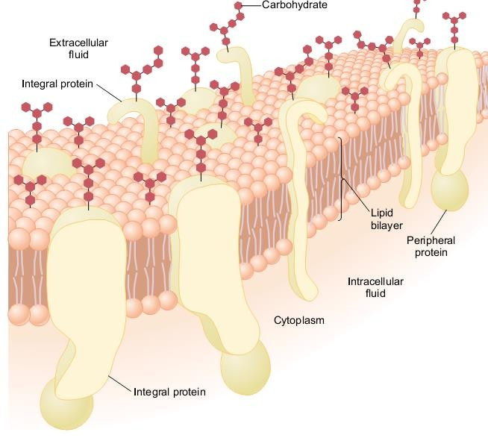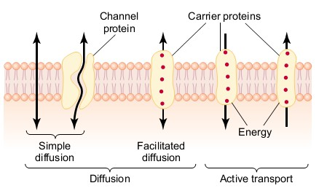
Cell Membrane Transport :
The substances can penetrate this lipid bilayer by:
1- Diffusing directly. Or Free diffusion:
it's t h e migration of molecules from a region of higher concentration to one of lower concentration as a result of random motion . Free diffusion energy and does not require external is therefore passive – Example:
Oxygen and carbon dioxide move across cell membranes down their concentration gradients by diffusion.

- Carrier-mediated Transport :( facilitated diffusion):
Bind with molecules or ions that are to be transported, Carriers are integral membrane proteins that transport substances that are hydrophilic or too large to cross the membrane by simple diffusion .
They also permit faster transport of lipid soluble substances than simple diffusion.

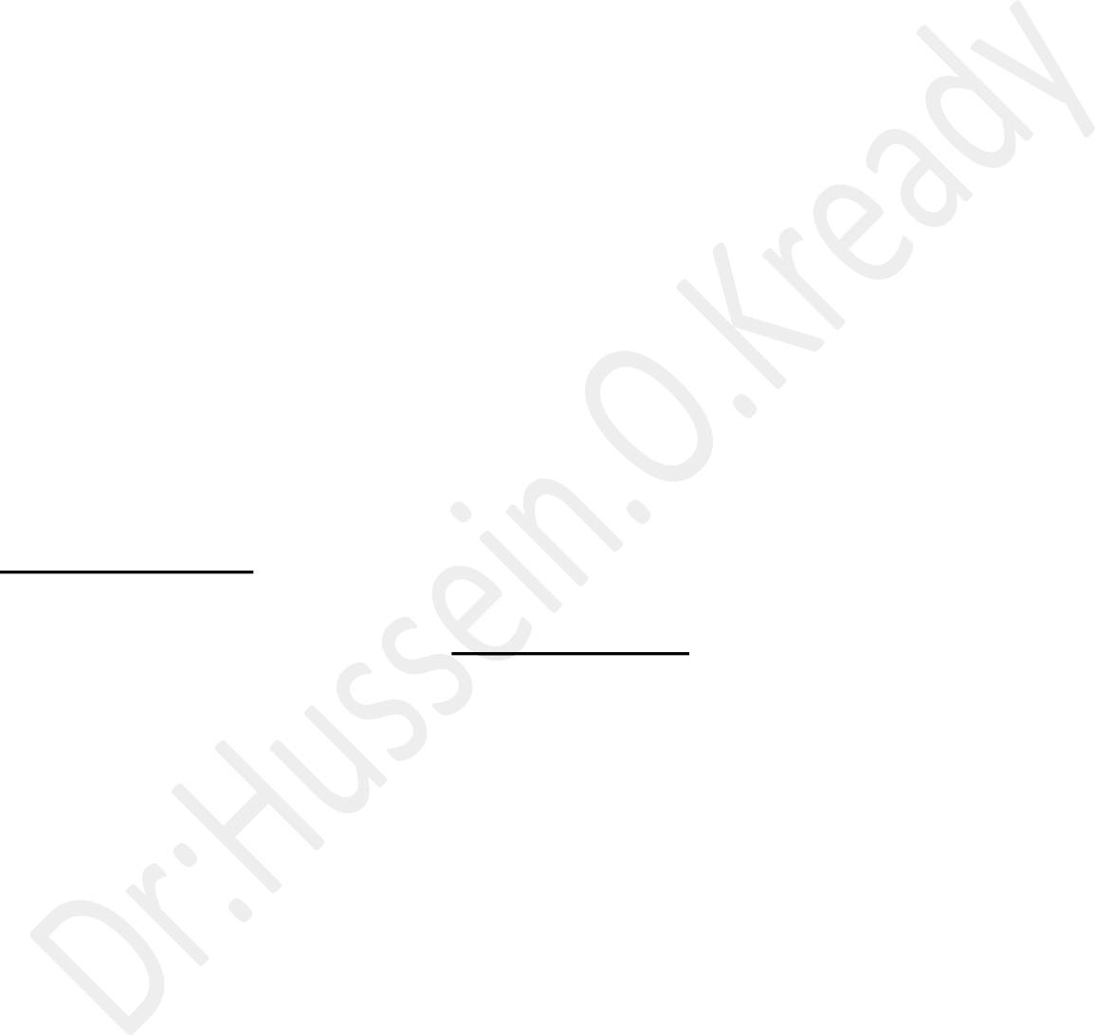
- Active transport: -
Active transport occurs when a substance i s transported across a membrane against its electrochemical gradient by transport proteins. This process requires energy i n the form of adenosinetriosphate (ATP), therefore it is active.

- Osmosis:
Osmosis is the net diffusion of water across a semipermeable membrane. (Permeable to water but not solutes membrane).
The net movement of water across asemipermeable membrane is due to the concentration differences of the no penetrating solutes. Water diffuse from a low osmolality solution (high water).

Second lecture :

The body fluids:
Essentially all the organs and tissues of the body perform functions that help maintain the constituents of the extracellular fluid so they are relatively stable, A condition called homeostasis.

Extracellular Fluid Transport and Mixing System:
Extracellular fluid is transported throughout the body in two stages.
- The first stage is movement of blood throughout the circulatory system.
- The second stage:
Is movement of fluid between the blood capillaries and cells.
The circulatory system keeps the fluids of the internal environment continuously mixed by pumping blood through the vascular system.
As blood passes through the capillaries, a large portion of its fluid diffuses back and forth into the interstitial fluid that lies between the cells, allowing continuous exchange of substances between the cells and the interstitial fluid and between the interstitial fluid and the blood.

Origin of Nutrients in the Extracellular Fluid:
- The respiratory system provides oxygen for the body and removes carbon dioxide.
- The gastrointestinal system digests food and facilitates absorption of various nutrients, including carbohydrates, fatty acids, and amino acids, into the extracellular fluid.
- The liver changes the chemical composition of many of the absorbed substances to more usable forms, and other tissues of the body (e.g., fat
cells, kidneys, endocrine glands) help modify the absorbed substances or store them until they are needed.
- The musculoskeletal system
Without this system, the body could not move to the appropriate place to obtain the foods required for nutrition.
The maintenance of a relatively constant volume and a stable composition of the body fluids are essential for homeostasis.
Some of the most common and important problems in clinical medicine arise because of abnormalities in the control systems that maintain this relative constancy of the body fluids.

DAILY INTAKE OF WATER:
Water is added to the body by two major sources:
- : It is ingested in the form of liquids or water in food, which together normally adds about 2100 ml/day to the body fluids.
- : it is synthesized in the body by oxidation of carbohydrates, adding about
200 ml/day.
These mechanisms provide a total water intake of about 2300 ml/day.

DAILY LOSS OF BODY WATER:
Insensible Water Loss:
Some water losses cannot be precisely regulated. For example:
Humans experience continuous loss of water by evaporation from the respiratory tract and diffusion through the skin, which together account for about 700 ml/day of water loss under normal conditions.
This loss is termed insensible water loss, because we are not consciously aware of it, even though occurs continually in all living humans.

BODY FLUID COMPARTMENTS:
The total body fluid is distributed mainly between two compartments:

1- Extracellular fluid :
Which divided into;- A-interstitial fluid.
A- Blood plasma.
B- Tran’s cellular fluid:

Small amount compartment includes:
- Fluid in the synovial.
- Peritoneal, pericardial.
- Intraocular spaces.
- Cerebrospinal fluid.
It is usually considered to be a specialized type of extracellular fluid. Although in some cases its composition may differ markedly from that of the plasma or interstitial fluid.
All the Trans cellular fluids together constitute about )1 to 2 liters in a 70-kilogram adult man), the total body water is about (60 %) of the body weight, or about 42 liters.
This percentage depends on:
A- Age.
B- Gender.
C- Degree of obesity.
As a person grows older:
The percentage of total body weight that is fluid gradually decreases. This decrease is due in part to the fact that aging is usually associated with an increased percentage of the body weight being fat, which decreases the percentage of water in the body
Because women normally have a greater percentage of body fat compared with men, their total body water averages about (50 %) of the body weight.
In premature and newborn babies, the total body water ranges from (70 - 75 %) of body weight.

2- Intracellular fluid:
About 28 of the 42 liters of fluid in the body are inside the 100 trillion cells (in human being) and are collectively called the intracellular fluid.
Thus, the intracellular fluid constitutes:
About 40% of the total body weight in an ―average person.
The fluid of each cell contains its individual mixture of different constituents, but the concentrations of these substances are not similar from one cell to another.

In fact the composition of cell fluids is remarkably similar even in different animals, ranging from the most primitive microorganisms to humans.
For this reason, the intracellular fluid of all the different cells together is considered to be one large fluid compartment.

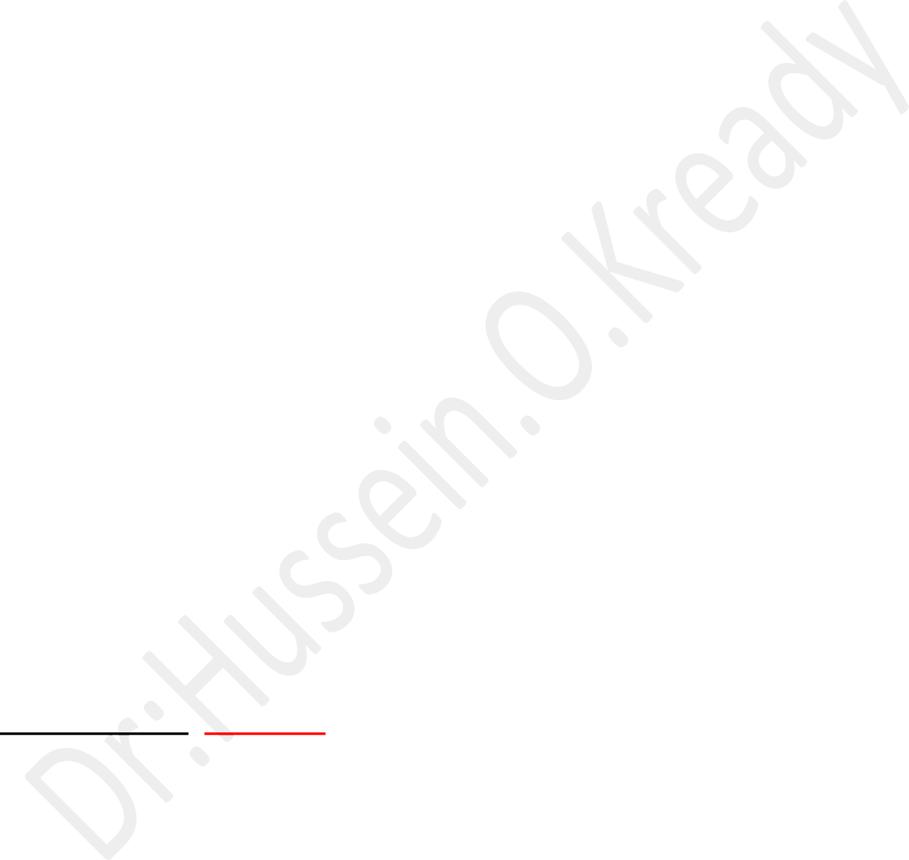
Some Important Constituents and Physical Characteristics of the Extracellular Fluid:
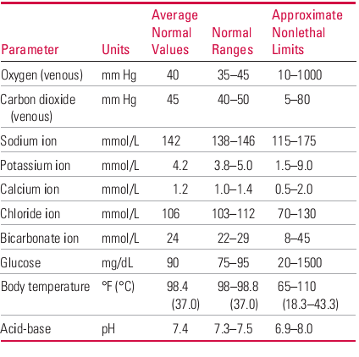
Third lecture 3: The blood
Blood is the vehicle for long-distance, mass transport of materials between the cells and external environment or between the cells themselves.
Such transport is essential for maintaining homeostasis.
- An average woman has about 5 liters of blood.
- An average man has approximately 6 liters of blood in the body.
- Blood accounts for about (8%) of total body weight.
- Blood is the uniquely specialized connective tissue in that it consists of two components:
- Blood or the blood cells.
- Fluid part of blood or plasma.

Blood cells become packed at the bottom of the test tube when whole blood is centrifuged, leaving the fluid plasma at the top of the tube.
Red blood cells are the most abundant of the blood cells.
white blood cells and platelets form only a thin ,light-colored ―buffy coat.
‖ at the interface between the packed red blood cells and the plasma.

Functions of the Blood:
- Blood transports oxygen from the lungs, where it enters the RBCs, to all cells of the body.
- Blood carries nutrients, ions and water from the digestive tract to all cells of the body.
- Blood transports waste products from the body’s cells to the sweat glands and kidneys for excretion.
- Blood transports hormones from endocrine glands to target organs in the body.
- Blood transports enzymes to body cells to regulate chemical processes and chemical reactions.
- Blood helps regulate body pH through buffers and amino acids that it carries.
- Blood plays a role in the regulation of normal body temperature.
- Blood also transports carbon dioxide from the cells.
- Blood plays a vital role in protecting the body against foreign microorganisms and toxins through its special combat unit cells.

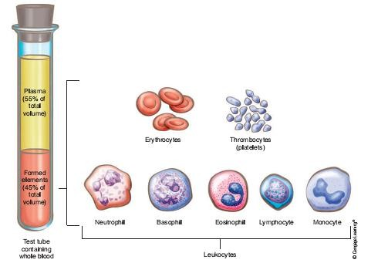

The classification of blood cells:
A- Erythrocytes or red blood cells (RBCs), which make up about 95% of the volume of blood cells
B- Leukocytes or white blood cells (WBCs) are divided into two subcategories: the granular leukocytes and the a granular or no granular leukocytes, which make up about 20% to 25% of WBCs.
C. Thrombocytes or platelets.

Plasma:

Viscous fluid obtained from blood which is prevented from clotting.
Its accounts for about 55% of blood; the formed elements make up about 45% of the total volume of blood
Serum: Plasma without the clotting proteins. Plasma–Fibrinogen = Serum.

Composition of plasma:

It’s a straw-colored liquid consisting of water and dissolved solutes.
The major solute of the plasma in terms of its concentration is Na , In addition to Na , plasma contains many other ions, as well as organic molecules such as ;
Metabolites, hormones, enzymes, antibodies, and other proteins.

Plasma Proteins:
Plasma proteins constitute (7% to 9%) of the plasma.
The three types of proteins are: 1-albumins.
2 –Globulins.
- Fibrinogen.


Fourth lecture:

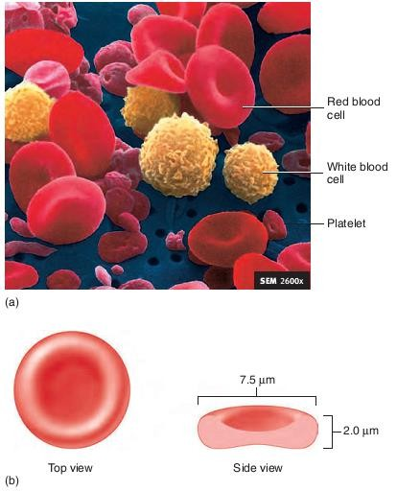

Erythrocytes: (General features):
  - Erythrocytes are flattened, biconcave discs about 7 µm in diameter and
2.2 µm thick. Their unique shape relates to their function of transporting oxygen.
  - The average volume of the RBC is 90 to 95 cubic micrometers.
  - Each erythrocyte contains approximately 280 million hemoglobin molecules, which give blood its red color.
  - A healthy man has 5.4 million RBCs/ mm³ of blood and a healthy woman has 4.8 million RBCs/mm³ of blood.
  - Erythrocytes lack nuclei and mitochondria (they obtain energy through anaerobic metabolism).
  - Erythrocytes have a relatively short circulating life span of only about 120
days.
  - The shapes of RBCs can change remarkably as the cells squeeze through capillaries. Actually, the RBC is a― bag‖ that can be deformed into almost any shape
  - Older erythrocytes are removed from the circulations by phagocytic cells in the liver, spleen, and bone marrow .
  - Persons living at high altitudes have greater red blood cells.

Majors Functions of RBCs:
- Transport hemoglobin, which, in turn, carries oxygen from the lungs to the tissues.
- They contain a large quantity of carbonic anhydrase, an enzyme that catalyzes the reversible reaction between carbon dioxide (CO and water to form carbonic acid (H₂CO₃).
Reaction makes it possible for the water of the blood to transport enormous.
- The RBCs are responsible for most of the acid- base buffering power of whole blood.

Hemoglobin molecule:
Hemoglobin is a pigment found in only in red blood cells (that is naturally colored because of its iron content;
It appears reddish when combined with O₂ and bluish when oxygenated. Thus, fully oxygenated arterial blood is red, and venous blood, load at the tissue level, has a bluish cast.
This has lost some of its O.

The structure:
Hemoglobin molecule has two parts:
  - The globin portion, a protein made up of four highly folded polypeptide chains.
  - Four iron-containing, no protein groups known as heme groups, each of which is bound to one of the polypeptides.
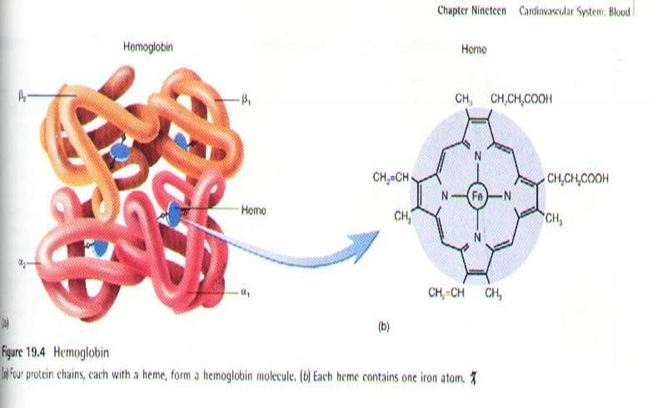

ABO system:
A system to identify the antigen on the surface of the blood cell into human being, also called to determine the blood type.

ABO system (General observation):
- There are several groups of red blood cell antigens, but the major group is known as the ABO system.
IN terms of the antigens present on the red blood cell surface, a person may be type A (with only A antigens), type B (with only B antigens), or type O (with neither A nor B antigens).
- Each person’s blood type—A, B ,or O—denotes the antigens present on the red blood cell surface, which are the products of the genes that code for these antigens.
- Each person inherits two genes (one from each parent) that control the production of the ABO antigens.
- The genes for A or B antigens are dominant to the gene for O.
- The O gene is recessive, simply because it doesn’t code for either the A or the B red blood cell antigens.
- The genes for A and B are often shown as I^{A} and I ^{B} ,and the recessive gene for O is shown as the lower-case I.

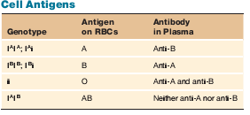

Lecture five : Erythropoiesis :
Its refers to the formation of erythrocytes.
The bone marrow produces all of the different types of blood cells. Erythropoiesis is an extremely active process.
It is estimated that about 2.5 million erythrocytes (2.5 million/ sec) are produced every second in order to replace those that are continuously destroyed by the spleen and liver.

Regulation of Erythropoiesis (Homeostasis ) :
- The primary regulator of erythropoiesis is:

Erythropoietin:
A hormone produced by the kidneys in response to tissue hypoxia when the blood oxygen levels are decreased.
- One of the possible causes of decreased blood oxygen levels is a decreased red blood cell count.
- Because of erythropoietin stimulation, the daily production of new red blood cells compensates for the daily destruction of old red blood cells, preventing a decrease in the blood oxygen content.
An increased secretion of erythropoietin and production of new red blood cells occurs when a person is at a high altitude or has lung disease, which is conditions that reduce the oxygen content of the blood.

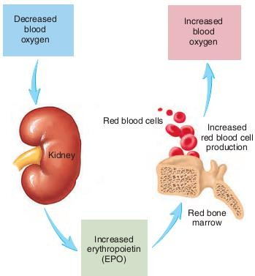

The Life spane of red blood cells:
When RBCs are delivered from the bone marrow into the circulatory system, they normally circulate an average of 120 days before being destroyed.

Even though mature RBCs do not have:
A- A nucleus.
B- Mitochondria.
C- Endoplasmic reticulum.
They do have cytoplasmic enzymes:
That is capable of metabolizing glucose and forming small amounts of adenosine triphosphate.
Death and Disposal:
- The metabolic systems of old RBCs become progressively less active and the
cells become more and more fragile.
- Presumably because their life processes wear out Once the RBC membrane becomes fragile,
- the cell ruptures during passage through some tight spot of the circulation.
- Many of the RBCs self-destruct in the spleen where they squeeze through the red pulp of the spleen there.
the spaces between the structural trabecular of the red pulp, through which most of the cells must pass, is only 3 micrometers wide, in comparison with diameter of the RBC. -the
When the spleen is removed, the number of old abnormal RBCs circulating in the blood increases considerably.

Destruction of Hemoglobin:
When RBCs burst and release their hemoglobin, the hemoglobin is phagocytized almost immediately by macrophages in any parts of the body, but especially by the:
  - Kupffer cells of the liver.
  - Macrophages of the spleen.
  - Bone marrow.
During the next few hours to days, the macro-phages release iron from the hemoglobin and pass it back into the blood, to be carried by transferrin either to the bone marrow for the production of new RBCs or to the liver and other tissues for storage in the form of ferritin .
The porphyrin portion of the hemoglobin molecule is converted by the macrophages, through a series of stages ,into the bile pigment bilirubin, which is released into the blood and later removed from the body by secretion through the liver into the bile.

Lecture sixth:

Leucocytes (White blood cells):
The leukocytes, also called white blood cells:
Are the mobile units of the body’s protective system. They are formed partially in the
- Bone marrow (granulocytes and monocytes and a few lymphocytes).
- Partially in the lymph tissue (lymphocytes and plasma cells).
After formation, they are transported in the blood to different parts of the body where they are needed.
The number of leukocytes in the blood:
Is often an indicator of disease, and thus the white blood cell count is an important subset of the complete blood count.
The normal white cell count is usually between 4 × 10⁹/L and 1.1 × 10¹⁰/L. Usually expressed as:
4,000 to 11,000 white blood cells per microliter of blood.
A- White blood cells make up approximately 1% of the total blood volume in a healthy adult, making them substantially less numerous than the red blood cells
at 40% to 45%.
B- However, this 1% of the blood makes a large difference to health, because immunity depends on it.
C- An increase in the number of leukocytes over the upper limits is called leukocytosis.
D- It is normal when it is part of healthy immune responses, which happen frequently.
E- It is occasionally abnormal, when it is neoplastic or autoimmune in origin.
F- A decrease below the lower limit is called leukopenia. This indicates a weakened immune system.

The main features of white Blood Cells:
- White blood cells are spherical cells that lack hemoglobin.
- White blood cells are larger than red blood cells.
- Each has nucleus.
- White blood cells can leave the blood and travel by amoeboid. Movement through the tissues.

Functions of white blood cells :
- -Protect the body against invading microorganisms and other pathogens.
- - Remove dead cells and debris from the tissues by phagocytosis.

Types of white blood cells( leukocytes):
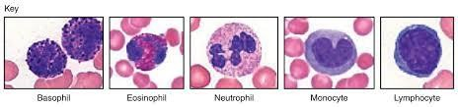
Each white blood cell type is named according to its appearance in stained preparations.
- Granules:
Are granulocytes those containing large cytoplasmic granules. 2- A granulocytes:
Those with very small granules that cannot be seen easily with the light microscope.
There are three tiypes of granulocytes:
A- Neutrophils.
B- Basophils. C-Eosinophil’s.
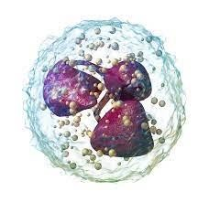

Neutrophils features:
- The most common type of white blood cells.
- Have small cytoplasmic granules that stain with both acidic and basic dyes.
- Their nuclei are commonly lobed, with the number of lobes varying from 2-5 4-Neutrophils usually remain in the blood for a short time (10–12 hours), move into other tissues, and phagocytize microorganisms and other foreign substances.
- Dead neutrophils, cell debris, and fluid can accumulate as pus at sites of infections.

Basophils features:
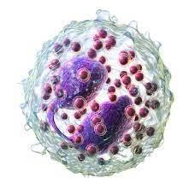

  - It's the least common of all white blood cells.
  - Contain large cytoplasmic granules that stain blue or purple with basic dyes.
  - Basophils release histamine and .They also release heparin, which prevents the formation of clots.

Eosinophil's features: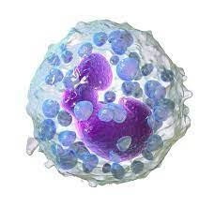
- Contain cytoplasmic granules that stain bright red with eosin, an acidic stain.
- They often have a two-lobed nucleus.
- Eosinophils are involved in inflammatory responses associated with
allergies and asthma.
- Chemicals from eosinophil's are involved in destroying certain worm parasites

There are two types of a granulocytes:
  - Lymphocytes.
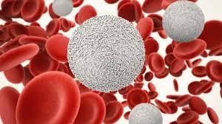
  - Monocytes.

Lymphocytes features :
- The smallest of the white blood cells.

- The lymphocytic cytoplasm consists of only a thin, sometimes imperceptible ring around the nucleus.
- There are several types of lymphocytes,( T,B, and natural killer cells ).
- They play an important role in the body’s immune response.
- Their diverse activities involve the production of antibodies and other chemicals that destroy microorganisms, contribute to allergic reactions….etc.


Monocytes features :
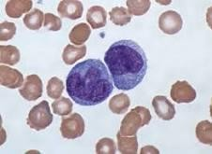

    - The largest of the white blood cells
    - After they leave the blood and enter tissues ,monocytes enlarge and become macrophages, which phagocytize bacteria, dead cells, cell fragments, and any other debris within the tissues.
    - Macrophages can break down phagocytized foreign substances and present the processed substances to lymphocytes causing activation of the lymphocytes

Life spans of te white blood cells
The life of the granulocytes after being released from the bone marrow is normally 4 to 8 hours circulating in the blood and another 4 to 5 days in tissues where they are needed.
In times of serious tissue infection, this total life span is often shortened to only a few hours because:
The granulocytes proceed even more rapidly to the infected area, perform their functions. And, in the process, are they destroyed.
The monocytes also have a short transit time, 10 to 20 hours in the blood, before wandering through the capillary membranes into the tissues. Once in the tissues, they
Swell too much larger sizes to become tissue macrophages and, in this form, they can live for months unless destroyed while performing phagocytic functions. These tissue macrophages are the basis of the tissue macrophage system).

- Which provides continuing defense against infection. Lymphocytes enter the circulatory system continually along with drainage of lymph from the lymph nodes and other lymphoid tissue.
- After a few hours, they pass out of the blood back into the tissues, then they reenter the lymph and return to the blood again and again; thus, there is continual circulation of lymphocytes through the body.
The lymphocytes have life spans of weeks or months, depending on the body’s need for these cells.
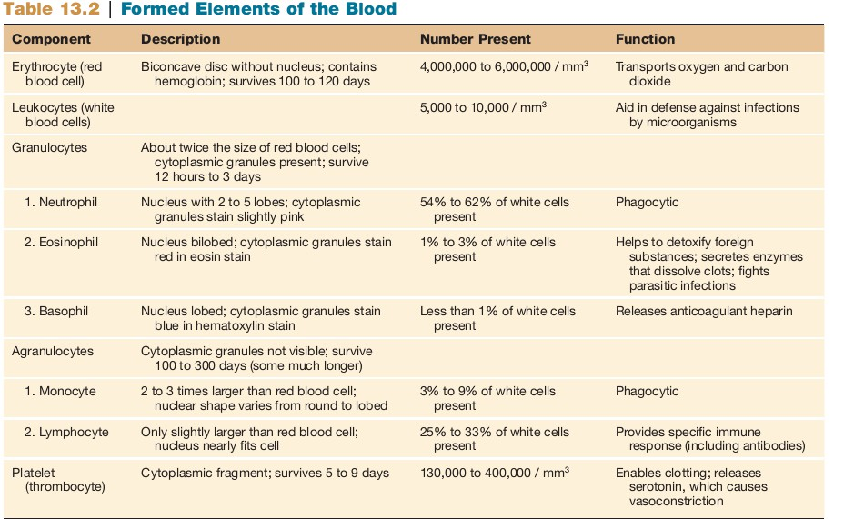

Lecture seventh:
Platelets

Platelets, also called thrombocytes.
Are minute component of blood cells, play an important role in preventing blood loss.
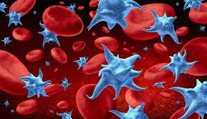
General features:
- Platelets have no cell nucleus.
- They are fragments of cytoplasm.
- Are the second most abundant of the formed elements, with each microliter of blood
- Containing between (150,000 and 400,000 platelets) .

Structure:
  - Platelets are biconvex discoid (lens-shaped) structures.2–3 µm in greatest diameter.
  - On a stained blood smear, platelets appear as dark purple spots, about 20% the diameter of red blood cells.
  - The ratio of platelets to red blood cells in a healthy adult ranges from
1:10 to 1:20.
Hemostasis events
Hemostasis:
Means the process of stopping bleeding at the site of interrupted endothelium.

Whenever a vessel is severed or ruptured, hemostasis is achieved by several mechanisms:
(1)- Vascular constriction.
(2)- Formation of a platelet plug.
(3)- Formation of a blood clot as a result of blood coagulation.
(4)- Growth of fibrous tissue into the blood clot to close the hole in the vessel permanently.


Platelet function :
- (Along with the coagulation factors) is to react to bleeding from blood vessel injury by clumping, thereby initiating a blood clot.
- They aggregate at the site and unless the interruption is physically too large, they plug the hole.

Thrombopoiesis:

Is the formation of platelets in the Bone marrow.
Thrombopoietin is the main regulator of thrombopoiesis.
Thrombopoietin affects most aspects of the production of platelets.
This includes self-renewal and expansion of hematopoietic stem cells,
stimulating the increase of megakaryocyte progenitor cells, and supporting these
cells so they mature to become platelet-producing cells.
(mature megakaryocyte membrane pseudopodial projections).
The process of Thrombopoiesis is caused by the breakdown of proplatelets
During the process almost all of the membranes, organelles, granules, and soluble macromolecules in the cytoplasm are being consumed.
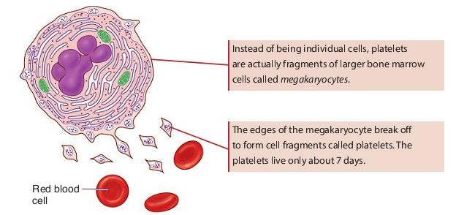

Lecture eighth:

Heart physiology:

The heart could be called the engine of life.
This organ works constantly, never pausing.Composed of a type of muscle found nowhere else in the body.
The heart works as:
  - Pump blood throughout the body, delivering oxygen-rich blood to organs and tissues and
  - Returning oxygen-poor blood to the lungs.

The heart chambers and great vessels:
The heart contains four hollow chambers.
- The two upper chambers are called atria (singular: atrium).
- The two lower chambers are called ventricles.
- Attached to the heart are several large vessels that transport blood to and from the heart. Called great vessels.
They include the:
A- Superior and inferior vena cava.
B- Pulmonary artery (which branches into a right and left pulmonary artery).
C- Four pulmonary veins (two for each lung).
D- Aorta.
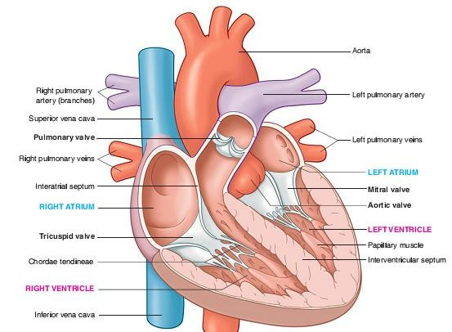

Cardiac Conduction:
Cardiac muscle is unique in that it doesn’t depend upon stimulation by extrinsic nerves to contract.

Rather; it contains special pacemaker cells that allow it to contract spontaneously, an ability called automaticity.
Also, because the heart beats regularly, it is said to have rhythmicity. (Although extrinsic nerves don’t cause the heart to beat,
- The nervous system.
- Certain hormones.
Can affect the heart’s rate and rhythm.

The electrical impulses generated by the heart follow a very specific route through the Myocardium.

Cardiac Output(CO):
Cardiac output (CO) refers to the amount of blood the heart pumps in 1 minute.
To determine cardiac output multiply the heart rate (HR)— the number of times the heart beats in 1 minute—by the stroke volume (SV)— the amount of blood ejected with each heartbeat.
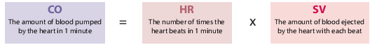

A typical resting heart rate is 75 beats per minute.
The heart ejects about 70 ml each time it beats:
That’s its stroke volume.
To determine cardiac output, multiply (75 × 70) = 5250 ml, or over 5 liters each minute. That is a typical cardiac put.
Cardiac output increases with activity, but the average resting cardiac output is
between 5 and 6 liters per minute.
- If an individual’s heart has a greater stroke volume
(Such as the well-conditioned heart of an athlete), the heart would have to beat fewer times to maintain a cardiac output of 5 liters per minute.
This explains why athletes tend to have slower pulse rates. Because cardiac output equals heart rate times stroke volume.
Because cardiac output is related to the quantity of blood delivered to various parts of the body, it is an important component of how efficiently the heart can meet the body's demands for the maintenance of adequate tissue perfusion.
- Body tissues require continuous oxygen delivery which requires the sustained transport of oxygen to the tissues by systemic circulation of

oxygenated blood at an adequate pressure from the left ventricle of the heart via the aorta and arteries.
- Oxygen delivery (DO₂ mL/min) :
Is the resultant of blood flow (cardiac output CO) times the blood oxygen content (CaO₂).
Mathematically this is calculated as follows:
  - Oxygen delivery = cardiac output × arterial oxygen content, giving the formula:
  - With a resting cardiac output of 5 L/min, a 'normal' oxygen delivery is around 1 L/min.
  - The amount / percentage of the circulated oxygen consumed (VO₂) per minute through metabolism varies depending on the activity level but at rest is circa 25% of the DO₂.
  - Physical exercise requires a higher than resting-level of oxygen consumption to support increased muscle activity.
  - In the case of heart failure, actual CO may be insufficient to support even simple activities of daily living; nor can it increase sufficiently to meet the higher metabolic demands stemming from even moderate exercise.
  - Cardiac output is a global blood flow parameter of interest in hemodynamics, the study of the flow of blood.
  - The factors affecting stroke volume and heart rate also affect cardiac output.

Heart Rate:
A person’s heart rate, or pulse, is the number of times the heart beats each minute.

Newborn infants have heart rates of about 120 beats per minute.
Young adult females tend to have heart rates of 72 to 80 beats per minute;

Young adult males have heart rates of 64 to 72 beats per minute.
A persistent pulse rate slower than 60 beats per minute is called bradycardia. Although this commonly occurs during sleep or in athletes.
A persistent, resting heart rate greater than 100 beats per minute is called

tachycardia.

Lecture ninth& tenth:
Arteries:
Arteries are high -pressure vessels that carry oxygenated blood from the Heart to the rest of the body, they have thick walls.

Arterioles:
Control blood flow and distribute blood in to the capillary beds. Their walls are com posed primarily of smooth muscle.
They are the major sites of controllable resistance in the systemic circulation.

Veins:
Are low-pressure vessels that return blood back to the heart via the Venaecavae. They also act as expandable reservoirs –They passively relax or actively constrict under sympathetic adrenergic Stimulation.

Venules:
Are small veins that collect blood from the capillaries.

Physics of blood Flow:
All blood pumped by the right side of the heart passes through the pulmonary circulation to the lungs for O₂ pickup and CO₂ removal.
The blood pumped by the left side of the heart into the systemic circulation is distributed in various proportions to the systemic organs through a parallel arrangement of vessels that branch from the aorta (Figure down).

This arrangement ensures that all organs receive blood of the same composition.
The blood vessels transport and distribute blood pumped through them by the heart to meet the body’s needs for:
- O₂ and nutrient delivery.
- Waste removal.
- Hormonal signaling.
The highly elastic arteries:
A-Transport blood from the heart to the organs.
B-Serve as a pressure reservoir to continue driving blood forward when the heart is relaxing and filling.
The mean arterial blood pressure is closely regulated to ensure adequate blood delivery to the organs.

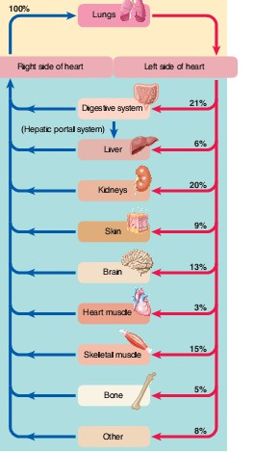
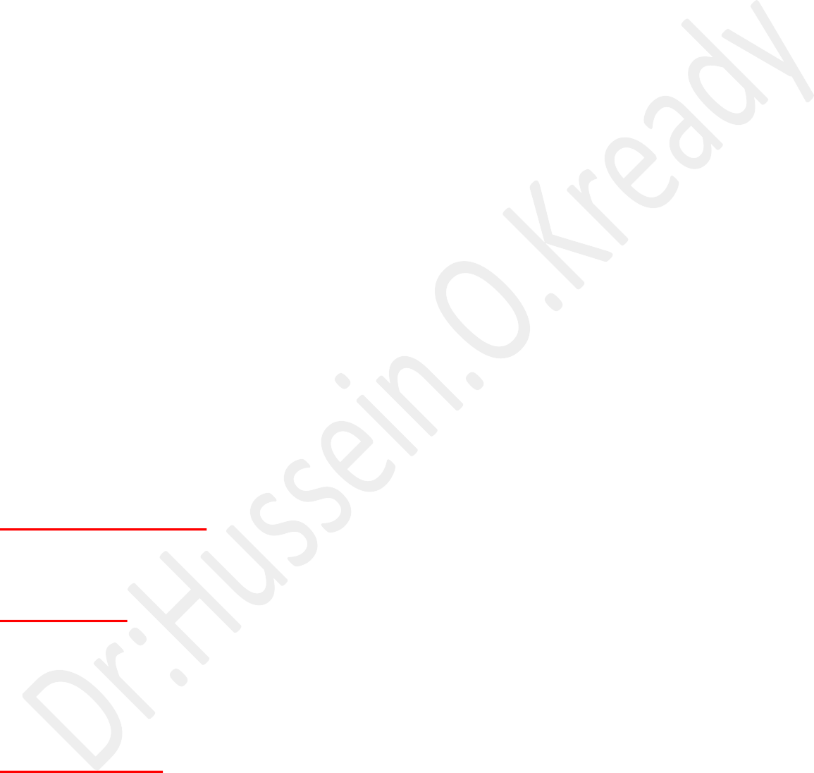
Distribution of cardiac output (CO) at rest:
Because reconditioning organs—digestive organs, kidneys and skin—receive blood flow in excess of their needs, they can withstand temporary reductions in blood flow much better than other organs can that do not have this extra margin of blood supply. The brain in particular suffers irreparable damage when transiently deprived of blood supply. After only 4 minutes without O₂, permanent brain damage occurs. Therefore, constant delivery of adequate blood to the brain, which can least tolerate disrupted blood supply, is a high priority in the overall operation of the circulatory system .
Pressure Gradient:
It's the difference in pressure between the beginning and the end of a vessel .
Resistance:
Is a measure of the hindrance or opposition to blood flow through the vessel.
As resistance to flow increases, it is more difficult for blood to pass through the vessel.

Blood resistant:
Standard units of pressure.
Blood pressure almost always is measured in millimeters of mercury (mm Hg) because the mercury manometer has been used as the standard reference for measuring pressure. Actually.
Blood pressure:
The force exerted by the blood against any unit area of the vessel wall.

Lecture eleventh:

System transports fluid.
The lymphatic system transports fluid called lymph through special vessels called lymphatic capillaries and lymphatics.
This lymph eventually gets returned to the blood from where it originated.

The primary function of this system is to:
- Drain from tissue spaces protein-containing fluid that escapes from the blood capillaries.
- Transport fats from the digestive tract to the blood. 3-Develop immunities.

Components of the lymphatic system ;
- Lymph vessels.
- Lymph nodes.
- Organs. (Tonsils, spleen, thymus gland, vermiform appendix and peyer patches) .

lymphatic Vessels:
Lymphatic vessels originate as blind-end tubes that begin in spaces between cells in most parts of the body .
The tubes, which are closed at one end, occur singly or in extensive plexuses and are called lymphatic capillaries.

These vessels are not found in the:
- Central nervous system.
- Red bone marrow.
- Vascular tissue or portions of the spleen.
Lymphatic capillaries eventually unite to form larger and larger lymph vessels called lymphatic's.

Lymphatic resemble veins in structure but have thinner walls and more valves.
The large number of valves helps to ensure that the lymph will not back flow but go in one direction only.
Along lymphatic there are lymph nodes found at various intervals.
All the lymphatic of the body converge into one of two main channels:

- Either the thoracic duct) the main collecting channel). Also known as the left lymphatic duct.
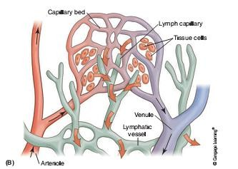
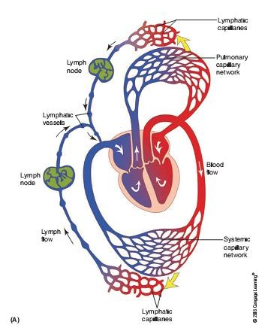
- The right lymphatic duct.

The organs of the Lymphatic system:

Tonsils:
Are masses of lymphoid tissue embedded in mucous membrane .
There are three groups of tonsils.
A- The palatine tonsils are the ones commonly removed in a tonsillectomy.
B- The pharyngeal tonsils. They are located close to the internal opening of the nasal cavity. When they become swollen, they can interfere with breathing.
C- The lingual tonsils are located on the back surface of the tongue at its base. Tonsils are more functional in children.
As we age, the tonsils decrease in size and may even disappear in some individuals.

The spleen:
Is oval in shape and is the single largest mass of lymphatic tissue in the body. It measures about 12 cm, or 5 inches, in length.
It is found in the left upper corner of the abdominal cavity.
It filters blood via the splenic artery and splenic vein, which enter the spleen at a slightly concave border called the hilum.

Functions:
- Phagocytizes bacteria.
- Worn-out platelets and red blood cells. This action releases hemoglobin to be recycled. It also produces lymphocytes and plasma cells.

- The spleen stores blood and functions as a blood reservoir.
- During a hemorrhage, the spleen releases blood into the blood circulation route.

The thymus gland:
Structure:

Is a blobbed mass of tissue located in the mediastinum along the trachea behind the sternum. Its role in the endocrine system. It reaches maximum size during puberty and then decreases. In older individuals, the thymus becomes small and is difficult to detect because it is replaced with fat and connective tissue. It is involved in immunity.
Functions:
- The thymus is a site for lymphocyte production and maturation.
- The thymus helps develop T lymphocytes in the fetus and in infants for a few months after birth.

Peyer’spatches (also known as aggregated lymphatic follicles):
Are found in the wall of the small intestine. They resemble tonsils.
Their macrophages destroy bacteria. Bacteria are always present in large numbers in the intestine, and the macrophages prevent the bacteria from infecting and penetrating the walls of the intestine.

Vermiform appendix:
Is also involved in immunity; after birth, lymphoid tissue begins to develop in the appendix, reaching peak amounts around the age of 25 .
The appendix assists in the maturing of B lymphocytes and produces immunoglobulin (IgA) antibodies.
The lymphoid tissue of the appendix decreases in amount around the age of
40 years.

Lectures 12

Respiratory system

Is a series of organs responsible for taking in oxygen and expelling carbon dioxide.

The organ of respiratory system
- Pharynx.
- Larynx.
- Trachea.
- Bronchi.
- Lungs.

The functions of the Pharynx:
- The pharynx is a passageway for both air and food.
- Forms a resonating chamber for speech sounds.

Larynx or Voice Box:
It is a very short passageway that connects the pharynx with the trachea. Its walls are supported by nine pieces of cartilage.
Three of the pieces are single and three are paired.
The three single pieces are the thyroid cartilage, the epiglottis ,and the
cricoid cartilage.
The thyroid cartilage is:
- Largest piece of cartilage.
- Is known as the Adam’s apple.
- It is larger in males than in females and can be easily seen externally , moving up and down when a person is speaking or swallowing.
The larynx is closed off when we swallow so that foods and liquids get routed posteriorly into the esophagus and are kept out of the trachea anteriorly.
If anything other than air passes into the larynx, a cough reflex should dislodge the foreign material.
When we try to talk and swallow at the same time ,we choke and the cough reflex functions.
Sensor receptors in the larynx detect the foreign substance and send a signal to the medulla oblongata, which triggers the cough reflex.
Air is taken in and the vestibular folds and vocal cords tightly close trapping the air in the lungs .

Muscular contractions increase the pressure in the lungs and the cords open, forcing air from the lungs at a very high velocity and carrying any foreign substance with it.

The trachea:
The trachea is also referred to as the windpipe.
It is a tubular passageway for air.
Approximately 4.5 inches in length and about 1 inch in diameter. It is found anterior to the esophagus.
The tracheal epithelium is pseudo stratified ciliated columnar cells with goblet cells and basal cells.
The cilia beat upward and move the mucus-dust package to the throat for elimination from the body.

The trachea is encircled by a series of horizontal incomplete rings of hyaline cartilage.
When we swallow, we temporarily stop breathing to permit the large food bolus
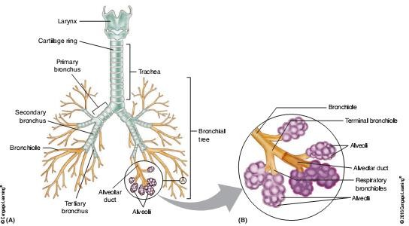
.

The Bronchi and the Bronchial tree:
The trachea terminates in the chest by dividing into a right primary bronchus and a left primary bronchus.
The right primary bronchus is more vertical, shorter, and wider than the left. If a foreign object gets past the throat into the trachea, it will frequently get caught and lodge in the right primary bronchus.
The bronchi, also contain the incomplete rings of hyaline cartilage and are lined with the same pseudo stratified ,ciliated columnar epithelium.

On entering the lungs, the primary bronchi divide to form smaller bronchi called the secondary or lobar bronchi.
one for each lobe of the lung.
The right lung has three lobes and the left lung has two lobes.
The boundary bronchi continue to branch forming even smaller bronchi called tertiary or gametal bronchi.
This branch into the segments of each lobe of the lung.
Tertiary or segmental bronchi divide into smaller branches called
bronchioles.
Bronchioles finally branch into even smaller tubes called terminal bronchioles.
As the branching becomes more and more extensive ,the rings of cartilage get replaced with plates of cartilage.
These finally disappear completely in the bronchioles .
As the cartilage decreases, the amount of smooth muscle in the branches increases.

The Anatomy And Function of the Lungs:
The lungs are paired, cone-shaped organs located in and filling the pleural divisions of the thoracic cavity .
Two layers of serous membrane, known as the pleural membrane, enclose and protect each lung .
The outer layer attaches the lung to the wall of the thoracic cavity and is called the parietal pleura.
The inner layer is called the visceral pleura and covers the lungs.
Between these two layers is a small space called the pleural cavity, which contains a lubricating fluid that is secreted by the membranes.

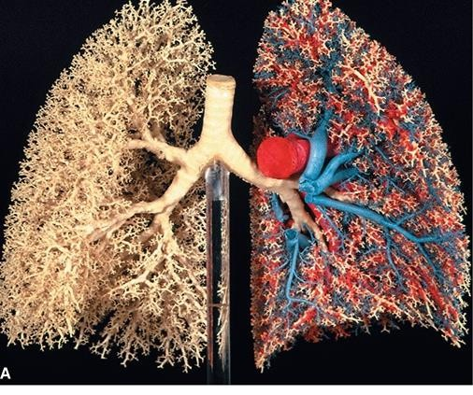

This pleural fluid ; Functions :
- Prevents friction between the two membranes.
- Allows them to slide past each other during breathing. as the lungs and thorax change shape
- Assists in holding the pleural membranes together.

The respiration Process:
There are three basic processes of respiration.
- ventilation or breathing:
Which is the movement of air between the atmosphere and the lungs. Ventilation has two phases:
A- Inhalation or inspiration to move air into the lungs
A- Exhalation or expiration to move air out of the lungs.
- External respirations: The exchange of gases between the lungs and the blood.
- internal respiration; the exchange of gases between the blood and the body cells.

When the diaphragm and external intercostal muscles contract, we breathe in.
  - The lungs get stretched to the larger size of the thorax.
Gases within the lungs spread out to fill the larger space, resulting in a decrease in gas pressure, causing a vacuum that sucks air into the lungs.
This is inspiration.
  - As the diaphragm and external intercostal relax, the rib cage descends, the space decreases, and the gases inside the lungs come closer together. Pressure increases ,causing the gases to flow out of the lungs.
  - This is expiration. And we breathe out.
This is mainly a passive activity. When we force air out, the internal intercostal muscles contract to help further decrease the size of the rib cage.
  - The pressure of a gas will determine the rate at which it diffuses from one area to another.
  - Molecules move from an area of high concentration to an area of low con-centration. In a mixture of gases, like the air, each gas contributes a portion of the total pressure of the mixture.

Lectures 13 &14

Lung volumes and lung capacities:

Refer to the volume of air in the lungs at different phases of the respiratory cycle.
The average total lung capacity of an adult human male is about 6 liters of air.

Tidal volume:

Is the volume of air that is inhaled or exhaled in only a single such breath.
The average human respiratory rate is 30-60 breaths / minute at birth, decreasing to 12-20 breaths / minute in adults.
Factors affecting volumes
Several factors affect lung volumes; some can be controlled and some cannot be controlled. Lung volumes vary with different people:
- A person who is born and lives at sea level will develop a slightly smaller lung capacity than a person who spends their life at a high altitude.
- This is because the partial pressure of oxygen is lower at higher altitude which, as a result means that oxygen less readily diffuses into the bloodstream.
In response to higher altitude, the body's diffusing capacity increases in order to process more air.
- Also, due to the lower environmental air pressure at higher altitudes, the air pressure within the breathing system must be lower in order to inhale; in order to meet this requirement, the thoracic diaphragm has a tendency to lower to a greater extent during inhalation, which in turn causes an increase in lung volume.
- The tidal volume, vital capacity, inspiratory capacity and expiratory reserve volume can be measured directly with a spirometer.

Spontaneous respiration
Spontaneous respiration is produced by rhythmic discharge of motor neurons above the origin of the phrenic nerves.
The rhythmic discharges from the brain that produce spontaneous respiration are regulated by alterations in:
- arterial PO2, PCO2, and H+ concentration.
- Supplemented by a number of nonchemical influences.

The overall respiration control system thus consists of a network of neurons in cortex and medulla/pons that exert voluntary control and automatic control, respectively.
The mechano- and chemoreceptors in the system sense the changes
In force/displacement and arterial levels of gases and metabolites, and adjust the Rate of ventilation to ensure optimal gas exchange in the lungs.

Control of Breathing :

Breathing is one of the few vital bodily functions that can be controlled consciously, as well as unconsciously.

Both the inhalation and exhalation are consciously controlled.

Conscious Control of Breathing:

You can control your breathing by:

- Holding your breath.

- Slowing your breathing.

- Hyperventilating, which is breathing more quickly and shallowly than necessary?

You can also exhale or inhale more forcefully or deeply than usual.

Conscious control of breathing is common in many activities besides blowing up balloons, including:

- swimming.

- speech training.

- Singing.

- Playing many different musical instruments.

- Doing yoga.
There are limits on the conscious control of breathing. e.g, it is not possible for a healthy person to voluntarily stop breathing indefinitely.
Before long, there is an irrepressible urge to breathe.
If you were able to stop breathing for a long enough time, you would lose consciousness.
The same thing would happen if you were to hyperventilate for too long.
Once you lose consciousness so you can no longer exert conscious control over your breathing, involuntary control of breathing takes over.

Unconscious Control of Breathing:

Unconscious breathing is controlled by respiratory centers in the medulla and pons of the brainstem.

The respiratory centers automatically and continuously regulate the rate of breathing based on the body’s needs.

These are determined mainly by:

- Blood acidity.

- pH. When you exercise, for example, carbon dioxide levels increase in the blood, because of increased cellular respiration by muscle cells.

  - The carbon dioxide reacts with water in the blood to produce carbonic acid, making the blood more acidic, so pH falls.

The drop in pH is detected by chemoreceptors in the medulla.

Blood levels of oxygen and carbon dioxide, in addition to pH, are also detected by chemoreceptors in major arteries, which send the ―data‖ to the respiratory centers.

The latter respond by sending nerve impulses to the diaphragm, ―telling‖ it to contract more quickly so the rate of breathing speeds up.

  - With faster breathing, more carbon dioxide is released into the air from the blood, and blood pH returns to the normal range.
  - The opposite events occur when the level of carbon dioxide in the blood becomes too low and blood pH rises.

This may occur with involuntary hyperventilation, which can happen in:

- panic attacks.

- Episodes of severe pain.

- Asthma attacks, and many other situations.
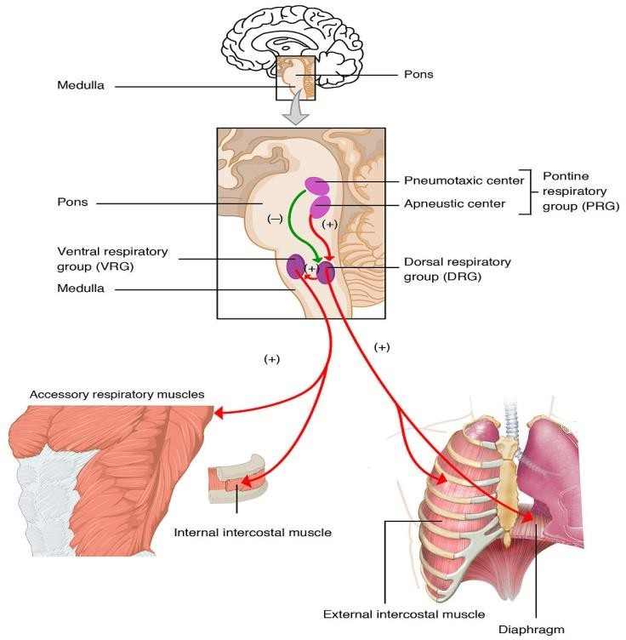
When you hyperventilate, you blow off a lot of carbon dioxide, leading to a drop in blood levels of carbon dioxide.

The blood becomes more basic (alkaline), causing its pH to rise.

Lecture 15:
Acid-Base Balance: Definition, Buffer Systems, and Role of Body Systems in the Regulation.

Buffer Systems in the Body:

The buffer systems in the human body are extremely efficient, and different systems work at different rates.

It takes only seconds for the chemical buffers in the blood to make adjustments to pH.

Factor that affect regulation buffer:

- The respiratory tract can adjust the blood pH upward in minutes by exhaling CO₂ from the body.

- The renal system can also adjust blood pH through the excretion of hydrogen ions (H⁺) and the conservation of bicarbonate, but this process takes hours to days to have an effect.
- The buffer systems functioning in blood plasma include plasma proteins, phosphate, and bicarbonate and carbonic acid buffers.
- The kidneys help control acid-base balance by excreting hydrogen ions and generating bicarbonate that helps maintain blood plasma pH within a normal range.
- Protein buffer systems work predominantly inside cells.

Protein Buffers in Blood Plasma and Cells:

Buffering by proteins accounts for two-thirds of the buffering power of the blood and most of the buffering within cells.

Hemoglobin as a Buffer:

Hemoglobin is the principal protein inside of red blood cells and accounts for one-third of the mass of the cell.

During the conversion of CO₂ into bicarbonate, hydrogen ions liberated in the reaction are buffered by hemoglobin, which is reduced by the dissociation of oxygen.

This buffering helps maintain normal pH.


The process is reversed in the pulmonary capillaries to re-form CO₂, which then can diffuse into the air sacs to be exhaled into the atmosphere.

Phosphate Buffer:

Phosphates are found in the blood in two forms:

- Sodium dihydrogen phosphate (Na₂H₂PO₄⁻), which is a weak acid.

- sodium monohydrogen phosphate (Na₂HPO4²⁻), which is a weak base.

Bicarbonate-Carbonic Acid Buffer:

The bicarbonate-carbonic acid buffer works in a fashion similar to phosphate buffers. The bicarbonate is regulated in the blood by sodium, as are the phosphate ions.

Bicarbonate ions and carbonic acid are present in the blood in a 20:1 ratio if the blood pH is within the normal range.

With 20 times more bicarbonate than carbonic acid, this capture system is most efficient at buffering changes that would make the blood more acidic.

This is useful because most of the body’s metabolic wastes, such as lactic acid and ketones, are acids.

Carbonic acid levels in the blood are controlled by the expiration of CO₂ through the lungs.

The level of bicarbonate in the blood is controlled through the renal system, where bicarbonate ions in the renal filtrate are conserved and passed back into the blood.

Respiratory Regulation of Acid-Base Balance:

The respiratory system contributes to the balance of acids and bases in the body by regulating the blood levels of carbonic acid.

CO₂ in the blood readily reacts with water to form carbonic acid, and the levels of CO₂ and carbonic acid in the blood are in equilibrium.

When the CO₂ level in the blood rises (as it does when you hold your breath), the excess CO₂ reacts with water to form additional carbonic acid, lowering blood pH.

Increasing the rate and/or depth of respiration (which you might feel the ―urge‖ to do after holding your breath) allows you to exhale more CO₂.

The loss of CO₂ from the body reduces blood levels of carbonic acid and thereby adjusts the pH upward, toward normal levels.

As you might have surmised, this process also works in the opposite direction.

Excessive deep and rapid breathing (as in hyperventilation) rids the blood of CO₂ and reduces the level of carbonic acid, making the blood too alkaline.

This brief alkalosis can be remedied by rebreathing air that has been exhaled into a paper bag.

Rebreathing exhaled air will rapidly bring blood pH down toward normal.

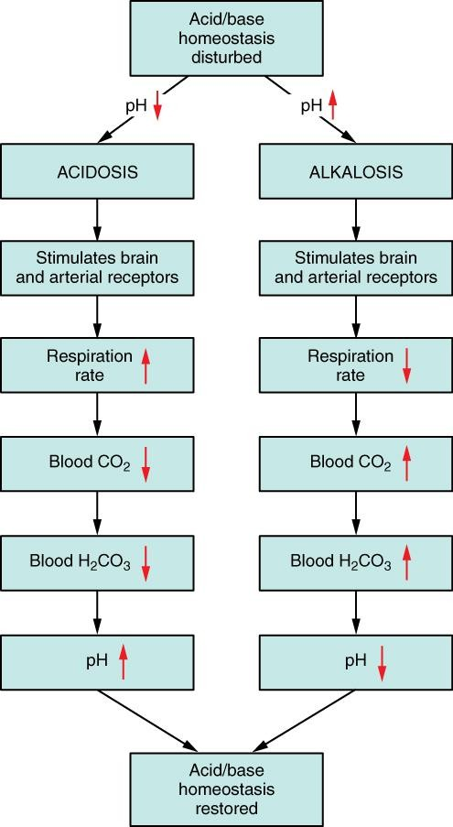

Respiratory Regulation of Blood pH:
The respiratory system can reduce blood pH by removing CO₂ from the blood.

The chemical reactions that regulate the levels of CO₂ and carbonic acid occur in the lungs when blood travels through the lung’s pulmonary capillaries.

Minor adjustments in breathing are usually sufficient to adjust the pH of the blood by changing how much CO₂ is exhaled.

In fact, doubling the respiratory rate for less than 1 minute, removing ―extra‖ CO₂, would increase the blood pH by 0.2.

This situation is common if you are exercising strenuously over a period of time.

To keep up the necessary energy production, you would produce excess CO₂ (and lactic acid if exercising beyond your aerobic threshold).

In order to balance the increased acid production, the respiration rate goes up to remove the CO₂.

This helps to keep you from developing acidosis.
The body regulates the respiratory rate by the use of chemoreceptors, which primarily use CO₂ as a signal.
Peripheral blood sensors are found in the walls of the aorta and carotid arteries.
These sensors signal the brain to provide immediate adjustments to the respiratory rate if CO₂ levels rise or fall.
Yet other sensors are found in the brain itself.
Changes in the pH of CSF affect the respiratory center in the medulla oblongata, which can directly modulate breathing rate to bring the pH back into the normal range.
Hypercapnia, or abnormally elevated blood levels of CO₂, occurs in any situation that impairs respiratory functions, including pneumonia and congestive heart failure.
Reduced breathing (hypoventilation) due to drugs such as morphine, barbiturates, or ethanol (or even just holding one’s breath) can also result in hypercapnia. Hypocapnia, or abnormally low blood levels of CO₂, occurs with any cause of hyperventilation that drives off the CO₂, such as salicylate toxicity, elevated room temperatures, fever, or hysteria.

Renal Regulation of Acid-Base Balance:

The renal regulation of the body’s acid-base balance addresses the metabolic component of the buffering system.

Whereas the respiratory system (together with breathing centers in the brain) controls the blood levels of carbonic acid by controlling the exhalation of CO₂, the renal system controls the blood levels of bicarbonate.

- A decrease of blood bicarbonate can result from the inhibition of carbonic anhydrase by certain diuretics or from excessive bicarbonate loss due to diarrhea.
- Blood bicarbonate levels are also typically lower in people who have Addison’s disease (chronic adrenal insufficiency), in which aldosterone levels are reduced, and in people who have renal damage, such as chronic nephritis.
- Finally, low bicarbonate blood levels can result from elevated levels of ketones (common in unmanaged diabetes mellitus), which bind bicarbonate in the filtrate and prevent its conservation.

Digestive system
Lecture 16,17&18

Function:
The alimentary tract provides the body with a continual supply of water, electrolytes, vitamins, and nutrients ,which requires:

These functions of the digestive system include:
- Motility: This refers to the movement of food through the digestive tract through the processes of:
A- Ingestion: Taking food into the mouth.
B- Mastication: Chewing the food and mixing it with saliva .
C- Deglutition: Swallowing food .
D- Peristalsis and segmentation: Rhythmic, wavelike contractions (peristalsis), and mixing contractions in different segments (segmentation), move food through the gastrointestinal tract .
2—Secretion: This includes both exocrine and endocrine secretions:
A- Exocrine secretions:
Water, hydrochloric acid, bicarbonate, and many digestive enzymes are secreted into the lumen of the gastrointestinal tract.
The stomach alone, for example, secretes 2 to 3 liters of gastric juice a day .
B- Endocrine secretions:
The stomach and small intestine.
Secrete a number of hormones that help to regulate the digestive system .
- Digestion: This refers to the breakdown of food molecules into their smaller subunits, which can be absorbed .
- Absorption:
This refers to the passage of digested end products into the blood or lymph. 1- Storage and elimination:
This refers to the temporary storage and subsequent elimination of indigestible food molecules.
- Immune barrier:
The simple columnar epithelium that lines the intestine, with its tight junctions between cells, provides a physical barrier to the penetration of pathological organisms and their toxins. Also, cells of the immune system reside in the connective tissue located just under the epithelium.

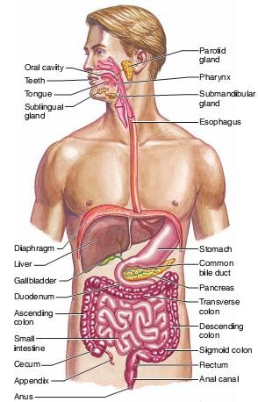

The anatomy of digestive system:
The digestive system can be divided into the:
- Tubular gastrointestinal (GI) tract, or alimentary canal.
- Accessory digestive organs.
The GI tract is approximately 9 m (30 ft) long and extends from the mouth to the anus. It traverses the thoracic cavity and enters the abdominal cavity at the level of the diaphragm. The anus is located at
the inferior portion of the pelvic cavity.

The organs of the GI tract include :
A-The oral cavity.
B- Pharynx.
C-Esophagus.
D- Stomach.
E-small intestine.
F-Large intestine.

The accessory digestive Organs: Include the:
A-Teeth.
B- Tongue.
C-Salivary glands.
D- Liver.

E-Gallbladder. F-Pancreas.

The term viscera is:
Frequently used to refer to the abdominal organs of digestion, but it can also refer to any organs in the thoracic and abdominal cavities.


Food movement :
Peristaltic contractions of the esophagus deliver food to the stomach, Which secretes very acidic gastric juice that is mixed with the food by gastric contractions.
Proteins in the resulting mixture ,called chyme, are partially digested by the enzyme pepsin.
Mastication (chewing) of food mixes it with saliva, secreted by the salivary glands.
In addition to mucus and various anti-microbial agents, saliva contains salivary amylase, an enzyme that can catalyze the partial digestion of starch.

The phases of swallowing:
Deglutition or swallowing: is divided into three phases:
- Oral, pharyngeal.
- Esophageal.
Swallowing is a complex activity that requires the coordinated contractions of 25 pairs of muscles in the mouth ,pharynx, larynx, and esophagus.

The oral phase:
Is under voluntary control, while the pharyngeal and esophageal phases are automatic and controlled by the swallowing center in the brain stem .
In the oral phase, the muscles of the mouth and tongue mix the food with saliva and create a bolus (a mass of a size to be allowed -of food that the tongue muscles move toward the oropharynx Receptors in the posterior portion of the oral cavity and oropharynx stimulate the pharyngeal phase of the swallowing reflex.

The soft palate lifts to close off the nasopharynx from the oropharynx (so food does not go out the nose);
- The vocal cords close off the opening to the larynx.
- The epiglottis covers the vocal cords.

- The larynx is moved away from the pathway of the bolus toward the esophagus:

These activities help prevent choking); and the upper esophageal sphincter relaxes.
These complex activities of the pharyngeal phase take less than 1 second. In the esophageal phase of swallowing ,which lasts from 5 to 6 seconds, the bolus of food is moved by peristaltic contractions toward the stomach .Once in the stomach, the ingested material is churned and mixed with hydrochloric acid and the protein-digesting enzyme pepsin. The mixture thus produced is pushed by muscular contractions of the stomach past the pyloric sphincter.

Esophagus:
The esophagus is the portion of the GI tract that connects the pharynx to the stomach .

Swallowing reflex:
The bolus is pushed from the oral to the anal end of the esophagus by a wavelike muscular contraction called peristalsis.
Movement of the bolus along the digestive tract occurs because the circular smooth muscle contracts behind, and relaxes in front of, the bolus.
This is followed by shortening of the tube by longitudinal muscle contraction.
These contractions progress from the superior end of the esophagus to the gastro esophageal junction at a rate of 2 to 4 cm per second as they empty the contents of the esophagus into the cardiac region of the stomach.
The lumen of the terminal portion of the esophagus is slightly narrowed because of a thickening of the circular muscle fibers in its wall. This portion is referred to as the lower esophageal gastro esophageal sphincter. After food passes into the stomach, constrictions of the muscle fibers of this region help prevent the stomach contents from regurgitating into the esophagus.
This is not a true sphincter muscle in humans, and so we are able to regurgitate.
During inhalation there is greater pressure in the abdominal cavity than in the thoracic cavity that promotes regurgitation.
This requires our lower esophageal sphincter to stay closed until peristaltic waves during swallowing push food through the esophagus. If the acidic contents of the stomach do rise into the esophagus burning sensation commonly called heartburn is produced.

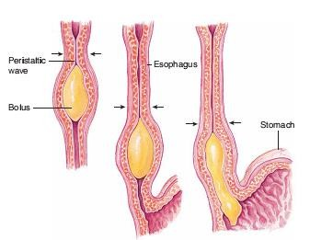

Stomach:
The J-shaped stomach is the most distensible part of the GI tract. It is continuous with the esophagus superiorly and empties into the duodenum of the small intestine inferiorly.

functions of the stomach :
- Store food, to initiate the digestion of proteins, to kill bacteria with the strong acidity of gastric juice.
- Move the food into the small intestine as a pasty material called chime.

Gastric glands contain several types of cells that secrete different products:
  - Mucous neck cells: which secrete mucus.
  - Parietal cells: which secrete hydrochloric acid (HCl ) .
  - Chief (or zymogenic) cells: which secrete pepsinogen, an Inactive form of the protein-digesting enzyme pepsin.
  - Enterochromaffin-like (ECL) cells: found in the stomach
And intestine, which secrete histamine and 5-hydroxytryp-tamine (also called serotonin) as paracrine regulators of the GI tract.
5-G cells: which secrete the hormone gastrin into the blood ;
6-D cells: which secrete the hormone somatostatin.

Digestion and Absorption in the Stomach :
Proteins are only partially digested in the stomach by the action of pepsin,
While carbohydrates and fats are not digested at all by pepsin.
(Digestion of starch begins in the mouth with the action of salivary amylase and continues for a time when the food enters the stomach,
But amylase soon becomes inactivated by the strong acidity of gastric juice.

The complete digestion of food molecules occurs later, when chyme enters the small intestine adequately digest and absorb their food.

Almost all of the products of digestion are absorbed through the wall of the small intestine;
The only commonly ingested sub-stances that can be absorbed across the stomach wall are alcohol and aspirin.
Absorption occurs as a result of the lipid solubility of these molecules. Aspirin:
Can promote damage to the gastric mucosa and cause bleeding, and must be avoided in people with gastric ulcers.

Small intestine:

The small intestine is the longest part of the GI tract,
However it is approximately 3 m long in a living person, is formed of:
- The first part extending from the pyloric sphincter is the duodenum.
- The next 2/5 of the small intestine is the jejunum.
- The last 1/3 is the ileum. The ileum empties into the large intestine through the ileocecal valve.
The mucosa of the small intestine is folded into:
Villi and microvilli:

This arrangement greatly increases the surface area for absorption and improves digestion.
Since digestive enzymes are embedded within the microvilli.
The products of digestion are absorbed across the epithelial lining of the intestinal mucosa.
Absorption of carbohydrates ,lipids, amino acids, calcium, and iron occurs primarily in the duodenum and jejunum.
Bile salts, vitamin B 12 ,water, and electrolytes are absorbed primarily in the
ileum.

Intestinal Enzymes :
In addition to providing a large surface area for absorption, the plasma membranes of the microvilli contain digestive enzymes that hydrolyze disaccharides, polypeptides, and other substrates.
These brush border enzymes are not secreted into the lumen, but instead remain attached to the plasma membrane with their active sites exposed to the chime.

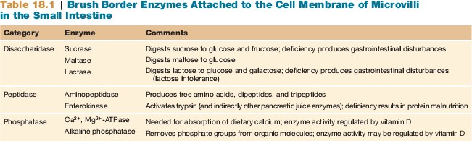

Intestinal Contractions and Motility:

Two major types of contractions occur in the small intestine :
- peristalsis
- segmentation.
Peristalsis is much weaker in the small intestine than in the esophagus and stomach.

segmentation:
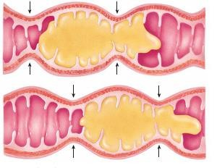
This term refers to muscular constrictions of the lumen, which occur simultaneously at different intestinal segments.

Large intestine :
Segmentation of the small intestine

The general features :
- The large intestine absorbs: Water, electrolytes, and certain vitamins from the chyme it receives from the small intestine.
- The large intestine then passes waste products out of the body through the rectum and anal canal.

- There are no villi in the large intestine, the intestinal mucosa therefore appears flat.
- The large intestine has little or no digestive function, but it does Absorb water and electrolytes from the remaining chyme, as well as several B complex vitamins and vitamin K.

Fluid and Electrolyte Absorption in the Intestine :
The GI tract receives about 1.5 L per day of water from food and
drink; additionally.
The GI tract secretes 8–10 L/day of fluid into the lumen.
This includes contributions from the:
  - Salivary glands.
  - Stomach.
  - Intestine.
  - Pancreas.
  - Liver.
  - Gallbladder.
The small intestine both secretes and absorbs water accompanying different transport processes, but these are not in balance.
The small intestine secretes about 1 L per day but absorbs most of the fluid in the chyme. As a result, only about 2 L per day of fluid pass into the large intestine .
The large intestine absorbs about 90% of this remaining volume , Leaving less than 200 ml of fluid to be excreted in the feces .
Absorption of water in the intestine occurs passively as a result of the osmotic gradient created by the active transport of ions.

Accessory organs:

Liver:
Liver is the largest internal organ; it is, in a sense ,only one to two cells thick. This is because the liver cells, or hepatocytes, form hepatic plates that are one to two cells thick.
The plates are separated from each other by large capillary spaces called sinusoids.

The liver has an amazing ability to regenerate itself .

Functions of the Liver:
- Detoxication of Blood Phagocytosis by Kupffer cells .
- Carbohydrate Metabolism Conversion of blood glucose to glycogen and fat Production of glucose from liver glycogen and from other molecules.
- Lipid Metabolism Synthesis of triglycerides and cholesterol.
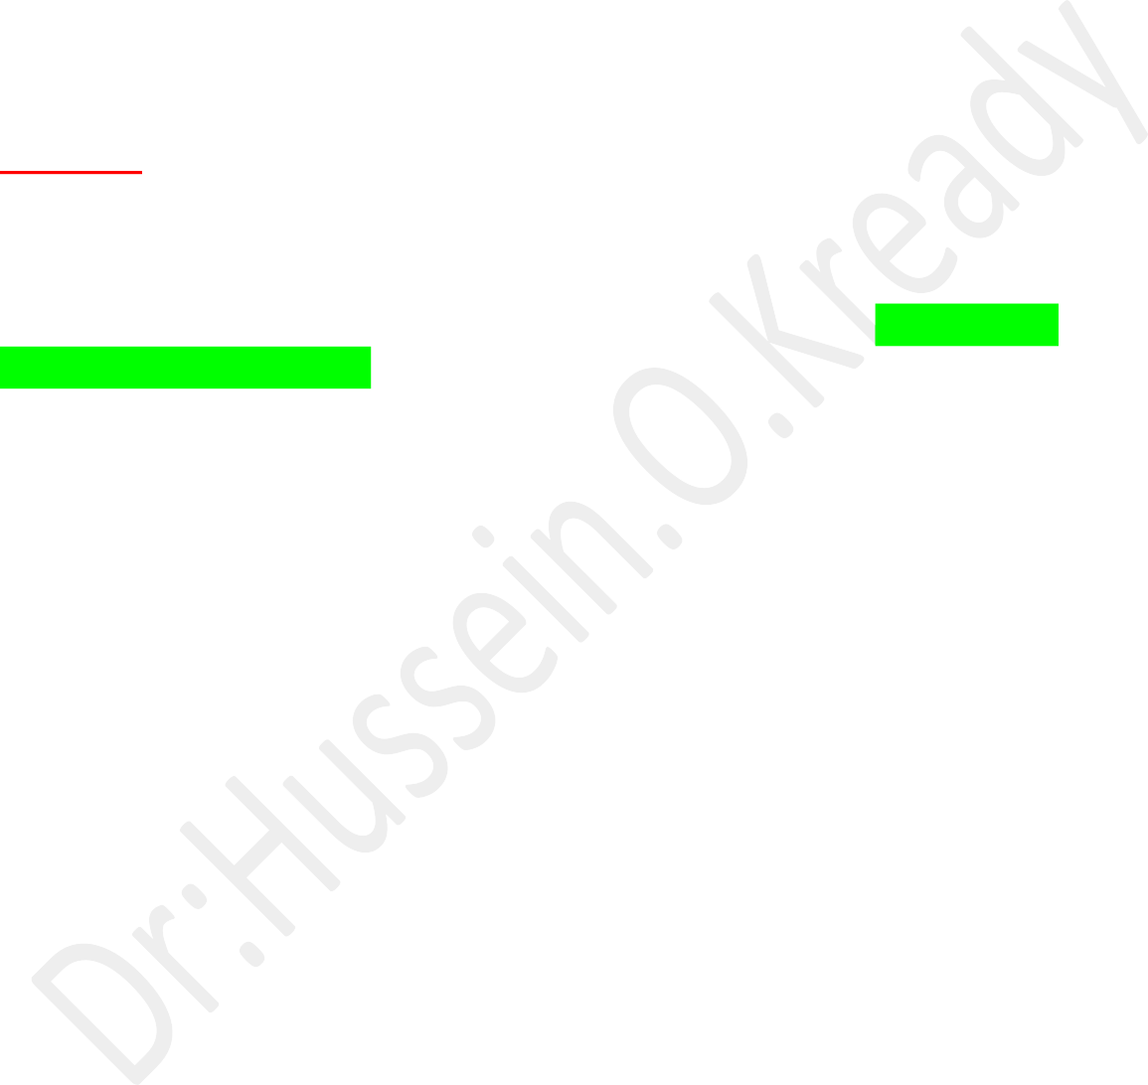
- Protein Synthesis Production of albumin Production of plasma transport proteins Production of clotting factors.
- Secretion of bile Synthesis of bile salts Conjugation and excretion of bile pigment (bilirubin).

Pancreas :
The pancreas is a soft, glandular organ that has both exocrine and endocrine functions.
The endocrine function is performed by clusters of cells called the pancreatic islets, or islets of Langerhans, which secrete the hormones insulin and glucagon into the blood.
As an exocrine gland, the pancreas secretes pancreatic juice through the pancreatic duct into the duodenum.
Within the lobules of the pancreas are the exocrine secretory units, called acini. Each acinus consists of a single layer of acinar epithelial cells surrounding a lumen, into which the constituents of pancreatic juice are secreted.

Pancreatic Juice :
Pancreatic juice contains bicarbonate and different digestive enzymes. These enzymes include:
(1)-A mylase, which digests starch. (2)- Trypsin, which digests protein.
(3)-Lipase, which digests triglycerides.
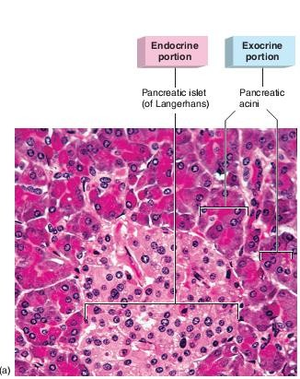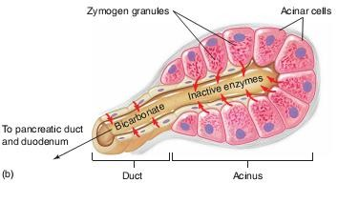

Lecture : 19,20&21

Is a group of organs in the body concerned with filtering out excess fluid and other substances from the bloodstream.
The Urinary organs include the: 1- Kidneys.



2-ureters. 3-Bladder. 4- Urethra

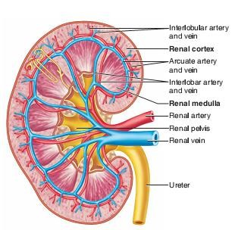


The paired kidneys lie on either side of the vertebral column. Each adult kidney weighs about 160 g and is about 11 cm long A coronal section of the kidney shows two distinct regions
- The outer cortex is reddish brown.
- The deeper region, or medulla, is striped in appearance.
The medulla is composed of 8 to 15 conical renal pyramids separated by renal columns.

The Functions :
- Regulation of plasma ionic composition.
- Regulation of plasma osmolality. .
- Regulation of plasma volume.
- Regulation of plasma hydrogen ion concentration (pH).

- Removal of metabolic waste products and foreign substances from the plasma.
- Secretion of Hormones e.g.
A- Renin is released by the kidneys.
B- Erythropoietin.
C- The Vitamin D from the skin is also activated with help from the kidneys. Calcium (Ca+) absorption from the digestive tract is promoted by vitamin D.

Nephrons:
A nephron is the basic structural and functional unit of the kidney. Responsible for the formation of urine.
Each kidney contains more than a million nephrons.

A nephron consists of:
- Small tubes or tubules.
- Associated small blood vessels. Nephron Tubules

The tubular portion of a nephron consists of:
A- A glomerular capsule.
B- A proximal convoluted tubule.
C- A descending limb of the loop of Henle, an ascending limb of the loop of Henle.
D-A distal convoluted tubule.
The (glomerular renal) corpuscle filters out large solutes from the blood, delivering water and small solutes to the renal tubule for modification.

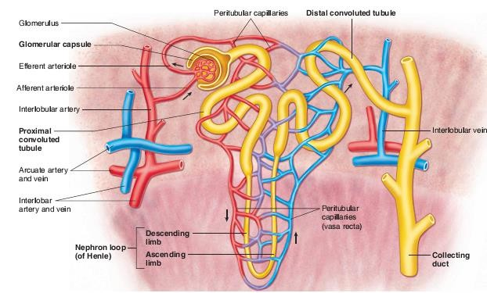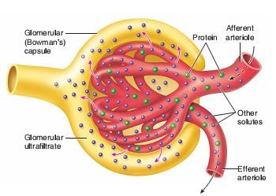

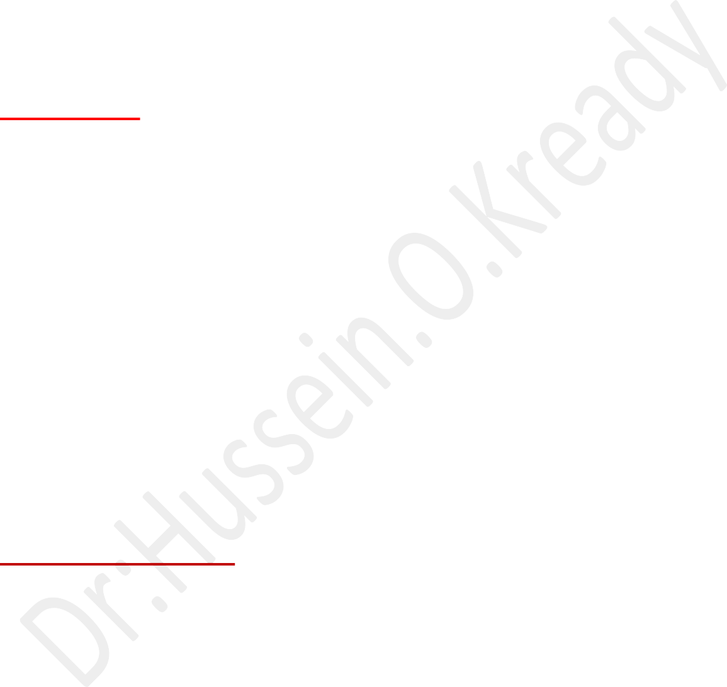
Glomerulus:
The glomerulus is a capillary tuft that receives its blood supply from an afferent
arteriole of the renal circulation.
The glomerular blood pressure provides the driving force for fluid and solutes to be filtered out of the blood and into the space made by Bowman's capsule. The remainder of the blood not filtered into the glomerulus passes into the narrower efferent arteriole.
It then moves into the vasa recta, which are collecting capillaries intertwined with the convoluted tubules through the interstitial space, where the reabsorbed substances will also enter.
This then combines with efferent venules from other nephrons into the renal vein, and rejoins with the main bloodstream.
Formation of Urine :
Urine is formed in three steps:
- Filtration.
- Reabsorption.
- Secretion.

Filtration:
Blood enters the afferent arteriole and flows into the glomerulus. Blood in the glomerulus has both:

Filterable blood components and non-filterable blood components. Filterable blood components:
Move toward the inside of the glomerulus.
While non-filterable blood components bypass the filtration process by exiting through the efferent arteriole.
Filterable Blood components will then take plasma like form called glomerular filtrate.
NORMAL GFR (Glomerular filtration rate )
The GFR in a healthy adult of average size is approximately 125 mL/min. Its magnitude correlates fairly well with surface area, but values in women are 10% lower than those in men even after correction for surface area. A rate of 125 mL/min is 7.5 L/h, or 180 L/d, whereas the normal urine volume is about 1 L/d. Thus, 99% or more of the filtrate is normally reabsorbed. At the rate of 125 mL/min, in 1 day the kidneys filter an amount of fluid equal to four times the
total body water, 15 times the ECF volume, and 60 times the plasma volume.

A few of the filterable blood components are:
- water.
- nitrogenous waste.
- Nutrients and salts (ions).
No filterable blood components include formed elements such as:

Blood cells and platelets along with plasma proteins.
The glomerular filtrate is not the same consistency as urine, as much of it is reabsorbed into the blood as the filtrate passes through the tubules of the nephron.

Reabsorption:
Within the peritubular capillary network, molecules and ions are reabsorbed back into the blood.

Sodium Chloride reabsorbed into the system increases the osmolarity of blood in comparison to the glomerular filtrate.
This reabsorption process allows water (H₂O) to pass from the glomerular filtrate back into the circulatory system.
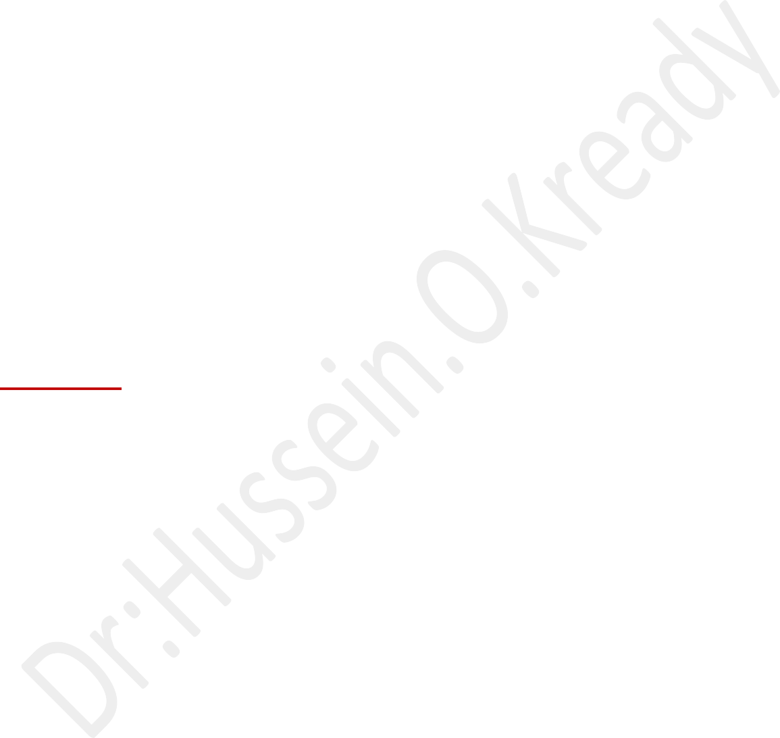
Glucose and various amino acids also are reabsorbed into the circulatory system.
These nutrients have carrier molecules that claim the glomerular molecule and release it back into the circulatory system. If all of the carrier molecules are used up, excess glucose or amino acids are set free into the urine.
A complication of diabetes is the inability of the body to reabsorb glucose. If too much glucose appears in the glomerular filtrate it increases the osmolarity of the filtrate, causing water to be released into the urine rather than reabsorbed by the circulatory system.

Frequent urination and unexplained thirst are warning signs of diabetes, due to water not being reabsorbed.
Secretion:
Some substances are removed from blood through the peritubular capillary network into the distal convoluted tubule or collecting duct.
These substances are Hydrogen ions, creatinine, and drugs.

Urine is a collection of substances that have not been reabsorbed during glomerular filtration or tubular reabsorption.
Urine Daily Volume :

The normal range for 24-hour urine volume is 800 to 2,000 milliliters per day (with a normal fluid intake of about 2 liters per day).

Factors Affecting:
- Average results are based on your age and sex.
- Typically, urine flow runs from 10 ml to 21 ml per second.
- Women range closer to 15 ml to 18 ml per second.
- A slow or low flow rate may mean there is an obstruction at the bladder neck or in the urethra, an enlarged prostate, or a weak bladder.

Maintaining Water-Salt Balance:
It is the job of the kidneys to maintain the water-salt balance of the blood. They also maintain blood volume as well as blood pressure.
Simple examples of ways that this balance can be changed include ingestion of water, dehydration, blood loss and salt ingestion.

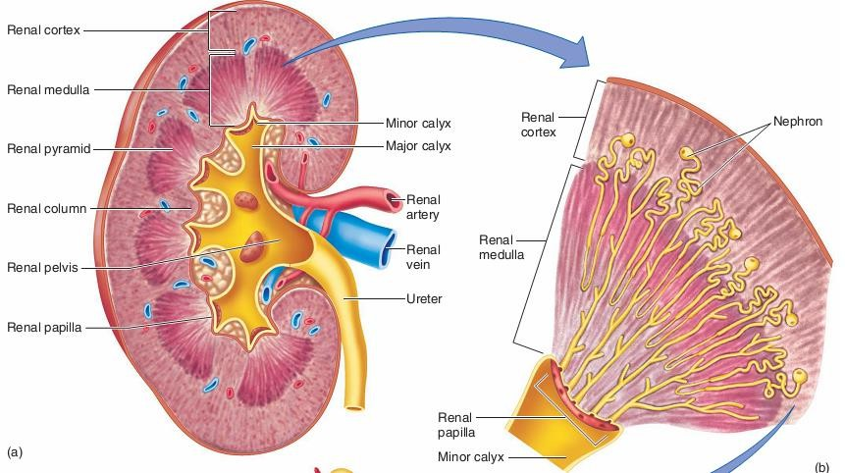
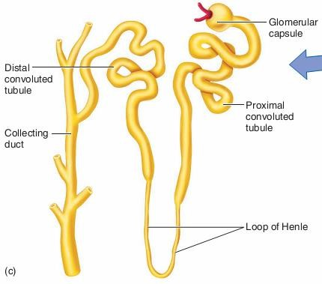

Lecture 22:
Endocrine system:
Is the collection of glands with internal secretion that produce hormones.
The endocrine system affects almost every organ and cell in the body.
Hormones:
Biologically active molecules that regulate metabolism, growth and development, tissue function, sexual function, reproduction, sleep, and mood, among other things.

Types of the endocrine system:
The endocrine system is made up of the: pituitary gland.
- Thyroid gland.
- Parathyroid glands.

- Adrenal glands.
- Pancreas.
- Ovaries (in females) and testicles (in males).

The mechanism of action of hormones:
For the hormone to reach its specific effect the presence of receptors on the cells of the target tissue is required. The presence or absence of specific receptors is responsible for ensuring that the effect of the hormone is targeted. If the cell does not express the receptor, it cannot respond to the presence of hormone even at un physiologically high concentrations. Conversely if the cell has expressed the receptor, it specifically reacts even at a very low concentration.
The location of the receptor depends on the nature of the hormone. We distinguish three types of receptors:
- Membrane receptors.
- Cytoplasmic receptors.
- Nuclear receptors. Pituitary gland :
This is the "master" gland of the endocrine system. It uses information it gets from the
brain to "tell" other glands in the body what to do.
It makes many different important hormones, including:
1- Growth hormone (GH ,or somatotropin).
This hormone promoting overall tissue and organ growth. Some of growth hormone’s actions, including growth of cartilage and bones and protein synthesis in muscles
- Thyroid-stimulating hormone (TSH, or thyrotropin).TSH stimulates the thyroid gland to produce and secrete thyroxine (tetraiodothyronine, or T 4) and triiodothyronine (T 3).
- Adrenocorticotropic hormone (ACTH, or corticotropin).
- Follicle-stimulating hormone (FSH, or folliculotropin).
FSH stimulates the growth of ovarian follicles in females and the production of sperm cells in the testes of males.

- Luteinizing hormone (LH,or luteotropin).This hormone and FSH are collectively called gonadotropic hormones.
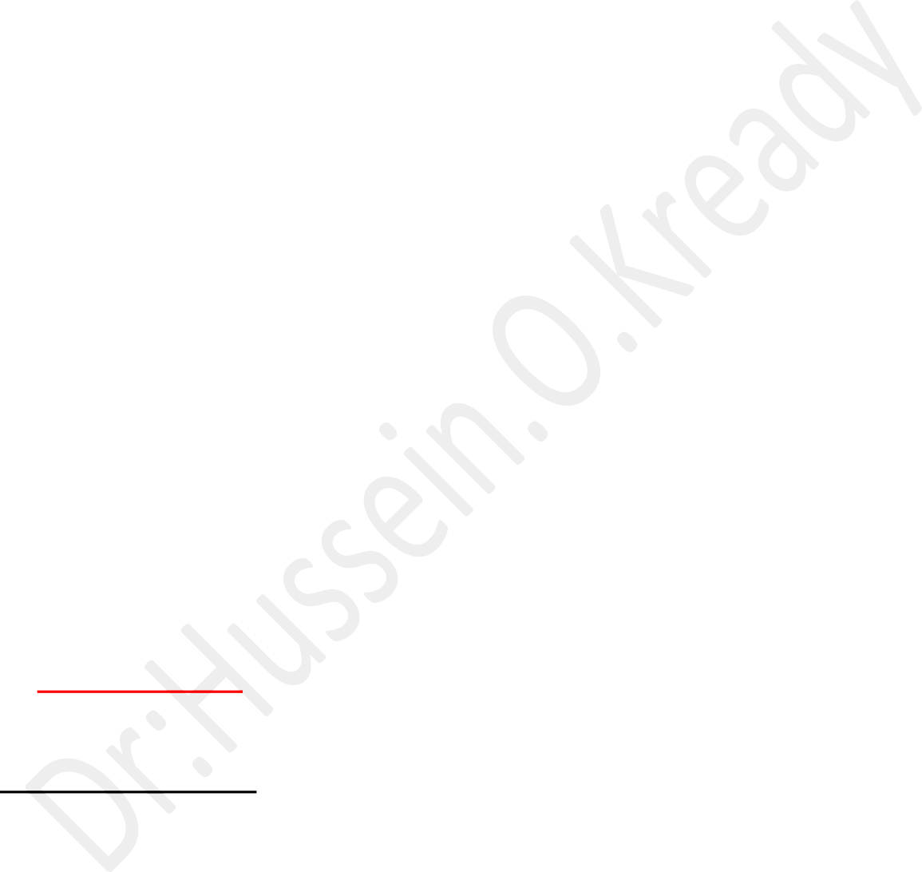
In females, LH stimulates ovulation and the conversion of the ovulated ovarian follicle into an. In males, LH stimulates the secretion of male sex hormones (mainly testosterone)

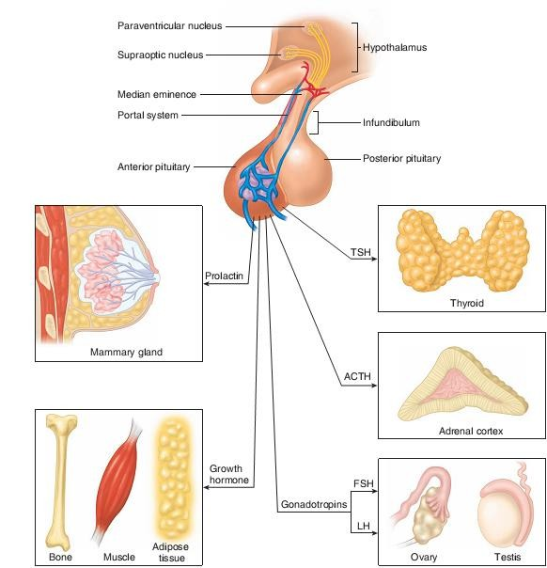
.

- Prolactin (PRL).This hormone is secreted in both males and females. Its best known function is the stimulation of milk production by the mammary glands of women after the birth of a baby.

Adrenal glands:
The adrenal cortex and adrenal medulla are structurally and functionally different.

The adrenal medulla:
secretes catecholamine hormones, which complement the sympathetic nervous system in the “fight-or-flight” reaction.
The adrenal cortex:

secretes steroid hormones that participate in the regulation of mineral and energy balance.

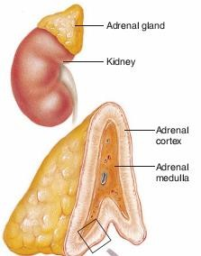

Pancreas and other endocrine glands:
The pancreatic islets secrete two hormones:
- insulin which promotes the lowering of blood glucose and the storage of energy in the form of glycogen
- Glucagon has antagonistic effects that raise the blood glucose concentration. The pancreas is both an endocrine and an exocrine gland.
The gross structure of this gland and its exocrine functions in digestion. The endocrine portion of the pancreas consists of :

scattered clusters of cells called the pancreatic islets or islets of Langerhans.
The human pancreas contains approximately one million islets, which are most common in the body and tail of the pancreas.

Pancreatic Islets (Islets of Langerhans) :
On a microscopic level, the most conspicuous cells in the islets are the alpha and beta
cells .
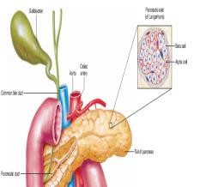




The alpha cells secrete the hormone
The beta cells secrete insulin. A human islet contains about 50% beta cells, 35% to 40% alpha cells, and 10% to 15% delta cells, which secrete the hormone somatostatin.

The effect of insulin hormone:
Insulin is the only hormone that acts to lower the blood glucose concentration.

  - After a carbohydrate meal or sugary drink, the plasma glucose level rises.
  - This rise in plasma glucose stimulates the beta cells of the islets to secrete increased amounts of insulin.
  - Insulin then binds to its receptors in the plasma membrane of its target cells.
  - Through the action of signaling molecules, causes intracellular vesicles containing GLU T4 carrier proteins to translocate to the plasma membrane.
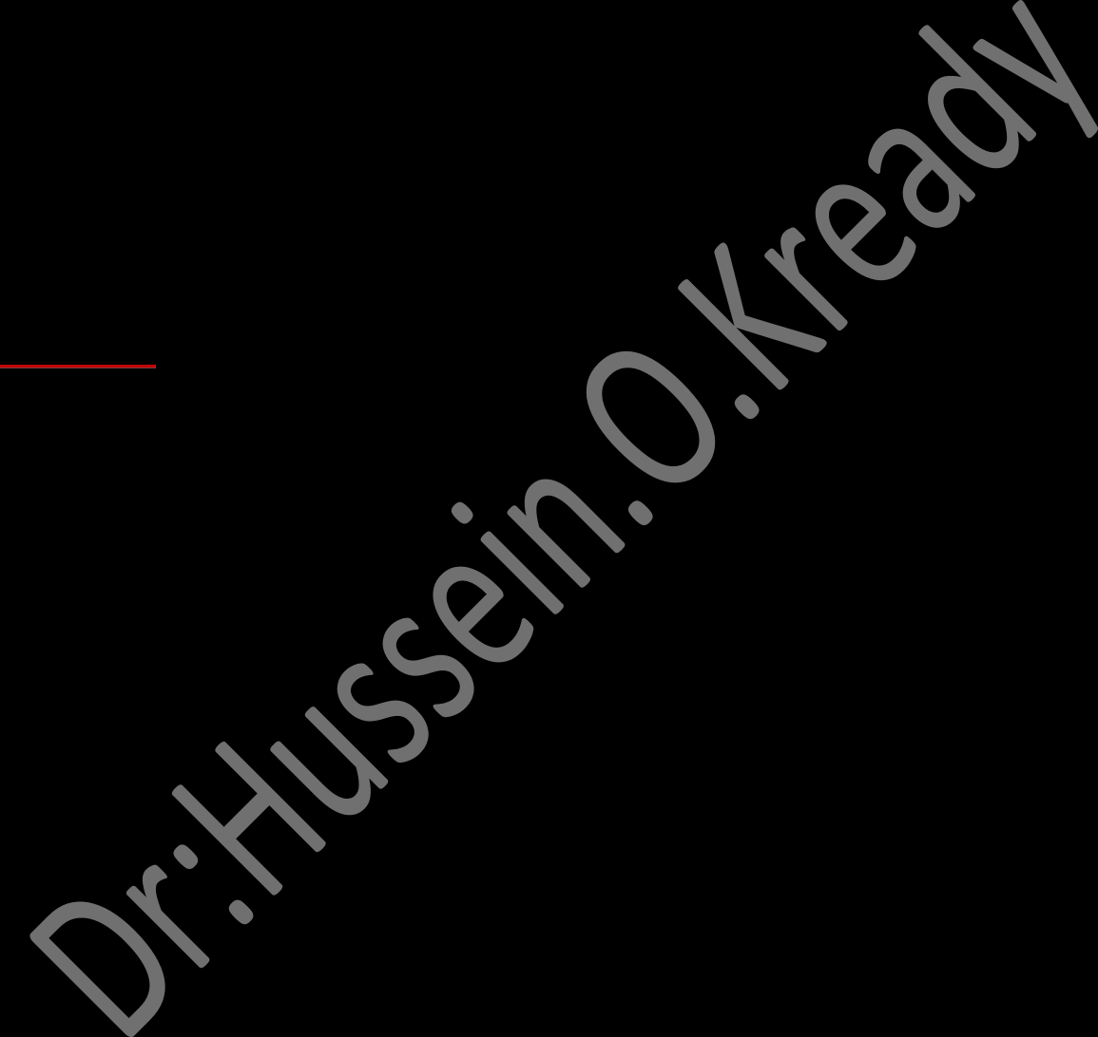
  - These carrier proteins promote the facilitated diffusion of glucose into the cells of insulin’s tar-get organs—primarily the skeletal muscles, liver, and adipose tissue.
  - Insulin indirectly stimulates the activity of the enzyme glycogen synthetase in skeletal muscles and liver, which promotes the conversion of intracellular glucose into glycogen. Insulin thereby causes glucose to leave the plasma and enter the target cells, where it is converted into the energy storage molecules of glycogen (in skeletal muscles and liver) and fat (in adipose tissue).

Glucagon:
Secreted by the alpha cells of the pancreatic islets, acts antagonistically to insulin-it promotes effects that raise the plasma glucose concentration. Glucagon secretion is stimulated by a fall in the plasma glucose concentration and insulin secretion that occurs when a person is fasting. Under these conditions, glucagon stimulates the liver to hydrolyze glycogen into glucose (a process called glycogenolysis), allowing the liver to secrete glucose into the blood.



Reproductive Physiology

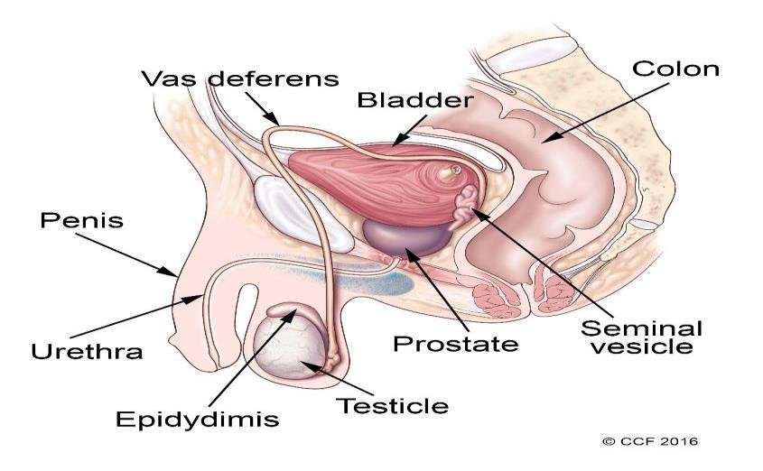

The male reproductive system includes a group of organs that make up a man’s reproductive and urinary system.
These organs do the following jobs within your body:
    - They produce, maintain and transport sperm (the male reproductive cells) and semen (the protective fluid around sperm).
    - They discharge sperm into the female reproductive tract.
    - They produce and secrete male sex hormones.
The male reproductive system is made up of:
- internal (inside your body). (Vas deferens, prostate and urethra).
- External (outside your body) parts (penis, scrotum and testicles).

REPRODUCTIVE HORMONES FUNCTIONS :
The entire male reproductive system is dependent on hormones.
The primary hormones involved in the functioning of the male reproductive system are:
- Follicle-stimulating hormone (FSH).
Is necessary for sperm production (spermatogenesis 2- Luteinizing hormone (LH).
LH stimulates the production of testosterone 3- Testosterone.
A- is necessary to continue the process of spermatogenesis.
B- is also important in the development of male characteristics, including muscle mass and strength, fat distribution, bone mass and sex drive.
The testes:
- Secrete large amounts of androgens, principally testosterone.
- They also secrete small amounts of estrogens.


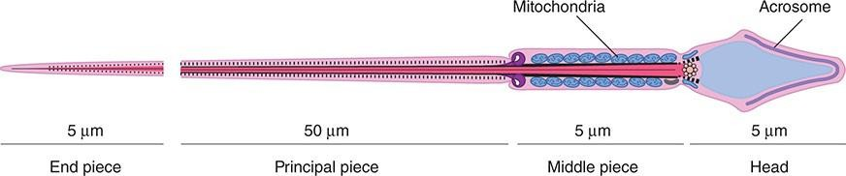

Each sperm is an intricate motile cell, rich in DNA, with a head that is made Up mostly of chromosomal material covering the head like a cap is the acrosome, a lysosome-like organelle rich in enzymes involved in sperm Penetration of the ovum and other events associated with fertilization.

The motile tail of the sperm is wrapped in its proximal portion by a sheath holding numerous mitochondria.

Semen:
The fluid that is ejaculated at the time of orgasm, The semen functions:
- contains sperm.
- Secretions of the seminal vesicles.
  - An average volume per ejaculate is 2.5–3.5 mL after several days of abstinence from sexual activity.
  - The volume of semen and the sperm count decrease rapidly with repeated ejaculation.
  - Even though it takes only one sperm to fertilize the ovum, each milliliter of semen normally contains about 100 million sperm.
  - Reduction in sperm production is associated with infertility:
50% of men with counts of 20–40 million/mL and essentially all of those with counts under 20 million/mL are sterile.
  - The presence of many morphologically abnormal or immotile spermatozoa also correlates with infertility.
  - The prostaglandins in semen: Which come from the seminal vesicles
Are at high concentrations, but their function in semen is unknown.
The causes of male infertility, as well as the underlying mechanisms of sperm in fertilization, are used as clues in developing male contraception.

Lecture 24;

The Female reproductive system:
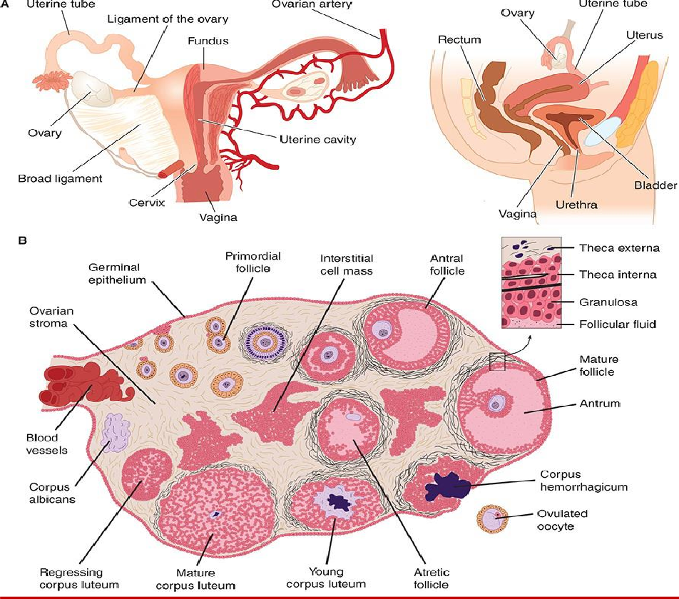

The menstrual cycle:
The reproductive system of women shows regular cyclic changes that teleological may be regarded as periodic preparations for fertilization and pregnancy.
  - In humans and other primates, the cycle is a menstrual cycle, and its most conspicuous feature is the periodic vaginal bleeding that occurs with the shedding of the uterine mucosa (menstruation).
  - The length of the cycle is notoriously variable in women, but an average figure is 28 days from the start of one menstrual period to the start of the next.
  - By common usage, the days of the cycle are identified by number, starting with the first day of menstruation.

Ovarian Cycle :
From the time of birth, there are many primordial follicles under the ovarian Capsule.
Each contains an immature ovum, at the start of each cycle, several of these follicles enlarge, and a cavity forms around the ovum (antrum formation). This cavity is filled with follicular fluid.
In humans;
- Usually one of the follicles in one ovary starts to grow rapidly on about the sixth day and becomes the dominant follicle,
- While the others regress, forming atretic follicles. It seems to be related to the ability of the follicle to secrete the estrogen inside it that is needed for final maturation.
- When women are given human pituitary gonadotropin preparations by injection, many follicles develop simultaneously.
- The structure of a maturing ovarian (graafian) follicle is shown in the primary source of circulating estrogen is the granulosa cells of the ovaries;
- At about the 14th day of the cycle, the distended follicle ruptures, and the Ovum is extruded into the abdominal cavity; this is the process of ovulation.
- The ovum is picked up by the oviducts.
- It is transported to the uterus and, unless fertilization occurs, out through the vagina.
- The follicle that ruptures at the time of ovulation promptly fills with blood, forming what is sometimes called a corpus hemorrhagicum.
- Minor bleeding from the follicle into the abdominal cavity may cause peritoneal irritation and fleeting lower abdominal pain (mittelschmerz).
- The granulosa and theca cell of the follicle lining promptly begin to proliferate, and the clotted blood is rapidly replaced with yellowish, lipid- rich luteal cells, forming the corpus luteum.
- This initiates the luteal phase of the menstrual cycle, during which the Luteal cells secrete estrogen and progesterone.
- Growth of the corpus luteum depends on its developing an adequate blood supply.
- If pregnancy occurs, the corpus luteum persists and usually there are no more periods until after delivery.
- If pregnancy does not occur, the corpus luteum begins to degenerate about 4 days before the next menses (24th day of the cycle) and is eventually replaced by scar tissue, forming a corpus albicans.
- The ovarian cycle in other mammals is similar, except that in many species more than one follicle ovulates and multiple births are the rule.

- Corpora lutea form in some sub mammalian species but not in others.
- In humans, no new ova are formed after birth.
- During fetal development, the ovaries contain over 7 million primordial follicles.
- However, many undergo atresia (involution) before birth and others are lost after birth.
- At the time of birth, there are 2 million ova, but 50% of these are atretic.

- The million that are normal undergo the first part of the first meiotic division at about this time and enter a stage of arrest in prophase in which those that survive persist until adulthood.
- Atresia continues during development, and the number of ova in both of the ovaries at the time of puberty is less than 300,000.
- Only one of these ova per cycle (or about 500 in the course of a normal reproductive life) normally reaches maturity; the remainder degenerate.
- Just before ovulation, the first meiotic division is completed. One of the daughter cells.
- the secondary oocyte, receives most of the cytoplasm, while the other, the first polar body, fragments and disappears.
- The secondary oocyte immediately begins the second meiotic division, but this division stops at metaphase and is completed only when a sperm penetrates the oocyte. At that time,
- The second polar body is cast off and the fertilized ovum proceeds to form a new individual. The arrest in metaphase is due, at least in some species, to formation in the ovum of the protein pp39mos, which is encoded by the cmos protooncogene. When fertilization occurs, the pp39mos is destroyed within 30 min by calpain, a calcium-dependent cysteine protease.

Uterine cycle:
- At the end of menstruation, all but the deep layers of the endometrium have sloughed.
- A new endometrium then regrows under the influence of estrogens from the developing follicle.
- The endometrium increases rapidly in thickness from the 5th to the 14th days of the menstrual cycle.
- As the thickness increases, the uterine glands are drawn out so that they lengthen, but they do not become convoluted or secrete to any degree.

- These endometrial changes are called proliferative, and this part of the menstrual cycle is sometimes called the proliferative phase.
- After ovulation, the endometrium becomes more highly vascularized and slightly edematous under the influence of estrogen and progesterone from the corpus luteum.

- The glands become coiled and tortuous and they begin to secrete a clear fluid. Consequently, this phase of the cycle is called the secretory or luteal phase.
Ovarian hormones :
Actions of the some female sex hormones:

- Estrogen, during the Follicular Phase of the Ovarian Cycle:
A- Inhibits the secretion of GnRH, FSH, and LH.
B- Causes the endometrium to thicken.
C- Induces the production of progesterone receptors in the myometrium.

- Estrogen, during Pregnancy:
A- Stimulates the growth of the myometrium and increases uterine strength which is necessary for parturition
B- Helps to prepare the mammary glands for lactation following parturition by Promoting the development of the ducts through which milk will be ejected
C- Inhibits the effects of prolactin during the last half of pregnancy and, thereby, prevents milk secretion prior to parturition
- Progesterone:
A- Inhibits the secretion of GnRH, FSH, and LH during the luteal phase of the ovarian cycle
B- Elicits the secretory phase in the endometrium and provides a suitable, nurturing environment for an implanted embryo
C- Promotes the formation of a mucus plug in the cervix
D- Stimulates breast development during pregnancy D- Inhibits the effects of prolactin during pregnancy
During the luteal phase, hormonal secretion and actions include the following:
- LH:
Promotes the production of locally acting prostaglandins, which cause the rupture of the follicle.

- The corpus luteum secretes:
Abundant progesterone as well as some estrogen.
- Progesterone from the corpus luteum acts:

On the endometrium to produce vascular and secretory changes that will provide a suitable and nurturing environment for an implanted embryo. 4- Specifically, progesterone:
A- Stimulates blood vessel growth in the connective tissue layer.
B- Elicits endometrial gland growth and coiling.
C- Stimulates endometrial cells to accumulate lipids and glycogen within their cytoplasm.
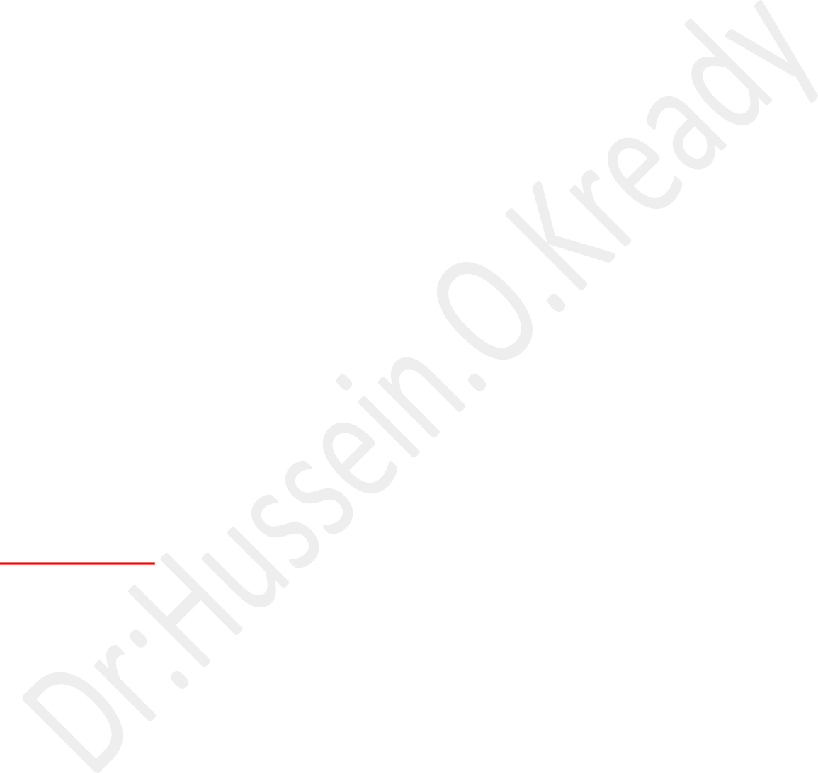
D-Causes cervical mucus to thicken, forming a plug that blocks the opening of the uterus and prevents the admission of bacteria and sperm.
E- Degeneration of the corpus luteum causes progesterone and estrogen.
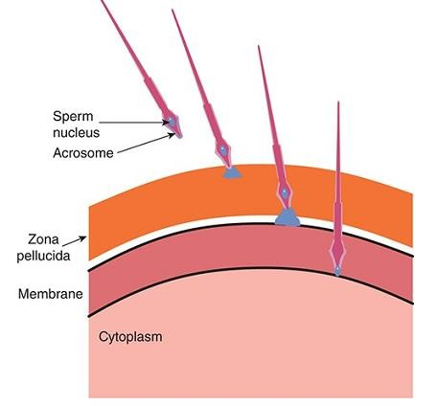

Fertilization:

)1(
Fertilization involves:
- chemo attraction of the sperm to the ovum by substances produced by

the ovum.
)2(- adherence to the zona pellucida, the membranous structure surrounding the ovum.
(3)- Penetration of the zona pellucida and the acrosome reaction.
)4( - adherence of the sperm head to the cellmembrane of the ovum,with breakdown of the area of fusion and release of the spermnucleus

into the cytoplasm of the ovum .)22–22( in the vagina during intercourse.
Millions of sperm are deposited

Eventually, 022–02sperm reach the ovum, and many of them contactthe
zona pellucida. Sperm bind to a receptor in the zona, and this is

Followed bythe a crosomal reaction, that is, the breakdown of the acrosome, the lysosome-like organelle on the head of the sperm .
When one sperm reaches the membrane of the ovum, fusion to the

ovum membrane is mediated by fertilin, a protein on the surface of the sperm head that resembles the viral fusionproteins that permit some viruses toattack cells. The fusion provides the signal that initiates development. In addition, the fusion sets off a reduction in the embrane potential of the ovum that prevents polyspermy, the fertilization of the ovum by more than one sperm.
This transient potential change is followed by a structural change in the zona pellucida that provides protection against poly spermy on a more long- term .basis
Pregnancy: ( gestation) :
Is the time during which one or more offspring develops inside a woman's womb.
Pregnancy usually occurs by sexual intercourse, but can also occur through assisted reproductive technology procedures.
A pregnancy may end in a live birth, a spontaneous miscarriage, an induced abortion, or a stillbirth.
Childbirth typically occurs around 40 weeks from the start of the last menstrual period (LMP). This is just over nine months (gestational age).
When using fertilization age, the length is about 38 weeks. An embryo is the term for the developing offspring during the first eight weeks following fertilization (i.e. ten weeks' gestational age), after which the term fetus is used until birth.
Signs and symptoms of early pregnancy may include;
- Missed periods.
- Tender breasts.
- Morning sickness (nausea and vomiting).
- Hunger, and frequent urination.
Pregnancy may be confirmed with a pregnancy test.
Methods of birth control—or, more accurately, contraception—are used to avoid pregnancy.
Pregnancy is divided into three trimesters of approximately 3 months each.
A- The first trimester includes conception, which is when the sperm fertilizes the egg.

B- The fertilized egg then travels down the Fallopian tube and attaches to the inside of the uterus, where it begins to form the embryo and placenta.
During the first trimester, the possibility of miscarriage (natural death of embryo or fetus) is at its highest.
Around the middle of the second trimester, movement of the fetus may be felt.
At 28 weeks, more than 90% of babies can survive outside of the
uterus if provided with high-quality medical care, though babies born at this time will likely experience serious health complications such as heart and respiratory problems and long-term intellectual and developmental disabilities.
Prenatal care improves pregnancy outcomes.
Prenatal care may include taking extra folic acid, avoiding drugs, tobacco smoking, and alcohol, taking regular exercise, having blood tests, and regular physical examinations.
Complications of pregnancy may include disorders of high blood pressure, gestational diabetes, iron-deficiency anemia, and severe nausea and vomiting.
In the ideal childbirth labor begins on its own when a woman is "at term". Babies born before 37 weeks are "preterm" and at higher risk of health problems such as cerebral palsy.
Babies born between weeks 37 and 39 are considered "early term" while those born between weeks 39 and 41 are considered "full term".
Babies born between weeks 41 and 42 weeks are considered "late term" while after 42 weeks they are considered "post term".
Delivery before 39 weeks by labor induction or caesarean section is not recommended unless required for other medical reasons.

parturition, or birth or childbirth or labour or delivery:
Process of bringing forth a child from the uterus, ending pregnancy.
It has three stages. In dilation, uterine contractions lasting about 40 seconds begin 20–30 minutes apart and progress to severe labour pains about every 3 minutes.
The opening of the cervix widens as contractions push the fetus.
Dilation averages 13–14 hours in first-time mothers, less if a woman has had previous babies.
When the cervix dilates fully, expulsion begins.
The ―water‖ (amniotic sac) breaks (if it has not already), and the woman may actively push.

Expulsion lasts 1–2 hours or less. Normally, the baby’s head emerges first; other positions make birth more difficult and risky.
In the third stage, the placenta is expelled, usually within 15 minutes. Within six to eight weeks, the mother’s reproductive system returns to nearly the prepregnancy state.

Lactation:
Lactation is the process of producing and releasing milk from the mammary glands in your breasts.
Lactation begins in pregnancy when hormonal changes signal the mammary glands to make milk in preparation for the birth of your baby. It’s also possible to induce lactation without a pregnancy using the same hormones that your body makes during pregnancy.
Lactation ends once your body stops producing milk.
Feeding your baby directly from your breasts is called breastfeeding (or sometimes chestfeeding) or nursing.
You can also feed your baby milk that you have expressed or pumped from your breast and saved in a bottle.

Where does human milk come from:
Human milk comes from your mammary glands inside your breasts.
These glands have several parts that work together to produce and secrete milk:
- Alveoli: These tiny, grape-like sacs produce and store milk. A cluster of alveoli is called lobules, and each lobule connects to a lobe.
- Milk ducts: Each lobe connects to a milk duct. You can have up to 20 lobes, with one milk duct for every lobe. Milk ducts carry milk from the lobules of alveoli to your nipples.
- Areola: The dark area surrounding your nipple, which has sensitive nerve endings that lets your body know when to release milk. To release milk, the entire areola needs stimulation.

- Nipple: Your nipple contains several tiny pores (up to about 20) that secrete milk. Nerves on your nipple respond to suckling (either by a baby, your hands or a breast pump). This stimulation tells your brain to release milk from the alveoli through the milk ducts and out of your nipple.
It helps to think of the lactation system as a large tree. Your nipple is the trunk of the tree. The milk ducts are the branches. The leaves are the alveoli.

Why do people lactate:
- The primary reason people lactate is to feed a baby.
- Lactation is a biological, hormonal response that occurs during and after pregnancy to feed a newborn baby.
- Your body triggers specific hormones to initiate milk production and ejection (releasing of milk).
- All mammals lactate for this purpose and it’s possible to induce lactation in men and in non-pregnant women using the right hormone medications.

Lecture 25:
There are three different types of muscles in the body :
- Skeletal muscles.
- Cardiac muscles.
- Smooth muscles
Based on certain distinctive features the muscles can be grouped as follows.
  - Striated versus non-striated muscles Striated muscle cells show large number of cross-striations at regular intervals when seen under light microscope .
  - Skeletal and cardiac muscles are striated.
  - Non-striated muscle cells do not show any striations .
  - Smooth muscles or the so-called plain muscles are non-striated.
  - All skeletal muscles are voluntary muscles. These are supplied by the somatic motor nerves.
  - Cardiac and all smooth muscles are involuntary muscles .
  - These are innervated by the autonomic nerves.

Skeletal muscles:
The skeletal muscles, as the name indicates, are attached with the bones of the body skeleton and their contraction.

Structural organization of muscle:
Structurally, the skeletal muscle consists of a large number of muscle fibers and a connective tissue framework organized.
- Each muscle fiber is surrounded by a delicate connective tissue called endomysium, which contains large quantity of elastic tissue arranged longitudinally.
- The muscle fibers are grouped into a number of bundles called fasciculi.

Each fasciculus is surrounded by a stronger sheath of connective tissue called

perimysium.
- All the fasciculi collectively form the muscle belly.
The connective tissue that surrounds the entire muscle belly is called
epimysium.
- At the junction of the muscle with its tendon, the fibers of endomysium, perimysium and epimysium become continuous with the fibers of the tendon.
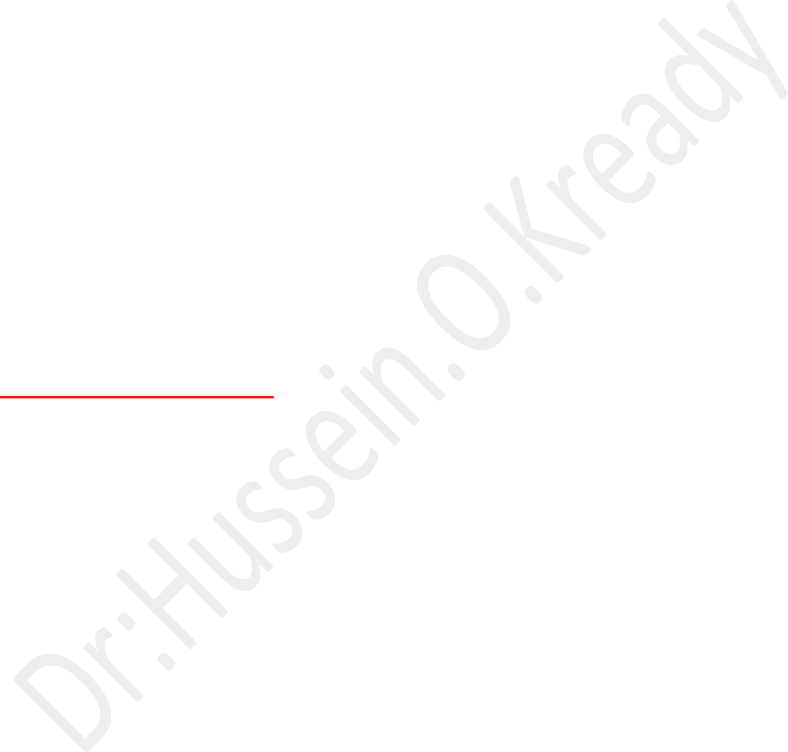
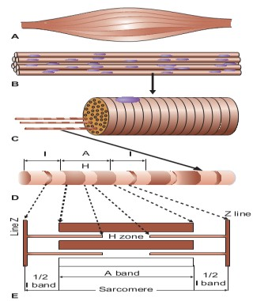
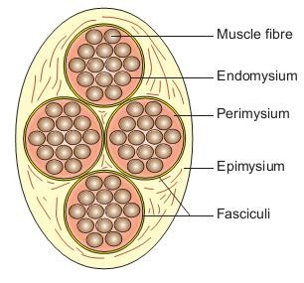
- Tendons are fibrous terminal ends of the muscles made up of collagen fibers

.

Structure of muscle fiber:
Each muscle fiber is basically:
  - A long (1–40 mm).
  - Cylindrical ( 111–11( μm in diameter).
  - Multinucleated cell.
  - Its cell membrane is called sarcolemma and the cytoplasm is called Sarcoplasm.
  - Like any other cell, in the sarcoplasm are embedded many structures, the nuclei, Golgi apparatus, mitochondria, sarcoplasmic reticulum, ribosomes, and glycogen and occasional lipid droplets.
  - In addition, the sarcoplasm mainly contains number of myofibrils which form the main structure of a muscle fiber.

  - The sarcolemma along with the band the thick (myosin) filaments line up the thin filaments.
  - In the center of each A band there is a lighter H zone where thin filaments do not overlap the thick filaments .
(The word H either represents the discoverer, Henson or the hell, which in German means light).
  - In the center of each H zone is seen an M line, which is more pronounced during muscle contraction.
  - The light band is called I band because it is isotropic to polarized light. It is about 1 μm in length. This area contains only thin (actin) filaments.
  - Each I band is bisected by a narrow dark Z line (the word Z has been taken from Z Wischenscheibe, which in German means between discs).
The portion of myofibril between two successive Z lines is called a sarcomere. Thus a sarcomere includes ½ I band, +1A band and ½ I band, and is about 2.5 μm in length at rest.
  - The sarcomere is the structural and functional unit of the muscle fiber. During muscle contraction the sarcomere reduces in length to 1.5 μm and during stretching of the muscle it increases in length to 3.5 μm.

Process of muscle excitation and contractility:
    - As we know, the muscle is an excitable tissue, i.e. when stimulated an action potential is produced (electrical phenomenon).
    - The skeletal muscle responds to stimulus by contracting (mechanical phenomenon).
    - The events which link the electrical phenomenon with the mechanical phenomenon is called excitation–contraction coupling phenomenon .
Process of muscle excitation:
Essential features of electrical phenomena which occur in the muscle fiber (resting membrane potential and action potential) are similar to those occurring in a nerve fiber.

Process of excitation- contraction coupling:
The sequence of events by which an action potential in the plasma membrane of a muscle fiber leads to cross-bridge activity (excitation–contraction coupling) is as follows:
- Action potential initiated in the plasma membrane of a muscle fiber spreads rapidly on the surface as well as into the interior of the muscle fiber through the
T-tubules.
- When the action potential reaches the tip of T-tubule; it activates the voltage-gated channels called DHP receptors
, 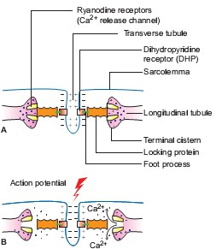
Which are located on the T-tubule membrane( .
  - Activated DHP receptors in turn trigger the opening of Ca⁺² release channels located on the terminal cisterns ,the so-called ryanodine receptor (RYR .)Due to opening of calcium release channels (RYR), calcium ions diffuse into the cytoplasm.
  - The concentration of Ca⁺² in the intracellular fluid is increased by some 2000 times .
  - The Ca⁺² ions get attached to troponin-C and start a chain of events (which produce contraction.
  - Thus the calcium ions act as linking or coupling material between the excitation and the contraction of the muscle.
  - Hence, the calcium ions are said to form the basis of excitation– contraction coupling.

Contractile and elastic component of muscle :
According to the model of skeletal muscle as a whole consists of three components:
- Contractile component:
The contractile component (CC) represents the thick (myosin) and thin (actin) filaments present in the myofibrils .
It offers no resistance to stretch and is unable to return to its original length after it has shortened.
- Series elastic component
The series elastic component (SEC) refers to that elastic tissue of the muscle which is present in series with the CC of the muscle. It consists of the elastic tendon of the muscle .
In resting condition the SEC offers resistance to passive stretch and explains how muscle is able to contract even when its external length does not change,
i.e. isometric contraction
- Parallel elastic component
The parallel elastic component (PEC) refers to the elastic tissue of the muscle which is attached parallel to the CC .
The PEC is represented by the structural elastic tissue of the muscle such as connective tissue sheaths of the muscle ,sarcolemma and filaments.
Presence of this component explains why the muscle regains its original length after it is passively stretched.
In isotonic con-traction this component gets folded up. It also offers some resistance to passive stretch.

Muscle tone:
Muscle tone is the state of slight contraction with certain degree of vigour and tension.

All the skeletal muscles exhibit muscle tone.
- However, it is more marked in the antigravity muscles.
- viz extensors of the lower limbs.
- Trunk muscles and muscles of the neck.

Maintenance of muscle tone:
Muscle tone is a state of partial tetanus of the muscle maintained by asynchronous discharge of impulses from motor neurons in the anterior grey horn of the spinal cord concerned with the motor nerve supply of the muscles.
The motor neurons in turn are controlled by some higher centers in brain.

Skeletal muscle blood flow :
At rest the blood flow to the skeletal muscle is about 2–4 mL/ 100 g/min of muscle tissue.
During strenuous exercise muscle blood flow can increase up to 20 times, i.e. about 50–80 mL/ 100 g/min muscle tissue.
This is called exercise hyperaemia.
This tremendous increase in the muscle blood flow during exercise is made possible by:
- Arteriolar dilatation.
- Opening up of the closed capillaries which greatly increase the surface area and the rate of blood.

Smooth muscle :
Characteristic of smooth muscle:
Certain characteristic features of smooth muscle contraction are as follows: 1- Plasticity
A smooth muscle exhibits the property of plasticity, i.e. it can readjust its resting length (the length at which a muscle generates maximum active tension).
2- Latch phenomenon

It refers to the mechanism by which a smooth muscle can maintain a high tension without actively contracting.
This phenomenon allows long-term maintenance of tone in many smooth muscle organs. In such a state muscle cannot generate active tension but can effectively resist passive stretching.


Cardiac muscles:
Properties of cardiac muscle 1-Automaticity.
- Rhythmicity.
- Conductivity.
- Excitability.
- Contractility.

Cardio vascular responses to exercise :
To meet the increased energy demand of muscles during exercise the primary cardiovascular response is in the form of:
- Increase in the skeletal muscle blood flow.
- Redistribution of blood flow in the body.
- Increase in the cardiac output.
- Blood pressure changes.
- Changes in the blood volume.

The nervous system is the body’s control center and communication network.

Organization:
The nervous system can be grouped into two major categories.
- The first is the central nervous system (CNS), which is the control center for the whole system. It consists of the brain and spinal cord.
- The peripheral nervous system (PNS), consists of all the nerves that connect the brain and spinal cord with sensory receptors, muscles, and glands.
The PNS can be divided into two subcategories:
A- The afferent peripheral system, which consists of afferent or sensory neurons that convey information from receptors in the periphery of the body to the brain and spinal cord,
2-The efferent peripheral system, which consists of efferent or motor neurons
that convey information from the brain and spinal cord to muscles and glands.
The efferent peripheral system can be further sub-divided into two subcategories.
A- The somatic nervous system:
Which conducts impulses from the brain and spinal cord to skeletal muscle, thereby causing us to respond or react to changes in our external environment.
B- The autonomic nervous system (ANS), which conducts impulses from the brain and spinal cord.
The ANS is considered to be involuntary. The organs affected by this system receive nerve fibers from two divisions of the ANS:
- The sympathetic division:
Which stimulates or speeds up activity and thus involves energy expenditure and uses norepinephrine.
- The parasympathetic.

It uses acetylcholine. As a neurotransmitter at nerve endings. Supporting network in the brain and spinal cord. They attach neurons to their blood vessels, thus helping regulate nutrients and ions that are needed by the nerve cells.

Nervous tissue:
Structure and function of neurons.


Neurons;
Structural units of the nervous system.
Composed of a body, axon, and dendrites. There are about 100 billion neurons in the human brain.

The soma (cell body):
Is the central part of the neuron It contains the nucleus of the cell.
Each nerve cell’s body contains a single nucleus. This nucleus is the control center of the cell. In the cytoplasm, contain many organelle especially mitochondria and a network of threads called neurofibrils that extend into the axon part of the cell, referred to as the fiber of the cell. In the cytoplasm of the cell body, there is extensive rough endoplasmic reticulum (ER).
In a neuron, the rough ER has granular structures referred to as Nissl bodies,
Also called chromatophilic substance, and are where protein synthesis occurs.

The axon:
Is a finer, cable-like projection, carries nerve signals away or to the soma. Many neurons have only one axon, the longest axon of a human motor neuron can be over a meter long, the (ex; Sensory neurons).
The axon:
Is a long process or fiber that begins singly but may branch and at its end has many fine extensions called:
Axon terminals:
That contact with dendrites of other neurons.
The large peripheral axons are enclosed in fatty myelin sheaths produced by the Schwann cells.
The portions of the Schwann cell that contain most of the cytoplasm of the cell
.
The nucleus remain outside of the myelin sheath and make up a portion called the neurilemma. Narrow gaps in the sheath are the nodes of Ranvier. dendrites :

Are cellular extensions with many branches, and are referred to as a dendritic tree .

synapse:
The chemical part happens at a junction between two neurons .
They use chemicals for communication called neurotransmitters.
The release of an excitatory neurotransmitter at the synapses will cause an inflow of positively charged sodium ions (Na⁺) making a localized depolarization of the membrane.
The current then flows to the resting (polarized) segment of the axon.

Inhibitory synapse: causes an inflow of Cl⁻ or outflow of K⁺ making the synaptic membrane hyperpolarized. This increase prevents depolarization, causing a decrease in the possibility of an axon discharge. If they are both equal to their charges, then the operation will cancel itself out. This effect is referred to as summation.
The neurons of the brain release inhibitory neurotransmitters far more than excitatory neurotransmitters, which helps explain why we are not aware of all memories and all sensory stimuli simultaneously. The majority of information stored in the brain is inhibited most of the time.

Classification of nerve cells:
Nervous tissue consists of groupings of nerve cells or neurons that transmit information called nerve impulses in the form of electrochemical changes.
Nerves a bundle of nerve cells or fibers.
Nervous tissue is also composed of cells that perform support and protection.
These cells are called neuroglia or glial cells Over 60% of all brain cells are neuroglia cells.

Neuroglia Cells:
There are different kinds of neuroglia cells, and, unlike neurons, they do not conduct impulses.
- Astrocytes:
Are star-shaped cells that wrap around nerve cells to form a supporting network in the brain and spinal cord? They attach neurons to their blood vessels, thus helping regulate nutrients and ions that are needed by the nerve cells.

Small astrocytes.

They also provide support by forming semi rigid connective-like tissue rows between neurons in the brain and spinal cord. They produce the fatty myelin sheath on the neurons of the brain and spinal cord of the CNS.
- Microglia cells: are small cells that protect the CNS and whose role is to engulf and destroy microbes like bacteria and cellular debris.
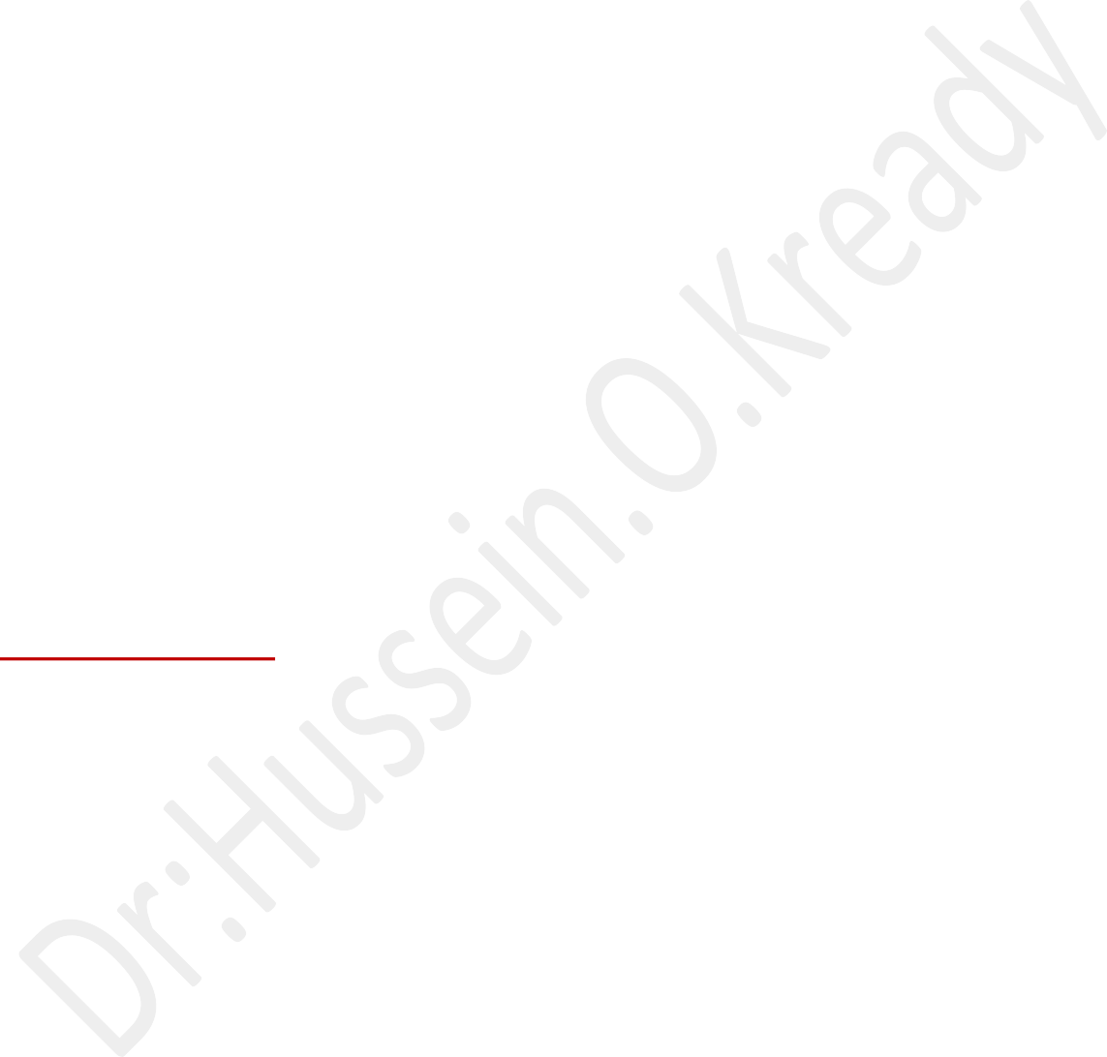
- Ependymal cells :line the fluid-filled ventricles of the brain. Some produce cerebrospinal fluid and others with cilia move the fluid through the CNS.
- Schwann cells form myelin sheaths around nerve fibers in the PNS.
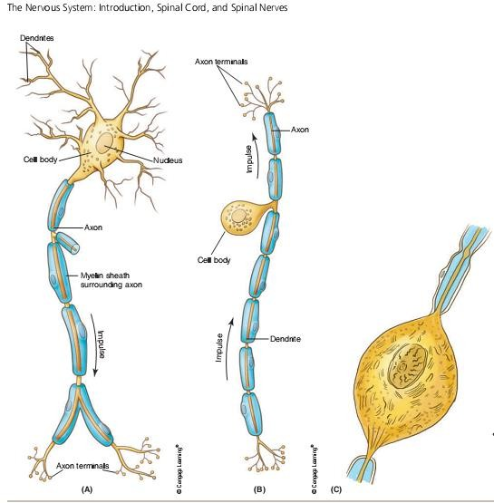

Types of neurons.
- Pseudo unipolar neurons, :
Which are sensory, have one process that splits. 2- Bipolar neurons,:
have two processes. . They are found in only three areas of the body: the
retina of the eye, the inner ear, and the olfactory area of the nose.

- Multipolar neurons,:
which are motor and association neurons, have many dendrites and one axon. . Most neurons in the brain and spinal cord are this type. As well as retina of
,the eye. Multipolar neurons, the most common type

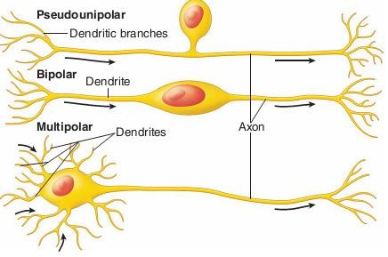

The Physiology of the nerve Impulses
A nerve cell is similar to a muscle cell in that there are concentrations of ions on the inside and the outside of the cell membrane.
Positively charged sodium (Na1) ions are in greater concentration outside the cell than inside.
There is a greater concentration of positively charged potassium (K1) ions
inside the cell than outside.
This situation is maintained by the cell membrane’s sodium-potassium pump.
In addition to the potassium ion, the inside of the fiber has negatively charged chloride (Cl2) ions and other negatively charged organic molecules.
Thus, the nerve fiber has an electrical distribution as well such that the outside is positively charged while the inside is negatively charged .
This condition is known as the membrane or resting potential.
Na1and K1ions:
Tend to diffuse across the membrane but the cell maintains the resting potential through the channels of the sodium-potassium pump that actively extrudes Na1and accumulates K1ions.
When a nerve impulse begins:
The permeability to the sodium (Na1) ions changes. Na1 rushes in, causing a change from a negative (2) to a positive (1) charge.
Inside the nerve membrane.
This reversal of electrical charge is called depolarization and creates the cell’s action potential.
The action potential moves in one direction down the nerve fiber.

Now the potassium ions (K⁺) begin to move outside to restore the resting membrane potential.
The sodium-potassium pump begins to function.
Pumping out the sodium ions that rushed in and pulling back in the potassium ions (K⁺) that moved outside,
Thus restoring the original charges. This is called repolarization.
This process continues along the nerve fiber acting like an electrical current, carrying the nerve impulse along the fiber.
The nerve impulse is a self-propagating wave of depolarization followed by repolarization moving down the nerve fiber.
Unmyelinated nerve fiber conducts an impulse over its entire length, But the conduction is slower than that along a myelinated fiber.
A myelinated fiber is insulated by the myelin sheath, so transmission occurs only at the nodes of Ranvier between adjacent Schwann cells.
Action potentials and inflow of ions occur only at these nodes, allowing the nerve impulse to jump from node to node, and the impulse travels much faster.
An impulse on a myelinated motor fiber going to a skeletal muscle could
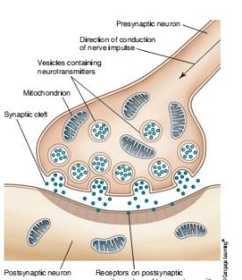
travel about 120 meters per second,
While an impulse on an unmyelinated fiber would travel only 0.5 meter per second.
On any nerve fiber, the impulse will never vary in strength. If the stimulus or change in the environment is barely great enough to cause the fiber to carry the impulse>
The impulse will be the same strength as one excited by a stronger stimulus.
This is known as the all-or-none law, which states that if a nerve fiber carries any impulse, it will carry a full strength impulse.

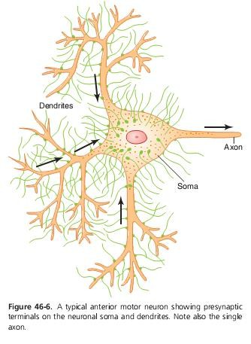
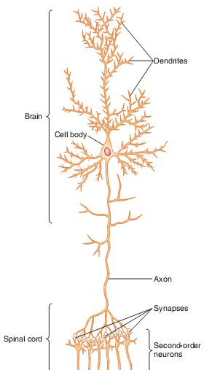
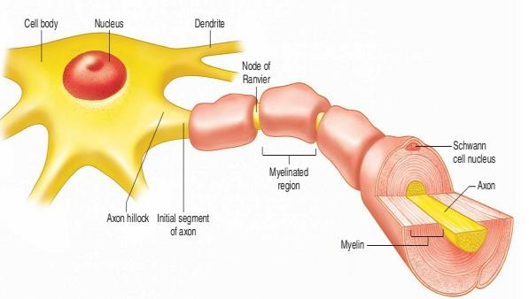
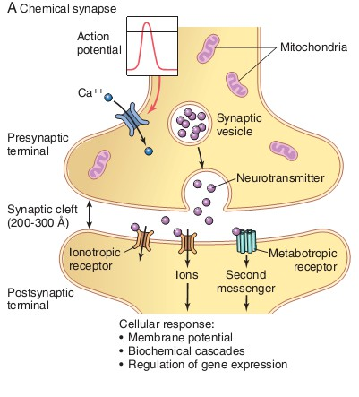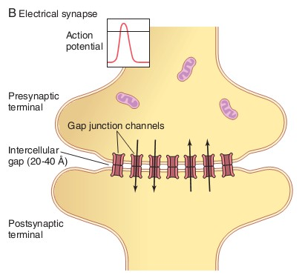

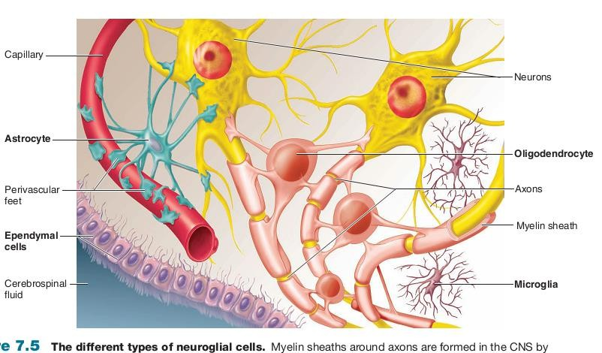

- 1- Guyton and Hall; Textbook of Medical Physiology; 13ed ;2016.
- 2-Ganongs, review of medical physiology, 26 ed ; 2019.
- 3- Advanced Physiology and Pathophysiology;ESSENTIALS FOR CLINICAL PRACTICE ;Nancy C.
Tkacs, D, RN Linda L. Herrmann, PhD, RN, AGACNPBC, GNP-BC, ACHPN,
FAANP, Randall L. Johnson, PhD, RN
;2021
- 4- Essential Physiology for Dental Students
; Edited by Kamran Ali Associate Professor/Consultant in Oral Surgery Peninsula Dental School University of Plymouth UK ;2919 .
- 5- Textbook of Human Physiology for Dental Students, Indu Khurana
  - Senior Professor, Department of Physiology,Postgraduate Institute of Medical Sciences,University of Health Sciences,Rohtak,
India.2 ed , 2013 .

