
كلية العلوم
قــســــــــــم الانظمة الطبية الذكية

Lecture: (4)

Arrays Part IV

Subject: Computer Programming II
Level: First
Lecturer: Dr. Maytham N. Meqdad

Main Diagonal
The main diagonal of a matrix consists of those elements that lie on the diagonal that runs from top left to bottom right.
If the matrix is A, then its main diagonal are the elements who's row number and column number are equal, a_{jj}.
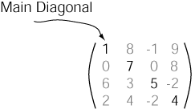

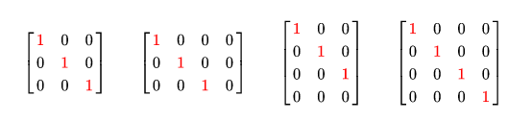

Main Diagonal

- Given a 2D square matrix, print the Principal and Secondary diagonals.
Examples :
Input:
1 2 3 4
4 3 2 1
7 8 9 6
6 5 4 3
Output:
Principal Diagonal: 1, 3, 9, 3
Secondary Diagonal: 4, 2, 8, 6
Input:
1 1 1
1 1 1
1 1 1
Output:
Principal Diagonal: 1, 1, 1
Secondary Diagonal: 1, 1, 1

/ Java Program to print the Diagonals of a Matrix
class GFG {
static int MAX = 100;

// Function to print the Principal Diagonal
static void printPrincipalDiagonal(int mat[][], int n)
{
System.out.print("Principal Diagonal: ");

for (int i = 0; i < n; i++) {
for (int j = 0; j < n; j++) {

// Condition for principal diagonal
if (i == j) {
System.out.print(mat[i][j] + ", ");
}
}
}
System.out.println("");
}

// Function to print the Secondary Diagonal
static void printSecondaryDiagonal(int mat[][], int n)
{
System.out.print("Secondary Diagonal: ");

for (int i = 0; i < n; i++) {
for (int j = 0; j < n; j++) {

// Condition for secondary diagonal
if ((i + j) == (n - 1)) {
System.out.print(mat[i][j] + ", ");
}
}
}
System.out.println("");
}

// Driver code
public static void main(String args[])
{
int n = 4;
int a[][] = { { 1, 2, 3, 4 },
{ 5, 6, 7, 8 },
{ 1, 2, 3, 4 },
{ 5, 6, 7, 8 } };

printPrincipalDiagonal(a, n);
printSecondaryDiagonal(a, n);
}
}
// This code is contributed by Rajput-Ji

Output
Principal Diagonal: 1, 6, 3, 8,
Secondary Diagonal: 4, 7, 2, 5,

Above and below the main diagonal java

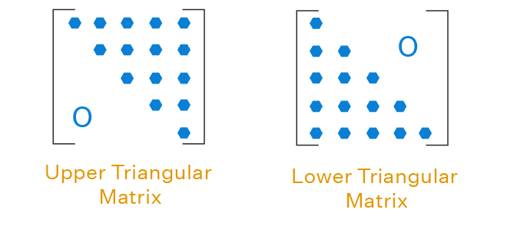

-To print the elements above the main diagonal of a matrix

class GFG {
static int MAX = 100;

// Function to print the elements above the main diagonal
static void printElementsAboveMainDiagonal(int mat[][], int n) {
System.out.println("Elements above the main diagonal:");
for (int i = 0; i < n; i++) {
for (int j = i + 1; j < n; j++) {
System.out.print(mat[i][j] + " ");
}
System.out.println();
}
}

// Driver code
public static void main(String args[]) {
int n = 4;
int a[][] = { { 1, 2, 3, 4 },
{ 5, 6, 7, 8 },
{ 1, 2, 3, 4 },
{ 5, 6, 7, 8 } };

printElementsAboveMainDiagonal(a, n);
}
}

Out put
Elements above the main diagonal:
2 3 4
- 8
4

- To print the elements below the main diagonal of a matrix in Java
class GFG {
static int MAX = 100;

// Function to print the elements below the main diagonal
static void printElementsBelowMainDiagonal(int mat[][], int n) {
System.out.println("Elements below the main diagonal:");
for (int i = 1; i < n; i++) {
for (int j = 0; j < i; j++) {
System.out.print(mat[i][j] + " ");
}
System.out.println();
}
}

// Driver code
public static void main(String args[]) {
int n = 4;
int a[][] = { { 1, 2, 3, 4 },
{ 5, 6, 7, 8 },
{ 1, 2, 3, 4 },
{ 5, 6, 7, 8 } };

printElementsBelowMainDiagonal(a, n);
}
}

Output
Elements below the main diagonal:
5
1 2
5 6 7

Anti-diagonal
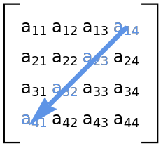
-To print the elements along the anti-diagonal of a matrix in Java, you can modify the code as follows:
class GFG {
static int MAX = 100;

// Function to print the elements along the anti-diagonal
static void printAntiDiagonal(int mat[][], int n) {
System.out.println("Elements along the anti-diagonal:");
for (int i = 0; i < n; i++) {
for (int j = 0; j < n; j++) {
// Condition to check if the element is on the anti-diagonal
if ((i + j) == (n - 1)) {
System.out.print(mat[i][j] + " ");
}
}
}
System.out.println();
}

// Driver code
public static void main(String args[]) {
int n = 4;
int a[][] = { { 1, 2, 3, 4 },
{ 5, 6, 7, 8 },
{ 1, 2, 3, 4 },
{ 5, 6, 7, 8 } };

printAntiDiagonal(a, n);
}
}
Output
Elements along the anti-diagonal:
4 7 2 5

