Lec Three : Body Membrane
Function of body membranes
- Line or cover body surfaces
- Protect body surfaces
- Lubricate body surfaces
Classification of Body Membranes
- Epithelial membranes
- Cutaneous membrane
- Mucous membrane
- Serous membrane
- Connective tissue membranes
- Cutaneous Membrane 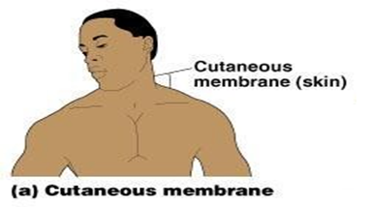
- Cutaneous membrane = skin , A dry membrane
- Outermost protective boundary
- Superficial epidermis : Keratinized stratified squamous epithelium
- Underlying dermis : Mostly dense connective tissue
- Dermis: consist of two layers
- Papillary layer
- Reticular layer
- Hypodermis
- Deep to dermis is the hypodermis
- Not part of the skin
- Anchors skin to underlying organs
- Composed mostly of adipose tissue
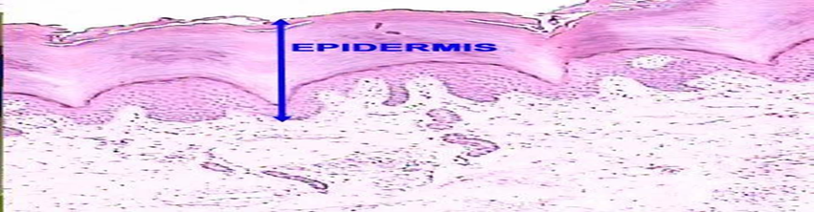

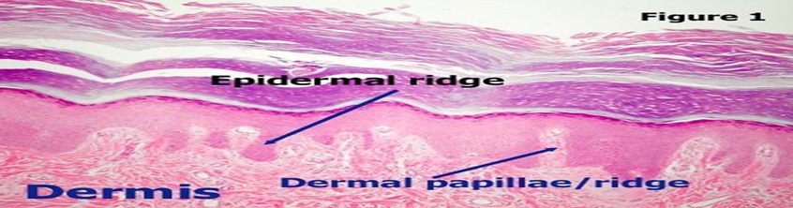
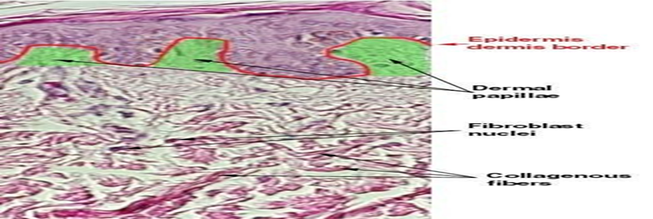
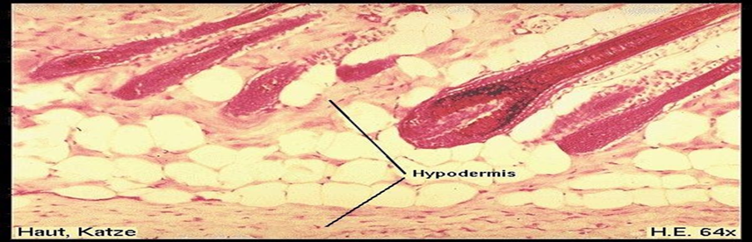
- Skin functions:
• Protects deeper tissues from:
• Mechanical damage
• Chemical damage
• Bacterial damage
• Thermal damage
• Ultraviolet radiation
• Desiccation
• Aids in heat regulation
• Aids in excretion of urea and uric acid
• Synthesizes vitamin D
Melanin
Skin Color Determinants
1.Melanin
Yellow, brown or black pigments
Pigment (melanin) produced by melanocytes
Amount of melanin produced depends upon genetic and exposure to sunlight .
2. Carotene
Orange-yellow pigment from some vegetables
3. Hemoglobin
Red coloring from blood cells in dermis capillaries
Oxygen content determines the extent of red coloring
- Appendages of the Skin
❖ Sebaceous glands: Produce oil
❖ Sweat glands
❖ Associated Hair Structures
• Hair follicle , Arrector pilli , Smooth muscle
• Dermal and epidermal sheath surround hair root
- Mucous Membranes
- Surface epithelium
- Type depends on site
- Underlying loose connective
- Lines all body cavities that open to the exterior body surfa
- Often adapted for absorption or secretion
- 

- Serous Membranes
- Surface simple squamous epithelium
- Underlying areolar connective tissue
- Lines open body cavities that are closed to the exterior of the body
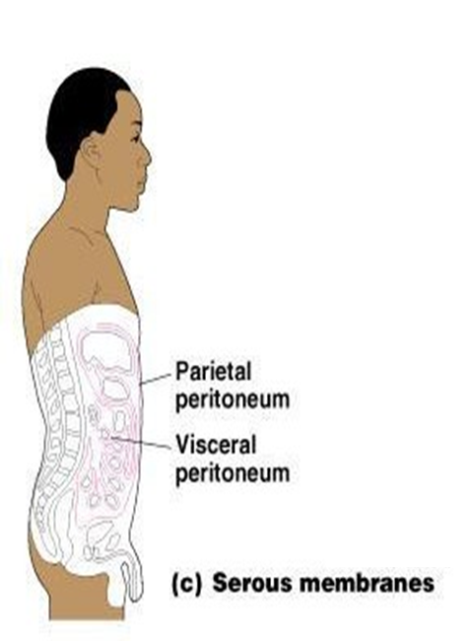
- Serous layers separated by serous fluid
Specific serous membranes : EXAMPLES
Peritoneum: Abdominal cavity
Pleura : Around the lungs
Pericardium : Around the heart

  - Connective Tissue Membrane
Synovial membrane: Connective tissue only Lines fibrous capsules surrounding joints
