Spectrophotometer
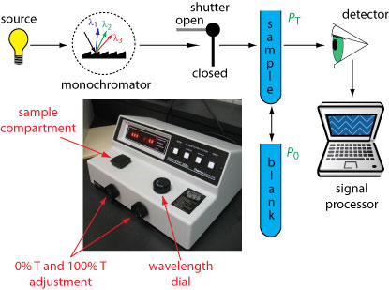

Spectrophotometer : its instrument for measure light intensity which measures light intensity in terms of color (Wavelength).
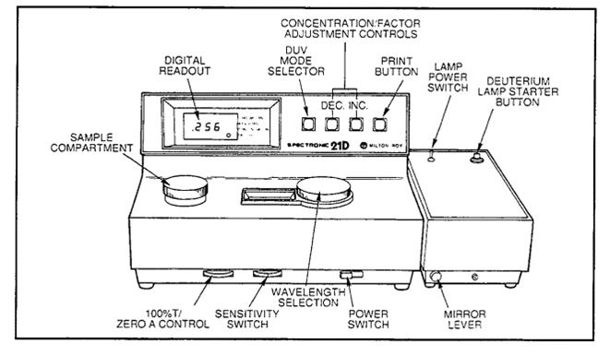

There two used for this spectrophotometer
1-Used for measure light absorption .
2- Used for measure light rebound .
In medical laboratories used the first type any light absorption . There are two types from this instrument .
1-Single beam : measure the absolute intensity of light .
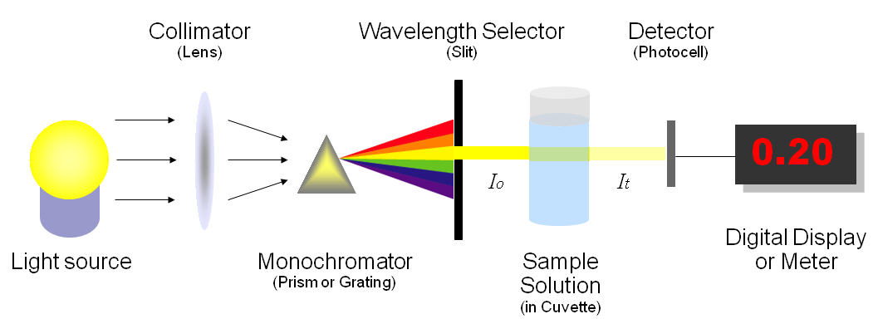
Single beam Spectrophotometer
2- Double beam : measure the percentage of light intensity by two beam different track .
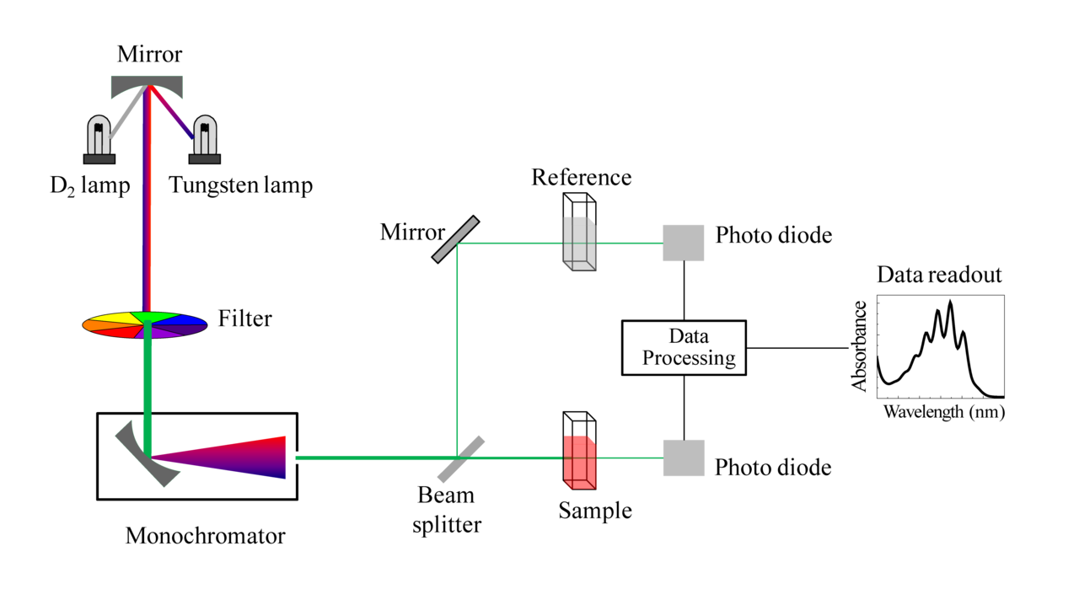
Double beam Spectrophotometer

The first type easier and more stability but second type more use because has a longer range of wavelengths .
Consists spectrophotometer of four main parts .
1-Light source : this part is the main source for radiation in this instrument used ( Hollow cathode lamps) (HCL) this type of light source consists of cathode and anode with inert gas (Ergun or neon ) in sealed tube .
2- Collimator (lens)
3- Monochromatic : it an important part in spectrophotometer function this part in work instrument separate wavelengths required for different wavelengths by (HCL). Where it to selection required wavelength to examine the sample .
4- Wavelength selector (slit)
5- Cuvette
6- photometer (photocell): after selecting wavelength required by monochromatic where it the light passes through the sample and be on the opposite side a set of detectors for the amount of remaining amount of energy then displays the result on the screen .
Method used spectrophotometer
1-Run instrument and leaves for 15 minutes for heated .
2- Use the key to the wavelength for adjust instrument on the wavelength required used .
3- Close the cover where placed the sample and used key (zero control) to adjust the gauge .
4- Adjust the gauge on (Transmittance 0%) this process is done without putting a sample in instrument where the path is closed the photometer does not record anything .

5- putting tube containing the reference solution in the space close the c0over and used key control of light where the absorption index of the spectrum becomes zero.
6- Get out reference sample , put the sample to be examined and close the cover then read absorption .

Some important notes
*Take a blood sample from the patient put in centrifuge for separation blood components and get a plasma .
* Mixing the limiting factor with serum interaction produces cause the movement of molecules or change in color. The color vary depending on the type of tests .
Maintenance
1-Change the light source .
2- Cleaning lenses and mirrors and optical lanes .
3- Must keep the lens from dust and touch because this change the outcome .
4- Lenses and mirrors sensitive very must be treated with caution .

