
Lecture 5
Fourth stage
Medical Physical Department

Medical Image Analysis

Image Enhancement
Contrast Manipulation, Histogram Modification, Edge Crispening, Color Image Enhancement,
By
Asst. Prof. Dr. Mehdi Ebady Manaa

- Image Enhancement

Two reasons exist for applying an image enhancement technique. Enhancement can increase the perceptibility of objects in an image to the human observer or it may be needed as a preprocessing step for subsequent automatic image analysis. Enhancement methods differ for the two purposes. An enhancement method requires a criterion by which its success can be judged. This will be a definition of image quality since improving quality is the goal of such a method. Various quality definitions will be presented and discussed. Different enhancement techniques will be presented covering methods for contrast enhancement, for the enhancement of edges, for noise reduction, and for edge-preserving smoothing
A seemingly simple operation on digital images is to enhance the image or features in the image. The main purpose of it is to map a given image to another image such that the content to be depicted is now easier to recognize. In medical imaging, image enhancement essentially enhances contrast by reducing any artefacts or noise in the image or by emphasizing the differences between objects. The reason for enhancement is to make structures more easily detectable by a human observer. It may also serve as some necessary preprocessing step for further automatic analysis. While in the latter case success or failure may be found by experimenting (e.g., does some image processing task perform better with or without the enhancement step?), deciding on the effectiveness of the former can be difficult because it requires modeling the human observer.
- Measures of Image Quality
  - Spatial and Contrast Resolution
The spatial and contrast resolution already being used to characterize images, determine the smallest structure that can be represented in a digital image. These two measures are easily computable and relevant to digital image processing. Structures can only be analyzed (delineated يحدد, measured, etc.) if they appear in the image.
- Spatial resolution describes this directly since the sampling theorem states that no detail with a frequency less than twice the sampling distance can be represented without aliasing.
- The contrast resolution is an indirect measure of the perceptibility of structures. The number of intensity levels has an influence on the likelihood with which two neighboring structures with similar but not equal appearance will be represented by different intensities.
Perceived resolution may be measured experimentally by treating the human visual system as a black box system with images as input and recognized objects determining resolution as output. The same kind of measure is also used when loss of resolution by transfer of information through a technical system shall be documented (such as creating a radiograph from a scene). The quantity that is measured is called line pairs per millimeter (lpmm), which refers to the thinnest pair of parallel black and white lines that can be differentiated (either by a human observer or by an image analysis algorithm). A sequence of parallel pairs of black and white lines with decreasing line thickness is displayed (see Fig. 5.1).

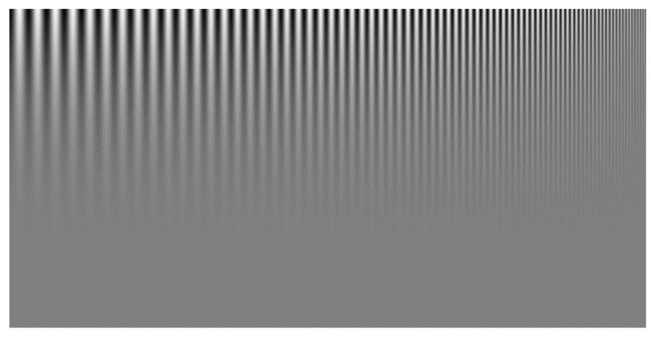

Fig.5.1 a test pattern for determining perceived resolution in line pairs per millimeter (lpmm). The number of line pairs per millimeter increases from left to right while the contrast decreases from top to down

2.2 Definition of Contrast

Determining contrast requires knowledge about what is an object and what is background. Since this is unknown prior to analysis, a number of measures for calculating image contrast exist that makes implicit assumptions about image content. Examples for object-independent contrast measures are global contrast, global variance, entropy, and contrast from the co-occurrence matrix.
- Global contrast M_{ichelson} according to the Michelson equations (Peli 1990) simply compares the ratio of difference between the highest and the lowest intensity values l_{max} and l_{min} of an image to the average intensity level given by the sum of l_{max} and l_{min}:
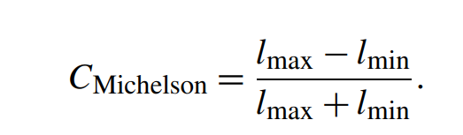
The measure assumes a simple image in which the number of foreground pixels approximately equals that of the background pixels. Michelson contrast ranges from 0 to 1. It is 1.0 if the full range of intensity values is used and less than 1.0 otherwise.
Example
Suppose we have a grayscale image with pixel values ranging from 0 to 255. We want to calculate the Michelson contrast for this image. The Michelson equation is:
Michelson contrast = (I_max - I_min) / (I_max + I_min)
where I_max is the maximum pixel value in the image, and I_min is the minimum pixel value in the image. Let's say the maximum pixel value in the image is 200 and the minimum pixel value is 50. Then, using the Michelson equation, we can calculate the contrast as:
Michelson contrast = (200 - 50) / (200 + 50) = 0.6
This means that the image has a contrast of 0.6 according to the Michelson contrast measure. A contrast of 0.6 indicates that the difference between the highest and lowest intensity values in the image is 60% of the average intensity level.

- root-mean square (rms) contrast
A somewhat better approach for measuring global contrast is the root-mean square (rms) contrast (see Fig. 5.2b). Given an image (x,y) with M · N pixels and intensities l(x,y), the expected value of l is
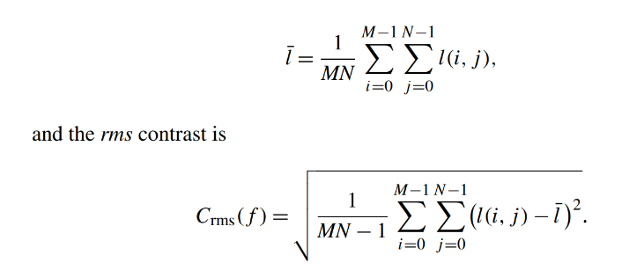

The measure takes all pixels into account instead of just the pixels with maximum and minimum intensity values. Crms does not differentiate well between different intensity distributions. Assuming lmin = 0, an image containing just two intensity levels 0.75 · lmax and 0.25 · lmax would have approximately the same variance than another one that contains all intensities between 0 and lmax equally distributed. If both are images of the same scene, the latter may show more details than the former.

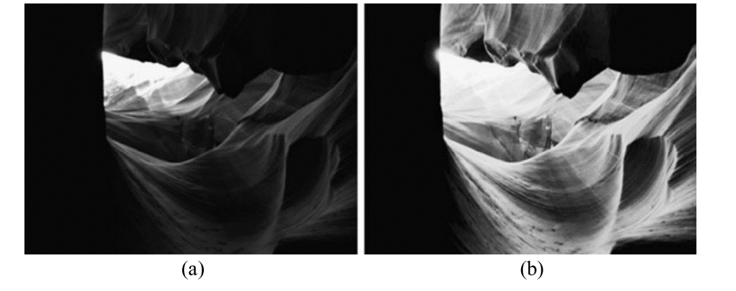
Fig. 5.2 The two images have the same global contrast CMichelson, while their local rms contrast Crms differs by a factor of three (Crms = 0.006 for (a) and Crms = 0.018 for (b))

- Entropy
Entropy as a contrast measure includes histogram characteristics into the measure. It is computed from the normalized histogram of image intensities. A histogram H(l) of an image l(x,y) gives the frequency of occurrence for each intensity. A normalized histogram H_{norm}(l) is computed from H(l) by

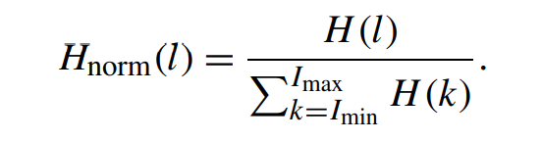
It gives the probability of l to appear in an image. If Hnorm(20) = 0.05, the probability is 0.05 that the gray value of a randomly picked pixel is 20. Entropy is computed from H_{norm}. It is being used in information theory for determining the average information capacity of a pixel. Entropy is a convenient measure for estimating compression rates for images for a type of lossless compression, but it may also be interpreted as representing the amount of information contained in an image. Increased entropy of an image would indicate enhanced contrast.

Example
Suppose we have a grayscale image with pixel values ranging from 0 to 255. We want to calculate the entropy of this image. The entropy is calculated as: Entropy = -sum(Hnorm(i)*log2(Hnorm(i))) for i = 0 to 255
where Hnorm(i) is the normalized histogram of the image, which gives the probability of a pixel with intensity i to appear in the image. log2 is the base-2 logarithm function.
Let's say we have the following normalized histogram for the image:
Hnorm = [0.01, 0.02, 0.03, ..., 0.05, ..., 0.03, 0.02, 0.01]
To calculate the entropy, we first calculate the logarithm of the normalized histogram:
log2(Hnorm) = [-6.6439, -5.6439, -4.6439, ..., -2.3219, ..., -4.6439, -5.6439, -6.6439]
Then, we multiply the normalized histogram with its logarithm and sum the values:
-sum(Hnorm(i)*log2(Hnorm(i))) = -0.0507
Therefore, the entropy of this image is 0.0507. This measure of entropy indicates the amount of information contained in an image. Higher values of entropy indicate greater randomness and hence greater information content. Where Information capacity is defined assuming that information I(l) of a pixel with intensity l is inversely proportional to the probability of its occurrence. Thus,
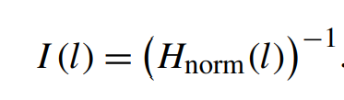
If information is stored in a binary number, the number of required digits would be
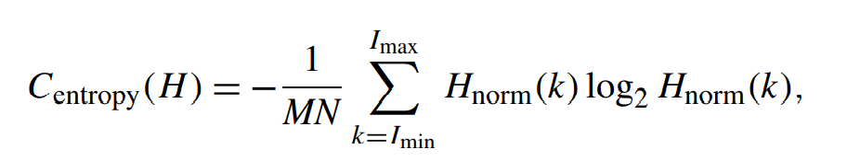
The entropy C_{entropy} is then the average signal length needed (see Fig. 5.3 for an example):
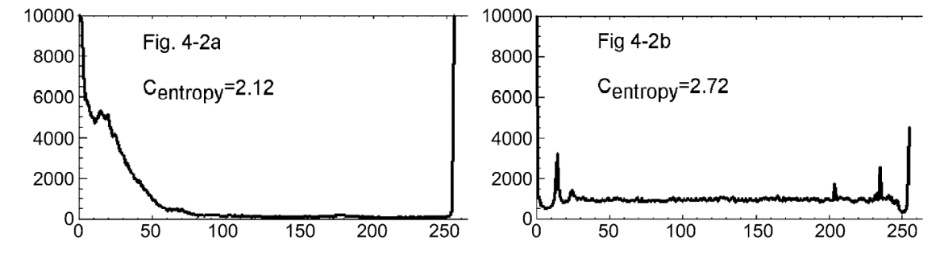

Fig. 5.3 Histograms of the pictures in Fig. 5.2 and entropy-based contrast measure

- Gray-level co-occurrence matrix (GLCM)
Co-occurrence calculates the normalized rates of co-occurring intensity values in a given neighborhood. The neighborhood is defined by the distance and direction between the two pixels. Hence, co-occurrence C_{α,d} is a two-dimensional function of intensities l1 and l2. C_{α,d} (l1,l2) is the probability with which pixels with intensities l1 and l2 occur such that pixel l1 and l2 are d units apart at an angle of α with the x-axis. Co-occurrence matrices can be computed with different distances and different directions representing intensity changes between structures at different angles and with different sharpness at the edge. For measuring contrast in a given image, co-occurrence is computed for a fixed distance (e.g., d = 1 pixel) and for arbitrary angles. C_{d} (l₁,l₂) is then the co-occurrence of pixels with gray levels l1 and l2 at distance d with an arbitrary angle. For d = 1 this would be the four pixels of the 4-neighborhood. Contrast CGLCM is then defined as

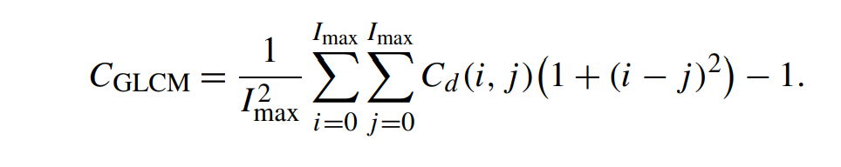
- Image Enhancement Techniques
Originally, image enhancement methods were meant to enhance the perceptibility of information. Hence, contrast or edge enhancement improve the image for inspection by a human observer. This should be kept in mind when considering an enhancement procedure
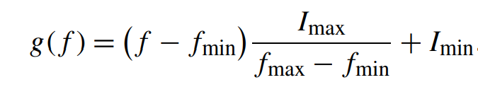
3.1 Contrast Enhancement Some of the contrast enhancement techniques can be directly related to contrast measures described in the previous section. The simplest method increases global contrast. If the range of possible intensity values I_{min} to I_{max} exceeds the range of intensities f_{min} to f_{max}, linear contrast enhancement is carried out creating new values g from intensities f for every pixel by

Or simply :
g (f)= (f - fmin) * (Imax - Imin) / (fmax - fmin) + Imin

The function to map f on g is called the transfer function. Contrast enhancement in an arbitrary intensity window w_{min} to w_{max} with I_{min} < w_{min} < w_{max} < I_{max} can be achieved with a similar transfer function.
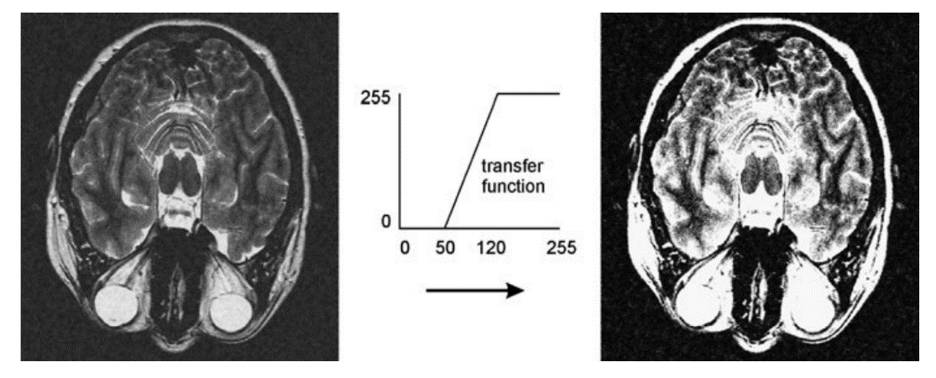
Fig. 4.4 Linear contrast enhancement in a window (50, 120) for enhancing soft tissue differences in an MR image. The enhancement comes at the cost of reducing contrast in regions outside of the window (such as the water in the eye balls)

Example:
For example, one simple method to enhance contrast is to increase the global contrast of the image. This can be achieved by using a linear contrast enhancement function, which maps the original intensity values of the image to a new range of values that span the full dynamic range of the display. The transfer function that maps the original intensity values to the new values can be calculated using the maximum and minimum intensity values of the image, as well as the maximum and minimum intensity values of the display.
Here's an example of how to perform linear contrast enhancement on a grayscale image:
Suppose we have an image with intensity values ranging from 0 to 255, but the range of intensities in the image is only from 50 to 200. We want to enhance the contrast of this image by mapping the intensity values to the full range of 0 to 255.
The transfer function can be calculated using the following formula:
g = (f - fmin) * (Imax - Imin) / (fmax - fmin) + Imin
where f is the original intensity value of the pixel, g is the new intensity value, Imax and Imin are the maximum and minimum intensity values of the display, and fmax and fmin are the maximum and minimum intensity values of the image.
In our example, fmin = 50, fmax = 200, Imin = 0, and Imax = 255. Plugging in these values into the transfer function, we get:
g = (f - 50) * 255 / (200 - 50) + 0
Simplifying this equation, we get:
g = 1.275 * f - 63.75
This transfer function maps the original intensity values of the image to the new values that span the full range of the display. By applying this transfer function to every pixel in the image, we can enhance the contrast of the image and make it more visually appealing.
3.2 Resolution Enhancement Improving the spatial resolution within an image is often avoided because information needs to be added for up-sampling a given image. Its simplest variant, interpolation is carried out as a 1D linear or cubic interpolation in the direction of the z-axis. Interpolation is improved if structures to be interpolated are already segmented and the data are binary. Shape-based interpolation consists of three steps.
1. Creation of a signed distance map from every slice For every voxel, a signed distance map contains a distance to the closest boundary. Voxels inside the object have a positive distance assigned to them.
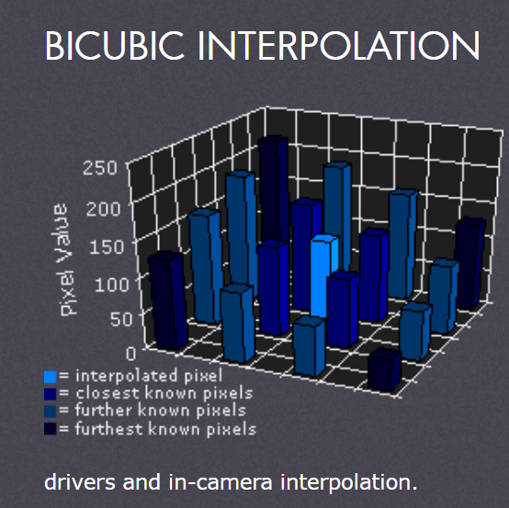
2. Linear (or cubic) interpolation of distance maps: Interpolation is carried out along the z-axis.

3. Binarization of interpolated slices Voxels with negative distances are mapped to a background and all other are mapped to foreground voxels.
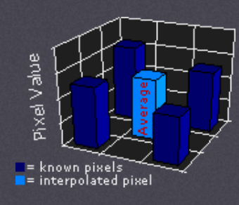

3.3 Edge Enhancement Enhancing the edges improves recognizing structures in images. Since automatic or interactive object delineation تحديد الكائنis a frequent task in image analysis, edge enhancement is often a prerequisite for tracking object boundaries. Edges are closely associated with the intensity gradient because the existence of an edge implies a local change of intensity. For a 2D image with continuous domain (x,y), the gradient is a vector. various kernels have been used. Examples are the Sobel operator with kernels D_{Sobel,x} and D_{Sobel,y}
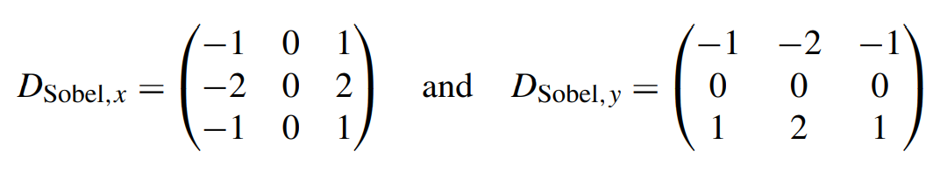

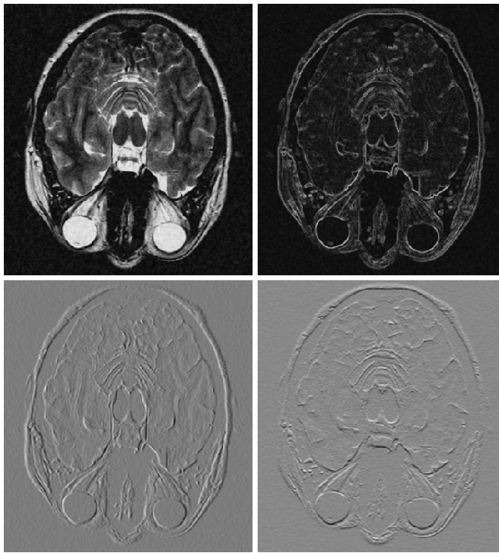

Fig. 4.5 Gradient filters produce approximations of the partial derivatives in x- and y-direction (the two pictures in the second row show the result from applying the Sobel operator). The length of the gradient (upper right) can be used for computing edge features

