Radiology
Lec. 16 Infection Control Dr. Areej

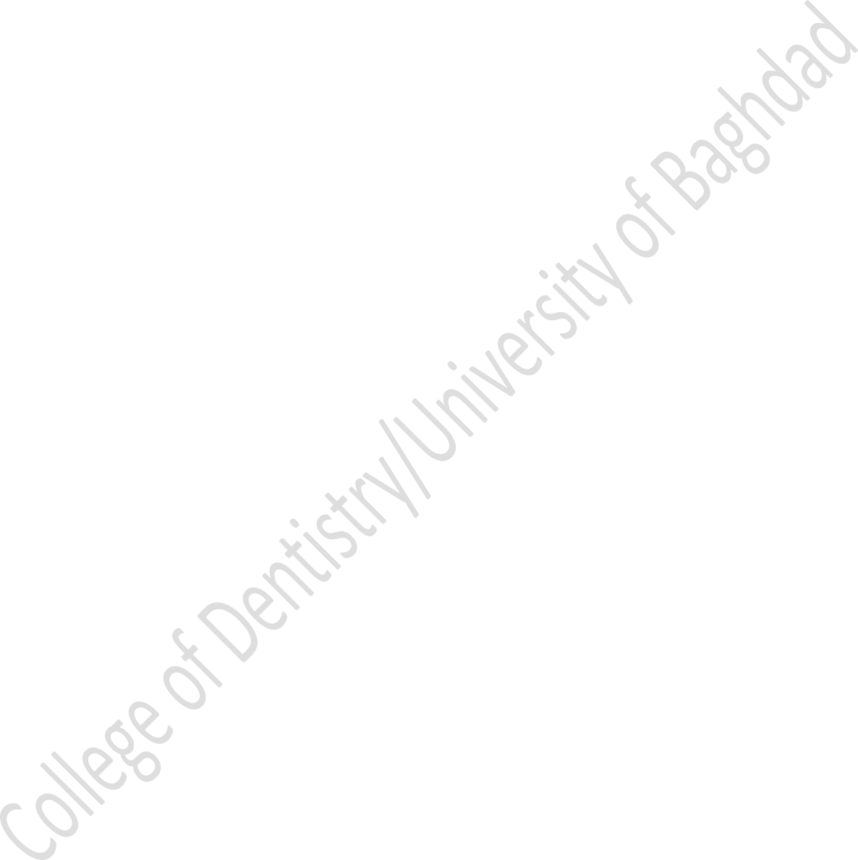
Dental personnel and patients are at increased risk for acquiring tuberculosis, HIV, herpes viruses, upper respiratory infections, and hepatitis strains A through E.
The primary goal of infection control procedures is to prevent cross- contamination and disease transmission from patient to staff, from staff to patient, and from patient to patient.
The potential for cross-contamination in dental radiography is great. Cross- contamination can be happened in different way:
- An operator's hands become contaminated by contact with a patient's mouth and saliva-contaminated films and film holders. Then the operator also must adjust the x-ray tube head and x-ray machine control panel settings to make the exposure.
- An operator handles digital sensors or opens film packets to process the films in the darkroom.
The dentist is responsible for minimizing or eliminating cross-contamination procedures. And responsible also to educates other members of the practice.

Key Steps in Radiographic Infection Control
- Apply standard precautions & Wear personal protective equipment during all radiographic procedures
- Disinfect and cover x-ray machine, working surfaces, chair, and apron

- Sterilize nondisposable instruments
- Use barrier-protected film (sensor)
- Prevent contamination of processing equipment

Standard Precautions & Wear Personal Protective Equipment During All Radiographic Procedures

Standard precautions (also called universal precautions) are infection control practices designed to protect workers from exposure to diseases spread by blood and certain body fluids, including saliva. Under standard precautions, all human blood and saliva are treated as infectious for human immunodeficiency virus (HIV) and hepatitis B virus.

According to standard precautions, Personal protective equipment is an effective means to shield the operator from exposure to potentially infectious material, including blood and saliva.
- Hand hygiene is most important to prevent spread of infections. After the patient is seated, the hand should be washed using plain or antimicrobial soap. Alcohol-based hand rubs are also effective.
- Disposable gloves should be worn in sight of the patient. The operator should always wear gloves when making radiographs or handling contaminated film or when removing barrier protections from surfaces and radiographic equipment.
- Operators should wear protective clothing (e.g., disposable gown or laboratory coat) that covers clothes and skin to protect against potential contamination.

Disinfect and Cover Clinical Contact Surfaces

Clinical contact surfaces are surfaces that might be touched by gloved hands or instruments that go into the mouth. These include the x-ray machine and control panel, chair-side computer, beam alignment device, dental chair and headrest, protective apron, thyroid collar, and surfaces on which the receptor is placed. These are noncritical items. The goal of preventing cross-contamination is by disinfecting all such surfaces and by using barriers to isolate equipment from direct contact.
Barriers made of clear plastic wrap should cover working surfaces that were previously cleaned and disinfected, and should be changed when damaged and routinely after each patient.

Intermediate- and low level activity disinfectants recommended for use on clinical contact surfaces.
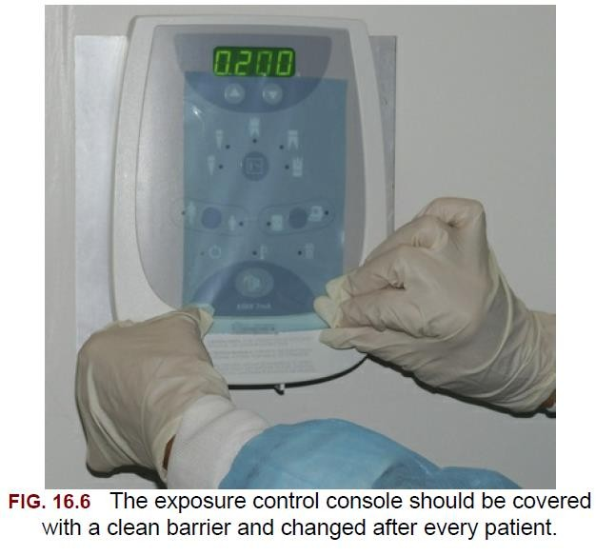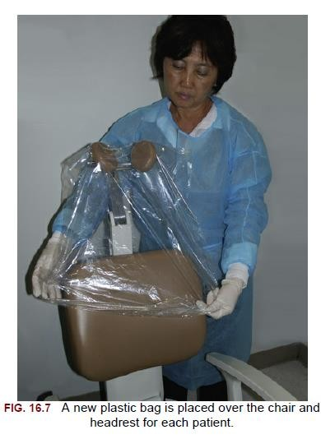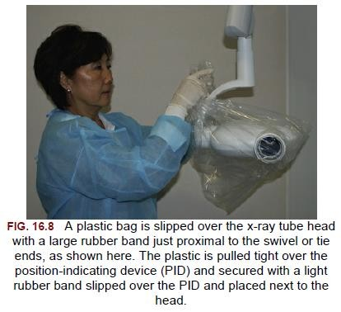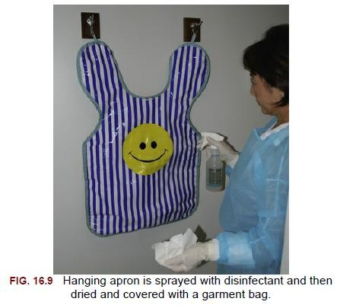

Panoramic chin rest and patient handgrips should be cleaned with a low-level disinfectant. Disposable biteblocks may be used. The head-positioning guides, control panel, and exposure switch should be carefully wiped with a paper towel that is well moistened with disinfectant.
Cephalostat ear posts, ear post brackets, and forehead support or nasion pointer should be cleaned and disinfected. These may then also be covered with a plastic barrier.
After patient exposures are completed, the barriers should be removed, and contaminated working surfaces (including surfaces in the darkroom) and the apron should be sprayed with disinfectant and wiped as described previously. The barriers should be replaced in preparation for the next patient.

Sterilize Non disposable Instruments

Film -holding instruments are classified as semicritical items —instruments that are not penetrate soft tissue or bone but do come in contact with the oral mucous membrane. It can be sterilized by steam under pressure (autoclave).

Use Barriers With Digital Sensors

Digital Sensors cannot be sterilized by heat, so a plastic barrier used to protect them from contamination when placed in the patient's mouth.

Prevent Contamination of Processing Equipment

After all film exposures are made, the operator should remove his or her gloves and take the container of contaminated films to the darkroom.
The goal in the darkroom is to break the infection chain so that only clean films are placed into processing solutions. Two towels should be placed on the darkroom working surface. The container of contaminated films should be placed on one of these towels. After the exposed film is removed from its packet, it should be placed on the second towel. The film packaging is discarded on the first towel with the container.

