Number, spacing and depth of Bore hole
Foundation layout
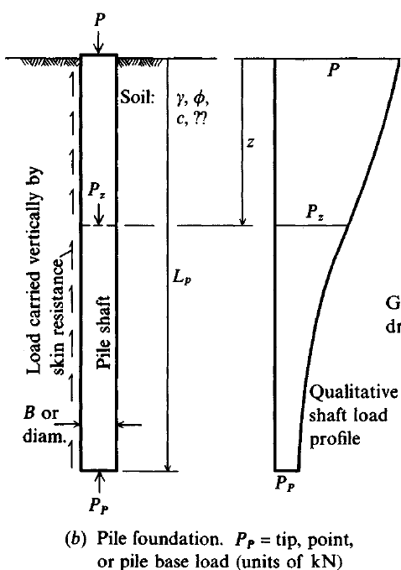
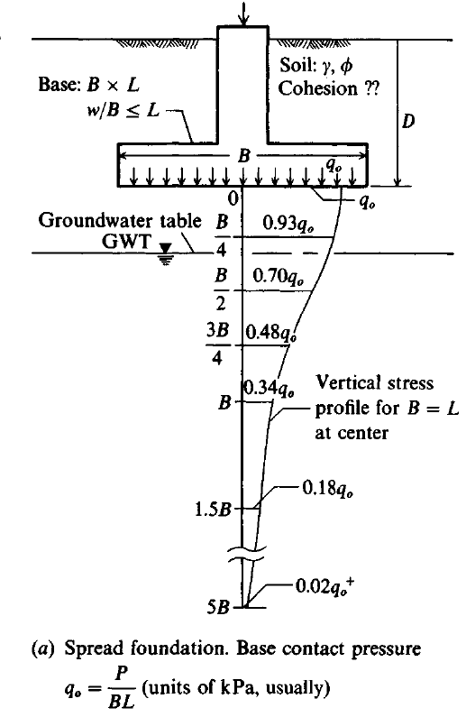

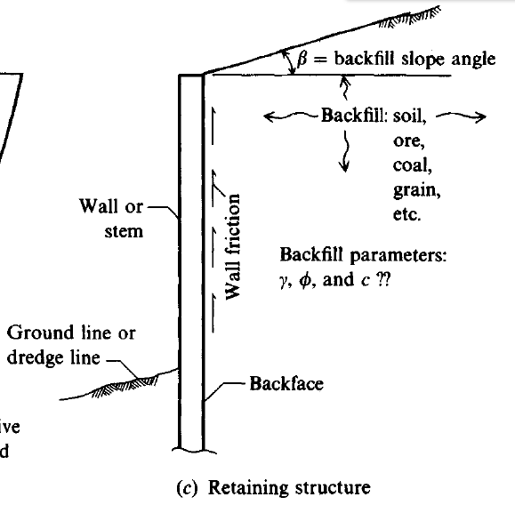
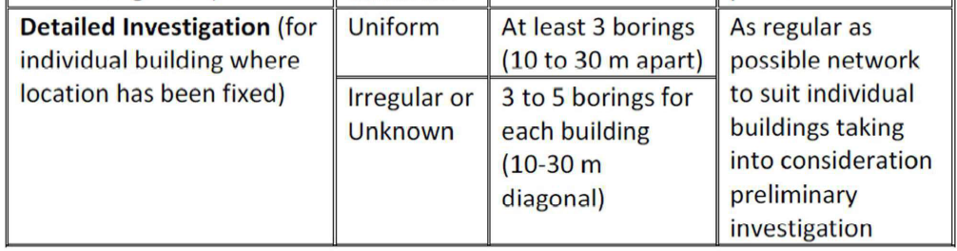
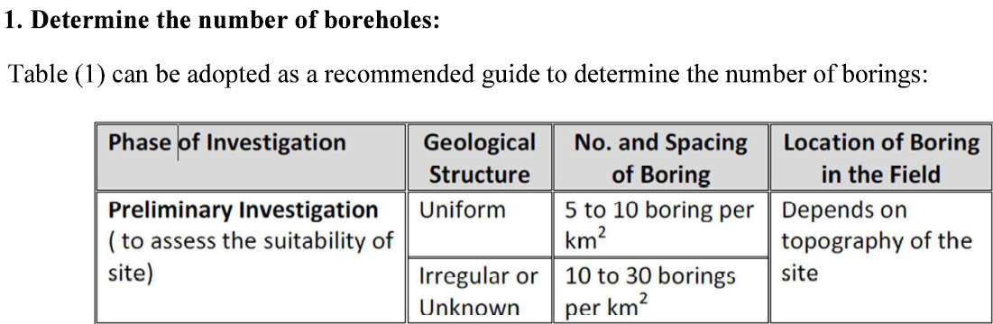

The following rules may be followed for finding the number of borings
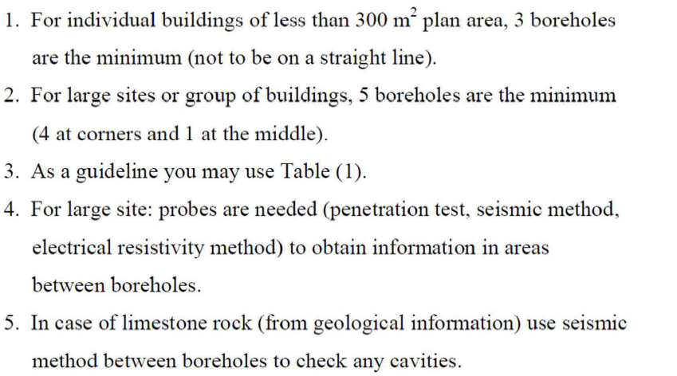
6. For some special structures
a. Retaining walls
Minimum spacing is 120m at the centerline with some of these BH located at both sides of the centerline.
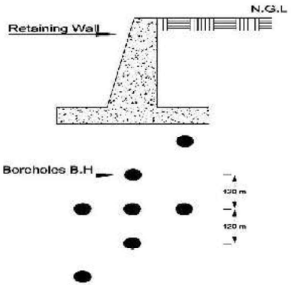
b. Slop stability
- to 4 BH under the critical zones and at least 1 outside the critical zone
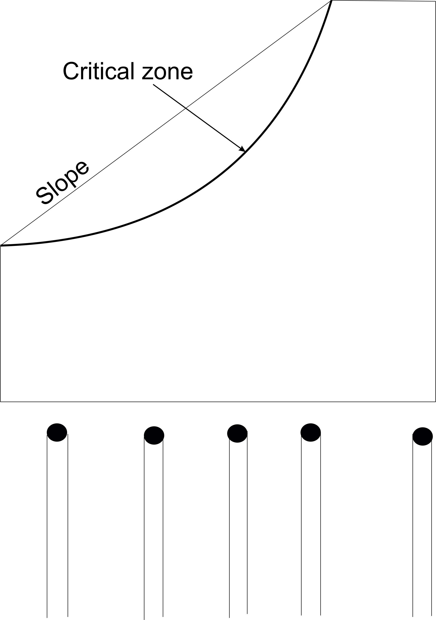
Bore holes under slopes
2. Depth of boreholes
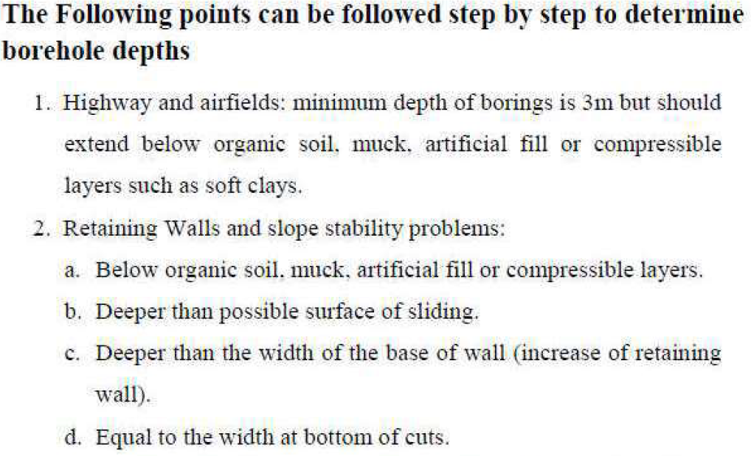
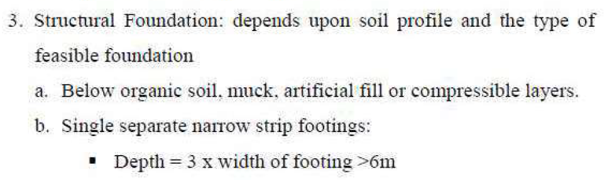
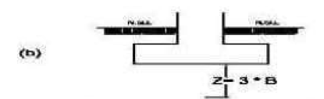
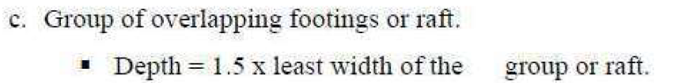
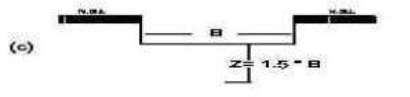
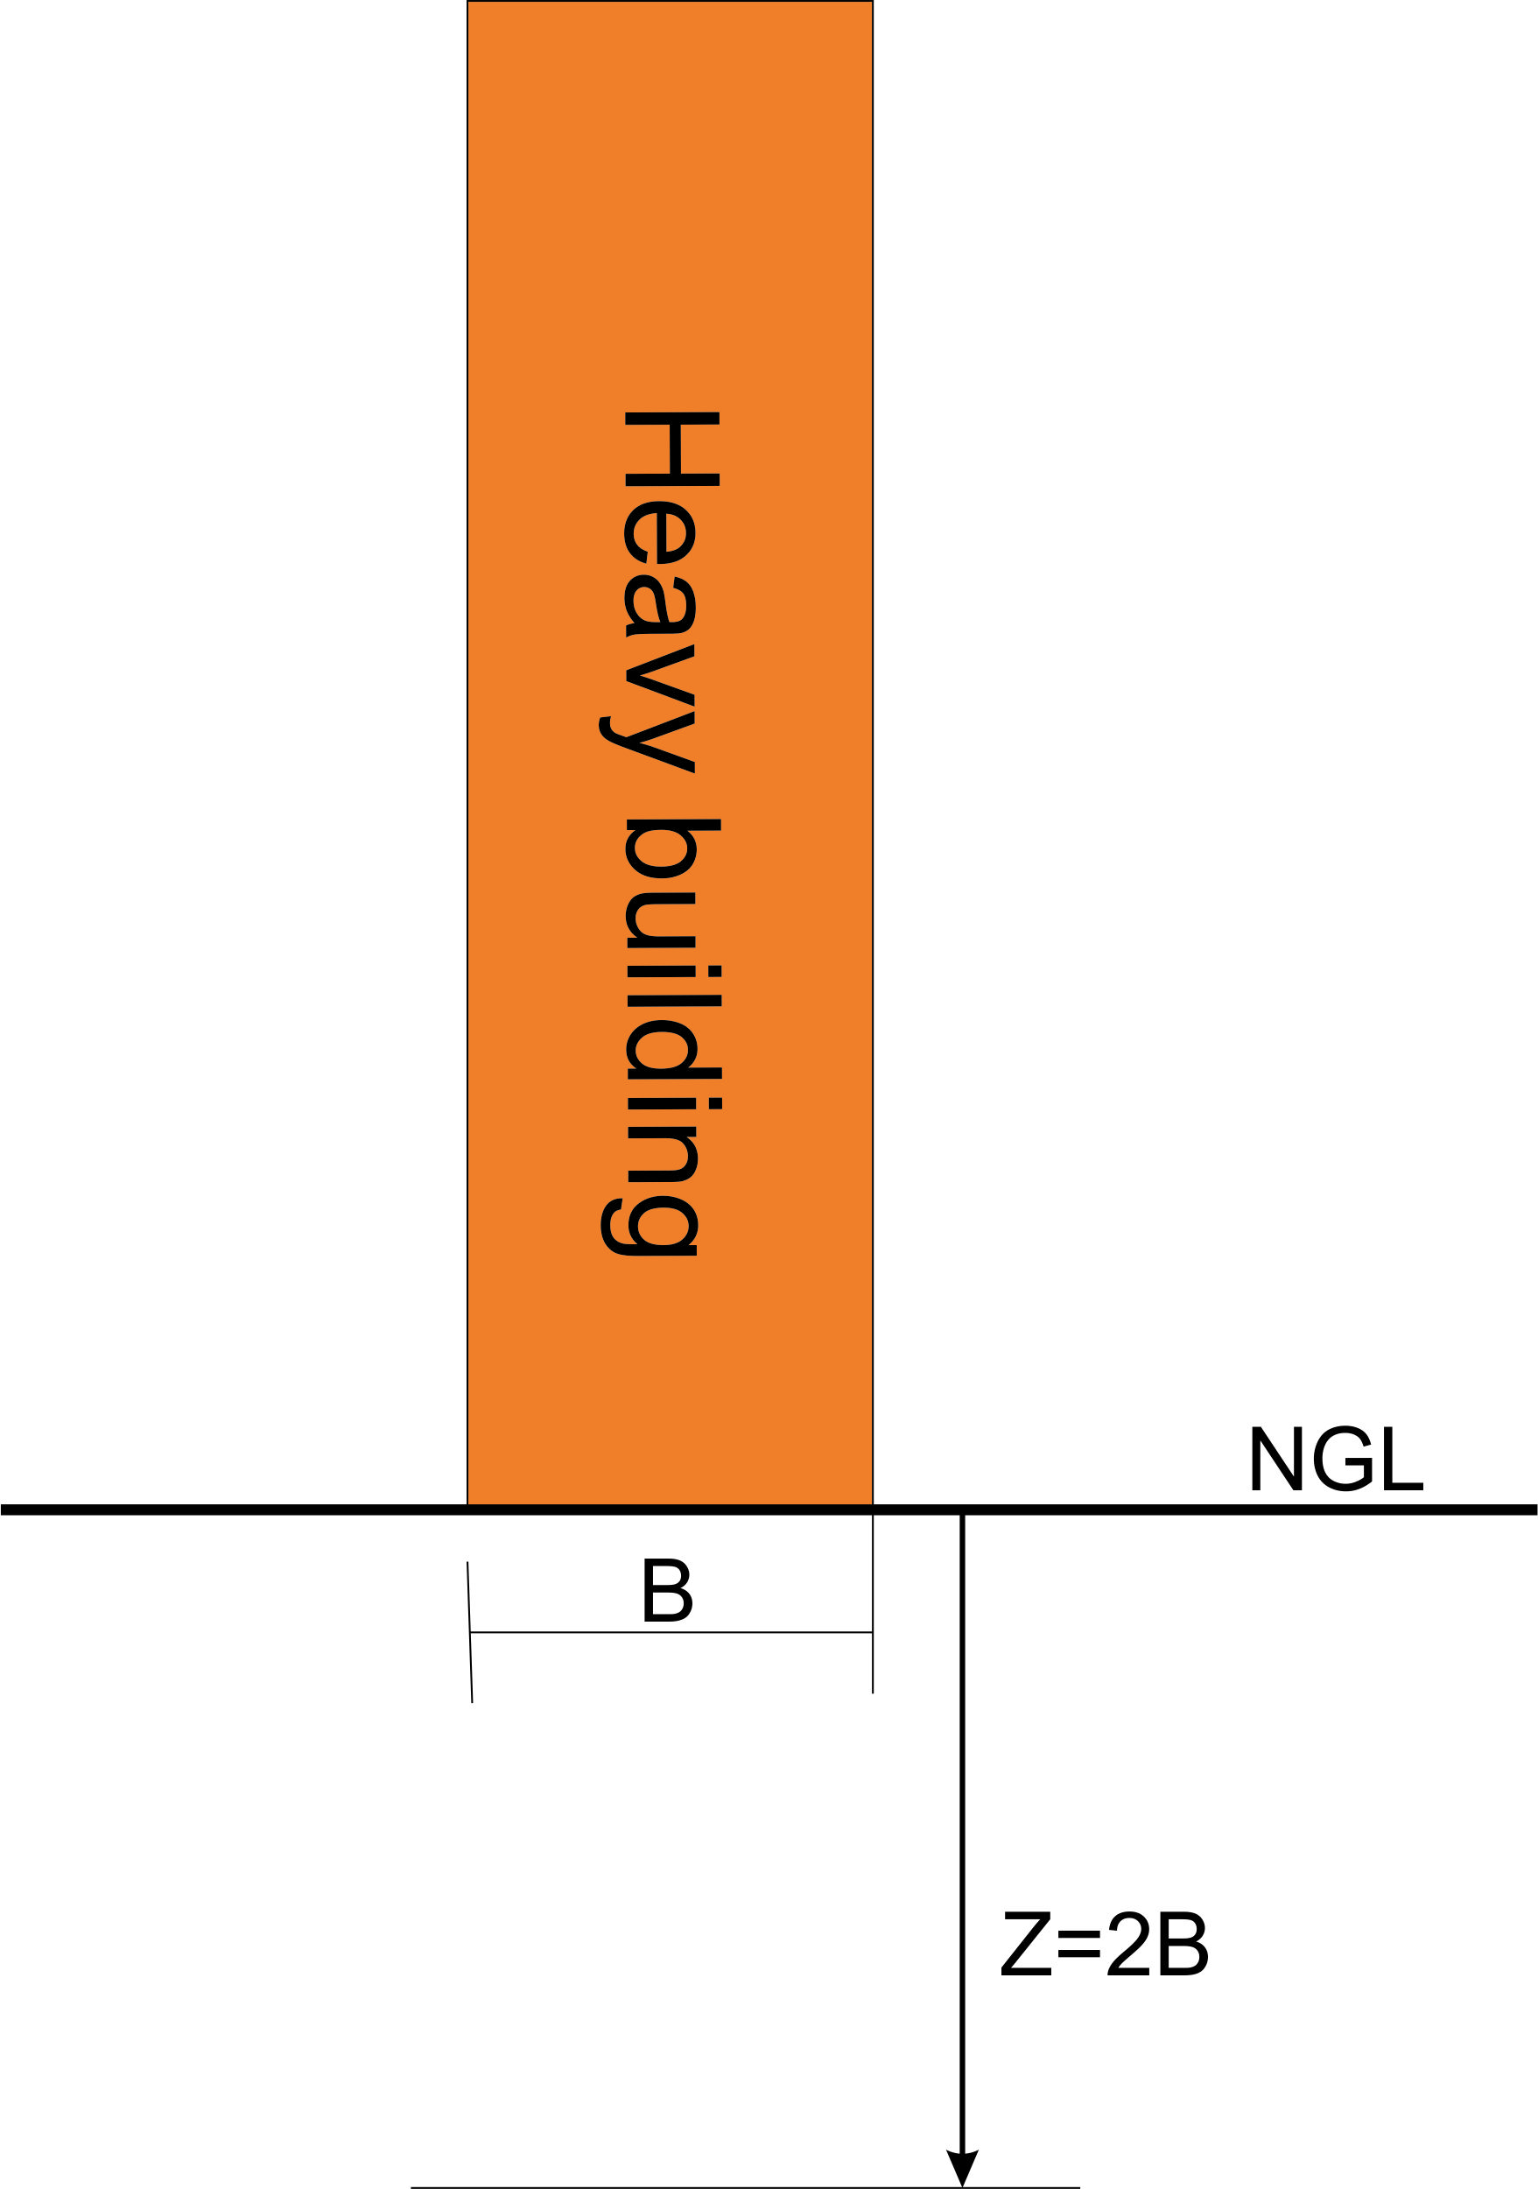
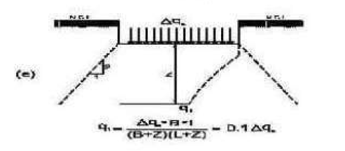
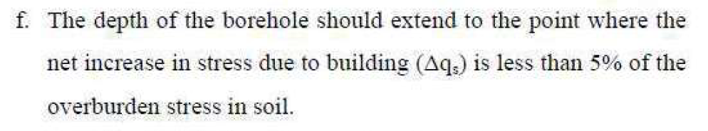
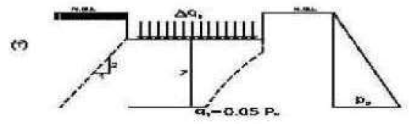
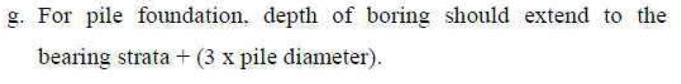
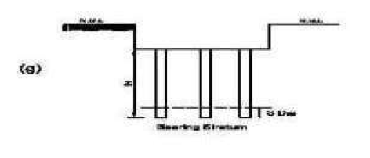
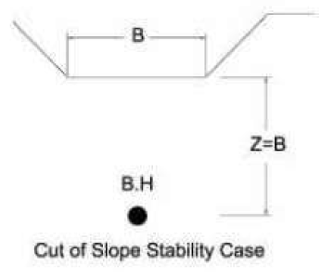
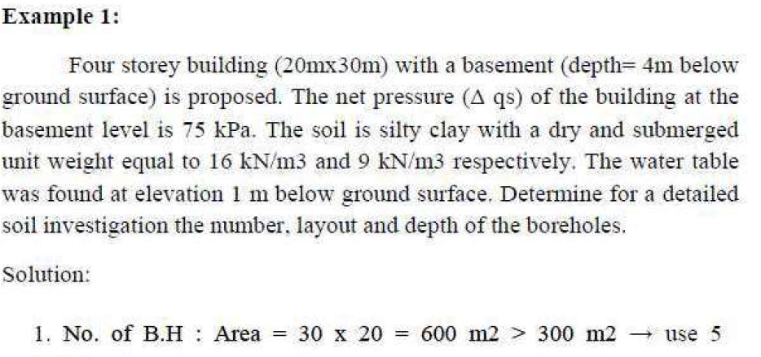
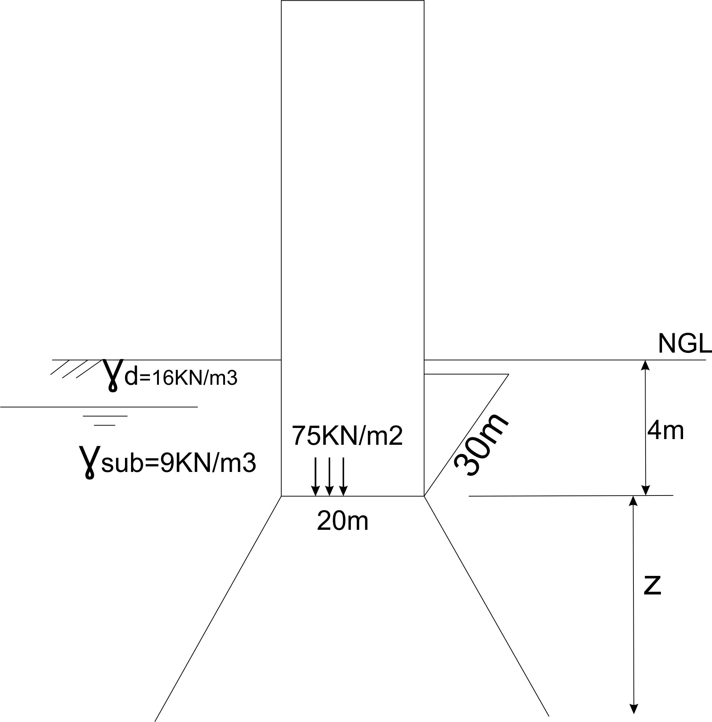
Layout: use 4 BH at corners and 1 at the center
Since it is a raft foundation
c) $Z=1.5*20n=30m$
e) assuming 2:1 distribution
$∆qBL=0.1∆q(B+z)(L+z)$
$\frac{BL}{(B+z)(L+z)}=0.1$
$\frac{20*30}{(20+z)(30+z)}=0.1$ , solving for z, the $z=52.6m$
f) effective stress at depth z; $P_{o}=1*\frac{16KN}{m3}+\left(3+Z\right)*\frac{9KN}{m3}=43+9Z$
$0.05P_{o}=\frac{∆qLB}{(B+Z)(L+Z)}$
$0.05(43+9Z)=\frac{75*20*30}{(20+Z)(30+Z)}$ , solving for $Z$
$Z=29.4m≈30m$ , the same as in C
Therefore, $Z=30+4=34m$
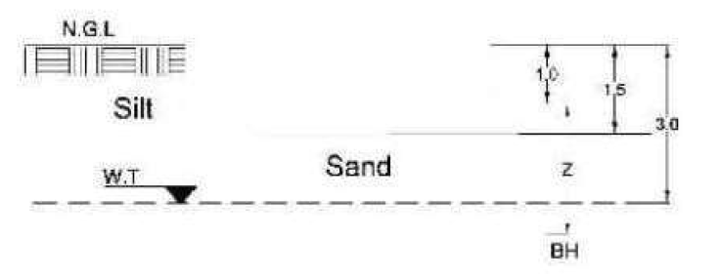
Example 2: A square building of 9 columns bears loads as below;
Col | No. | Load  KN
C1 | 5 | 1500
C2 | 4 | 2500
$γ_{sat}of sand=19KN/m3$ , $γ_{dry}of silt=17KN/m3$
Estimate Z if B = 8.5m and number of boring
$A={8.5}^{2}=72.25m2<300m2$, therefore use 3 BH
$∆q=\frac{P}{A}=\frac{P}{BL}=\frac{5*1500KN+4*2500kN}{8.5m*8.5m}=\frac{235KN}{m2}>200KN/m2$ , therefore it is a heavy building
$Z=8.5*2=17m$
e) $\frac{8.5*8.5}{(8.5+z)(8.5+z)}=0.1$, $Z=18.3m$
f) $0.05P_{o}=\frac{∆qLB}{(B+Z)(L+Z)}$
$$0.05{(1.5*\frac{17KN}{m3}+1.5*\frac{19KN}{m3}+\left(Z-3\right)*9KN/m3}_{}=\frac{17500}{(8.5+Z)(8.5+Z)}$$
$Z=27.26m$
Use the minimum Z , $Z=17+0.5m*2=18m$ Below NGL.

