head & neck anatomy 2nd y

Pterygopalatine fossa:
The pterygopalatine fossa is a cone-shaped depression , It is located between
the maxilla, sphenoid and palatine bones, and communicates with other regions of
the skull and facial skeleton via several canals and foramina.
Boundaries :
Anterior: Posterior wall of the maxilla.
Posterior: Pterygoid process of the sphenoid bone.
Inferior: Palatine bone. At the bottom of the fossa, the pyramidal process of the palatine bone articulates with the lateral pterygoid plate and maxilla and forming the narrow floor of the pterygopalatine fossa.
Superior: body of the sphenoid and the Inferior orbital fissure.
Medial: Perpendicular plate of the palatine bone
Lateral: Pterygomaxillary fissure Pterygopalatine fossa contain , 3rd part of maxillary artery, maxillary nerve and its branches and pterygopalatine ganglion.
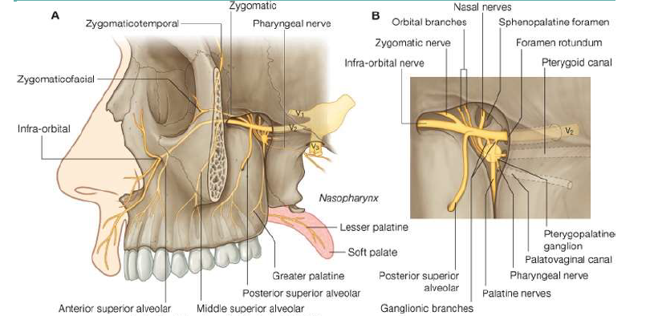
Maxillary vessels
The 3rd part of maxillary artery passes through the pterygomaxillary fissure,
enters the pterygopalatine fossa in front of the ganglion and gives off its branches.
Veins accompany the arteries and, passing through the fossa, emerge at the
pterygomaxillary fissure to drain into the pterygoid plexus.
Maxillary nerve
The maxillary nerve arises from the trigeminal ganglion in the middle cranial
fossa. It passes forward in the lateral wall of the cavernous sinus and leaves the skull
through the foramen rotundum and crosses the pterygopalatine fossa to enter the
orbit through the inferior orbital fissure. It then continues as the infraorbital nerve in
the infraorbital groove, and it emerges on the face through the infraorbital foramen.
Direct branches of maxillary nerve
1. meningeal branch [dural branch or middle meningeal nerve] to the middle
cranial fossa.
2. Ganglionic branches, which are two short nerves that suspend the
pterygopalatine ganglion in the pterygopalatine fossa.
3. zygomatic nerve arises from the maxillary nerve in the fossa and runs through
the inferior orbital fissure to enter the orbit, which divides into the
zygomaticotemporal and the zygomaticofacial nerves that supply the skin of
the face. The zygomaticotemporal branch gives parasympathetic secretomotor
fibers [communicating brach] to the lacrimal gland via the lacrimal nerve.
4. The posterior superior alveolar nerve is also given off in the fossa. It passes
through the pterygomaxillary fissure on to the posterior wall of the maxilla.
which supplies the maxillary sinus as well as the upper molar teeth and
adjoining parts of the gum and the cheek'
5. infraorbital nerve passing through inferior orbital fissure to become in the
floor of the orbit running in the infraorbital groove and give here the middle
superior alveolar nerve, and anterior superior alveolar in the infraorbital canal.
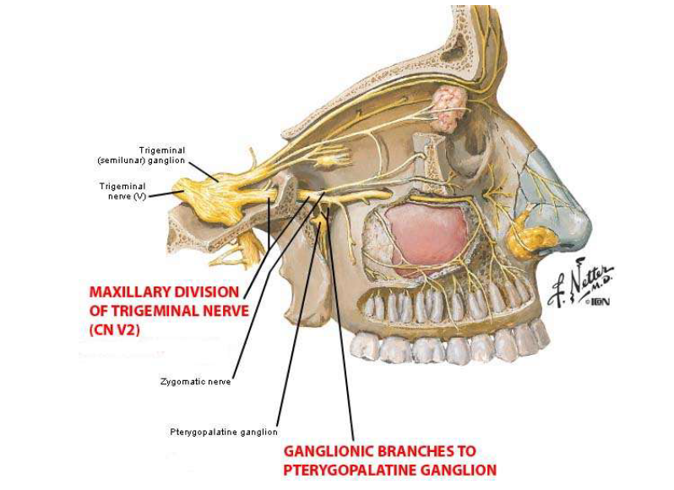
Pterygopalatine Ganglion
The ganglion lies immediately in front of the opening of the pterygoid canal and
the nerve of that canal runs straight into the back of the ganglion. The ganglion sits
deep within the pterygopalatine fossa near the sphenopalatine foramen. It is the largest
parasympathetic ganglion related to branches of the maxillary nerve (via
pterygopalatine branches). The autonomic root is the nerve of the pterygoid canal
(Vidian nerve). This nerve is formed in the foramen lacerum by union of the greaterpetrosal nerve, containing mainly parasympathetic secretomotor fibers, with the
deep petrosal nerve, containing postganglionic sympathetic fibers from the superior
cervical ganglion. The former is a branch of the facial nerve and the latter is a branch
from the internal carotid sympathetic plexus. The combined nerve passes forward in
the pterygoid canal and joins the ganglion.
Postganglionic parasympathetic fibers leave the ganglion and distribute with
branches of the maxillary nerve. These fibers are secretomotor in function, and
provide parasympathetic innervation to the 1/lacrimal gland, and muscosal glands of
the 2/palate, 3/nose 4 / paranasal sinuses and 5/nasopharynx. It is the ganglion of hay
fever (‘running nose and eyes’).
The postganglionic secretomotor fibers to the lacrimal gland leave the ganglion
and join the maxillary nerve, pass in its zygomatic branch into the orbit, join the
lacrimal branch of the ophthalmic nerve and so reach the lacrimal gland.
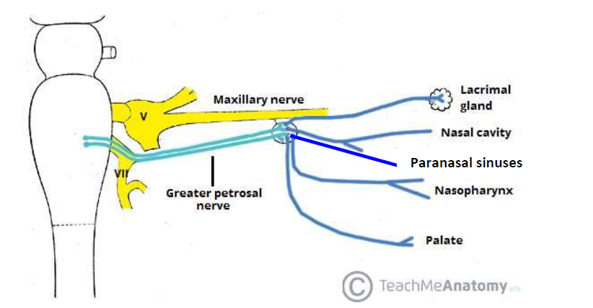

The rest of the fibers in the connections between the maxillary nerve and the
ganglion are sensory and, like the sympathetic fibers in the deep petrosal nerve, they
pass through the ganglion without relay.
The only cell bodies in the ganglion are parasympathetic (secretomotor). The
branches of the pterygopalatine ganglion are distributed to the nose, palate and
nasopharynx. Every branch carries a mixture of all three kinds of fibers: sensory,
secretomotor and sympathetic.
Indirect branches of maxillary nerve : which are distributed through the
branches of pterygopalatine ganglion.
1/ Medial posterior superior nasal nerves pass through the sphenopalatine
foramen, cross the roof of the nose, and are distributed to the septum. The largest
of these is termed the nasopalatine nerve [long sphenopalatine], as it continues
beyond the septum through the incisive canal to supply the anterior part of the hard
palate.
2/The lateral posterior superior nasal nerves [short sphenopalatine] pass
through the sphenopalatine foramen and turn forward to supply the
posterosuperior part of the lateral wall of the nose.
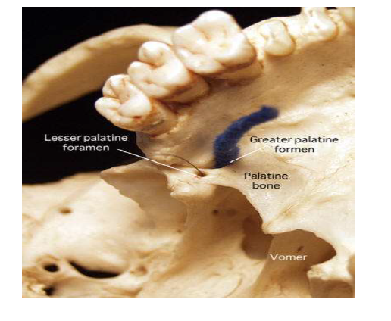
3/The greater palatine nerve passes down through the greater palatine canal,
between the perpendicular plate of the palatine bone and the maxilla. At the greater
palatine foramen it turns forward to supply the mucous membrane of the hard
palate. As it descends it also supplies the posteroinferior part of the lateral wall of
the nose and the medial wall of the maxillary sinus.
4/The lesser palatine nerves, two in number, pass down behind the greater
palatine nerve and emerge through the lesser palatine foramen. They pass back to
the soft palate and the mucous membrane of the palatine tonsil. They carry the only
special sensory fibers transmitted in the greater petrosal nerve; these are sensory
(taste) fibers that have their cell bodies in the genicular ganglion of the facial nerve.
5/The pharyngeal nerve passes back through the palatovaginal canal (a little
canal between the vaginal process of the medial pterygoid plate and the sphenoidal
process of the palatine bone) and supplies the mucous membrane of the
nasopharynx.
6/A few fine orbital branches enter the orbit via the inferior orbital fissure and
supply periosteum of the orbital floor and the mucous membrane of the sphenoidal
and ethmoidal sinuses.
Openings
There are seven openings that connect the pterygopalatine fossa with the orbit, nasal
and oral cavities, middle cranial fossa and infratemporal fossa. The openings
transmit blood vessels and nerves between these regions.
1/Pterygomaxillary Fissure
The pterygomaxillary fissure connects the infratemporal fossa with the pterygopalatine
fossa . It transmits two neurovascular structures:
• Posterior superior alveolar nerve – a branch of the maxillary nerve. It exits through
the fissure into the infratemporal fossa, where it goes on to supply the maxillary
molars.
• 3rd part of the maxillary artery – enters the pterygopalatine fossa via the fissure.
2/Foramen Rotundum
The foramen rotundum connects the pterygopalatine fossa to the middle cranial fossa.
It conducts a single structure, the maxillary nerve.
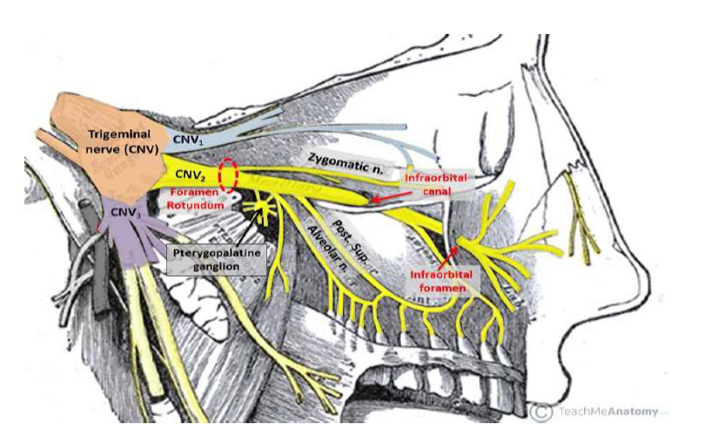
3/Pterygoid canal: runs from the middle cranial fossa [anterior wall of foramen
lacerum] and through the medial pterygoid plate. It carries the nerve, artery and
vein of the pterygoid canal.
4/Pharyngeal Canals [palatovaginal canal]: communicates with the
nasopharynx. It carries the pharyngeal branches of the maxillary nerve , artery and
vein.
These two canals, with the foramen rotundum, are the three openings in the posterior wall of the pterygopalatine fossa

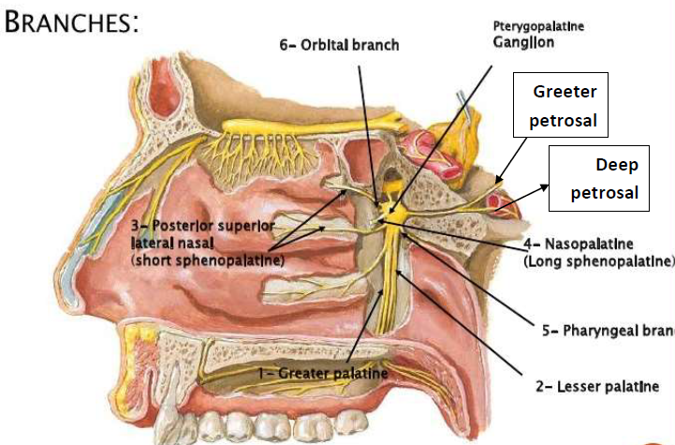
5/Inferior Orbital Fissure
The inferior orbital fissure forms the superior boundary of the pterygopalatine
fossa and communicates with the orbit. It is a space between the sphenoid and maxilla
bones.
*The zygomatic branch of the maxillary nerve
*The infraorbital nerve, artery and vein pass through the inferior orbital fissure
*The inferior ophthalmic vein communicate with pterygoid venus pluxes through this fissure.
*The orbital branches from pterygoid ganglion .
6/Greater Palatine Canal
The perpendicular plate of palatine bone articulates anteriorly with the maxilla
and between the two lies the greater palatine canal which opens below at a foramen
on the hard palate.The greater palatine canal lies in the floor of the pterygopalatine
fossa, and communicates with the oral cavity. Branching from the greater palatine canal
are the lesser palatine canals. The greater palatine canal transmits the descending
palatine artery and vein, the greater palatine nerve and the lesser palatine nerve.
7/Sphenopalatine Foramen
This foramen is the only opening in the medial boundary. It connects the
pterygopalatine fossa to the nasal cavity. It is formed by the sphenopalatine notch at
the superior aspect of the perpendicular plate of the palatine bone [orbital process
anteriorly and sphenoidal process posteriorly]and the body of the sphenoid.
The sphenopalatine foramen transmits the sphenopalatine artery and vein, as well as
the nasopalatine nerve (a large branch of the pterygopalatine ganglion), with other
branches mentioned above.

