Human Anatomy
م.د علي سلمان
Lec. 8
Parotid region
Regions of Head
To allow clear communications regarding the location of structures, injuries, or pathologies, the head is divided into regions (Fig. 1).
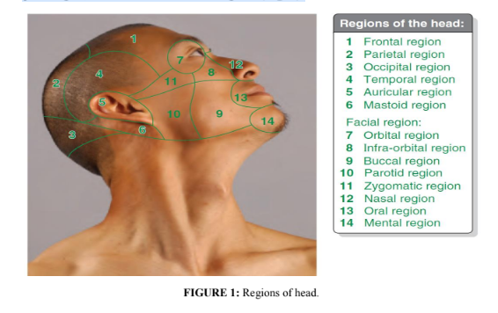
Parotid Region
The parotid region is the posterolateral part of the facial region (Fig. 2), bounded by the:
• Zygomatic arch superiorly.
• Angle and inferior border of the mandible inferiorly.
• Ramus of the mandible medially.
• Anterior border of the masseter muscle anteriorly.
• External ear and anterior border of the sternocleidomastoid muscle posteriorly.
The parotid region includes the parotid gland and duct, the parotid plexus of the facial
nerve (CN VII), the retromandibular vein, the external carotid artery, and the masseter
muscle. On the parotid sheath and within the gland are parotid lymph nodes. The five
terminal branches of the facial nerve leave through the anterior border of the gland in
a radiating manner that resembles the foot of a goose. Hence, this pattern is known as “pes anserinus”.
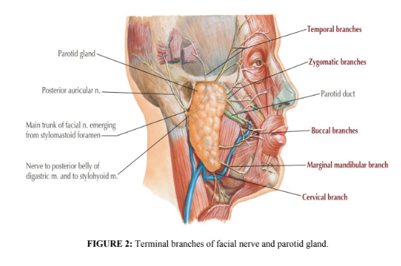
Parotid Gland
The parotid gland is the largest of three paired salivary glands and is composed mostly
of serous acini. It is enclosed within the parotid sheath, a tough unyielding capsule
derived from the deep cervical fascia. (Fig. 3). It lies in a deep hollow below the
external auditory meatus, behind the ramus of the mandible (Fig. 4), and in front of the
sternocleidomastoid muscle.
The parotid gland has an irregular shape; the apex is posterior to the angle of the
mandible, and its base is related to the zygomatic arch. The subcutaneous lateral
surface of the parotid gland is almost flat (Fig. 4).The facial nerve divides the gland
into superficial and deep lobes. Fatty tissue between the lobes confers the flexibility
the gland must have to accommodate the motion of the mandible.
Parotid Duct
The parotid (Stensen’s) duct passes horizontally from the anterior edge of the gland
(Figs. 2 & 4) and passes forward over the lateral surface of the masseter muscle about
one fingerbreadth below the zygomatic arch. It then turns medially, dives deeply into
the buccal fat-pad, piercing the buccinator muscle and enters the vestibule of oral cavity
through a small orifice (papilla) opposite the second maxillary molar tooth (Fig. 4).
The oblique passage of the duct in the buccinator muscle acts as a valve-like
mechanism & prevents inflation of the duct during blowing. The duct is about 2 in. (5
cm) long. It is represented by the middle 1/3rd of a line extending from the tragus of
the auricle to a point midway between the ala of nose & upper lip.
Innervation of Parotid Gland and Related Structures
Although the parotid plexus of the facial nerve (CN VII) is embedded within the parotid
gland, CN VII does not provide innervation to the gland. The auriculotemporal and
great auricular nerves provide sensory fibers to the gland and innervate the parotid
sheath (Fig. 3) as well as the overlying skin. The parasympathetic component of the
glossopharyngeal nerve (CN IX) supplies presynpatic secretory fibers to the otic
ganglion (Fig. 5). The postsynaptic parasympathetic fibers are conveyed from the
ganglion to the gland by the auriculotemporal nerve. Stimulation of the
parasympathetic fibers produces a thin, watery saliva. Sympathetic fibers are derived
from the cervical ganglia through the external carotid nerve plexus on the external
carotid artery (Fig. 3).

Arterial Supply:
External carotid artery & its terminal branches.
Venous Drainage
Into the retro-mandibular vein.
Lymph Drainage
Into the parotid & then into the deep cervical lymph nodes.
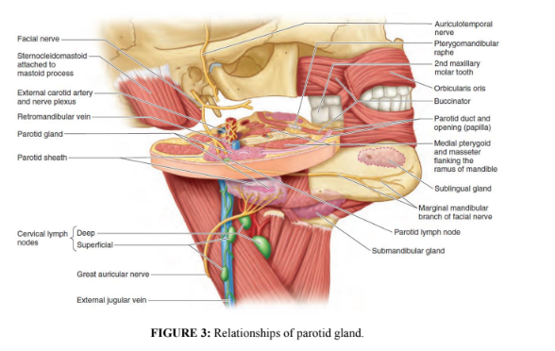
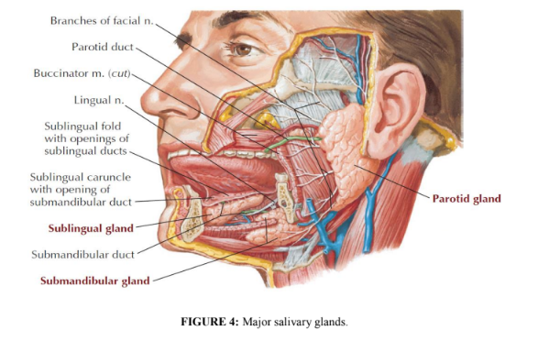
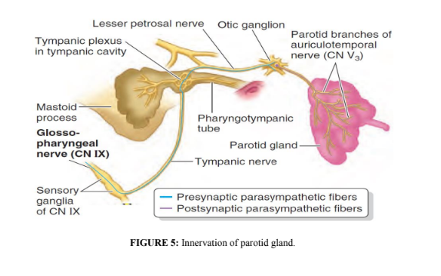

The Buccal Pad of Fat
Superficial to the buccinators (on either side of the face) are encapsulated collections
of fat; these buccal fat-pads are much larger in infants, to reinforce the cheeks and
keep them from collapsing during sucking. The blood supply to the buccal fat-pad
originates from the buccal and deep temporal branches of the maxillary artery, the
transverse facial branch of the superficial temporal artery, and branches of the facial
artery. This rich vascularity allows a reliable long axial flap and explains the rapid
surface re-epithelialization. The cheeks are innervated by buccal branches of the
mandibular nerve.
The buccal fat-pad’s primary function is thought to be related to chewing and suckling,
especially in infants. Another proposed function is as gliding pads that facilitate the
action of the muscles of mastication. The buccal fat pad may also function as a cushion
to protect sensitive facial muscles from injury due to muscle action or exterior force.
Clinical Notes
➢ Parotid Duct Injury
The parotid duct may be damaged in injuries to the face or may be inadvertently
cut during surgical operations on the face.
➢ Parotid Salivary Gland and Lesions of the Facial Nerve
The parotid salivary gland consists essentially of superficial and deep parts, and the
important facial nerve lies in the interval between these parts. A benign parotid
neoplasm rarely, if ever, causes facial palsy. A malignant tumor of the parotid is
usually highly invasive and quickly involves the facial nerve, causing unilateral
facial paralysis.
➢ Parotid Gland Infections
The parotid gland may become acutely inflamed as a result of retrograde bacterial
infection from the mouth via the parotid duct. The gland may also become infected
via the bloodstream, as in mumps. In both cases, the gland is swollen; it is painful
because the fascial capsule derived from the investing layer of deep cervical fascia
is strong and limits the swelling of the gland.
➢ Frey’s Syndrome
Frey’s syndrome is an interesting complication that sometimes develops after
penetrating wounds of the parotid gland. When the patient eats, beads of
perspiration appear on the skin covering the parotid. This condition is caused by
damage to the auriculotemporal and great auricular nerves. During the process
of healing, the parasympathetic secretomotor fibers in the auriculotemporal nerve
grow out and join the distal end of the great auricular nerve. Eventually, these fibers
reach the cutaneous sympathetic nerves that supply the sweat glands in the facial
skin. By this means, a stimulus intended for saliva production produces sweat
secretion instead.
References
1. Snell RS. Clinical Anatomy by Regions. 9th edition. Philadelphia, PA:
Lippincott Williams & Wilkins, 2012.
2. Keith LM: Clinically Oriented Anatomy, 7th edition. Wolters Kluwer, 2014.
1- one of the following statement is false the parotid region is bounded by the:
a. Zygomatic arch superiorly.
b. Ramus of the mandible medially.
c. Anterior border of the masseter muscle anteriorly.
d. orbit posteriorly.
2- The parotid region includes the following except:
a. the parotid gland
b. the parotid gland and duct.
c. the retromandibular vein.
d. optic nerve.
3.One of the following nerve has five terminal branches that leave that leave the parotid gland in radiating manner that resembles the foot of a goose:
a. trigeminal nerve.
b. optic nerve.
C . abducent nerve
d. fascial nerve.
4- Frey’s Syndrome :
a. develops after penetrating wounds of the parotid gland.
b. When the patient eats, beads of perspiration appear on the skin covering the parotid.
c. This condition is caused by damage to the auriculotemporal and great auricular nerves.
d.all of the above.
5- The Parotid Duct enters the vestibule of oral cavity through a small orifice (papilla) and opens opposite:
a. the second upper maxillary molar tooth.
b. first upper maxillary molar tooth.
c. the second lower molar tooth.
d.None of the above.

