

Oral Pathology

Prof. Dr.Muna Merza

Lecture 9 Oral ulceration

Lec. 9 ORAL PATHOLOGY Dr. Muna

Oral ulceration
An oral ulcer is the name for the appearance of an open sore inside the mouth caused by a break in the mucous membrane or the epithelium on the lips or surrounding the mouth.
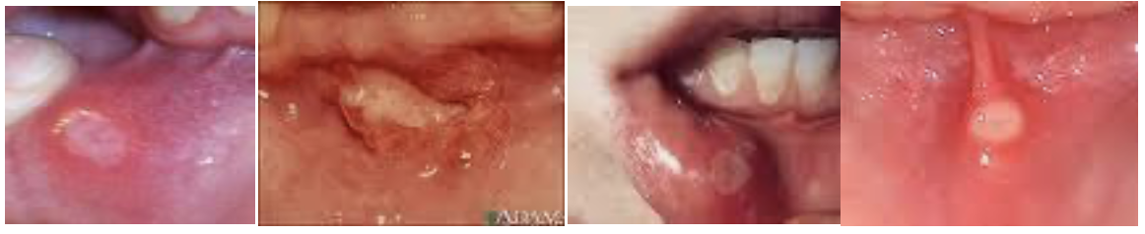
Types of oral ulcer:
1-minor ulcer
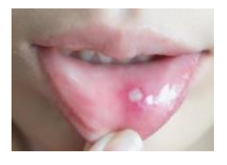
2-major ulcer
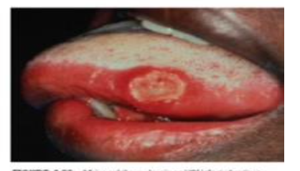
3-herptiform ulcer
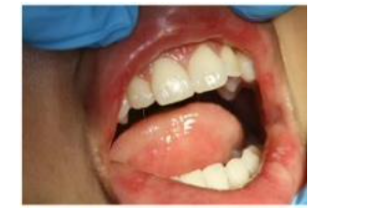
Causes of oral ulcer:
1-Minor physical injuries
1-Trauma to the mouth is a common cause of oral ulcers.
2-A sharp edge of a tooth,
3-accidental biting (this can be particularly common with sharp (canine teeth)
4-sharp or abrasive food,
5-poorly fitting dentures,
6-dental braces or trauma from a toothbrush.

-These ulcers usually heal at a moderate speed if the source of the injury is removed (for example, if poorly fitting dentures are removed or replaced).
- It is also common for these ulcers to occur after dental work, when incidental abrasions to the soft tissues of the
mouth .A dentist can apply a protective layer of Vaseline before carrying out dental work in order to minimize this abrasions.
2-Chemical Injuries:
Chemicals such as:
1- aspirin or 2-alcohol that come in contact with the oral mucosa may cause necrotic tissues and slough off creating an ulcerated surface. 3-sodium lauryl sulfate (SLS), one of the main ingredients in most toothpastes, has been implicated in increased incidence of oral ulcers.
3-Infection
A-Viral, B- bacterial C- fungal D- Protozoans processes can lead to oral ulceration.

A-Viral
1-Herpes simplex virus which causes recurrent herpetiform ulcerations usually painful multiple vesicles,which burst
2- Herpes Zoster (shingles) 3-Varicella Zoster (chicken pox) 4-Coxsackie A virus lead to oral ulceration. 5-HIV creates immune deficiencies which allow opportunistic infections or neoplasms to proliferate.

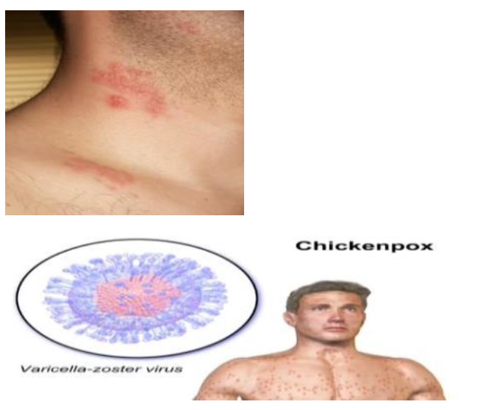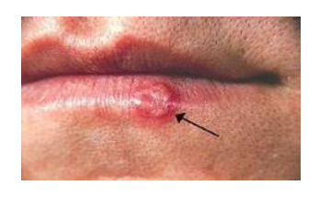
B-Bacterial
Bacterial processes leading to ulceration can be caused by : 1-Mycobacterium tuberculosis(tuberculosis) 2- Treponema pallidum (syphilis).

C-Fungal infections
D-Protozoans
Entamoeba histolytica, a parasitic protozoan cause mouth ulcers through formation of cysts.


4-Immun system :
A-Immunodeficiency
Repeat episodes of mouth ulcers can be indicative of an immunodeficiency, signaling low levels of immunoglobulin in the oral mucous membranes. Chemotherapy, HIV, and mononucleosis are all causes of immunodeficiency
B-Autoimmunity is also a cause of oral ulceration. Mucous membrane pemphigoid, an autoimmune reaction to the epithelial basement membrane, causes desquamation /ulceration of the oral mucosa.
5-Allergy
Contact with allergens can lead to ulcerations of the mucosa.

6-Dietary
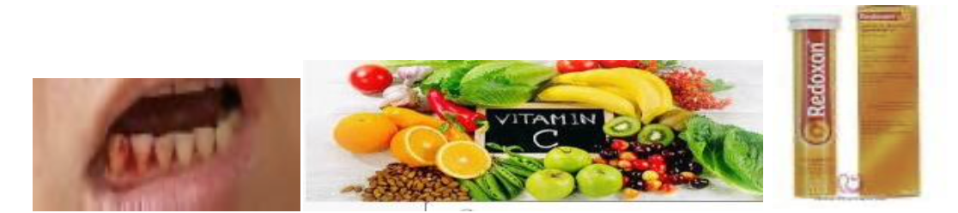
A-Vitamin C
deficiencies may lead to scurvy which impairs wound healing, also cause ulcer.
B- Deficiencies in vitamin B12, zinc have been linked to oral ulceration.
C- Coeliac disease
in which case consumption of wheat can result in chronic oral ulcers.( gluten sensitivity )
Artificial sugars, such as those found in diet cola and sugarless chewing gum, have been reported as causes of oral ulcers as well.
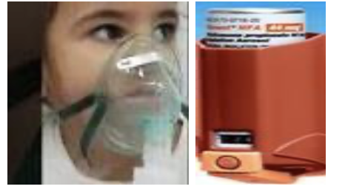
7-Flovent
Use of Flovent without rinsing mouth out after use may cause an oral ulcer.
8-Cancer
Oral cancers can lead to ulceration as the center of the lesion loses blood supply and necrosis. Squamous cell carcinoma is just one of these.
9-Medical conditions associated with mouth ulcers Some medical conditions are associated with mouth ulcers ex: Bechet's disease
Treatment
1-Symptomatic treatment, if the cause is unknown,
2-adequate oral hygiene
3-remove the causative factors
4-topical antihistamine ,antacid and corticosteroid
5- avoid spicy food
6-chlorhexidine mouth wash

Prevention of mouth ulcers
1-Brush your teeth gently with a soft toothbrush
2-Eat a well-balanced and nutritious diet.(balanced vitamin and mineral)
3-Try to make sure that underlying medical conditions are well- controlled

