GENERAL ANATOMY ORAL CAVITY
LEC.6

The Lips
The lips are two fleshy folds that surround the oral orifice They are covered on the outside by skin and
are lined on the inside by mucous membrane. The substance of the lips is made up by the orbicularis oris muscle and the muscles that radiate from the lips into the face.
The submandibular duct of the submandibular gland opens onto the floor of the mouth on the summit of a small papilla on either side of the frenulum of the tongue The sublingual gland projects up into the mouth, producing a low fold of mucous membrane, the sublingual fold. Numerousducts of the gland open on the summit of the fold.
Mucous Membrane of the Mouth
In the vestibule, the mucous membrane is tethered to the buccinator muscle by elastic fibers in the submucosa
that prevent redundant folds of mucous membrane from being bitten between the teeth when the jaws are closed.
The mucous membrane of the gingiva, or gum, is stronglyattached to the alveolar periosteum.
The mouth extends from the lips to the palatoglossal arches. The
palatoglossal arches (anterior pillars) are ridges of mucous membrane raised
up by the palatoglossus muscles. The roof is the hard palate and the floor
is the mylohyoid muscle. Rising from the floor of the mouth, the tongue
occupies much of the oral cavity. The red margin of the lips, is devoid of
hair, highly sensitive and has a rich capillary blood supply.
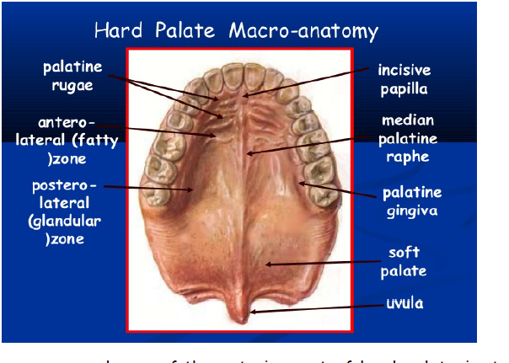
The mucous membrane of the anterior part of hard palate is strongly
united with the periosteum. From a little incisive papilla overlying the
incisive foramen a narrow low ridge, the median palatine raphe, runs
anteroposteriorly. Palatine rugae are short horizontal folds of mucous
membrane, located on each sides of the anterior parts of median palatine
raphe. Over the horizontal plate of the palatine bone mucous membrane and
periosteum are separated by a mass of mucous glands tissue.

Nerve supply:
Much of the mucous membrane of the cheeks and lips is supplied by
the buccal branch of the mandibular nerve, mental branch of the inferior
alveolar and the infraorbital branch of the maxillary nerve; the last two
also supply the red margin of the lower and upper lips respectively.
The upper gums are supplied by the superior alveolar, greater
palatine and nasopalatine nerves (maxillary), while the lower receive
their innervation from the inferior alveolar, buccal , mental and lingual
nerves (mandibular). The buccal nerve does not usually innervate the upper gums.

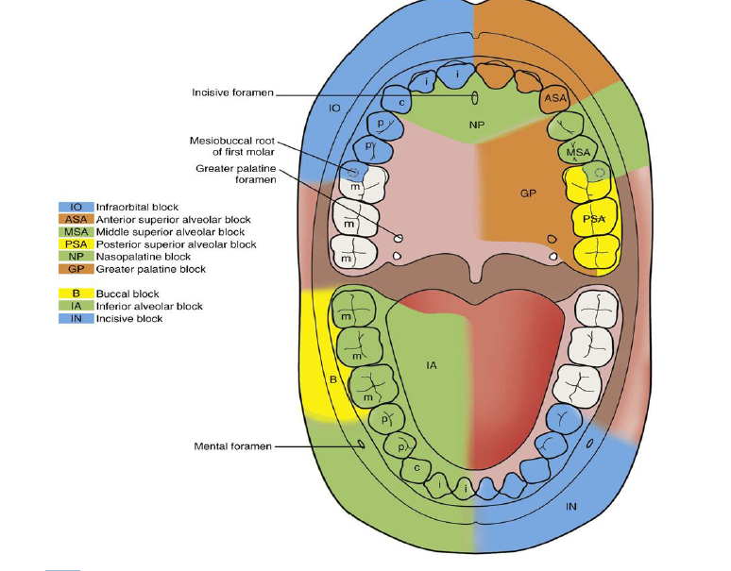

The upper teeth are supplied by the superior alveolar nerves[ anterior, middle and posterior].

In the lower jaw the molars and premolars are supplied by the main
trunk of the inferior alveolar nerve, whose terminal incisor branch supplies
the canine and incisors, overlapping to the opposite central incisor.
The Tongue
The tongue is a mass of skeletal muscle covered by mucous membrane,
and with a midline fibrous septum separating the two muscular halves. It
consist of body and root. The anterior two-thirds, or oral part, of the
dorsum faces upwards towards the hard palate, and the posterior onethird,
or pharyngeal part, faces backwards towards the oropharynx. The
tip is the most anterior and mobile part.
The oral part of the dorsum of the tongue is covered by mucous
membrane into which the underlying muscles are inserted. The surface is
roughened by the presence of three types of papillae: filiform, fungiform
and vallate.

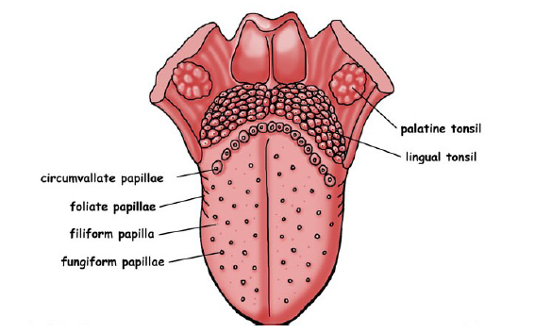

The vallate papillae are about a dozen in number and are arranged in
the form of a V with the apex pointing backwards, just in front of shallow
groove, the sulcus terminalis, which marks the junction of the oral and
pharyngeal parts of the tongue.

On the undersurface behind the tip there is a rather large mixed gland,
the lingual gland, on each side of the midline. From each gland small ducts
open on the undersurface of the tongue.
The posterior third of the dorsum of the tongue slopes downwards
from the sulcus terminalis as the anterior wall of the oropharynx. At the
apex of the sulcus is a small depression, the foramen caecum. The mucous
membrane has a nodular appearance due to underlying masses of mucous
and serous glands and aggregations of ‘lingual tonsil’.
A small midline septum of mucous membrane (lingual frenulum) unites
the inferior surface of the tongue to the floor of the mouth. Lateral to this,
the deep lingual vein can usually be seen through the mucosa.
Muscles
The muscles of the tongue are divided into intrinsic and extrinsic
groups; the intrinsic muscles are wholly within the tongue and not attached
to bone, while the extrinsic muscles have a bony attachment. There are four
muscles in each group in each half of the tongue, with a midline fibrous
septum dividing the organ into two symmetrical halves.
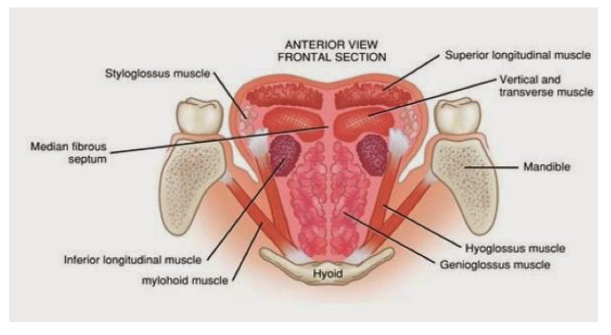
The muscles of the intrinsic group are the superior and inferior
longitudinal, transverse and vertical, and the extrinsic group comprises
genioglossus (which is the largest of all the muscles and makes up the bulk
of the tongue), hyoglossus, styloglossus and palatogloss.
Genioglossus arises from the superior mental spine (genial tubercle)
of the mandible, the fibers radiate backwards in a fan-shaped manner to be
inserted into the mucous membrane of the tongue, with the lowest fibers
passing backward and downward to the hyoid body.

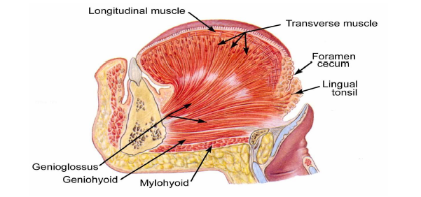

Hyoglossus arises from the length of the greater horn of the hyoid
bone and from its body. It extends upwards as a quadrilateral sheet, its
upper border interdigitating at right angles with the fibers of styloglossus,
and is attached to the side of the tongue. Superficial (lateral) to the muscle
from above downwards lie the lingual nerve, submandibular duct, and the
hypoglossal nerve with its accompanying veins, while passing deep to its
posterior border from above downwards are the glossopharyngeal nerve,
stylohyoid ligament and the lingual artery with its accompanying veins
lying on the anterior fibers of the middle constrictor.

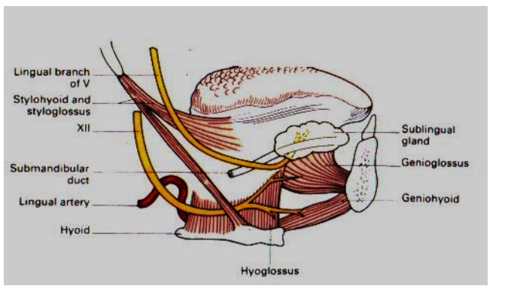
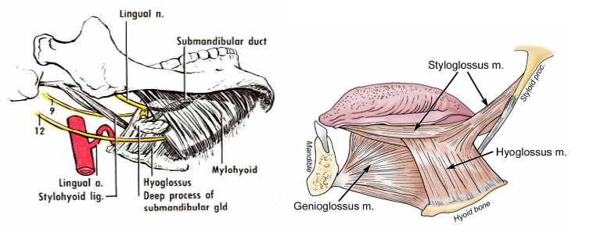
Styloglossus arises from the front of the lower part of the styloid process
and the upper part of the stylohyoid ligament. It passes forwards below the
superior constrictor to be inserted into the side of the tongue,
interdigitating with the upper fibers of hyoglossus.
Palatoglossus descends from the undersurface of the palatine aponeurosis to
the side of the tongue, forming with its fellow of the opposite side the
palatoglossal arch. It is described with the soft palate.
Movements of the Tongue
Protrusion, The genioglossus muscles on both sides. Retraction, Styloglossus
and hyoglossus muscles on both sides. Depression, Hyoglossus muscles on
both sides. Retraction and elevation of the posterior third, Styloglossus
and palatoglossus muscles on both sides. Shape changes, Intrinsic muscles.
Palatoglossus: Pulls up the root of tongue.
Blood supply
The tongue is supplied by the lingual artery, which runs above the
greater horn of the hyoid bone deep to hyoglossus and passes forwards to
the tip. Beneath hyoglossus it gives off dorsal lingual branches into the
posterior part. At the anterior border of hyoglossus it gives a branch to the
sublingual gland and the floor of the mouth. There are small contributions
from the tonsillar branch of the facial artery and from the ascending
pharyngeal artery. The fibrous septum dividing the two halves of the tongue
prevents any significant anastomosis of blood vessels across the midline.

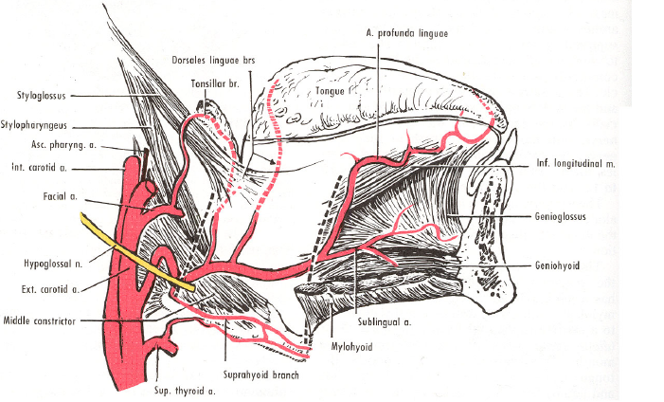

VENOUS DRAINAGE
The arrangement of the vena comitantes/veins of the tongue is
variable. Two venae comitantes accompany the lingual artery, and one
vena comitantes accompanies the hypoglossal nerve. The deep lingual
vein is the largest and principle vein of the tongue. It is visible on the
inferior surface of the tongue. It runs backwards and cross the
genioglossus and the hyoglossus below the hypoglossal nerve. These veins
unite at the posterior border of the hyoglossus to form the lingual vein
which ends in the internal jugular vein. Sometimes, these veins drain
independently into the jugular veins.
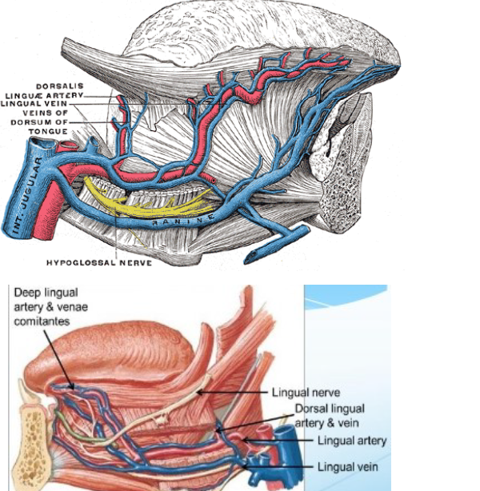

NERVE SUPPLY
Motor Nerves: All the intrinsic and extrinsic muscles except the
palatoglossus, are supplied by the hypoglossal nerve, The palatoglossus is
supplied by the pharyngeal plexus.
Sensory nerves: The lingual nerves is the nerve of general sensation and
the chorda tympani is the nerve of taste for the anterior two-thirds of the
tongue except vallate papillae. The glossopharyngeal nerve is the nerve for
both general sensation and taste for the posterior one-third of the tongue
including the circumvallate papillae. The posterior most part of the
tongue is supplied by the vagus nerve through the internal laryngeal
branch.
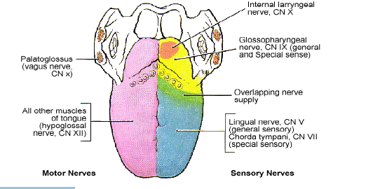
Lymph drainage:
The tip drain to submental lymph nodes. Marginal lymphatics from the
rest of the anterior part tend to drain to ipsilateral submandibular lymph
nodes. Central lymphatics from the anterior part descend between the
genioglossi and drain to deep cervical nodes of either side. The posterior
part drains directly and frequently bilaterally to deep cervical nodes.

