

تطبيقات الحاسوب
STAAD.pro advanced CONNECT Edition

Sally Selan Hussein

The main components of the start page

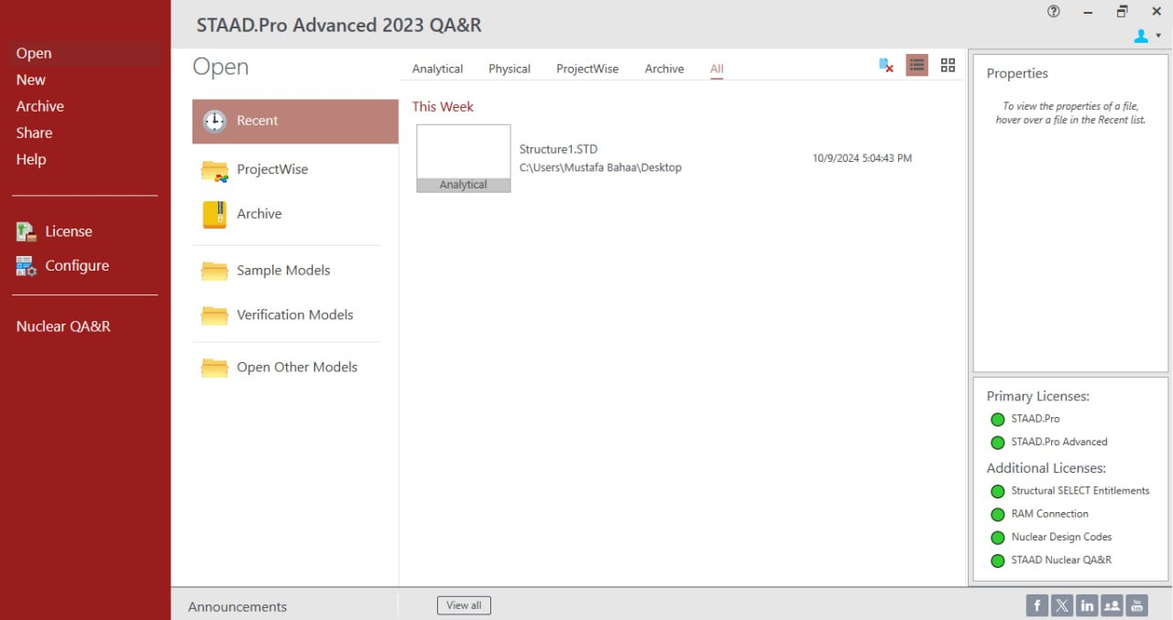
Section1: includes several commands related to files, licensing, and configuring input settings for the program as fallowing:
1- Open (To open any previous project that has been worked on, the details of previous projects are displayed in the section ( 2)
2- New ( There are seven step to make a new project )
1. click on the new item. Then, enter the following information:
2. File Name: Storage Shed_1.std
3. Location: (navigate to the dataset folder that was supplied with this training)
4. Type: Analytical
5. Units: Metric
6. Job Info: Optional input for job information
7. Then, click on the Create button.

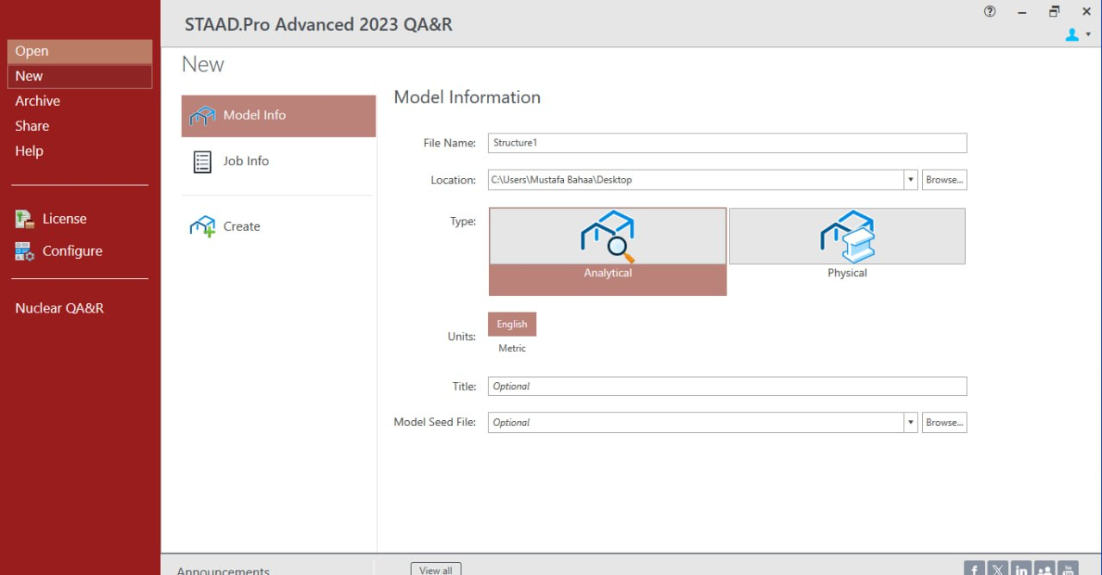
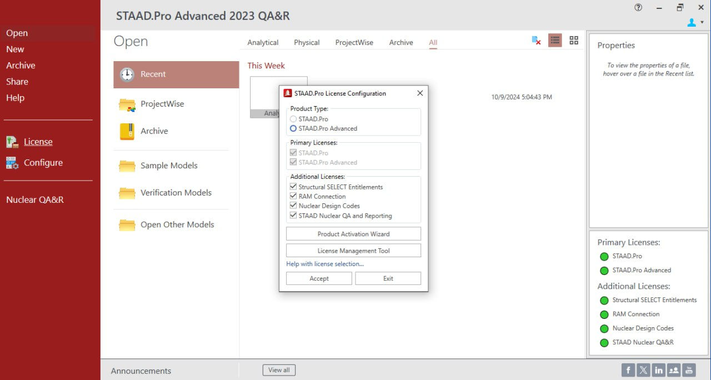

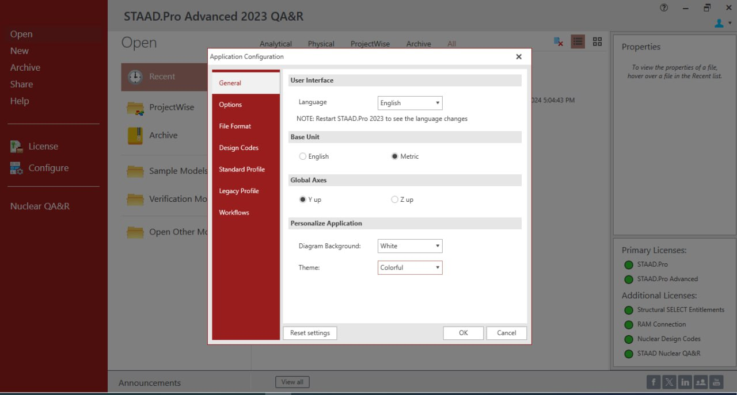

A- Language
B- Base unite (matric or English)

C- Global axis the default orientation of the global coordinate system is that the Y axis points in the vertical direction and a plan view is represented by the XZ plane.
You do have an option to specify the vertical axis as the Z axis, but this option will eliminate the ability to use some other functions in the program, such as the wind load generator)

D- Diagram background
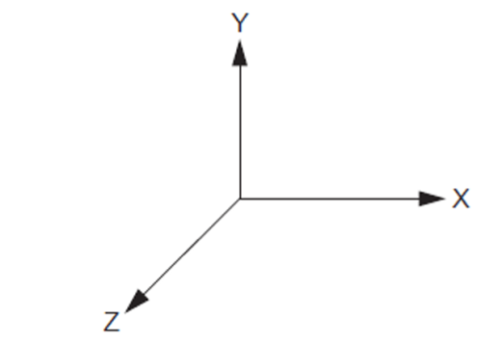
F- Default design codes
E- Theme

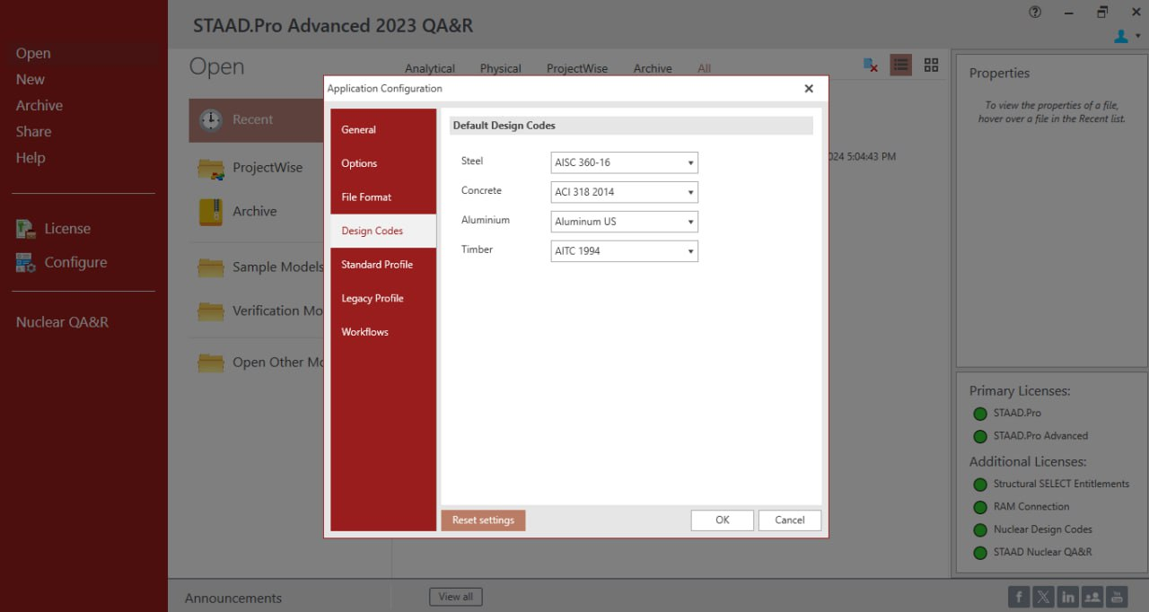

- Section 2: The display in this section changes depending on the command selected in the first section.
- If the command is to open a project, it will show recent projects that have been worked on and provide options to import projects from the computer.
- It also indicates the type of project, whether it's (analytical, physical, project wise or all)
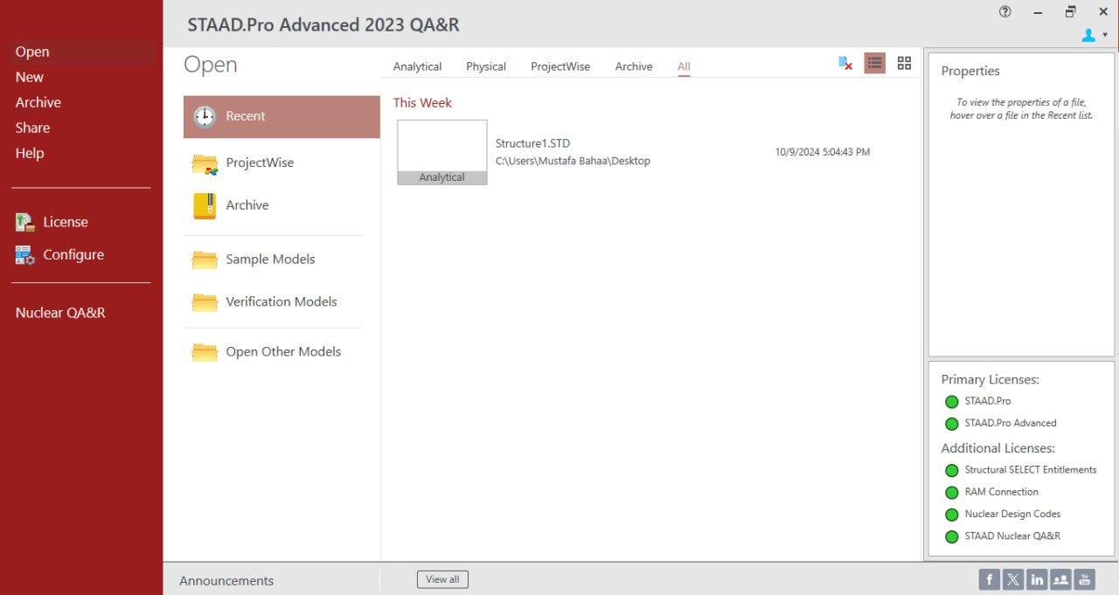

Section 3: display some details related to the information of previously worked-on projects. In addition to the licenses information

