Al-Mustaqbal University


College of Medical and Health Techniques
Medical Laboratories Techniques Departments

Biochemistry Lectures for 2nd Year Students

(2 Credit Hrs. Theory + 2 Credit Hrs. Practice / Week = 3 Credit Unit
Academic Year: 2024 - 2025

Course Organizers:

- Prof. Dr. Fadhil Jawad Al-Tu'ma, Ph.D., Professor of Clinical Biochemistry.
- Dr. Dalya Shakir Obaida, Ph.D. Lecturer of Clinical Biochemistry.

Lecture No. 4
Date: Nov., 3rd, 2024

Nutrition, Vitamins and Coenzymes
Objectives
- Nutrition and Nutrients
- Define and classify vitamins.
- There are two water-soluble vitamins—vitamin C and vitamin B complex groups.
- Study the chemistry, dietary sources and absorption of vitamin C, various metabolic functions and fate of vitamin C, especially its role in collagen synthesis.
- List all the vitamin B complex dietary sources, daily requirement of each constituent with the chemistry and “biological active” coenzyme form of each one with the metabolic role and the deficiency manifestations.
- There are four fat soluble vitamins A, D, E and K.
- Study different forms of vitamin A, dietary sources, daily requirement and biochemical roles.
- Study different forms of vitamin D and their synthesis specially calcitriol, the active form with their various functions and deficiency diseases.
- Study different forms of tocopherols (vitamin E), its absorption and transport with various functions specially antioxidant property and deficiency manifestations.
- Study different forms of vitamin K, list the dietary sources and daily requirement with various functions of vitamin K especially in coagulation process and its deficiencies.

Nutrients and Nutrition:
Nutrients:
They are classified into macro and micro-nutrients. The macronutrients include:
- Proteins provide the body with amino acids, which are used for endogenous protein biosynthesis. Excess amino acids are broken down to provide energy. Most amino acids are glucogenic which can be converted into glucose.
Proteins are essential components of the diet, as they provide essential amino acids that the human body is not capable of producing on its own. Some amino acids, including cysteine and histidine, are not absolutely essential, but promote growth in children.
The minimum daily requirement of protein is 37 g for men and 29 g for women depending upon body weight, but the recommended amounts are about twice these values. Requirements in pregnant and breastfeeding women are even higher. Not only the quantity, but also the quality of protein is important.
Proteins that lack several essential amino acids or only contain small quantities of them are considered to be of low value, and larger quantities of them are therefore needed. For example, pulses only contain small amounts of methionine, while wheat and corn proteins are poor in lysine. In contrast to vegetable proteins, most animal proteins are high-value (with exceptions such as collagen and gelatin).
- Carbohydrates serve as a general and easily available energy source. In the diet, they are present as monosaccharides in honey and fruit, or as disaccharides in milk and in all foods sweetened with sugar (sucrose). Metabolically usable polysaccharides are found in vegetable products (starch) and animal products (glycogen). Carbohydrates represent a substantial proportion of the body’s energy supply, but they are not essential.
- Fats are primarily important energy suppliers in the diet. Per gram, they provide more than twice as much energy as proteins and carbohydrates. Fats are essential as suppliers of fat-soluble vitamins and as sources of polyunsaturated fatty acids, which are needed to biosynthesize eicosanoids.
- Minerals
The essential minerals are classified according to their recommended intake.
- Macro minerals, also called major minerals, are needed in amounts greater than 100 milligrams per day.
- Micro minerals, also called trace minerals or trace elements, are needed in less than 100 milligrams per day, see Table-1.
There are seven macro minerals; calcium, phosphorus, magnesium, sulfur, sodium, potassium, and chloride. As well as being needed in amounts greater than 100 milligrams per day, each of the macro minerals makes up more than 0.01% of the body’s weight.
Table-1: Classification of essential minerals
Macro minerals, (˃100 mg/day) | Micro minerals, (<100 mg/day)
Calcium, phosphorous, magnesium, sulfur, sodium, potassium, chloride | Iron, zinc, copper, iodine, fluoride, manganese, selenium, chromium, molybdenum

Many of the essential minerals are widely distributed in foods, and most people eating a mixed diet are likely to receive adequate intakes. The amounts required vary from grams per day for sodium and calcium, through milligrams per day (e.g., iron and zinc), to micrograms per day for the trace elements.
In general, mineral deficiencies occur when foods come from one region where the soil may be deficient in some minerals (e.g., iodine and selenium, deficiencies). When foods come from a variety of regions, mineral deficiency is less likely to occur. Iron deficiency is an important problem worldwide, because if iron losses from the body are relatively high (e.g., from heavy menstrual blood loss or intestinal parasites), it is difficult to achieve an adequate intake to replace losses.
Functions, sources and deficiency of some macro minerals:
Calcium: Calcium is by far the most prevalent mineral in the body. About 98% of the 1200 grams of calcium in the average adult body is found in the bones. Small amounts of calcium (1%) are also found in the extracellular fluid, certain intracellular structures, and cell membranes.
Functions
- Calcium is one of the minerals needed for the growth and strength of the bones.
- Calcium is needed for muscle contraction
- Calcium ions are essential for blood clotting.
- Calcium is needed for the functioning of neuro transmitters.
Food sources: Milk and milk products are among the best sources of calcium; also leafy greens and small fish with bones are a good sources.
Deficiency: A deficiency of calcium leads to the condition hypocalcemia resulting in rickets in children and osteomalacia in adults.
Phosphorus: Approximately 85% of the 700 grams of phosphorus in the adult body is present in the bones. The ratio of calcium to phosphorus in the bones is 2:1.
Functions:
- Phosphorus is involved in a variety of chemical reactions in the body, many of which are related to energy metabolism.
- Mineralization of bones and teeth
- Facilitation of energy transaction
- Absorption and transport of nutrients
- Regulation of protein activity
- Component of essential body compounds.
Food sources: In general, good sources of protein are also good sources of phosphorus. Meat, fish and eggs are rich in phosphorus. Milk and milk products are good sources.
Deficiency: A phosphorus deficiency is characterized by weakness, lack of appetite, fatigue and muscle pain.
Magnesium: About 60% of the body’s magnesium is contained in the bones; most of the remaining magnesium is present in the muscles and other tissues, with about 1% circulating extracellular fluids.
Functions:
- The activity of hundreds of enzymes depends on magnesium
- Magnesium also helps maintain calcium and potassium homeostasis.
Food sources: Nuts, legumes, dark green leafy vegetables, soya beans and milk are good sources.
Deficiency: Symptoms of magnesium deficiency include weakness, confusion, lack of appetite, nausea, and lack of coordination.
Sulfur: Because sulfur is part of the essential amino acid methionine and the nonessential amino acid cysteine, it is present in the body’s proteins. Interactions among sulfur atoms in cysteine helps to give proteins their three-dimensional shape.
The Electrolytes:
Three of the macrominerals – sodium, potassium and chloride are the body’s main electrolytes. The major function of the electrolytes is to maintain the proper distribution of water inside and outside cells. If this water balance is not maintained, cells will shrink or swell beyond their normal size. Sodium and chloride are found in the extracellular fluid; potassium is found in the intracellular fluid (ICF).
Sodium: Sodium is the principal cation of extracellular fluid. Human body has approximately 1.8 g of sodium per kilogram of body weight. The body regulates the sodium concentration in the extracellular fluid within narrow limits.
Functions: In addition to its role in maintaining the body’s water balance, sodium functions in maintaining extracellular fluid volume and in regulating the body’s acid – base balance.
Food sources: The major dietary source of sodium is sodium chloride, more commonly called table salt. One teaspoon of table salt supplies 2132 milligrams of sodium.
Deficiency: Excessive sodium loss, not a low dietary intake; is the usual cause of sodium deficiency. Trauma, long – term diarrhea, vomiting and kidney disease may also lead to excessive sodium losses. A sodium deficiency, with fluid levels remaining constant or increasing, leads to a decrease in the extracellular sodium concentration. As a result, water migrates into cells, leading to water intoxication. Water intoxication causes loss of appetite, muscle twitching, mental apathy, coma, and seizures.
Potassium: This electrolyte is found mainly in the intracellular fluid.
Functions
- The main function of potassium, like sodium, is to maintain water balance.
- Potassium is required for maintaining a normal heartbeat.
Food sources: This mineral is widely distributed in foods, but fruits and vegetables are generally the most nutrient – dense sources of potassium.
Deficiency: Deficiencies of potassium are usually caused by excessive losses, not low intakes. Losses occur primarily via the urine; lesser amounts are lost in sweat. Much potassium can also be lost through long-term vomiting or prolonged diarrhea. Symptoms of a potassium deficiency include weakness, loss of appetite, nausea, fatigue, irrational behavior, muscle weakness, and muscle cramping. A severe deficiency may cause an abnormal heartbeat and possibly death.
Chloride: The electrolyte chloride is found primarily in the extracellular fluid.
Functions
- Chloride’s major functions are maintaining the body’s water and electrolyte balance.
- Chloride is mainly a component of hydrochloric acid, which is secreted in the stomach and helps in the digestion of protein.
Food sources: The main dietary sources of chloride are sodium chloride salt. Chloride is also found in many processed foods that contain added salt.
Deficiency: As with the other two electrolytes, chloride deficiency rarely results from poor dietary intake. Rather, chloride deficiencies are typically caused by excessive losses due to diarrhea or vomiting, heavy perspiration, trauma, or kidney disease.
Micro minerals:
Some of them are requiring in amounts of less than 100 milligrams per day. The essential trace micro minerals are iron, zinc, copper, iodine, manganese, fluoride, chromium, selenium, and molybdenum.
Iron: About 30% of the iron in the body is stored in the spleen, liver, and bone marrow. Iron is a constituent of hemoglobin and myoglobin, which are iron-binding proteins found in red blood cells and muscle, respectively. Iron also functions as a cofactor for a number of enzymes and is required for their activity.
Deficiency: Iron deficiency develops in stages; the last stage is iron-deficiency anemia.
Zinc: Most zinc in the body is found in the bones and muscles. This trace mineral is necessary for optimal activity of many enzymes and for various bodily processes, including the following:
- Protein metabolism, wound healing, and growth
- Metabolism of DNA, the genetic material
- Development of sexual organs and bones
- Immune responses
- Memory formation
- Alcohol metabolism
- Required during growth and development.
Food sources: Meat, fish, eggs, milk and nuts are rich sources.
Deficiency: A zinc deficiency impairs protein synthesis, collagen formation, and energy production; it also decreases alcohol tolerance.
Copper: The trace mineral copper is required for proper use of iron by the body and for the activity of certain enzymes. This trace mineral also aids in the production of connective tissue, blood vessels, phospholipids, and melanin (a skin pigment).
Food sources: The main dietary sources of copper are shellfish, whole grains, legumes, and nuts.
Deficiency: Symptoms include decreased blood levels of copper, fewer white blood cells, anemia, bone demineralization, deterioration of the nervous system.
Iodine: The micro mineral iodine is a necessary component of two hormones produced by the thyroid gland (thyroxine and triiodothyronine). These thyroid hormones are critical in regulating the body’s metabolic rate.
Food sources: The amount of iodine present in a particular food depends on the amount of iodine in the environment in which that food was raised.
Deficiency: A prolonged deficiency of iodine causes enlargement of the thyroid gland, known as goiter.
Fluoride: Fluoride is an essential nutrient for humans, this trace mineral is currently considered essential. The main function of fluoride is to harden the bones and teeth.
Food sources: The only good dietary sources of fluoride are fluoridated water, seafood and tea. Some natural water sources are also high in fluoride.
Deficiency: Deficiency of fluoride results in the development of dental caries.
Manganese: The trace mineral manganese is required for normal brain function. This micro mineral also aids in the synthesis of collagen, urea, fatty acids, and cholesterol. Manganese is involved in bone growth and is required for the digestion of protein.
Food sources: Manganese is present in many vegetable foods, and our diets supply plenty to meet the requirement, which is minimal.
Deficiency: For the above reason, deficiency of this trace mineral has not been observed in humans, it may be induced in experimental animals.
Selenium: The best understood role of the micro mineral selenium is its involvement in an enzyme system that helps to protect cell membranes against oxidative damage. Thus, selenium has an effect similar to that of the antioxidant vitamin E.
Food sources: Selenium is widely distributed in both animals and plant foods.
Deficiency: Deficiency resulting from low dietary intake is unlikely because of its wide distribution in animals and plant foods.
Chromium: The trace mineral chromium is involved in the normal use of glucose and blood lipids and in the functioning of insulin.
Molybdenum: Molybdenum is required for several enzyme systems in the body. One of these enzyme systems involved in the formation of uric acid, a waste product of protein metabolism is excreted in the urine.
Food sources: The molybdenum of plant foods depends on the type of soil in which they are grown.
Deficiency: Molybdenum deficiency has not been observed in human beings or any other species.
Ultra Trace Minerals:
Seven minerals present in foods and in human bodies have been found to be essential nutrients for animals and may be essential for humans, but nutritional requirements for them have not yet been clearly defined. This group of minerals sometimes called ultra-trace minerals, includes arsenic, boron, cobalt, nickel, silicon, tin, and vanadium, see Table 2.

Table 2: Functions and dietary sources of ultra-trace minerals.
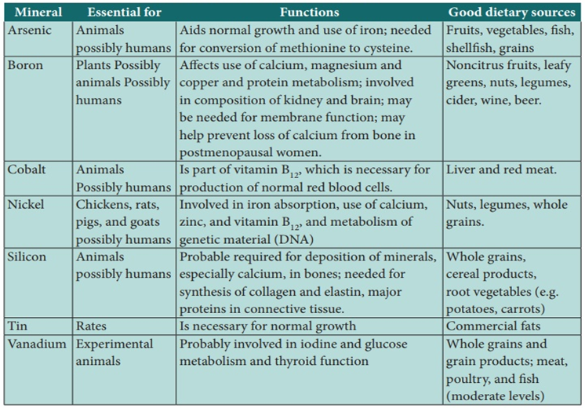
Nutrient Requirements:
For any nutrient, there is a range of intakes between that which is clearly inadequate, leading to clinical deficiency disease, and that which is so much in excess of the body’s metabolic capacity that there may be signs of toxicity. Between these two extremes are a level of intake that is adequate for normal health and the maintenance of metabolic integrity. Individuals do not all have the same requirement for nutrients, even when calculated on the basis of body size or energy expenditure. There is a range of individual requirements of up to 25% around the mean. Therefore, in order to assess the adequacy of diets, it is necessary to set a reference level of intake high enough to ensure that no-one either suffers from deficiency or is at risk of toxicity.
Dietary Substances:
A balanced human diet needs to contain a large number of different components. These include proteins, carbohydrates, fats, minerals (including water), and vitamins. These substances can occur in widely varying amounts and proportions, depending on the type of diet. As several components of the diet are essential for life, they have to be regularly ingested with food.
Energy Requirements:
The amount of energy required by a human is expressed in kJ/d (kilo joule per day). An older unit is the kilocalorie (kcal; 1 kcal = 4.187 kJ). However, actual requirements are based on age, sex, body weight, and in particular on physical activity. In those involved in competitive sports, for example, requirements can increase from 12000 to 17000 kJ/day.
It is recommended that about half of the energy intake should be in the form of carbohydrates, a third at most in the form of fat, and the rest as protein.
Vitamins:
Nutritionally, vitamins are organic molecules occurring in small amounts in natural foods and are required in the diet in small amounts (micrograms or milligrams per day) for maintenance of normal health, metabolic integrity, growth differentiation and maintenance of normal cellular functions in human beings and in experimental animals. The most prominent function is as cofactors for enzymatic reactions. They are thus differentiated from the essential minerals and trace elements (which are inorganic) and from essential amino and fatty acids, which are required in larger amounts.
They are occurring in natural foods either as such or as utilizable precursors, which are required in minute amounts for normal growth, maintenance and reproduction, i.e. for normal nutrition and health.
- They differ from other organic food stuffs in that:
- They do not enter into tissue structures, unlike proteins.
- Do not undergo degradation for providing energy unlike carbohydrates and lipids.
- Several B complex vitamins play an important role as coenzymes in several energy transformation reactions in the body.
- They differ from hormones: In not being produced within the organism, and most of them have to be provided in the diet.
- The animal body requires them in very small quantities in order to synthesize coenzymes and signaling substances. For a compound to be considered a vitamin, it must be shown to be a dietary essential.

Generally, vitamins are of two distinct types:
- Water-soluble vitamins (B complex vitamins and vitamin C).
- Fat - soluble or water-insoluble vitamins (A, D, E and K).
Biomedical Importance:
- Vitamins are a group of organic nutrients, required in small quantities for a variety of biochemical functions that, generally, cannot be synthesized by the body and must therefore be supplied in the diet.
- The lipid-soluble vitamins are hydrophobic compounds that can be absorbed efficiently only when there is normal fat absorption. Like other lipids, they are transported in the blood in lipoproteins or attached to specific binding proteins. They have diverse functions—for example, vitamin A, vision and cell differentiation; vitamin D, calcium and phosphate metabolism, and cell differentiation; vitamin E, antioxidant; and vitamin K, blood clotting. As well as dietary inadequacy, conditions affecting the digestion and absorption of the lipid soluble vitamins, such as a very low-fat diet, steatorrhea and disorders of the biliary system, can all lead to deficiency syndromes, including night blindness and xerophthalmia (vitamin A); rickets in young children and osteomalacia in adults (vitamin D); neurological disorders and hemolytic anemia of the newborn (vitamin E); and hemorrhagic disease of the newborn (vitamin K). Toxicity can result from excessive intake of vitamins A and D. Vitamin A and the carotenes (many of which are precursors of vitamin A), and vitamin E are antioxidants and have possible roles in prevention of atherosclerosis and cancer, although in excess they may also act as damaging pro-oxidants.
- The water-soluble vitamins are vitamin B complex and C, folic acid, biotin and pantothenic acid; they function mainly as enzyme cofactors. Folic acid acts as a carrier of one-carbon units. Deficiency of a single vitamin of the B complex is rare since poor diets are most often associated with multiple deficiency states.
In general, deficiency of vitamins may occur due to:
- Reduced intake.
- Impaired absorption.
- Impaired activation or metabolism.
- Additional requirements due to various physiological functions e.g. growth, pregnancy, lactation ……etc.
- Increased losses.
Table 3 Summarizes a comparison of two types of water-soluble and water-insoluble vitamins
Table 3: Comparison of two types of vitamins
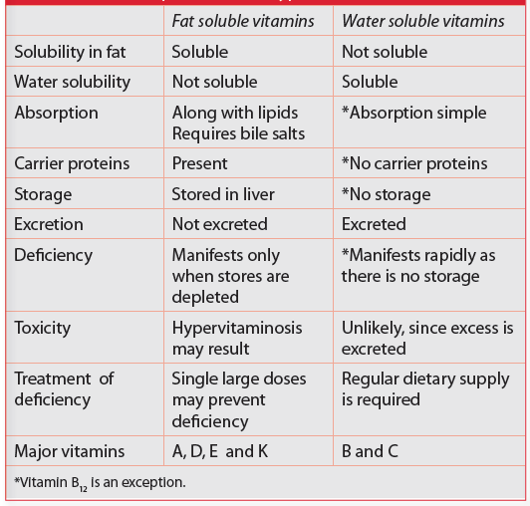
Most vitamins are precursors of coenzymes; in some cases, they are also precursors of hormones or act as antioxidants. Vitamin requirements vary from species to species and are influenced by age, sex, and physiological conditions such as pregnancy, breast-feeding, physical exercise, and nutrition. A healthy diet usually covers average daily vitamin requirements. By contrast, malnutrition, malnourishment (e. g., an unbalanced diet in older people, malnourishment in alcoholics, ready meals), or resorption disturbances lead to an inadequate supply of vitamins from which hypovitaminosis, or in extreme cases a vitaminosis, can result. Medical treatments that kill the intestinal flora, e. g., antibiotics, can also lead to vitamin deficiencies (e.g. K, B₁₂) due to the absence of bacterial vitamin synthesis. Since only a few vitamins can be stored (A, D, E, B₁₂), a lack of vitamins quickly leads to deficiency diseases, see Fig. -1-.
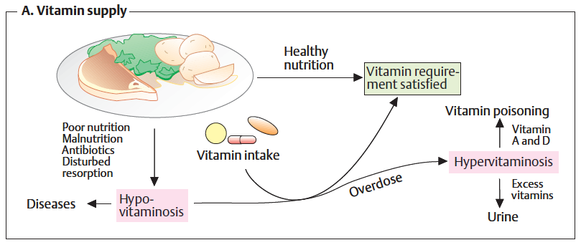
Fig. 1: Role of vitamins.
An overdose of vitamins only leads to hypervitaminoses, with toxic symptoms, in the case of vitamins A and D. Normally; excess vitamins are rapidly excreted with the urine.
Water-Soluble Vitamins and Coenzymes
Classification:
Figure (2) indicates the different classes of water-soluble vitamins: The B group of vitamins covers water-soluble vitamins, all of which serve as precursors for coenzymes. Vitamins are chemically unrelated organic compounds that cannot be synthesized by humans and, therefore, must be supplied by the diet.
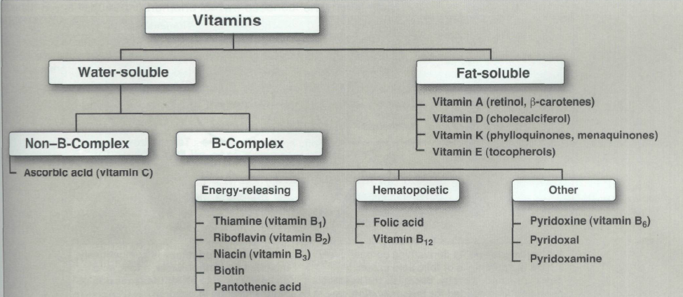
Fig. 2: Classification of Water-soluble vitamins
Thiamine or Vitamin B1
Absorption: Free thiamine is absorbed readily from the small intestine, but the pyrophosphate (ester-form) is not. Bulk of the dietary vegetable thiamine is in the “free” form. In tissues, it is actively phosphorylated to form Thiamine pyrophosphate (TPP) in liver, and to a lesser extent in other tissues like muscle, brain and nucleated RB Cells.

Thiamine contains (a) a pyrimidine, and (b) a thiazole ring. It contains Sulphur (Sulphur containing vitamin). Generally prepared as a chloride-hydrochloride.  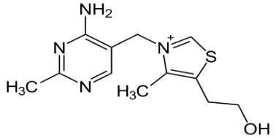 Thiamine | Chemical Formula
Biological active form is thiamine pyrophosphate (TPP), acts as a coenzyme in several metabolic reactions.  Thiamine Pyrophosphate 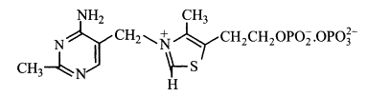 | Coenzyme Form with Reactive Group
Adult: 0.5 mg for each 1000 calories; 1.0 to 1.5 mg for diets providing 2000 to 3000 C. Actual requirement is related more directly to carbohydrates content of diet than to calorie value of diet.  Children: Ranges from 0.4 mg for infants to 1.3 mg for 10 - 12 years of age.  Requirements Increases in hemorrhage, serious illness and injury, during prolonged administration of broad-spectrum oral antibiotics, increased calorie expenditure like fever, hyperthyroidism, increased carbohydrate intake, Increased alcohol intake, and pregnancy and in lactation. | Daily Requirements
Plant source: Widely distributed in plant kingdom. In cereal grains, it is concentrated in outer germ/bran layers (e.g. rice polishings) (Richest source). Other good sources are peas, beans, whole cereal grains, etc. Whole white bread is a good source.  Animal source: Thiamine is present in most animal tissues. Liver, meat and eggs supply considerable amounts. Milk has low concentration, but a good source as large quantities are consumed. | Occurrence and Food Sources
Biological active form is thiamine pyrophosphate (TPP), acts as a coenzyme in several metabolic reactions.  - Acts as coenzyme to the enzyme pyruvate dehydrogenase complex (PDH) which converts pyruvic acid to acetyl-CoA (oxidative decarboxylation).  PDH, TPP  Pyruvate -----------------------► Acetyl-CoA  - Similarly acts as a coenzyme to α-oxoglutarate dehydrogenase complex and converts α-oxoglutarate to succinyl-CoA (oxidative decarboxylation).  α-Oxoglutarate dehydrogenase  α-Oxoglutarate ------------------------------------►Succinyl-CoA  TPP  TPP also acts as a coenzyme with the enzyme transketolase in transketolation reaction in HMP-shunt of glucose metabolism.  Transketolase , TPP  Ribose-5-P + Xylulose-5-P ----------------► Sedoheptulose-7-P + Glyceraldehyde-3-P  B1 is also required in amino acid tryptophan metabolism for the activity of the enzyme tryptophan pyrrolase.  - TPP acts as the coenzyme (Co-carboxylase) of pyruvate carboxylase in yeasts for the non-oxidative decarboxylation of pyruvate to acetaldehyde. | Biochemical roles with some examples
Deficiency Manifestation: Beriberi. The deficiency of thiamine produces a condition called beriberi. It is characterized by the following manifestations.  - Dyspnea, cardiac hypertrophy and dilatation, which may progress to congestive cardiac failure.  - Neurological manifestations: These are predominantly those of ascending, symmetrical, peripheral polyneuritis. These neurological features may be accompanied occasionally by an acute hemorrhagic polio-encephalitis which is then called as Wernicke’s encephalopathy.  - GI symptoms: Amongst these, anorexia is an early symptom. There may be gastric atony, with diminished gastric motility and nausea; fever and vomiting occur in advanced stages.  Dry beriberi: When it is not associated with oedema.  Wet beriberi: Oedema is associated. It is probably in part to congestive cardiac failure and in part to protein malnutrition (Low plasma albumin). | Symptoms of Vit. B1 Deficiency

Biochemical Features in Thiamine Deficiency
- Decreased level of thiamine and co-carboxylase TPP in blood and urine. Determination of amount of thiamine excreted in 4 hours urine is used.
- Accumulation of pentose sugars in RB cells due to retardation of transketolation reaction.
- Increased level of pyruvic acid and lactic acid in blood, due to retardation of oxidative decarboxylation of pyruvic acid.
- LA/PA ratio: Abnormal blood LA/PA ratio is said to be more specific indicator of B1 deficiency.

