B. Lateral Load Systems

- Frame Overview
- Flat plate (& slab)-column (w/ and w/o drop panels and/or capitals) frame systems
- Beam-column frame systems
- Shear wall systems (building frame and bearing wall)
- Dual systems (frames and shear walls)

23

Frame: Coplanar system of beam (or slab) and column elements dominated by flexural deformation






Planar (2D) Space (3D)

24

Basic Behavior

Gravity Load
Lateral Loading

25

2D vs. 3D Frames (Plan)

2 or 4 frames , 2 frames 4 frames , 4 frames

Planar
Floor joists, type

Space


26

- Optimum use of floor space, ie. optimal for office buildings, retail, parking structures where open space is required.
- Relatively simple and experienced construction process
- Generally economical for low-to mid-rise construction (less than about 20 stories)
- In Houston, most frames are made of reinforced concrete.

27

- Generally, frames are flexible structures and lateral deflections generally control the design process for buildings with greater than about 4 stories. Note that concrete frames are about 8 times stiffer than steel frames of the same strength.
- Span lengths are limited when using normal reinforced concrete (generally less than about 40 ft, but up to about 50 ft). Span lengths can be increased by using pre-stressed concrete.

28




Flat plate-column frame: Effective
slab width

Plan Elevation

29

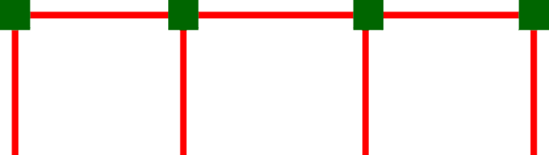

Beam-column frame:

Elevation

30

Diaphragm (shear) element: Carries lateral loading to the lateral load resisting system

Lateral load frame, type.
Plate element

Deformed shape - Lateral load distributes to frames proportional to tributary area

31



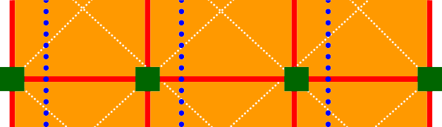
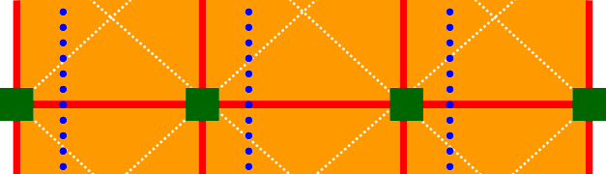

For relatively square plans, diaphragms are generally considered rigid

Space frame with square plan

Deformed shape has constant lateral displacement - No diaphragm flexibility, ie. lateral load distributes to frame proportional to frame stiffness

32




Shear wall Edge column Shear deformations
generally govern

Interior gravity frames
Elevation

33

Elevator shaft configuration

Gravity frames

Hole
Shear walls

Coupling beams

34

Wall-Frame Dual System:

Lateral frames – 25% of lateral
load, minimum

Hole
Shear walls

35



Beams
- Columns

Slabs/plates/shells/folded plates
- Walls/diaphragms

36

Defn: Members subject to bending and shear

L V
M
V E,I,A
M
δ1,Θ1

δ2 Θ2

Elastic Properties:
kb = f ( EI/Ln) (bending) σ = My/I (normal stress) ks = GA/L (shear) v = VQ/Ib (shear stress)
δb = f (load, support conditions, L, E, I) (bending)

37

Defn: Members subject to bending, shear, and axial

L V
F F
M V E,I,A M

δ1,Θ1
δ3
δ2,Θ2

Elastic Properties:
k_{a} = EA/L (axial) σ_{a} = F/A (normal stress) kb = f ( EI/Ln) (bending) σb = My/I (normal stress) ks = GA/L (shear) v = VQ/Ib (shear stress)
δb = (load, support conditions, L, E, I, A) (normal)
38



Defn: Members subject to bi-directional bending & shear

z
y
M_{x}, M_{y}, and V_{z}
x Θ_{x}, Θ_{y}, and δ_{z}

39

Defn: Members subject to shear

y
V_{x} and V_{x}
x δ_{x} and δ_{y}

40

