Loading

SPECIFICATIONS
Cities in the U.S. generally base their building
code on one of the three model codes:
- Uniform Building Code
- Basic Building Code (BOCA)
- Standard Building Code

Loading
These codes have been consolidated in the 2000 International Building Code.

Loadings in these codes are mainly based on ASCE Minimum Design Loads for Buildings and Other Structures (ASCE 7-95) – has been updated to ASCE 7-98.

Dead Loading
- Weight of all permanent construction

- Constant magnitude and fixed location

Examples:

Dead Load

  - Weight of the Structure
(Walls, Floors, Roofs, Ceilings, Stairways)
  - Fixed Service Equipment
(HVAC, Piping Weights, Cable Tray, Etc.)

Can Be Uncertain…
  - pavement thickness
  - earth fill over underground structure

Live Load
    - Loads produced by use and occupancy of the structure.
    - Maximum loads likely to be produced by the intended use.
    - Not less than the minimum uniformly distributed load given by Code.

Live Load

See Table 2-1 from ASCE 7-95
Stairs and exitways: 100 psf Storage warehouses: 125 psf (light)
250 psf (heavy)

Minimum concentrated loads are also given in the codes.

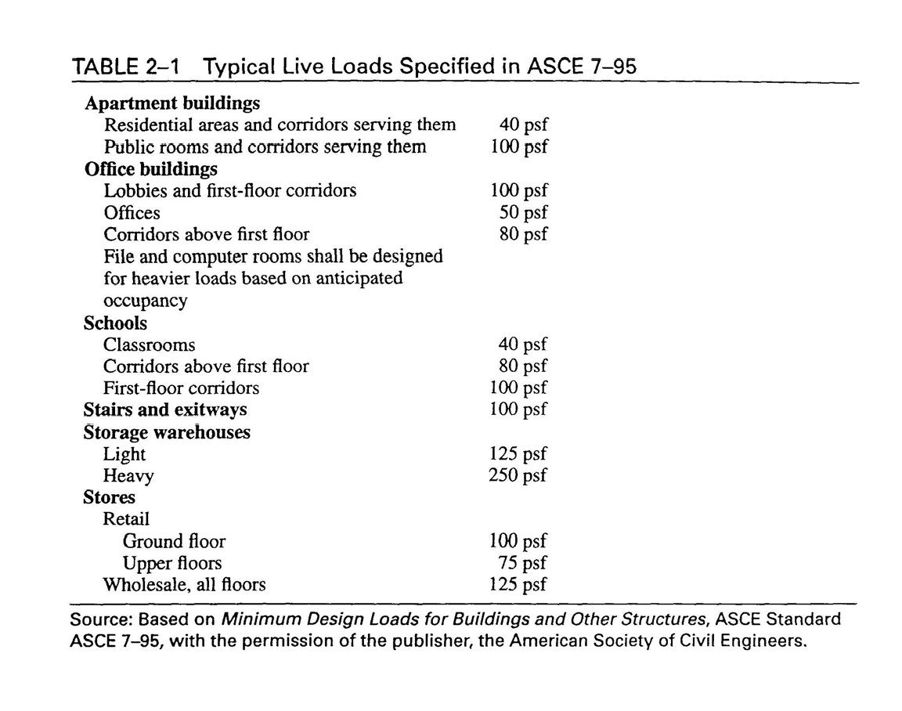
Live Loads

Live Load
ASCE 7-95 allows reduced live loads for members with influence area (AI) of 400 sq. ft. or more:

⎛
L = L
o
⎜
⎝
⎜ 0 . 25
+
⎟
A
I
⎟
⎠
where Lo
≥ 0.50 Lo for members
15 ⎞

supporting one floor
≥ 0.40 Lo otherwise

Live Loads

AI determined by raising member to be designed by a unit amount. Portion of loaded area that is raised = AI
Beam: AI = 2 * tributary area
Column: AI = 4 * tributary area Two-Way Slab: AI = panel area
(see Fig. 2-10, text)

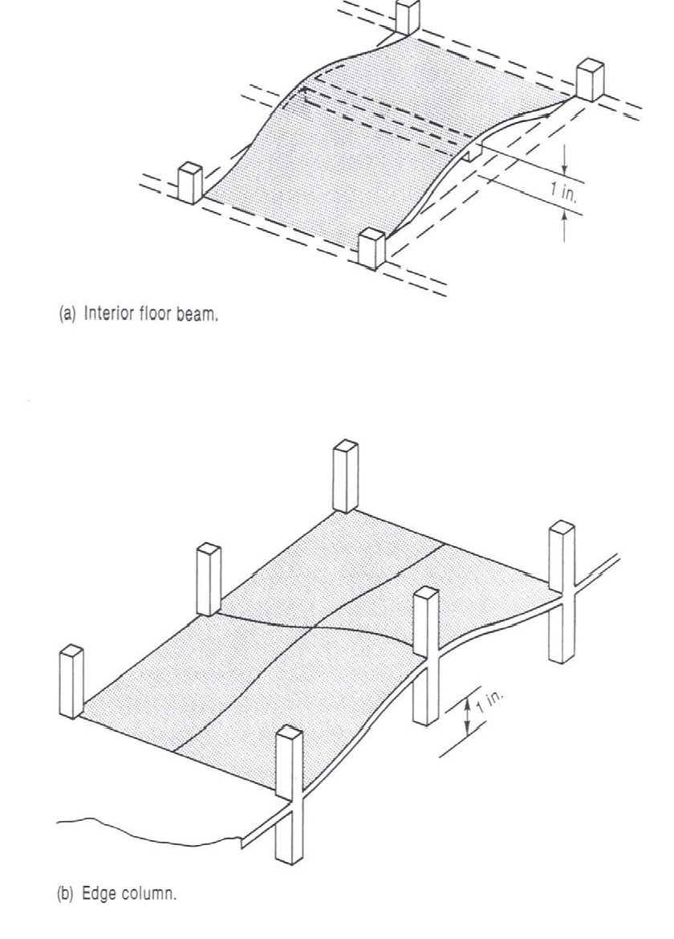
Load Reduction

Environmental Load

- Snow Loads
- Earthquake
- Wind
- Soil Pressure
- Ponding of Rainwater
- Temperature Differentials

Classification of Buildings for Wind, Snow and Earthquake Loads

Based on Use Categories (I through IV)
- Buildings and other structures that represent a low hazard to human life in the event of a failure (such as agricultural facilities)

- Buildings/structures not in categories I, III, and IV

Classification of Buildings for Wind, Snow and Earthquake Loads

Based on Use Categories (I through IV)
- Buildings/structures that represent a substantial hazard to human life in the event of a failure (assembly halls, schools, colleges, jails, buildings containing toxic/explosive substances)

Classification of Buildings for Wind, Snow and Earthquake Loads

Based on Use Categories (I through IV)

- Buildings/structures designated essential facilities (hospitals, fire and police stations, communication
centers, power-generating stations)

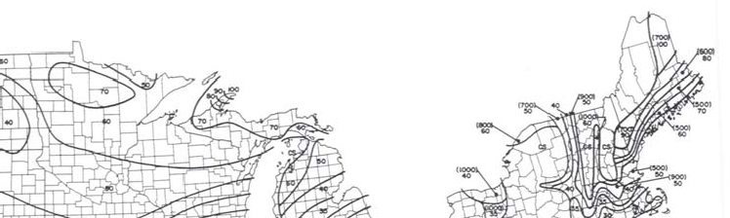
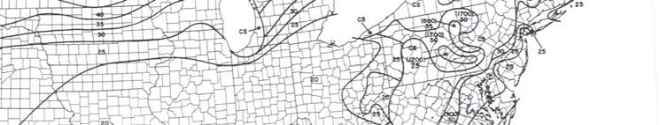
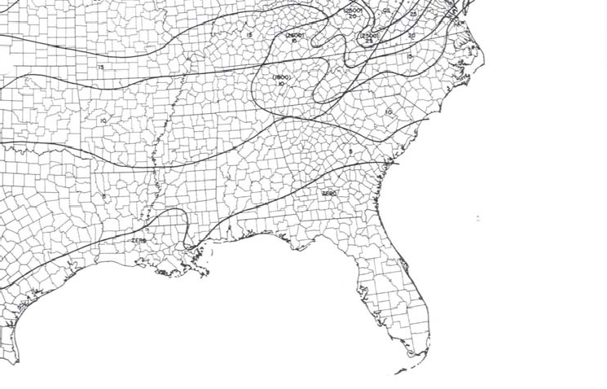
Snow Load

The coefficients of snow loads are defined in weight.

Snow Load
Ground Snow Loads (Map in Fig. 6, ASCE 7):
  - Based on historical data (not always the maximum values)
  - Basic equation in codes is for flat roof snow loads
  - Additional equations for drifting effects, sloped roofs, etc.
  - Use ACI live load factor
  - No LL reduction factor allowed

Wind Load
    - Wind pressure is proportional to velocity squared (v2 )

    - Wind velocity pressure = qz

qz =
0.00256 Kz
kzt
V ² I

Wind Load

where
2
qz =
0.00256 Kz
kzt V I

0.00256 reflects mass density of air and unit conversions.
V = Basic 3-second gust wind speed (mph) at a height of 33 ft. above the ground in open terrain. (1:50 chance of exceedance in 1 year)
Kz = Exposure coefficient (bldg. ht., roughness of terrain) kzt = Coefficient accounting for wind speed up over hills I = Importance factor

Wind Load
Design wind pressure,
p = qz * G * Cp

G = | Gust Response Factor
Cp = | External pressure coefficients (accounts for  directions on building) | pressure
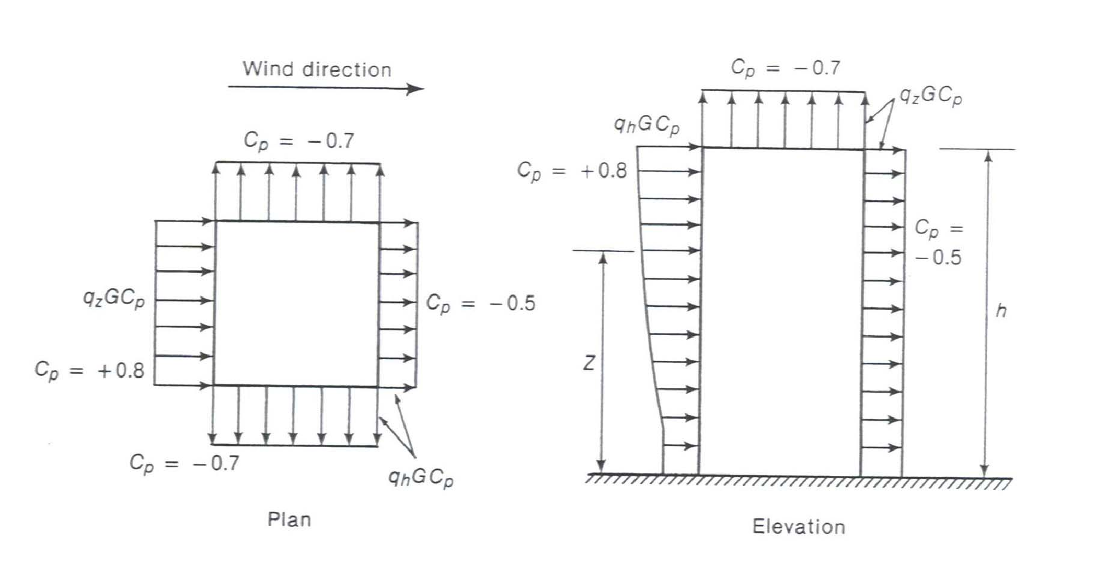

Earthquake Load
Inertia forces caused by earthquake motion

F = m * a

- Distribution of forces can be found using equivalent
static force procedure (code, not allowed for every
building) or using dynamic analysis procedures

Earthquake Load
Inertia forces caused by earthquake motion. Equivalent Static Force Procedure for example, in ASCE 7-95:

where
V = Cs * W

V = Total lateral base shear
Cs = Seismic response coefficient W = Total dead load

Earthquake Load
Total Dead Load, W:
1.0 * Dead Load
+ 0.25 * Storage Loads
+ larger of partition loads or 10 psf
+ Weight of permanent equipment
+ contents of vessels
+ 20% or more of snow load

Earthquake Loads

⎧1.2 C
2.5 C

C = smaller of
⎨ v
and a

s ⎩ R T
2 / 3 R

where
Cv = Seismic coefficient based on soil profile and Av Ca = Seismic coefficient based on soil profiled and Aa
R = Response modification factor (ability to deform in inelastic range)
T = Fundamental period of the structure

Earthquake Loads

⎧1.2 C
2.5 C

C = smaller of
⎨ v
and a

s

where
⎩ R T
2 / 3 R

T = Fundamental period of the structure

T = CT hn 3/4

where CT = 0.030 for MRF of concrete
0.020 for other concrete buildings. hn = Building height

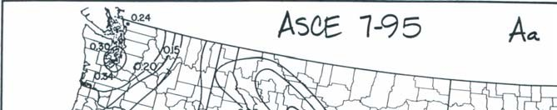
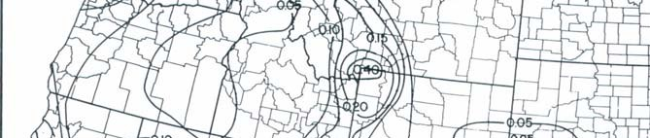
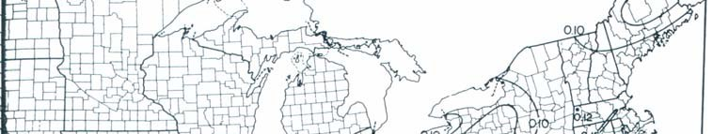
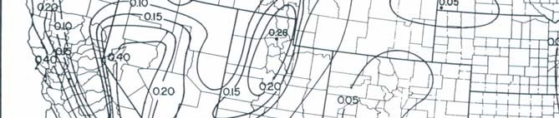
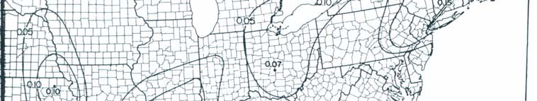
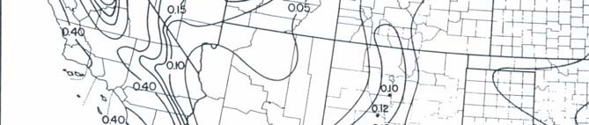
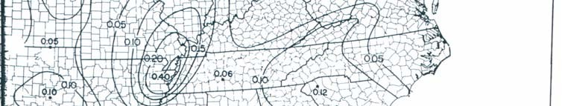
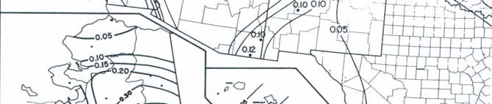
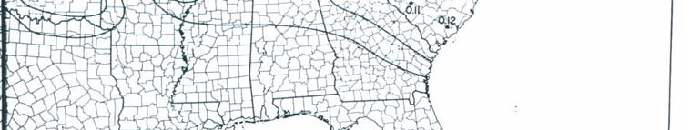
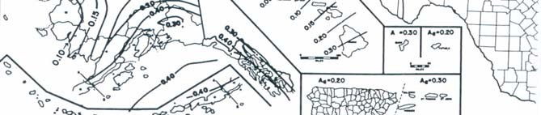
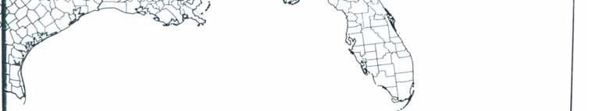
Earthquake Map

Roof Load
- Ponding of rainwater
  - Roof must be able to support all rainwater that could accumulate in an area if primary drains were blocked.
  - Ponding Failure:
→ Rain water ponds in area of maximum deflection
→ increases deflection
→ allows more accumulation of water → cycle continues…→ potential failure

Roof Load

    - Roof loads are in addition to snow loads

    - Minimum loads for workers and construction materials during erection and repair

Construction Loads

    - Construction materials

    - Weight of formwork supporting weight of fresh concrete

