Concrete Mixing and Proportioning
    - Concrete: Composite material composed of portland cement, fine aggregate (sand), coarse

aggregate (gravel/stone), without other additives.
and water; with or

    - Hydration: Chemical process in which the cement powder reacts with water and then sets and hardens into a solid mass, bonding the aggregates together

Concrete Mixing and Proportioning

    - Heat of Hydration: Heat is released during the hydration process.
– In large concrete masses heat is dissipated slowly temperature rises and volume expansion later cooling causes contraction. Use special measures to control cracking.

Proportioning

Proportioning: Goal is to achieve mix with
  - Adequate strength
  - Proper workability for placement
  - Low cost
- Low Cost:
  - Minimize amount of cement
  - Good gradation of aggregates (decreases voids and cement paste required)

- Water-Cement Ratio (W/C)
  - Increased W/C: Improves plasticity and fluidity of the mix.
  - Increased W/C: Results in decreased strength due to larger volume of voids in cement paste due to free water.

- Water-Cement Ratio (W/C) (cont..)
  - Complete hydration of cement requires W/C ~ 0.25.
  - Need water to wet aggregate surfaces, provide mobility of water during hydration and to provide workability.
  - Typical W/C = 0.40-0.60

- Water/Concrete table
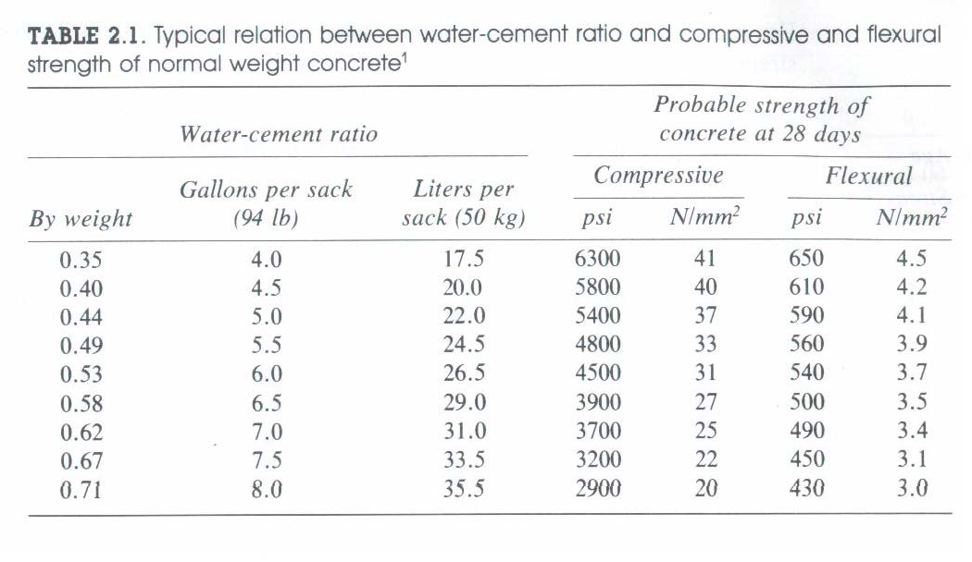

Proportioning
- Proportions have been given by volume or

weight of cement to sand to gravel (ie. with W/C specified separately
1:2:4)

- Now customary to specify per 94 lb. Bag of cement: wt. Of water, sand & gravel
- Batch quantity: wt. per cubic yard of each component

- Aggregates
- 70-75% of volume of hardened concrete
- Remainder = hardened cement paste, uncombined water, air voids
- More densely packed aggregate give better
  - strength
  - weather resistance (durability)
  - Economical

- Aggregates
  - Fine aggregate: sand (passes through a No. 4 sieve; 4 openings per inch)
  - Coarse aggregate: gravel
  - Good gradation:
    - 2-3 size groups of sand
    - Several size groups of gravel

Proportioning
- Maximum size of coarse aggregate in RC structures: Must fit into forms and between reinforcing bars:(318-99, 3.3.2)
  - 1/5 narrowest form dimension
  - 1/3 depth of slab
  - 3/4 minimum distance between reinforcement bars

Aggregate Strength
- Strong aggregates: quartzite, felsite
- Weak aggregates: sandstone, marble
- Intermediate strength: limestone, granite

In the design of concrete mixes, three principal requirements for concrete are of importance:
- Quality

Workability
- Economical

Proportioning
    - Quality of concrete is measured by its strength and durability. The principal factors affecting the strength of concrete , assuming a sound aggregates, W/C ratio, and the extent to which hydration has progressed. Durability of concrete is the ability of the concrete to resist disintegration
due to freezing and thawing and chemical attack.

    - Workability of concrete may be defined as a composite characteristic indicative of the ease with which the mass of plastic material may deposited in its final place without segregation during placement, and its ability to conform to fine forming detail.

    - Economical takes into account effective use of materials, effective operation, and ease of handling. The cost of producing good quality concrete is an important consideration in the overall cost of the construction project.

Proportioning

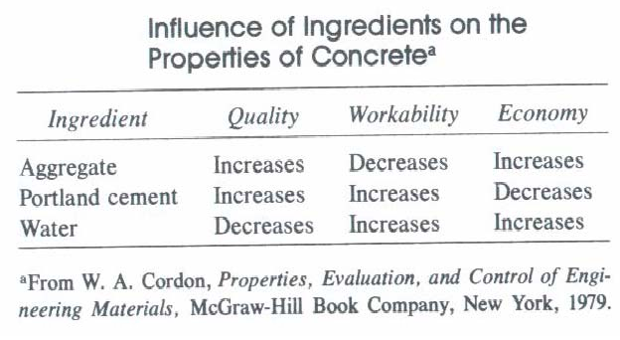
The influence of ingredients on properties of concrete.

- Workability
  - Workability measured by slump test









12”
slump
1 2 3 4
- Layer 1: Fill 1/3 full. 25 stokes
- Layer 2: Fill 2/3 full. 25 stokes
- Layer 3: Fill full. 25 stokes
- Lift cone and measure slump (typically 2-6 in.)

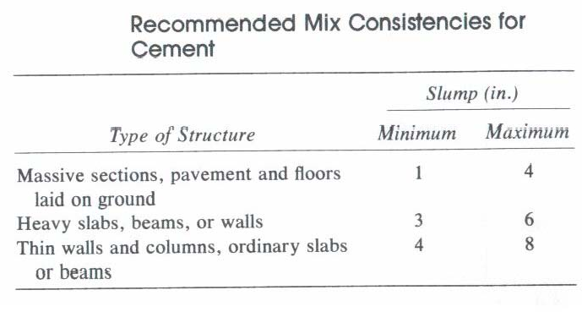
Slump test - The measurement of the consistency of the mix is done with the slump-cone test. The recommend consistency for various classes of concrete structures .

Concrete Mixing and Proportioning
- Admixtures
  - Applications:
    - Improve workability
    - Accelerate or retard setting and hardening
    - Aid in curing
    - Improve durability

Concrete Mixing and Proportioning

Admixtures
  - Air-Entrainment: Add air voids with bubbles
    - Help with freeze/thaw cycles, workability, etc.
    - Decreases density: reduces strength, but also decreases W/C
  - Superplasticizers increase workability by chemically releasing water from fine
aggregates
.

  - Type I: General Purpose
  - Type II: Lower heat of hydration than Type I
  - Type III: High Early Strength
    - Higher heat of hydration quicker strength (7 days vs. 28 days for Type I)

  - Type IV: Low Heat of Hydration
    - Gradually heats up, less distortion (massive structures).
  - Type V: Sulfate Resisting
    - For footings, basements, sewers, etc. exposed to soils with sulfates.

