Flexural stresses

Lecture Goals
- Basic Concepts
- Rectangular Beams
- Non-uniform beams
- Balanced Beams

Flexural Stress
Example
Consider a simple rectangular beam( b x h ) reinforced with steel reinforcement of As.
- Determine the centroid ( neutral axis, NA ) and moment of inertia Izz of the beam for an ideal beam (no cracks).
- Determine the NA and moment of inertia, Izz, of beam if the beam is cracked and tensile forces are in the steel only.

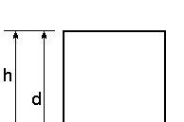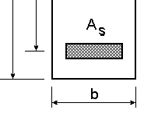
Ec – Modulus of Elasticity - concrete
Es – Modulus of Elasticity - steel As – Area of steel
d – distance to steel
b – width
h – height
n = s
Ec
E

y = ∑
∑Ai
I =
∑
I +
i
∑
(
y − y
i
)
2
A
i
Moment of Inertia
yi Ai

Centroid (NA)

 | Area | yi | y_{i}A | I | y_{i} - y | (y_{i} -y)² A
Concrete | bh | h/2 | bh²/2 | bh³/12 | (h/2-y) | (h/2-y)bd
Steel | (n-1)A_{s} | d | d(n-1)A_{s} | --- | (d-y) | (d-y)²(n-1)A_{s}

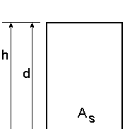
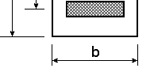
2
Example (uncracked)
y =
∑y A
bh
∑Ai
i i
=
2
+ (n −1) A d
s
bh + (n −1) As

I = ∑ Ii
+ ∑( yi
− y )2 A
= bh³
12
⎛ h ⎞2
⎜ 2 y ⎟
+
−
bh + (d
− y )2 (n −1) A

⎝ ⎠
i
s

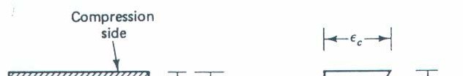
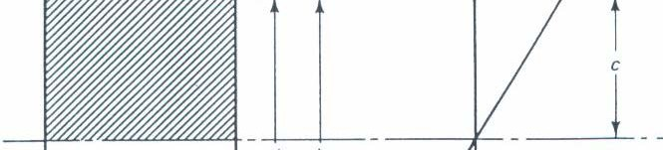
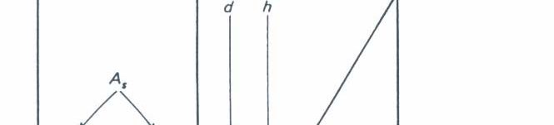
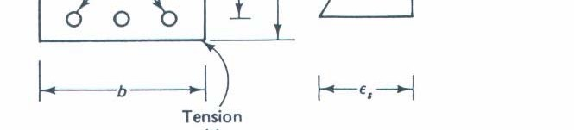
For a cracked section the concrete is in compression and steel is in tension.
The strain in the beam is linear.
C = yb 1 f
2 c
T = As fs

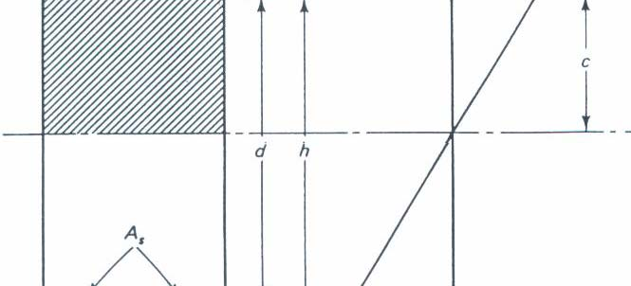
Using Equilibrium
T = C
A f = yb 1 f
s s
2
c
f = ⎛ yb ⎞ f
s
⎜ 2 A ⎟
⎝
s ⎠
c

Using Hooke’s law f
= Eε

E
ε
= ⎛
yb
⎞

E
ε ⇒
εc =
⎛
Es
⎞⎛
2 As ⎞ =
2nAs

However, this is an indeterminate problem to
s s
⎝
⎜ 2 A ⎟
s ⎠
c c
ε
s
⎝
⎜ E ⎟⎜ yb ⎟
c ⎠⎝
⎠
yb
find y . We will need to use a compatibility
condition.

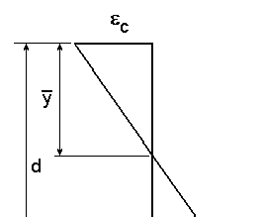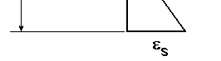
Using a compatibility
condition.
εs
d − y
= εc
y
⇒ εc
εs
=
y
d − y
Substitute into the first equation.

Substitute in for the strain relationship.
y = 2nAs
d y yb
Rearrange the equation into a quadratic equation.

y +
2
⎜
⎛
2nA
s
⎝
b
⎟
⎞
⎠
⎜
⎛
2nA
s
⎝
b
⎟
⎞
⎠
d = 0
y −

Example (cracked

Use a ratio of areas of concrete and steel.

ρ = As
bd
y ² + 2nρd y − 2nρd ² = 0
Modify the equation to create a non-dimensional ratio.

2
⎛ y ⎞
⎜ d ⎟ + 2nρ ⎜ d ⎟ − 2nρ = 0
⎛ y ⎞
⎝
⎠
⎝
⎠

Example - (cracked)
Use the quadratic formula
−2nρ ±
(2nρ )2 + 8nρ

⎛
⎜ d ⎟ =
⎝
⎠
⎛ y ⎞ =
⎜ d ⎟
⎝
⎠
2
(nρ 2 + 2nρ − nρ
y ⎞

Solve for the centroid by multiplying the result by d.

Example (cracked
The moment of inertia using the parallel axis
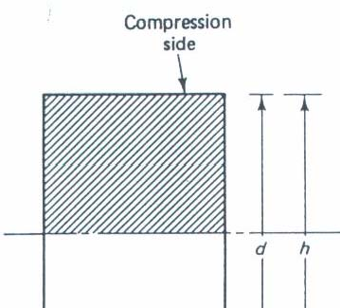
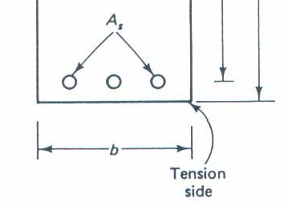
∑
I +
i
∑
(
y − y
i
)
2
A
i
=
by ³
12
+ ⎜
I =
⎝ 2 ⎠
⎟
by + d
(
−
2
y
)
nA
s
= by
3
3
+ d − y ² nA
s
⎛ y ⎞2

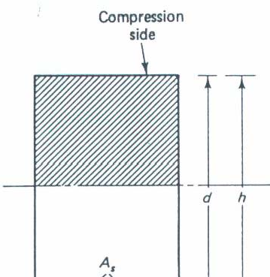
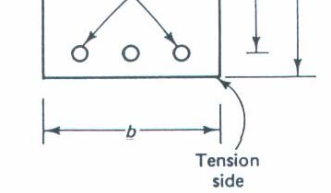
For the following example find centroid and moment of inertia for an uncracked and cracked section and compare the results.
Es = 29000 ksi Ec = 3625 ksi
d = 15.5 in b = 12 in. h = 18 in. Use 4 # 7 bars for the steel.

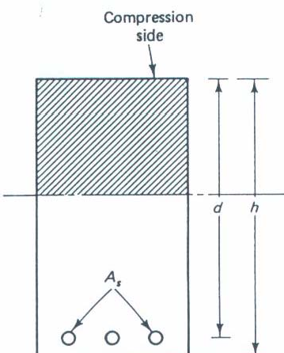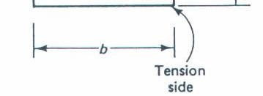
n = Es
Ec
= 29000 ksi = 8
3625 ksi
A #7 bar has an As = 0.6 in2
A = 4 0.6 in²
s
= 2.4 in²

The uncracked centroid is

bh²
y = 2
+ (n −1
As d

bh + (n −1) As

(12 in)(18 in)2
+ (8 −1)(2.4 in² )(15.5 in)

2
=
(12 in)(18 in) + (8 −1)(2.4 in² )

= 2204.4 in³
232.8 in²
= 9.47 in

The uncracked moment of inertia

I =
bh³
12
+ ⎜
⎛ h
⎞2
⎝ 2
− y
⎟
⎠
bh + d − y
(
2
) (
n −1 A
)
s

(12 in)(18 in)3
⎛ 18 in ⎞2

= 12 + ⎜ 2
− 9.47 in ⎟
(12 in)(18 in)

⎝ ⎠

+(15.5 in
− 9.47 in)2 (8 −1)(2.4 in² )

= 6491 in⁴

The cracked centroid is defined by:
0.0129

ρ = A =
s
2.4 in² =

⎛ y ⎞
⎜ d ⎟
bd (12 in)(15.5 in)

− nρ
(nρ )2 + 2nρ
=

⎝ ⎠
((8)(0.0129))2 − 2 (8)(0.0129)
=
= 0.3627
y = 0.3627 (15.5 in)

= 5.62 in

− (8)(0.0129)

The cracked moment of inertia is
I =
by ³
3
+ d − y
(
2
)
nA
s
= 1 (12 in)(5.62 in)3 3

+(15.5 in − 5.62 in)2
(8)(2.4 in² )

= 2584.2 in⁴

= A f
⎛ d −
a ⎞

